w

**Military English**

Vocabulary Builder: Military time



**Overview:**  
This sheet lists vocabulary of numbers and the military way of referring to time.

**In this vocabulary builder, you will:**

* use vocabulary related to time in the military.

1. Write the number in words next to the figure OR the figure next to the word.

|  |  |  |  |  |
| --- | --- | --- | --- | --- |
| 0 | zero |  |  | seventeen |
| 1 | one |  | 18 |  |
|  | two |  | 19 |  |
| 3 |  |  |  | twenty |
|  | four |  | 21 |  |
| 5 |  |  | 22 |  |
| 6 |  |  | 23 |  |
|  | seven |  |  | twenty-four |
|  | eight |  | 25 |  |
| 9 |  |  | 26 |  |
| 10 |  |  |  | twenty-seven |
| 11 |  |  | 28 |  |
|  | twelve |  |  | twenty-nine |
|  | thirteen |  | 30 |  |
| 14 |  |  | 40 |  |
|  | fifteen |  |  | fifty |
| 16 |  |  | 100 |  |

1. Check your spelling, and listen to the words practised in the table. Listen and repeat.

Practise pronunciation of the numbers with your teacher.

1. In the military, we use a 24-hour clock to tell the time.

* The 24-hour clock uses the numbers 00:00 to 23:59 (midnight is 00:00).
* Remember, for everything after 1259 p.m. in the afternoon, and evening hours, add 12.
  + **2:00 p.m.** becomes **1400** (2 in the afternoon +12=14).
  + **10:00 p.m.** becomes **2200** (10 in the evening +12=22).

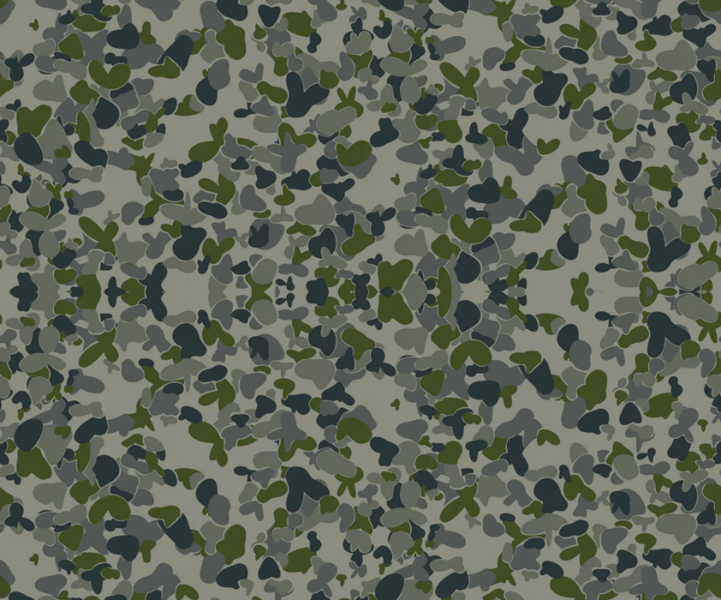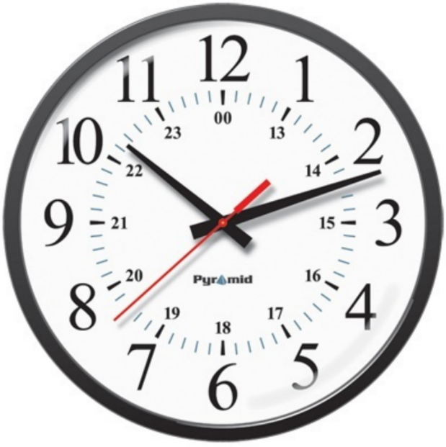

Also, in the military, the time is often written **without** the two dots, between the hours and the minutes e.g. **07:55** is usually written as **0755** (seven fifty-five in the morning).

Time for the **whole world** is usually [Coordinated Universal Time/UTC](https://militarytimechart.com/coordinated-universal-time-utc/) and is written with a “Z” at the end, and is written as **0755Z.**

Write the correct military time.

1. *zero eight hundred = _0800_* (class / start)
2. zero six thirty = ________ (breakfast)
3. zero two thirteen = ________ (my flight / arrive)
4. eleven forty-five = ________ (lunch / start)
5. sixteen twenty-five = ________ (class / finish)
6. twenty-two fifty = ________ (the lights / go off)
7. 13 20 = __________________________________ (lunch / finish)
8. 09 55 = __________________________________ (morning tea)
9. 18 10 = __________________________________ (the gym / close)
10. 07 00 = __________________________________ (parade)
11. 11 35 = __________________________________ (the mess / open / for lunch)
12. Now let’s listen to the words practised in this exercise. Listen and repeat.
13. When saying military time, 0700 is said as “zero seven hundred” or “oh seven hundred” because the two zeros are like ‘hundred’. If the time is 0752, we say “oh seven fifty-two”.

Practice saying the time in pairs. Use the times in exercise three. Take turns to ask, and answer.

**B: oh eight hundred**

**A: What time does class start?**

**A: zero six thirty**

**B: What time is breakfast?**

© Commonwealth of Australia 2023  
This work is copyright. Apart from any use as permitted under the Copyright Act 1968 (Cth),   
no part may be reproduced by any process without prior written permission from the Department of Defence.