**Military English**

Vocabulary Builder: Compass points



**Overview:**  
This sheet lists the 16 compass (cardinal) points.

**In this vocabulary builder, you will:**

* use vocabulary related to directions and compass points

1) There are four main points of the compass – see one example below. Can you spell the other three main points?

2) Now fill in the other 12 sub-points of the compass.

orth



**N**

**E**

**S**

**W**

NE

SE

SW

NW

NNW

NNE

ENE

ESE

SSE

SSW

WSW

WNW

3) Now let’s listen to the words practised in this worksheet. Listen and repeat:

1. north (N)
2. east (E)
3. north-east (NE)
4. north-north-east (NNE)
5. east-north-east (ENE)
6. east (E)
7. south (S)
8. south-east (SE)
9. east-south-east (ESE)
10. south-south-east (SSE)
11. west (W)

With the words you have just practised you can now pronounce all 16 compass points. For example, you have learned to pronounce north and west, so you can now say north-west, north-north-west, etc.

4) Work with a partner. Say where countries and cities are on the map. Use the compass points you have learned. Look at the language box to help you. For example:

A: Which city is in in the north of Vietnam, Hanoi or Ho Chi Minh City?  
B: It’s Hanoi.  
A: Yes, correct.

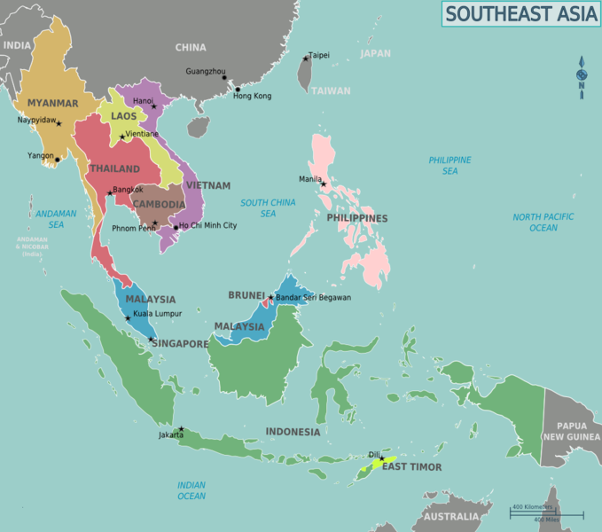

|  |  |
| --- | --- |
| LANGUAGE BOX | Asking:   * Which city is…   + **in** the north/east/south-west/etc. **of** Vietnam/Thailand/etc.? * Which country is…   + **to** the north/east/south-west/etc. **of** Vietnam/Thailand/etc.?   Answering:   * Bangkok/Hanoi/etc. is **in** the north/east/south-west/etc. **of** the country.   Asking for clarification:   * Could you repeat, please? |

* Check this YouTube video for more listening practice and information compass points.

Type on YouTube [What are the 16 Cardinal Points of a Compass?](https://www.youtube.com/watch?v=V3n_-Dg2AwA) or scan the QR Code below:



* This Vocabulary Builder links with 🡪 Lesson – Map Reading and Navigation.

© Commonwealth of Australia 2023  
This work is copyright. Apart from any use as permitted under the Copyright Act 1968 (Cth),   
no part may be reproduced by any process without prior written permission from the Department of Defence