**Military English**

Vocabulary Builder: Natural Disasters



**Overview:**  
This sheet lists vocabulary of natural disasters.

**In this vocabulary builder, you will:**

* learn and use vocabulary related to natural disasters.

1. What are some examples of ‘natural disasters’ that you know?
2. Look at the pictures. Work in pairs. Finish the spelling of each natural disaster. Look at example a.

2

3

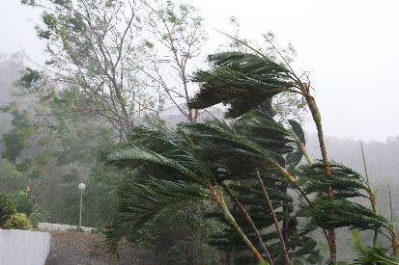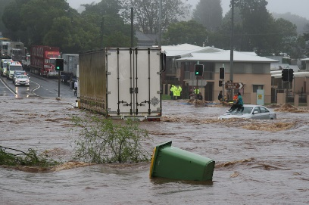

1

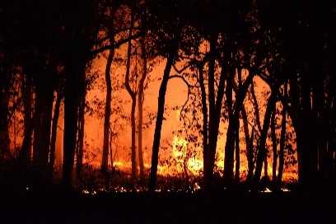

1

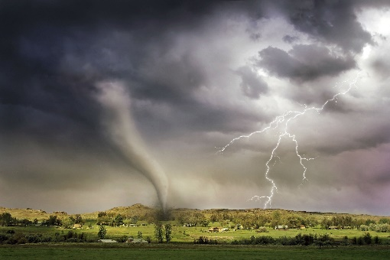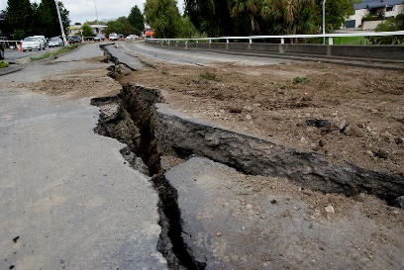a. b u s h f i r e b. t__ __ __ oo __ / c. f __ __ __ d  
 __ y__ __ o __ e

4

5

6

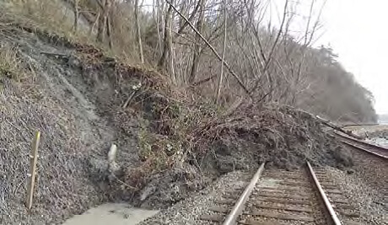

d. l __ __ d __ __ i __ e e. t __ r __ a __ o f. e __ r __ __ q __ a __ __

8

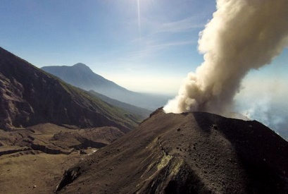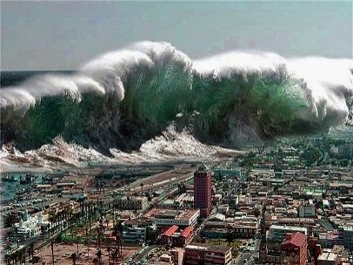

7

g. t s __ __ __ m __ h. a vol __ __ __ ic eruption

1. Now let’s listen to the words practised in this worksheet. Listen and repeat.
2. How often does your country have these natural disasters? Complete the table to answer the question.

|  |  |  |  |  |  |  |  |
| --- | --- | --- | --- | --- | --- | --- | --- |
| How often 🡪  Natural Disasters ↓ | always  100% | usually  90% | often  70% | sometimes  50% | occasionally  30% | rarely  5% | never  0% |
| bushfires |  |  |  |  |  |  |  |
| typhoons /  cyclones |  |  |  |  |  |  |  |
| floods |  |  |  |  |  |  |  |
| landslides |  |  |  |  |  |  |  |
| tornados |  |  |  |  |  |  |  |
| earthquakes |  |  |  |  |  |  |  |
| tsunamis |  |  |  |  |  |  |  |
| volcanic eruptions |  |  |  |  |  |  |  |

Now, write some sentences. Look at the example here:

*ex. There are* ***some*** *natural disasters in Victoria. We* ***usually*** *have bushfires, floods, and cyclones. We* ***often*** *have landslides in mountains, but we* ***rarely*** *have big natural disasters like tsunamis. I think it’s a* ***safe*** *place to live.*

Which words in the example above can you change to make this true for you?

When you have finished writing, tell a partner about the natural disasters in your country, city or region.

* 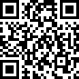Watch this YouTube video and try to write down what natural disasters you can see.   
  Type on YouTube [natural disasters](https://youtu.be/q8eIwmSJP0o) or scan the QR Code to the right:
* This Vocabulary Builder links with 🡪 Lesson – Disaster Relief; Lesson – Humanitarian Aid.

© Commonwealth of Australia 2023  
This work is copyright. Apart from any use as permitted under the Copyright Act 1968 (Cth),   
no part may be reproduced by any process without prior written permission from the Department of Defence

© Commonwealth of Australia 2023  
This work is copyright. Apart from any use as permitted under the Copyright Act 1968 (Cth),   
no part may be reproduced by any process without prior written permission from the Department of Defence