

**Military English**

Vocabulary Builder: Parts of a Helicopter

**Overview:**   
This worksheet lists vocabulary for the parts of a helicopter.

**In this vocabulary builder, you will:**

* use vocabulary related to the parts of a helicopter.

1. 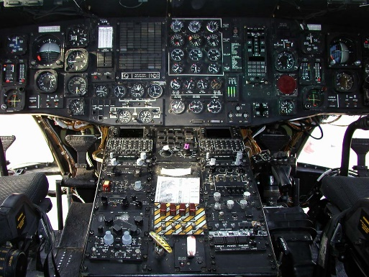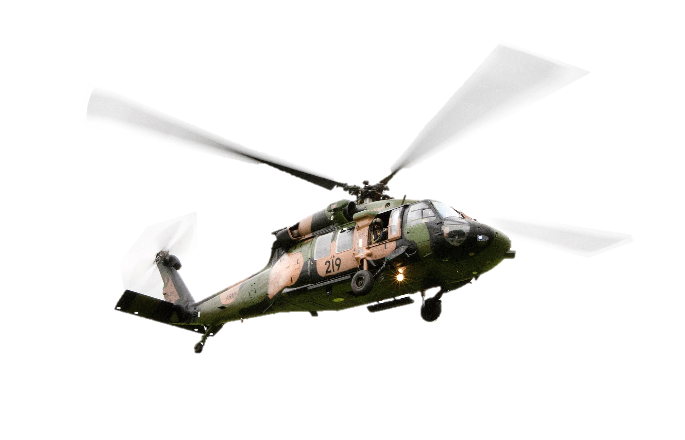Label the picture. Use the words in the box below.

h. ________________

b. ________________

f. ________________

a. ________________

e. ________________

g. ________________

cabin // cabin door // cockpit // landing gear // main rotor // tail rotor // rotor blade // tail boom

d. ________________

c. ________________

1. Now let’s listen to the words practised in this worksheet. Listen and repeat.
2. Which parts of a helicopter can you also see in an aircraft? Discuss in groups, then write in the boxes below.

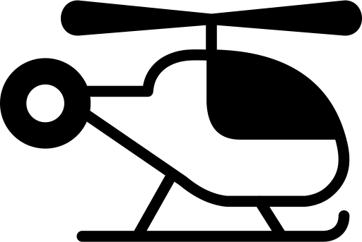

Parts that are on helicopters   
and aircraft.



Parts that are only on helicopters.

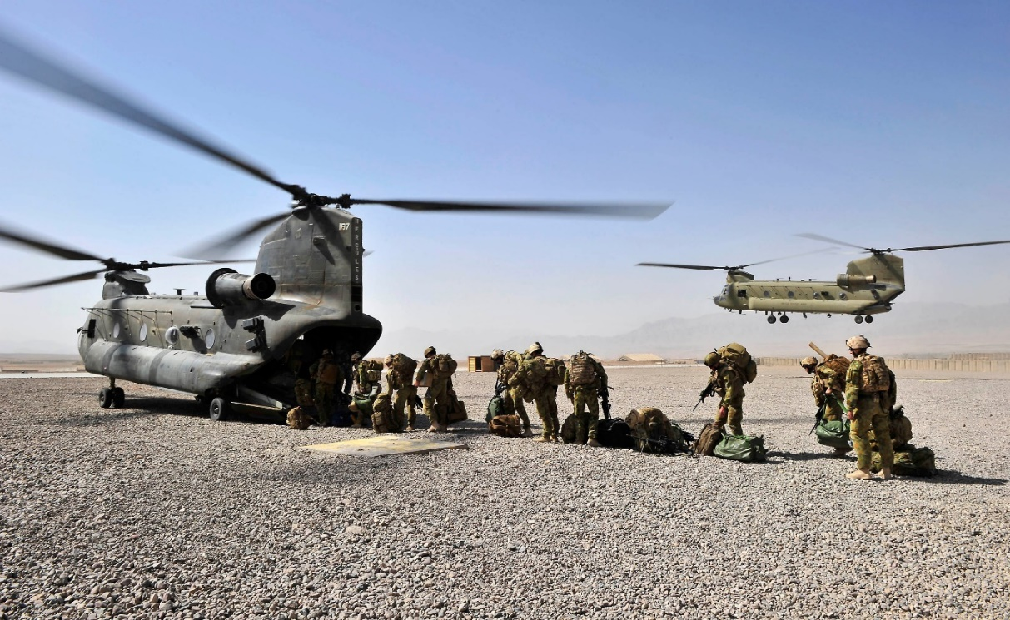

The CH-47 Chinook is a very different helicopter. It has two main rotors. It can carry about 36 personnel. It’s one of the fastest and largest military helicopters in the world. The Australian Army has more than 10 Chinook helicopters.

* Watch this YouTube video and try to write down parts you didn’t learn from this lesson.  
  Type on YouTube [Parts of a helicopter and their functions](https://youtu.be/Jg9NLUJKmdM) or scan the QR Code 🡪
* This Vocabulary Builder links with 🡪 Vocabulary Builder - Military vehicles; Vocabulary Builder – Parts of an Aircraft.

© Commonwealth of Australia 2023  
This work is copyright. Apart from any use as permitted under the Copyright Act 1968 (Cth),   
no part may be reproduced by any process without prior written permission from the Department of Defence.