

**Military English**

Vocabulary Builder: Parts of a ship

**Overview:**  
This worksheet presents vocabulary related to the parts of a ship.

**In this lesson, you will:**

* use vocabulary related to ships

1. Let’s learn the sides of a ship. Write the words from the box in the correct space.

a. ________

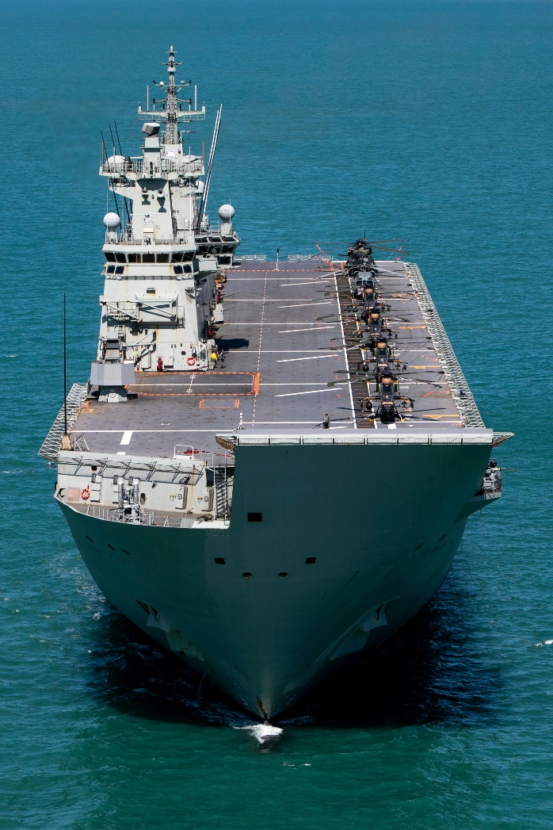

c.

b. _________

d. _________

bow // starboard // stern // portside

1. Now let’s learn the parts of an amphibious assault ship. Match the words in the box to each part.

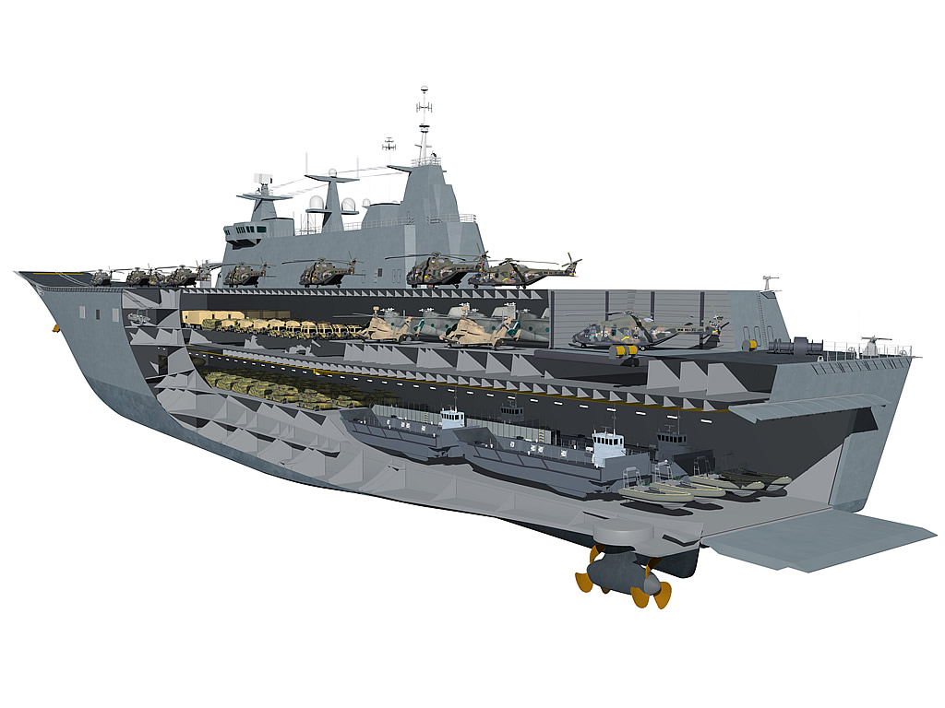

a. _________

b. _________

f. _________

c. _________

d. _________

e. _________

The Canberra Class Amphibious Assault Ship – LHD. (This stands for Landing Helicopter Dock), pictured in both pages, is the Royal Australian Navy’s largest warship. One of its many uses is to deliver humanitarian aid.

propeller // ramp // well dock // flight deck // bridge // hangar

Some of these parts above are also in other types of ship. Write them below:

__________________________________________________________________________________

1. Now let’s listen to the words practised in this worksheet. Listen and repeat.

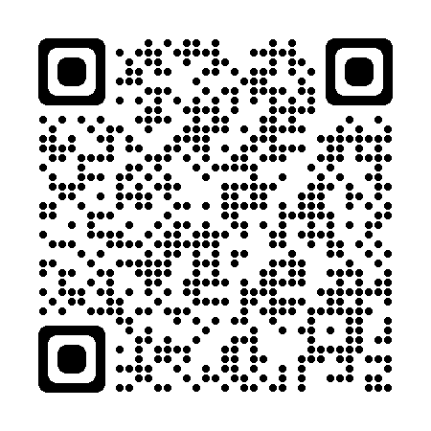

* Watch this YouTube video about the Canberra Class Amphibious Assault Ship.

Type on YouTube [Navy: 360 degree HMAS Canberra](https://www.youtube.com/watch?v=OTVt5_OvCz0) or scan the QR Code:

* This Vocabulary Builder links with 🡪 Vocabulary Builder - Military vehicles;

Vocabulary Builder – Parts of an Aircraft.

© Commonwealth of Australia 2022  
This work is copyright. Apart from any use as permitted under the Copyright Act 1968 (Cth),   
no part may be reproduced by any process without prior written permission from the Department of Defence.