

**Military English**

Vocabulary Builder: Parts of an Assault Rifle

**Overview:**  
This worksheet presents vocabulary for the parts of an assault rifle.

**In this vocabulary builder, you will:**

* use vocabulary related to the parts of an assault rifle.

1. Match the words to the pictures.

d. ________________

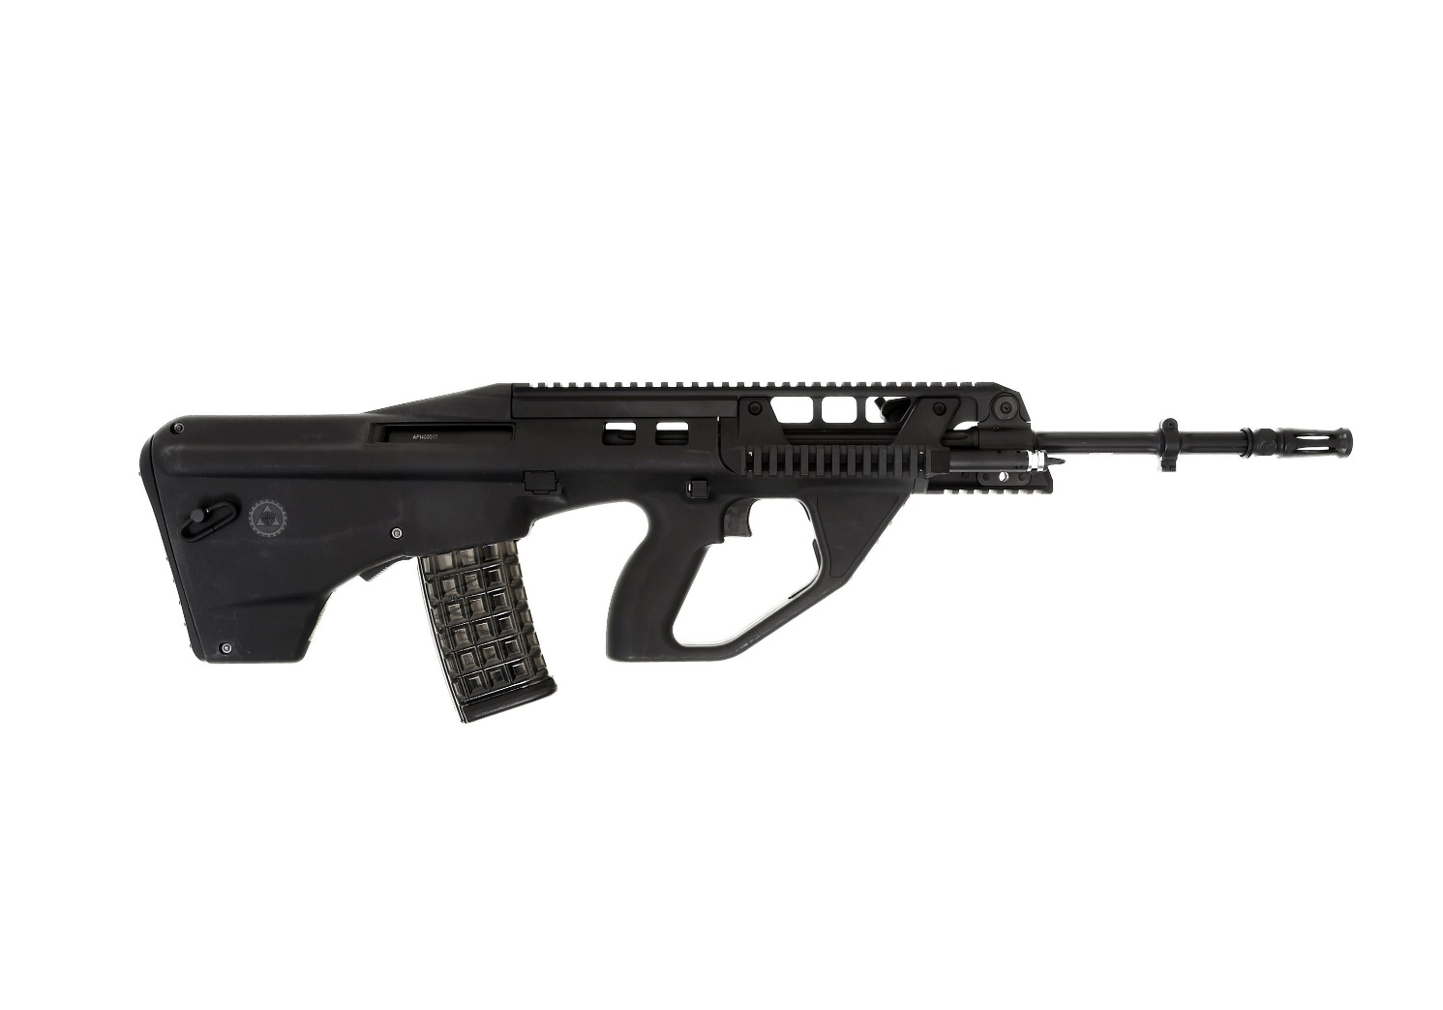

f. ________________

a. ________________

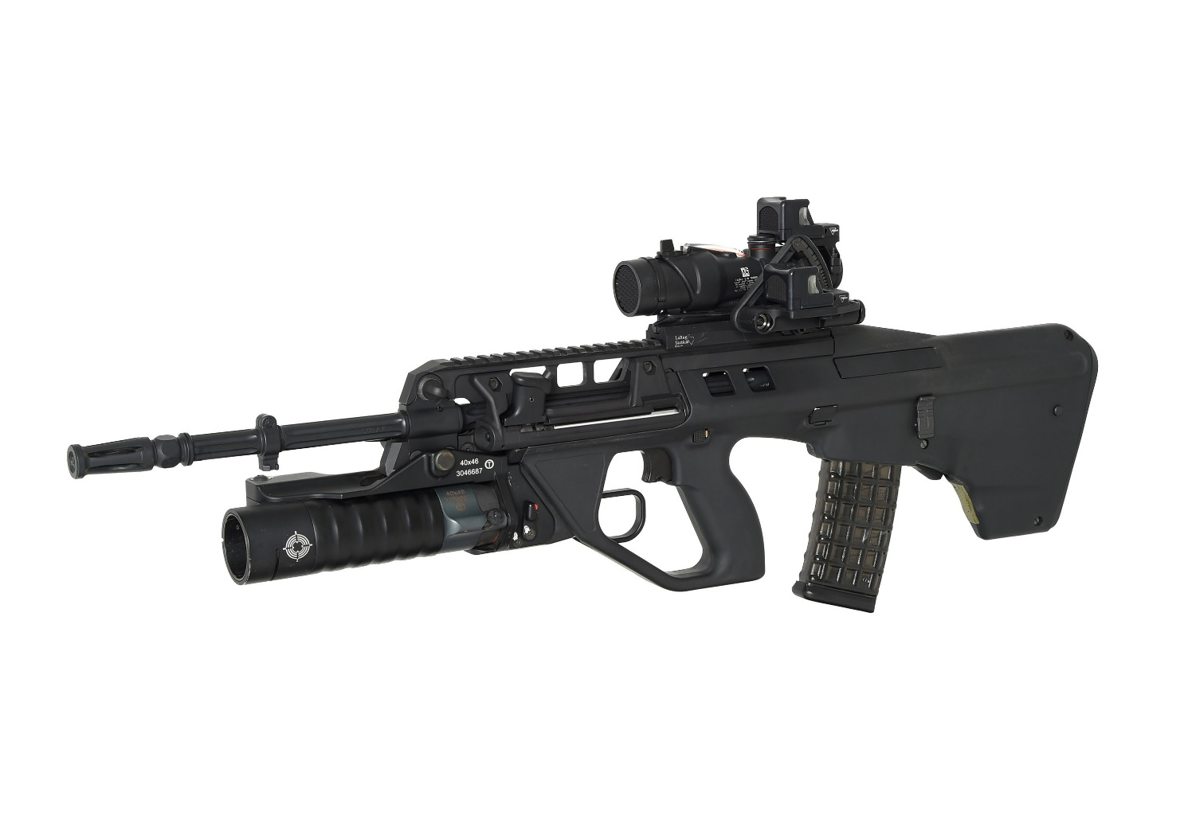

e. ________________

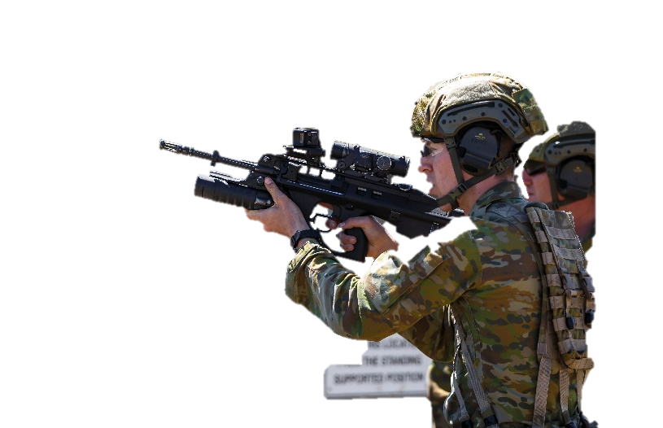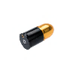

c. ________________

b. ________________

g. ________________

barrel // butt plate // trigger // sight // trigger guard // magazine // grenade launcher

1. Now let’s listen to the words practised in this worksheet. Listen and repeat.
2. Work with a partner. Point to a rifle part in the pictures below and ask your partner to say the word.   
   Use the language box below to help you. For example:

A: What’s this part called?  
B: It’s called a ___________.  
A: That’s right.

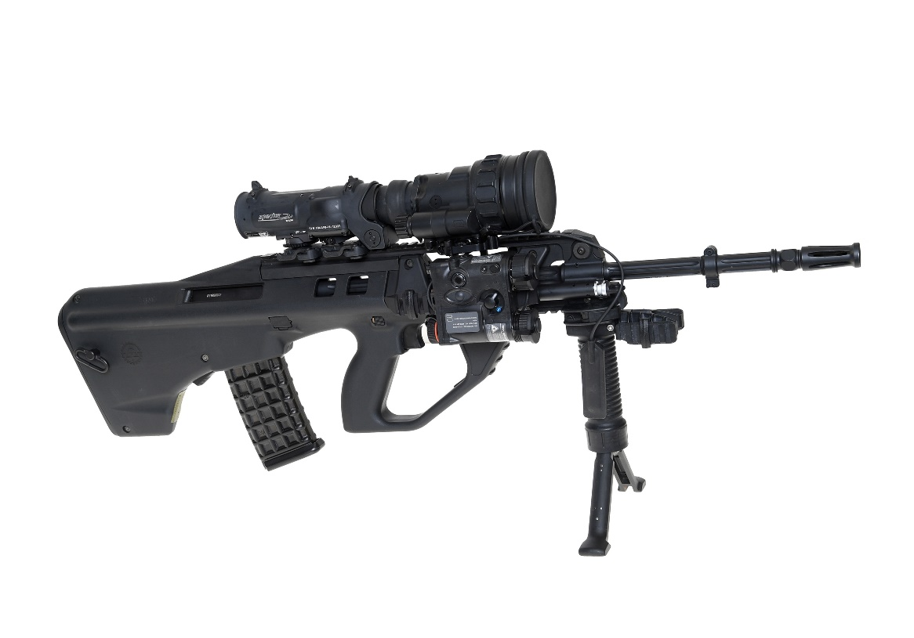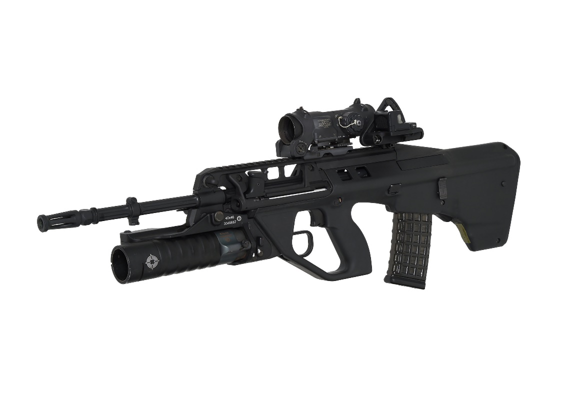

**The EF88 Austeyr assault rifle – pictured   
here – is the Australian Defence Force’s   
individual weapon. All three services   
(Army, Air Force and Navy) use it.**

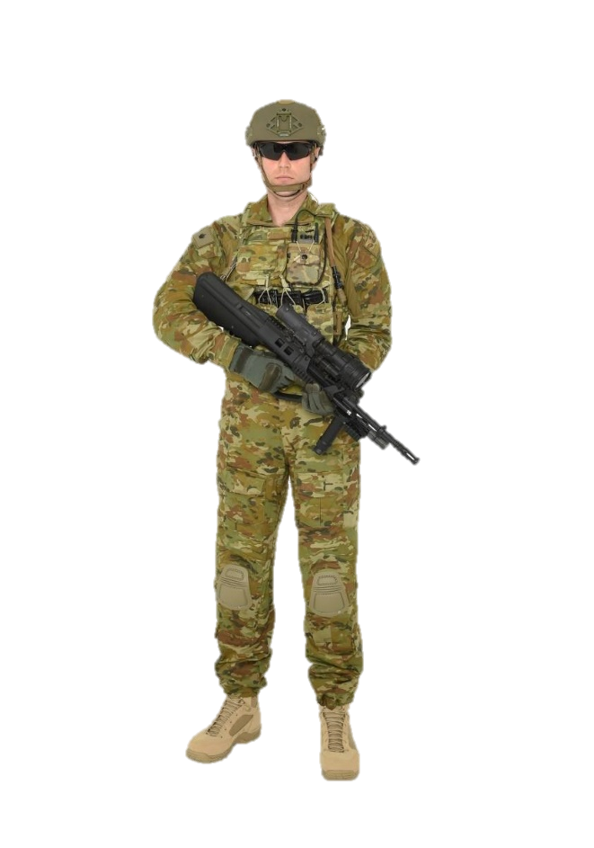

|  |  |  |
| --- | --- | --- |
| **LANGUAGE  BOX** | Asking:   * What’s this (part) called? * What’s the name of this part?   Answering:   * It’s a ______________. * This is (called) a _____________. | Responding:   * That’s right. * No. Try again. |

* Watch this YouTube video and try to write down what you didn’t learn from this lesson.  
  Type on YouTube [ak47 all parts names](https://youtu.be/WyJv34zKivA) or scan the QR Code to the right:
* This Vocabulary Builder links with 🡪 Vocabulary Builder – Soldier Combat Equipment.

© Commonwealth of Australia 2023  
This work is copyright. Apart from any use as permitted under the Copyright Act 1968 (Cth),   
no part may be reproduced by any process without prior written permission from the Department of Defence