

**Military English**

Vocabulary Builder: Ranks in the Royal Australian Navy

**Overview:**  
This worksheet presents vocabulary for ranks in the Royal Australian Navy.

**In this vocabulary builder, you will:**

* use vocabulary related to ranks in the Royal Australian Navy.

1. Let’s learn the words for the ranks of the most senior officers in the Royal Australian Navy. Look at the ranks below and fill in the gaps. Look at the example in a.

a. In Australia, the Vice Chief of the Defence Force (VCDF) is a Vice Admiral.

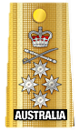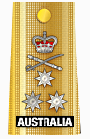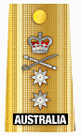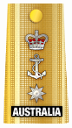

Admiral  
ADML

Vice Admiral  
ADML

Rear Admiral  
RADM

Commodore  
CDRE

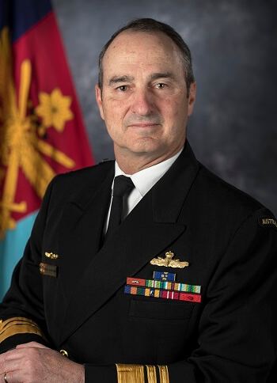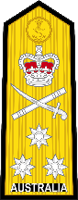

b. The Chief of the Navy is a

_______________________.

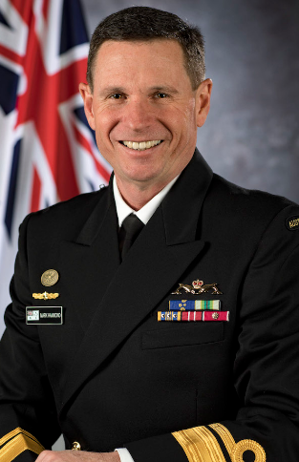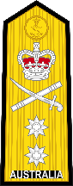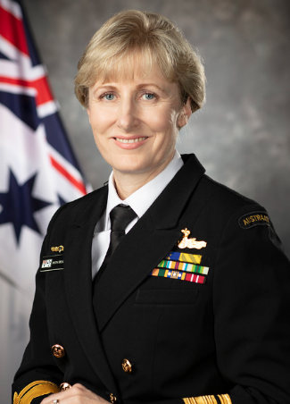

c. The Head of Navy Engineering (HNE) is also a

__________________________.

**Pronunciation**

Now let’s practice saying the words. Listen and repeat.

1. Admiral
2. Vice Admiral
3. Rear Admiral
4. Commodore

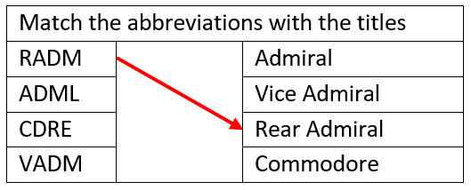

1. Now let’s look at Senior and Junior Officer ranks in the Royal Australian Navy. Look at the ranks below and fill in the gaps.

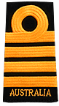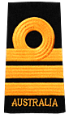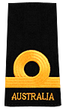

Captain (RAN)  
CAPT

Commander  
CMDR

Lieutenant Commander  
LCDR

Lieutenant  
LEUT

Sub Lieutenant  
SBLT

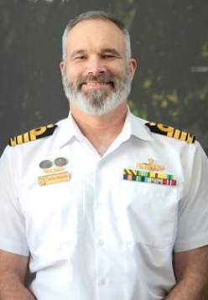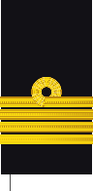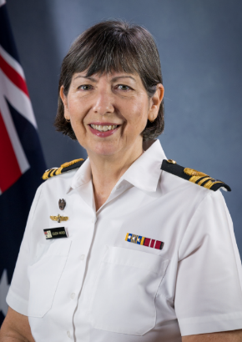

a. His rank is

______________.

b. His rank is ____________________.

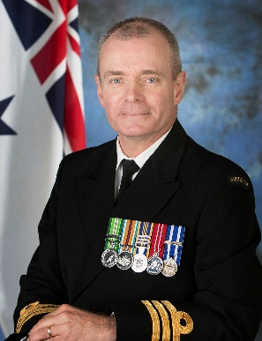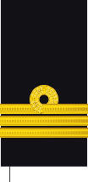

c. She is the Executive Officer (XO) of a unit. Her rank is

_____________________________.

d. He is a musician and his rank is

____________________________.

**Pronunciation**

Now let’s practice saying the words. Listen and repeat.

1. Captain
2. Commander
3. Lieutenant Commander
4. Lieutenant
5. Sub Lieutenant

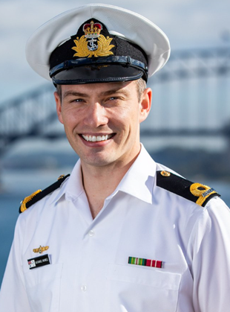

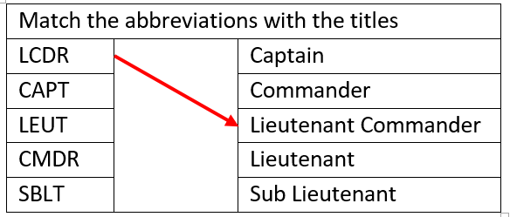

1. And finally, let’s learn about the Non-Commissioned Officer and Enlisted ranks in the Royal Australian Navy. Look at the ranks below and fill in the gaps.

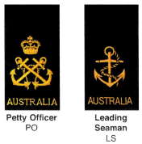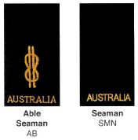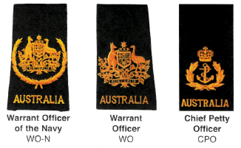

Warrant Officer of the Navy  
WO-N

Warrant   
Officer   
WO

Chief Petty Officer  
CPO

Petty Officer  
PO

Leading Seaman  
LS

Able Seaman  
AB

Seaman  
SMN

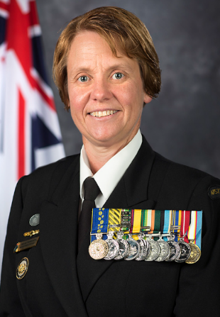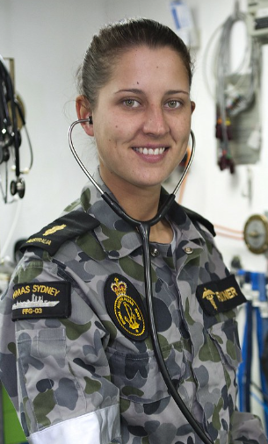

a. Her rank is

_________________________.

b. She is a medic and she is an

_________________________.

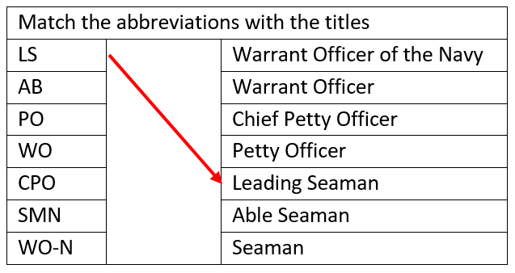

c. His rank is

_________________________.

**Pronunciation**

Now let’s practice saying the words. Listen and repeat.

1. Warrant Officer of the Navy
2. Warrant Officer
3. Chief Petty Officer
4. Petty Officer
5. Leading Seaman
6. Able Seaman
7. Seaman

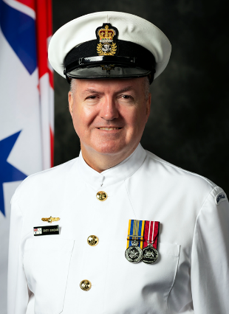

* This Vocabulary Builder links with 🡪 Vocabulary Builder – Ranks in the Army;   
   Vocabulary Builder – Ranks in the Air Force.

© Commonwealth of Australia 2023  
This work is copyright. Apart from any use as permitted under the Copyright Act 1968 (Cth),   
no part may be reproduced by any process without prior written permission from the Department of Defence.