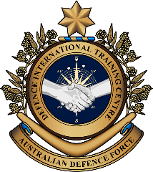

**Military English**

Vocabulary Builder: Soldier Combat Equipment

**Overview:**  
This sheet lists the Australian Army soldier’s main combat equipment he/she would take on deployment.

**In this vocabulary builder, you will:**

* use vocabulary related to a soldier’s personal combat equipment

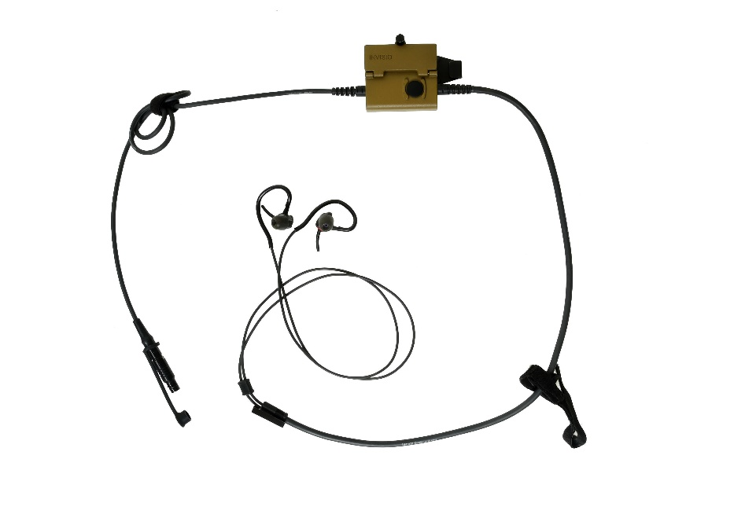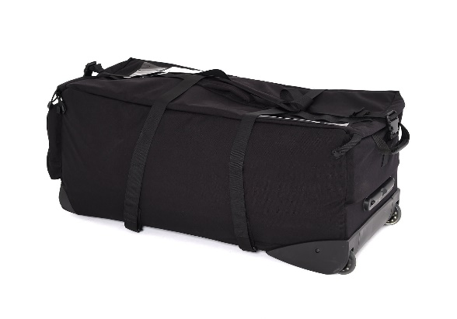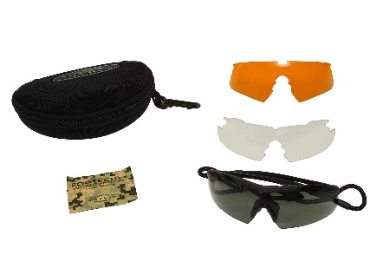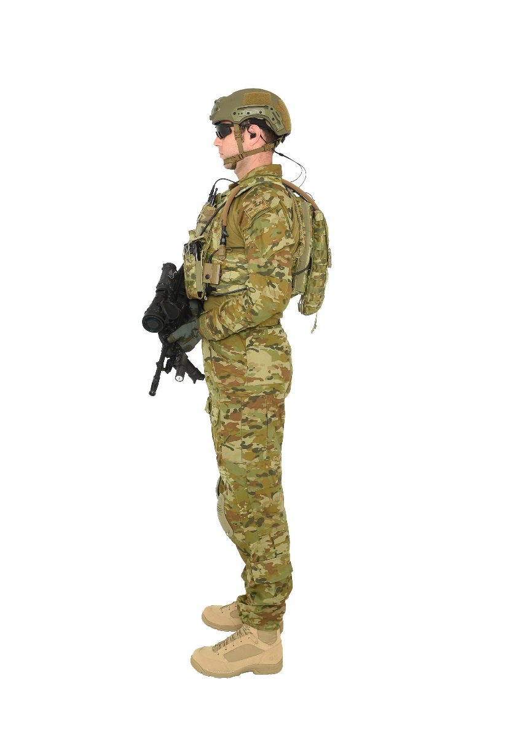1) Match the words to the picture.

c. ________________

i. ________________

d. ________________

a. ________________

e. ________________

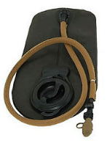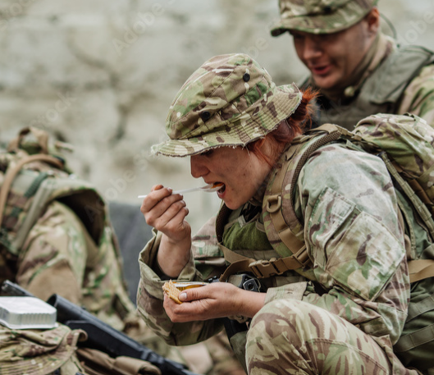

carry all // body armour // rat pack // helmet // assault rifle // boots // Camelbak©   
hearing protection // eye protection

h. ________________

g. ________________

f. ________________

b. ________________

2) Now let’s listen to the words practised in this worksheet. Listen and repeat.

3) Work with a partner. Point to an item in the pictures below and ask your partner to say the word. Use the language box below to help you. For example:

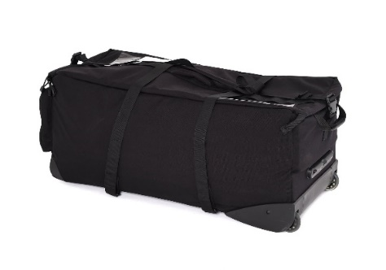

|  |  |
| --- | --- |
| LANGUAGE BOX | Asking:   * What’s this called? * What’re these?   Answering:   * It’s (a) ______________. * This is (called) (a / an) _______________. * These are_________. * Correct! * Try again☺ |

4) Which combat equipment is the same for your army? What is different?

* Watch this YouTube video and try to write down what you didn’t see from this lesson .  
  Type on YouTube [the gear soldiers carry](https://youtu.be/LKH_M2nPBKE) or scan the QR Code to the right:
* This Vocabulary Builder links with 🡪 Vocabulary Builder – Parts of a Rifle;

Vocabulary Builder - Parts of a Uniform.

© Commonwealth of Australia 2023  
This work is copyright. Apart from any use as permitted under the Copyright Act 1968 (Cth),   
no part may be reproduced by any process without prior written permission from the Department of Defence.