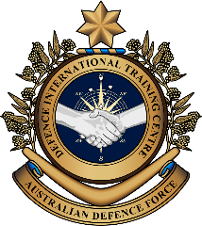

**Military English**

Lesson: A job in the Navy - Reading

**Overview:**  
This lesson involves a reading about training for a special job in the Navy, and vocabulary for navy roles.

**In this lesson, you will:**

* read and find general information in a text
* read and find specific information in a text
* learn the meaning of new words
* use new words in a conversation

## Prepare for Reading

1. Look at the pictures below. The sailors are doing some training. What do you think this training is?

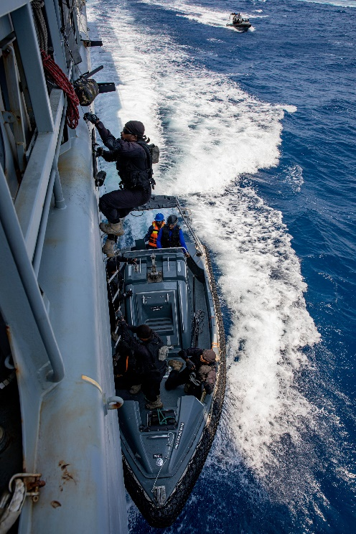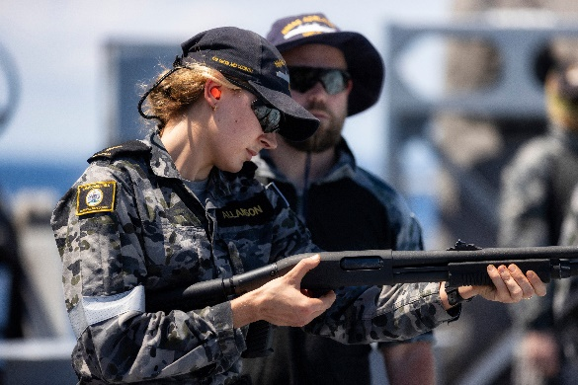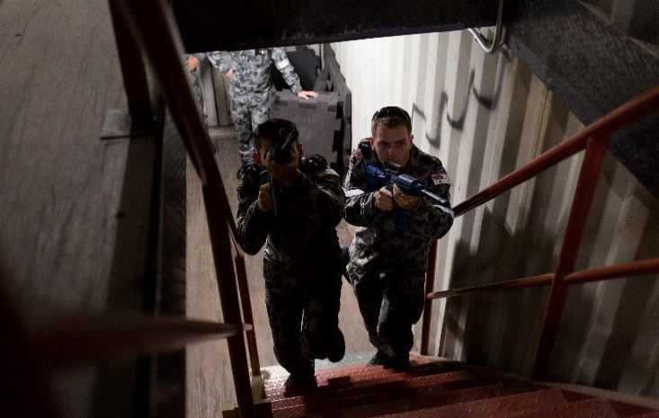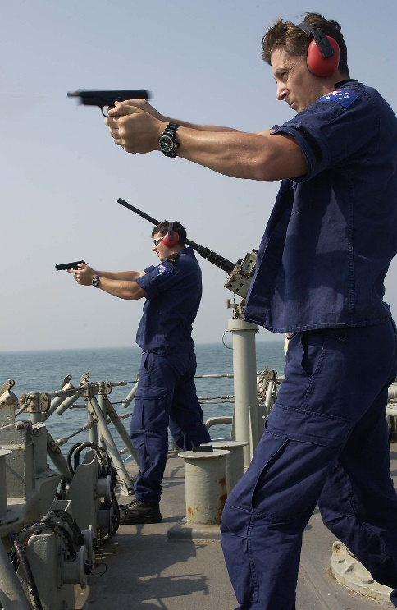

Here are three of the weapons – or ‘*small arms’* – used by the Royal Australian Navy (RAN):

EF88 rifle

870P shotgun

Browning   
Mark II pistol

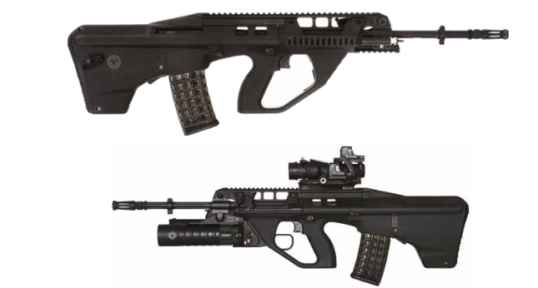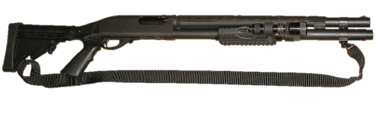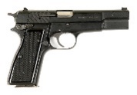

## Reading

1. Skim the text quickly. Decide what the **main idea** in the text is.

Choose from a, b, c or d.

1. International exercises help the Navy
2. Training in the Navy
3. Sailors do a good job
4. Seamanship in the Navy
5. Check your answer with a partner.

Tips for finding the main idea of a text:

* Look at the title of a text, and pictures or headings.
* Read the first and last paragraph of a text.
* Find any words or phrases that are repeated in a text.

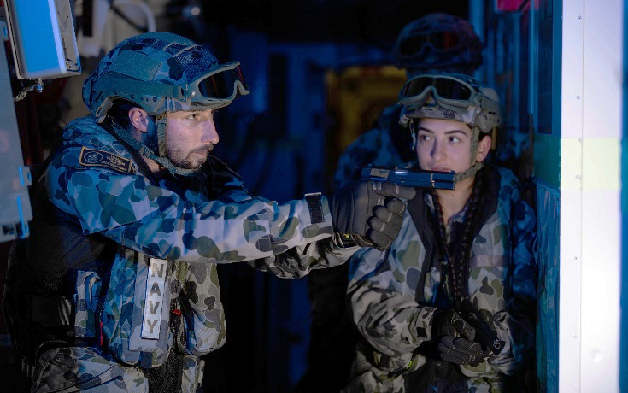

Looking through **the scope** of his EF88 rifle, **Leading Seaman** Bill Bett and his team in *HMAS Brisbane* entered a **compartment**. Their job is to clear the room of any **threats**. This was part of the training for the **boarding party**. Boatswain’s mates who specialise in many weapons often do this.

Leading Seaman Bett and his team are on Exercise TALISMAN SABRE, the largest bilateral exercise between Australia and the United States. Talisman Sabre happens every two years off the coast of Queensland.

As part of their training, *Brisbane’s* **Boatswain’s Mates**\* (BM) did exercises in darkness, including compartment entries, room clearances and **close-combat behaviours** using the EF88, 870P shotgun and Browning Mark II pistol.

Boatswain’s mates get trained in many weapons. They are experts in the use of small arms and in other work on board ships. This other work includes **rope** work, **handling small boats,** and **crewing amphibious landing craft**.

Leading Seaman Bett said the training helped his team with boarding operations and to **safeguard** the ship in Australia and when in other foreign countries’ **ports**.

Seaman Melly Tennen did this training and said it was very helpful. “This is my first sea **posting**. It is my first exercise since joining the Navy a few years ago. I was very happy to practise the **maritime** close-combat behaviours,” she said.

* Boatswain’s Mate can also be spelled Bosun’s Mate

## Learning Military Vocabulary

1. The words in **bold** in the text are important military vocabulary that you should learn to use. Read the military words on the left and their definitions on the right.

🡪 Find the two definitions that are **NOT** correct.

🡪 What should they be? Look at the box. Choose the correct meaning for the two words.

|  |  |  |
| --- | --- | --- |
| his team entered a **compartment** (of a ship) | 🡪 | Rifle Scope Australia - Buy Riflescopes Online Today | OZScopesa room on board a shipto make something / a person feel safe; not in danger |
| a **scope** of a rifle (n) | 🡪 | the part of the rifle that you look  through to find your target |
| a **threat** (n) to the team | 🡪 | a danger; something that might cause danger |
| training for a **boarding party** (n) | 🡪 | when people get together to celebrate the day you were born |
| a **boatswain’s mate (BM)** | 🡪 | a job on board a ship |
| a **leading Seaman** | 🡪 | a rank in the Navy (= to a Corporal in the Army) |
| **close-combat behaviours** (n) | 🡪 | what you need to do when fighting the enemy in a small space |
| including **rope work** (n) | 🡪 |  |
| including **handling** small boats(n) | 🡪 | **driving** small boats |
| including **crewing** (n) amphibious landing craft | 🡪 | working on board a boat |
| **amphibious landing craft** (n) | 🡪 | types of boats that can go on land AND on water |
| to **safeguard** (v) the ship | 🡪 | to make something / a person feel safe; not in danger |
| a foreign country’s **port** | 🡪 | the part of a city or town that has water and where a boat can stay |
| **maritime** (adj) close-combat behaviours | 🡪 | connected with the sea / the oceans |
| my first sea **posting** (n) | 🡪 | when you put a letter in an envelope and send it to someone |

x. the length of time you stay in a job in the military

z. a group of seamen that work together to get on board another ship

1. Now let’s practice saying the words. Listen and repeat.
2. Now test your partner with some of the words from exercise 4.
3. Choose one of the words. Do NOT say the word. Instead read the meaning. Your partner must not look at his/her sheet, but try to remember the correct word.
4. Are there any other words in the reading that you would like to learn? Write them below, and check with a good dictionary after class.
5. Now read again and finish the sentences about the reading, using a word from the reading. The first one is done for you.
6. Training in the Navy helps sailors practise using weapons.
7. Australia and the United States practise war-games in _______________ TALISMAN SABRE.
8. The training for ______________________________ (BM) is usually on board a ship.
9. As a BM, a seaman might work with ______________, and pistols as well as drive ____________________________.
10. The BM also works to make sure the ___________________ is safe, when the RAN ship sails to another country.
11. ___________________ Melly enjoyed the training.

## Practice

1. Discuss these questions with a partner. Try to use some of the words from activity 4.

## How is the work in the Navy different from (or the same as) a job in the Army?

## Do you think a Boatswain’s mate sounds like a good job on board a ship? Why (not)?

## In many militaries, personnel have ‘a posting’ for two or three years in one job and then they move to another ‘posting’ – is this the same in your military?

## If yes, do you like changing jobs like this?

## If not, do you think it’s a good idea to move like this every two years?

## This lesson links with: Vocabulary Builder – Parts of a Ship; Vocabulary Builder – Parts of a Rifle

## Watch this video about someone who works as a Boatswain’s Mate:

## Type on YouTube [Kerrin Humphrey - Boatswain's mate, Royal Australian Navy](https://www.youtube.com/watch?v=TfrpfPtVOsI)

## or scan the QR code:

© Commonwealth of Australia 2023   
This work is copyright. Apart from any use as permitted under the Copyright Act 1968 (Cth), no part may be reproduced by any process without prior written permission from the Department of Defence.