# 

**Military English**

Lesson: ANZAC Day - A Special Day for the ADF and Australia - Listening

|  |
| --- |
| **Overview:** This lesson describes an important day for the ADF, which commemorates significant events in the past. |
| **In this lesson, you will:**   * listen for some general information in a text * listen for some specific information in a text * learn the meaning of new words * use new words in sentences * speak about a celebration |

## Prepare for Listening / Watching

1. Work with a partner, and think of some answers for these questions. You will use these in a speaking task with a new partner later.
2. What is the most important day (for the defence force) in your country?
3. What does it celebrate or remember?
4. Are there any special things used on this day?

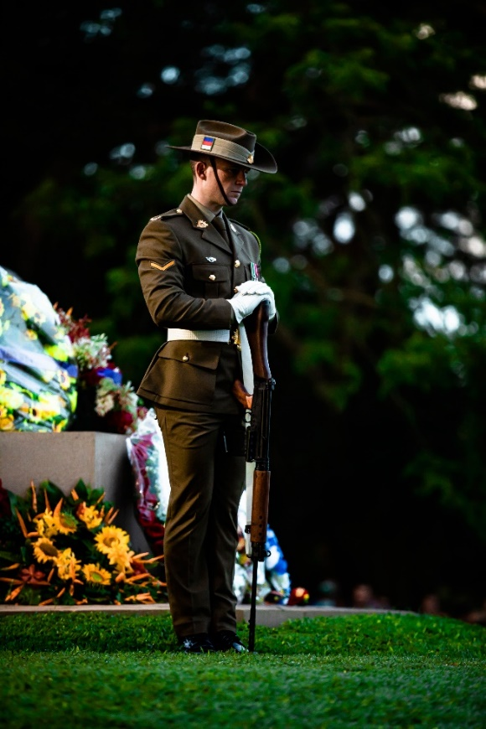**Listening / Watching**

1. Watch or listen to the video explaining one of the special days for the Australian Defence Force (ADF).

While you watch / listen, think about these questions:

1. What is the day?
2. What does it celebrate or remember?
3. Are there any special things used to celebrate this day?



1. Now, watch the video again, and listen for some information. Write your answers to these questions while you listen. Check with a partner after.
2. ANZAC (pronounced /ˈænzæk/) means A____________________ and N___________ Z________________ A____________________ C_____________________
3. How long were the ANZACs in Turkey? ___________________
4. How many ANZACs died there? _____________________
5. When was the first ‘ANZAC Day’ that people in Australia ‘celebrated’? ____________________
6. Why did they choose the flowers as a symbol?   
   ______________________________________________________________________________
7. Which two things here are an important part of the ‘Australian identity’:  
   biscuits // courage // soldiers // mateship // respect
8. Why is the dawn service special to the ANZACs?  
   ______________________________________________________________________________

**After Listening / Watching**

1. Can you name these three things?

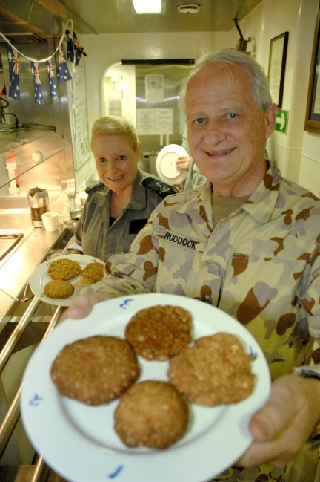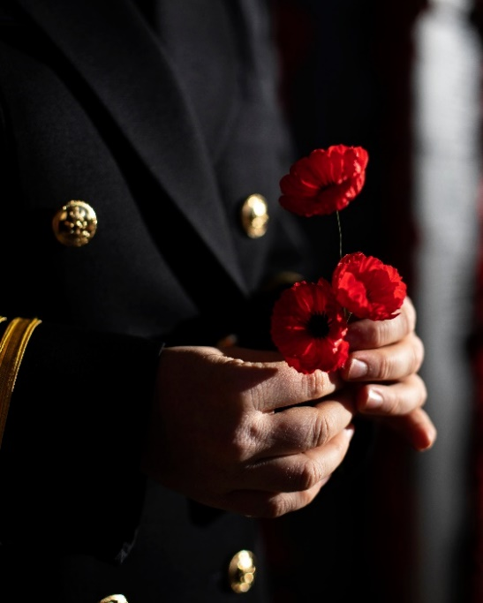

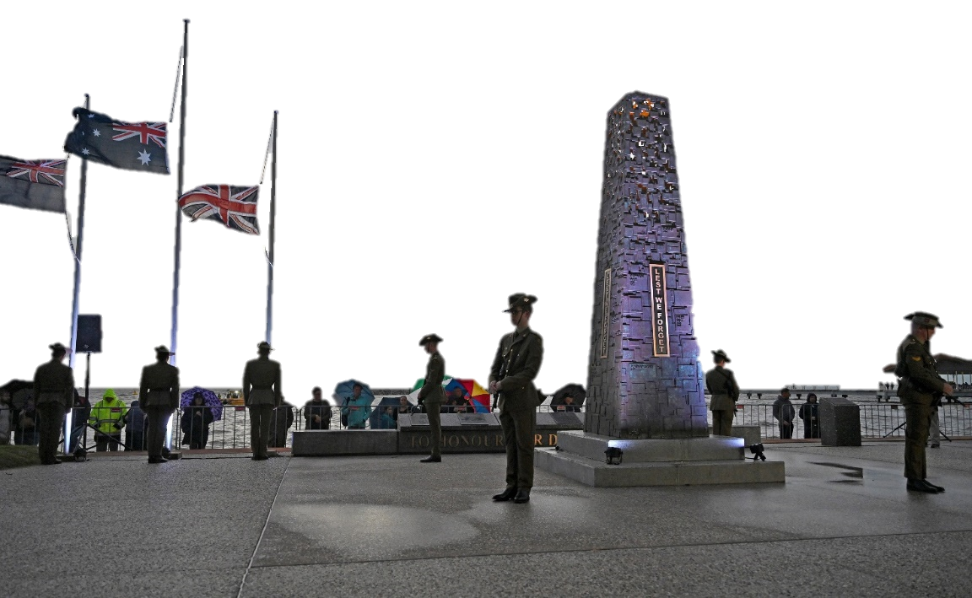

**Learning Military Vocabulary**

1. Look at the sentences from the video. The words in **bold** are military words that you should learn to use in writing and speaking. Match the words in bold with a meaning from the box below.   
   Look at example a.
2. ...both of these countries came together to help their British **allies** in the war. 3
3. These soldiers were called ANZACs, which stands for Australia and New Zealand Army **Corps**. __
4. … the ANZACs travelled to a place called the Gallipoli peninsula to **capture** the Turkish capital of Istanbul. __
5. …they were met by a fierce **defence** from Ottoman Turkish soldiers. __
6. ...hoped to be a quick **campaign** __ turned out to be eight months of brutal **warfare**. __
7. Eight months after their arrival the ANZACs **evacuated** from Gallipoli but not before many soldiers had given their life… __
8. There are many ways we **commemorate** ANZAC Day today. __

1. to take over / to control by force 2. protection of land or a country against an enemy ~~3. friend / another country that helps you~~ 4. part of an army 5. in general, the common activities of a war  
6. to remove someone or take someone out of a dangerous place to go somewhere safe 7. not just one battle but a number of them needed to win 8. to remember something in a special celebration

1. Let’s practise saying the words in bold in exercise 5. Listen and repeat.
2. Now try to use the words from Exercise 5 correctly in the sentences below.
3. The Education _______________ is one part of the Australian Army. What ___________ are you in?
4. In many wars, Australia and the USA are __________________.
5. The civilians _____________________ from the town before the bombing began.
6. If you are in the Navy, you might learn about ‘maritime _________________’ or how to conduct war by ship, at sea.
7. In WW2, many soldiers _____________________ their country from the German army.

## Practice

1. Find a new partner. Use the questions from Exercise 1 to interview another classmate about a celebration in their part of the country.
2. What is the most important day (for the defence force) in your country?
3. What does it celebrate or remember?
4. Are there any special things used on this day?

Practice speaking. Answer your classmate’s questions, and add more information to help them understand.

Tell other members of the class about what you learn from your classmate.

© Commonwealth of Australia 2023  
This work is copyright. Apart from any use as permitted under the Copyright Act 1968 (Cth),   
no part may be reproduced by any process without prior written permission from the Department of Defence.