# 

**Military English**

Lesson: Disaster Relief - Listening

**Overview:**   
This lesson practises listening in the context of disaster relief operations and related vocabulary of natural disasters.

**In this lesson, you will:**

* listen for specific information
* learn the meaning of new words
* use new words in context

## Prepare for Listening

1. Look at the pictures and discuss the questions with a partner.
2. What are people in the pictures doing?
3. What can military personnel do when a natural disaster happens?

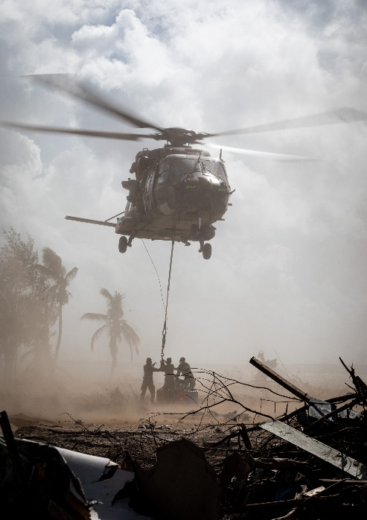

**A**

personnel (n) 🡪 people who work for the military. Example: My unit has about 35 personnel. Short form: pers

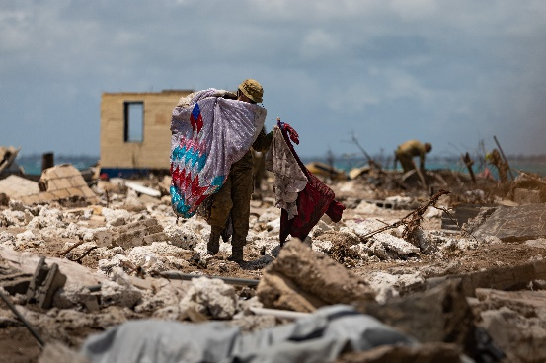

**B**

* a ‘**natural disaster’** is something **good / bad / very bad**.

## Listening

1. Listen to the news report. Which natural disasters does the news reporter talk about?

tsunami cyclone flood bushfire earthquake

1. Listen to the news again. Circle the correct answers.

What time did the earthquake happen?

12 a.m. // 3 a.m. // 5 a.m.

The C-130 Hercules is a military transport aircraft. Many countries use it in their Defence Forces, including Australia,   
Indonesia,   
Vietnam and Thailand.

Which aircraft was sent to help people   
after the earthquake?

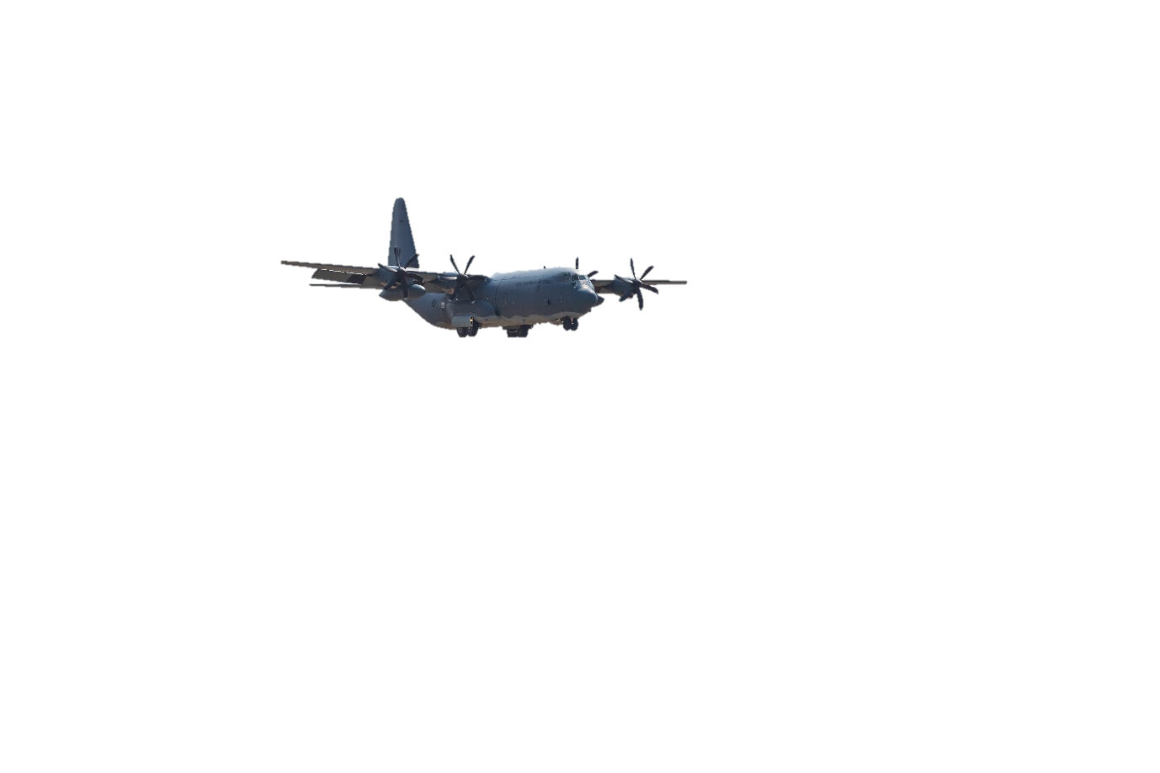 C-130 Hercules // C-17A Globemaster // CH-47 Chinook

How many helicopters were sent   
to the bushfire area?

2 // 3 // 5

In which state did the bushfire happen?

Tasmania // Victoria // Queensland

## Learning Military Vocabulary

1. The words in **bold** are important military vocabulary that you should learn. Match them to their definitions on the right. Look at the example and write the answers in the middle column.

|  |  |  |  |
| --- | --- | --- | --- |
| **deploy** (v) | **f** |  | 1. a fire in the forest that can spread quickly and be difficult to control |
| to be **on standby** |  |  | 1. to help someone to do something |
| has set up a **disaster relief operation** (n) |  |  | 1. shaking of the ground |
| a large **earthquake** (n) |  |  | 1. to move people from a place because it is not safe |
| a **tsunami warning** (n) |  |  | 1. a job the military does to give food or water to the people in a disaster |
| to **airlift** survivors (v) |  |  | 1. **to send soldiers or weapons to a place for military action** |
| the **strong winds** (n) |  |  | 1. to be ready and able to go to work suddenly |
| more news from the **bushfire** (n) |  |  |  |
| deliver **disaster relief supplies** (n) |  |  | 1. an alarm that tells people when a tsunami might happen |
| to **evacuate** about 500 survivors (v) |  |  | 1. when the military uses aircraft to take people, soldiers, animals or things to and from a place; the plane lands. |
| the **survivors** (n) |  |  | 1. a job the military does using aircraft to drop things into a place; the plane doesn’t land. |
| to **assist** the local population (v) |  |  | 1. things that people receive to help them during natural disasters, for example, food, first aid kit, water, medicine |
| an **airdrop** operation (n) |  |  | 1. a person who was in a very dangerous situation, but didn’t die. |

1. Now let’s practise saying the words in this worksheet.
2. Circle the correct answer to complete sentences.
3. People living near the beach have to *assist // evacuate* when they receive a *bushfire // tsunami warning* from the government.
4. *Disaster relief supplies // Disaster relief operations* will be *evacuated* // *airdropped* to people   
   in the villages because roads and the airport are completely underwater.
5. The government will *airlift // assist* the *disaster relief supplies* // *survivors* of the bushfire   
   in repairing their houses.
6. The government put the army *assist // on standby*. This is to make sure that they   
   are ready to *deploy // evacuate* to Africa.

## Practice

1. Discuss these questions with a partner:
2. What natural disasters usually happen in your country and how often?
3. Do you know of any natural disasters that happened recently? Talk about:

* where and when it happened
* how the military assisted people during the disaster
* number of survivors
* This lesson links with 🡪 Vocabulary Builder – Natural disasters; Lesson – Humanitarian Aid.
* Watch this video about a disaster relief training exercise by the Australian Defence Force.  
  Type on [YouTube Humanitarian Assistance and Disaster Relief training activity](https://www.youtube.com/watch?v=qYHFeGALGD4) or scan the QR code.

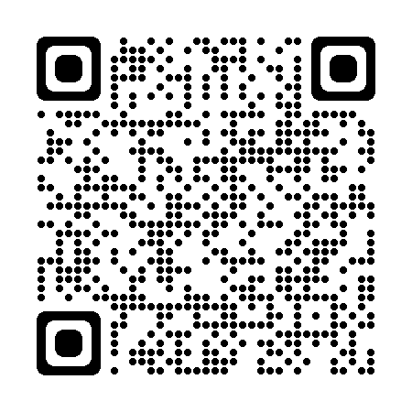

© Commonwealth of Australia 2023  
This work is copyright. Apart from any use as permitted under the Copyright Act 1968 (Cth),   
no part may be reproduced by any process without prior written permission from the Department of Defence.