

**Military English**

Lesson: Jungle Warfare Training - Listening

|  |
| --- |
| **Overview:** This lesson will use a listening text to introduce words associated with jungle warfare training.  **In this lesson, you will:**   * listen for some general information in a text * listen for some specific information in a text * learn the meaning of new words * use new words in sentences * speak about jungle warfare training for soldiers |

## Prepare for Listening

1. Look at the pictures below (1 - 4).

What are the differences between the combat environments* and type of terrain** in each picture?

Why is it difficult to conduct operations in these different environments? Discuss your ideas with a partner.

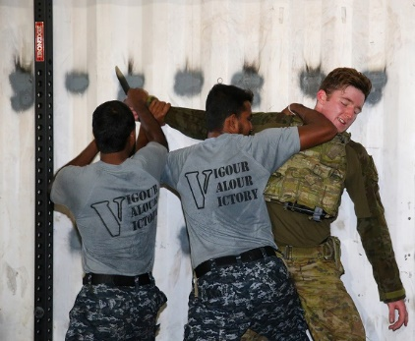

3

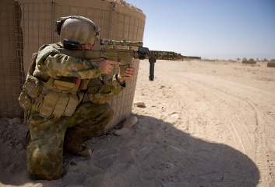

1

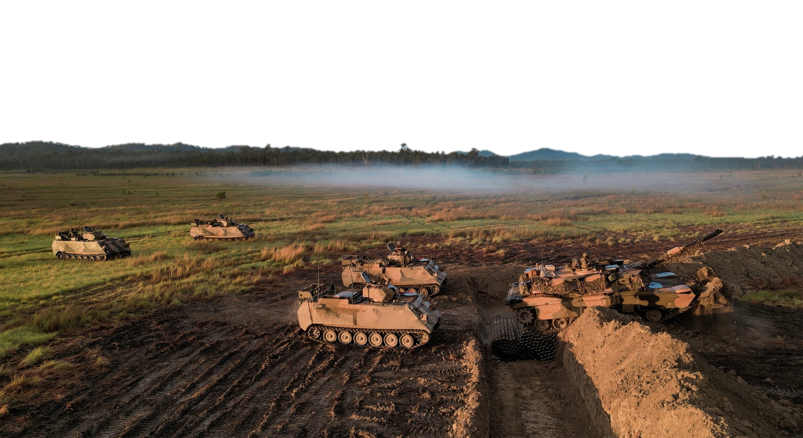

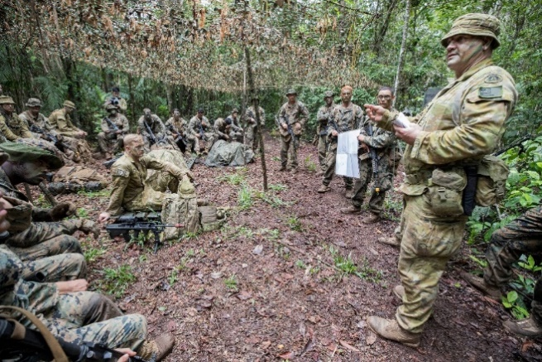

2

* combat environment (n) 🡪 an area where you fight the enemy

**terrain (n) 🡪 the geography of an area of land

4

**Listening**

1. Listen to the recording.
2. Which picture in Task 1 best matches what you hear?
3. Who is speaking? To who? Why? Choose:
4. instructor – student – giving feedback on scores at shooting range
5. instructor – student – giving instruction on how to fire rifle
6. instructor – class – giving information about a course

Check your answers with a partner.

1. Now listen again. Fill in the spaces with words you hear from the listening.

Over the next ten days we’ll be taking you through the basics of _________________ **Warfare**.

An important point here is **terrain** – thinking about it not as an ________________ but as a very closed area.

First the most basic – we’ll review **camouflage** and **concealment** and the ways we can _______________ ourselves from an enemy using such things as our paints and also ways to use foliage and other things you ______________ in the jungle.

Next, basic **manoeuvres**. …We’ll also review **patrolling**, where we will pay special attention to **reconnaissance** and other skills that will help us ________________ others within the jungle.

We’ll also look at **infiltration** and ways to get __________________ the lines of our enemies.

Our last topic will be in setting up and using various **ambush** methods to ___________ the enemy and the use of ‘**booby traps**’ that we can _______________ in the jungle.

You will find leading your **platoon** through this environment a serious test of your _____________ and of your ability to look after your _______________ …

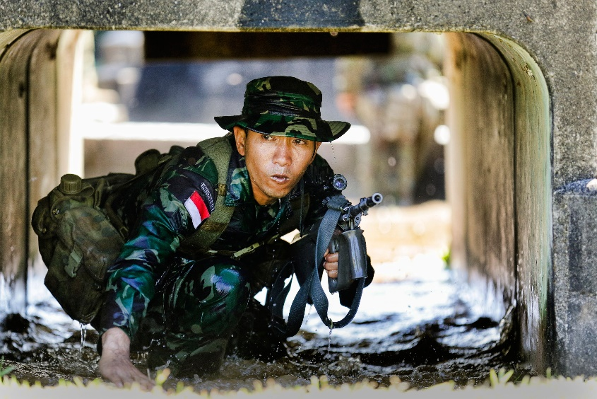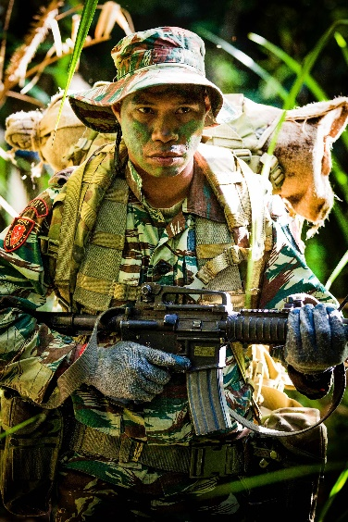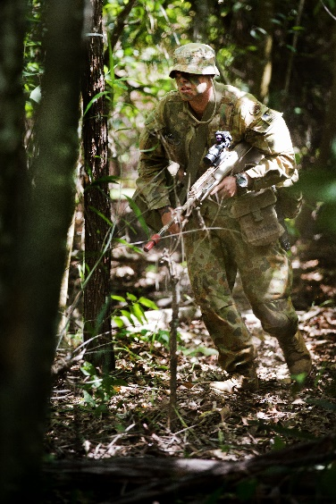

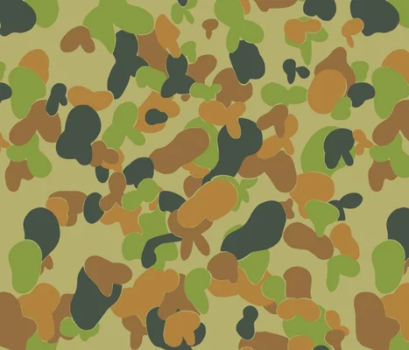

**The Australian Army often train in Tully with soldiers from other countries. On the left is a Timorese, in the centre an Australian and on the right an Indonesian soldier.**

**Learning Military Vocabulary**

1. The words in **bold** are important military vocabulary that you should learn. Match them to their definitions on the right. Look at the example and write the answers in the middle column.

|  |  |  |  |
| --- | --- | --- | --- |
| **infiltration** (n)/ to **infiltrate** (v) | **e** |  | 1. a smaller group of soldiers often commanded by a lieutenant |
| a **reconnaissance** patrol (n) |  |  | 1. movement of military troops and military vehicles/vessels, and exercise |
| a **booby trap** (n) can surprise the enemy |  |  | 1. a planned way to do something; to plan and organise how soldiers and equipment will be used in battle |
| different **ambush** methods(n) |  |  | 1. walking or moving through an area in order to guard against danger or to gain information |
| **guerrilla warfare** (n) |  |  | 1. **secretly going behind an enemy's lines or into their territory** |
| use **foliage** to help hide yourself..(n) |  |  | 1. the physical features of a piece of land, such as hills, valleys, and rivers, which can affect military operations in the jungle |
| open **terrain** (n) |  |  | 1. the leaves and branches of trees and plants, often used for cover in jungle warfare |
| basic **manoeuvres** (n) |  |  | 1. irregular warfare in which a small group of soldiers use surprising military tactics such as ambushes |
| **patrolling /** to **go on patrol** (n) |  |  | 1. a surprise attack by people lying in wait in a hidden position |
| we’ll review **camouflage** (n)…  *We can also say* ***cam*** |  |  | 1. a hidden device that can injure or kill |
| **tactics (n)** used by the enemy … |  |  | 1. a military observation of an area to find an enemy or find strategic features |
| **platoon** (n) |  |  | 1. HD wallpaper: weapon, pistol, access, armed, human, violent, violence,  dangerous | Wallpaper Flarethe action of hiding something or preventing it from being known or seen. For example: the concealment (n) of weapons |
| **concealment** (n) / conceal (v) |  |  | 1. to hide yourself or your equipment by making it look like the surroundings |

1. Let’s practise saying the words. Listen and repeat.
2. Now choose the best word from Exercise 4 to complete these sentences.
3. How long will we need to go across this hill? The *tactics // terrain // ambush* looks very rough.
4. We were given orders to *patrol // manoeuvre // camouflage* the area at night.
5. The rebels used *reconnaissance // infiltration // guerrilla warfare* to attack the town.
6. The uniforms we wear are usually made from *foliage // camouflage // booby trap* material.
7. Armies need to plan how to attack a target and what *patrol // terrain // tactics* they will use.
8. Your task today is to find out how many enemy soldiers are in the area. You will need to do a *reconnaissance // platoon // ambush patrol* first.

## Practice

1. Find a new partner. Use the flow diagram of questions below to interview another classmate. Listen and make sure you choose the next step in the conversation correctly.

Do you like going into the jungle?

Not me / No, I don’t really

Yes / Absolutely / For sure

What don’t you like about it?

What do you like about it?

(own answer)

Many soldiers train in the jungle – have you?

No

Yes

What might you learn?

What did you learn?

(your own answer)

That’s very interesting, thank you.

What words from this lesson can you use to answer this question?

What words from this lesson can you use to answer this question?

Now change roles. Answer your classmate’s questions, and add more information of your own to help them understand.

* This lesson links with 🡪 Lesson – On Patrol.
* Watch these videos about Australian Army jungle training. Type the video titles on YouTube or scan the QR codes.

 [Exercise Mallee Bull Survival Training](https://www.youtube.com/watch?v=1TGQCs3-AYI) [Exercise True Grit](https://www.youtube.com/watch?v=wNRm34A14YA)

© Commonwealth of Australia 2023  
This work is copyright. Apart from any use as permitted under the Copyright Act 1968 (Cth),   
no part may be reproduced by any process without prior written permission from the Department of Defence.