# 

**Military English**

Lesson: Leadership - Reading

**Overview:**  
This lesson looks at the topic of ‘leadership’ and includes vocabulary associated with this topic.

**In this lesson, you will:**

* read and find general information in a text
* identify the main idea in a text
* learn the meaning of new words
* use new words in a conversation

## Prepare for Reading

1. Look at the photos below and discuss these questions with a partner.

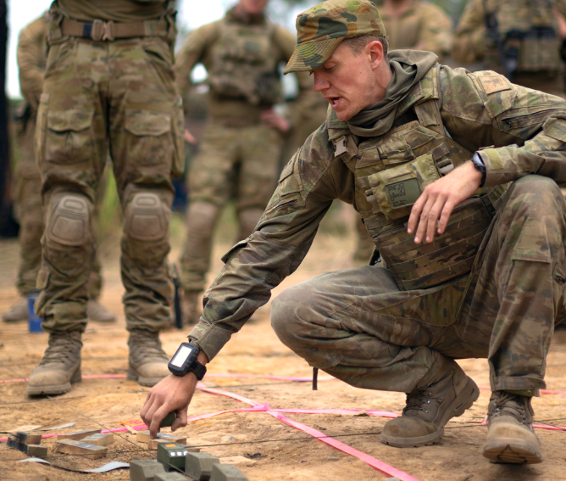

B

1. Leaders in the military are important people. Why?
2. What is happening in the pictures? What are the leaders doing?

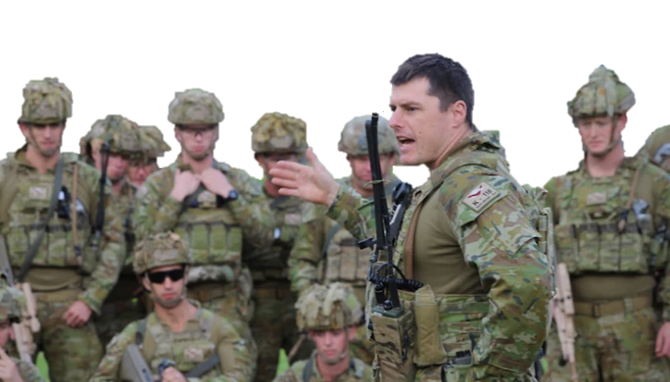

A

## Reading

1. Read the text carefully. Try to decide what the **main idea** in the text is.

Now choose the main idea a, b, or c for the article.

Do not use a dictionary yet. You are going to learn the meaning of the words in **bold** in the next exercise.

Tips for finding the main idea of a text:

* Look at the title of the text, and pictures or headings.
* Read the first and last paragraph of the text.
* Find any words or phrases that are repeated in the text.

1. A leader has to be good at planning battles.
2. A leader has to be good at motivating his/her soldiers.
3. A leader has to be good at inspiring his/her soldiers, planning battles, and managing supplies.

**Military Leadership**

Military leadership is an important part of a country's defence. It is when an officer leads a group of soldiers and helps them work together to complete important **missions**. Military leaders come from different **branches** of the military, like the army, navy, or air force. They have to be very good at inspiring their **subordinates**, planning attacks, and managing their supplies.

A good military leader is someone who is **brave** and **disciplined**. They inspire everyone in their **unit** to fight harder. They might lead a small unit, like a **platoon**, or a big unit, like a **brigade**. They know that **teamwork** is important.

One of the most important things a military leader does is make plans in places like **battlefields**. In these places, they have to think quickly and make choices that are best for their team. Leaders might need to **sacrifice** some of their goals to achieve **victory**.

Military leaders have to manage their unit’s supplies of **equipment** and **resources**. These have to be used the right way, so the army can win the battle.

Military leadership is all about inspiringothers, planning missions, and managing supplies. You have to take care of many things, but it is also a great **honour** to serve your country as a military leader.

**Vocabulary. Learn the meaning of the words highlighted in the text.**

Plan (v): to think about a way to do something

Inspire (v): to encourage other people to do something

Manage (v): to control something that is difficult to control

Supplies (n): equipment, weapons, trucks, tanks, food, oil, etc.

**Learning Military Vocabulary**

1. The words in **bold** in the text are common general and military vocabulary that you should learn to use. Read the text again and match the words on the left to their definitions on the right. Look at the example.

|  |  |  |  |
| --- | --- | --- | --- |
| complete important **missions** (n) | **f** |  | 1. people working together to finish something |
| military leaders come from different **branches**  (n) |  |  | 1. a place where soldiers are fighting |
| lead **subordinates** (n) |  |  | 1. tanks, trucks, weapons, planes, ships, etc. |
| **brave** soldiers (adj) |  |  | 1. oil, gas, food, water, etc. |
| someone who is **disciplined** (adj) |  |  | 1. a group of 36-40 soldiers |
| military **unit** (n) |  |  | 1. **special military tasks** |
| **platoon** (n) |  |  | 1. not afraid in a dangerous situation |
| **brigade** (n) |  |  | 1. a feeling of pride, to feel proud |
| **teamwork** is important (n) |  |  | 1. able to control yourself in difficult situations |
| a dangerous **battlefield** (n) |  |  | 1. someone with lower rank (for example, a captain has a lower rank than a major) |
| might need to **sacrifice** (v) |  |  | 1. a part of the armed forces (e.g. army, navy, air force) |
| to achieve **victory** (n) |  |  | 1. to give away something very important to you |
| supplies of **equipment** (n) |  |  | 1. a group of 2500-5000 soldiers |
| supplies of **resources** (n) |  |  | 1. when you win a game or win a war |
| it is an **honour** to serve your country (n) |  |  | 1. a group of people in the military (e.g. platoon, battalion) |

*Example: missions (n) = f. special military tasks*

1. Now let’s practise saying the words from exercise 3. Listen and repeat.
2. Now try to use some of the words from exercise 3 correctly in the sentences below.
3. Private Johnson is not afraid of anything. He is very _________________.
4. Corporal Faro is in trouble again. He cannot control himself. He has no ________________.
5. Major Smith is very popular with his __________________. They will always follow him into battle.
6. General Jones has planned a new __________________. It will be an important battle.
7. Captain Wang serves in the ___________________ of the Army, not the Navy.
8. Lieutenant Wilson is a _____________________ leader. He leads a group of 36 soldiers.

**Practice**

1. Discuss these questions with a partner:
2. What makes a good leader? Choose three words from this lesson to describe a good leader.

(e.g. a good leader is brave). Explain why to your partner.

1. Would you be a good leader? Why?

* Watch this video about leadership training in the Australian Defence Force.

Type on YouTube [ADFA Leadership Training](https://www.youtube.com/watch?v=GjSVgQ_v-Ig) or scan the QR code.

© Commonwealth of Australia 2023  
This work is copyright. Apart from any use as permitted under the Copyright Act 1968 (Cth),   
no part may be reproduced by any process without prior written permission from the Department of Defence.