

**Military English**

Lesson: Map reading and navigation - Listening

**Overview:**  
This lesson covers features of a map, map reading/navigation and terrain features.

**In this lesson, you will:**

* listen for general information
* listen for specific information
* learn the meaning of new words
* use new words in context

## Prepare for Listening

1. What can you see on this map? Discuss with a partner. Then write the words in the correct box.

## 

c. ___________

b. _____________

a. _______ ________

d. ________________

compass // hill // grid lines // road // contour lines

e. ____________ ______________

1. Match the pictures with the words.

a. ______________

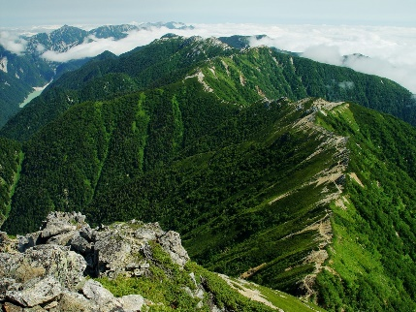

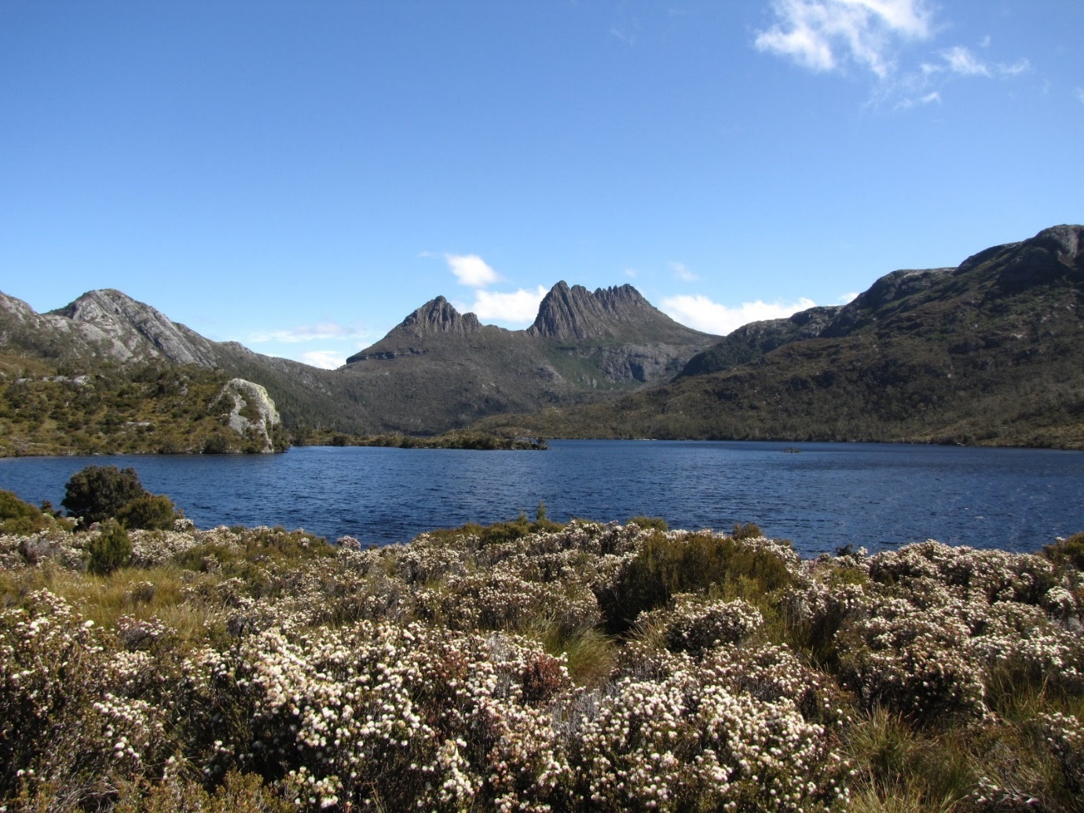

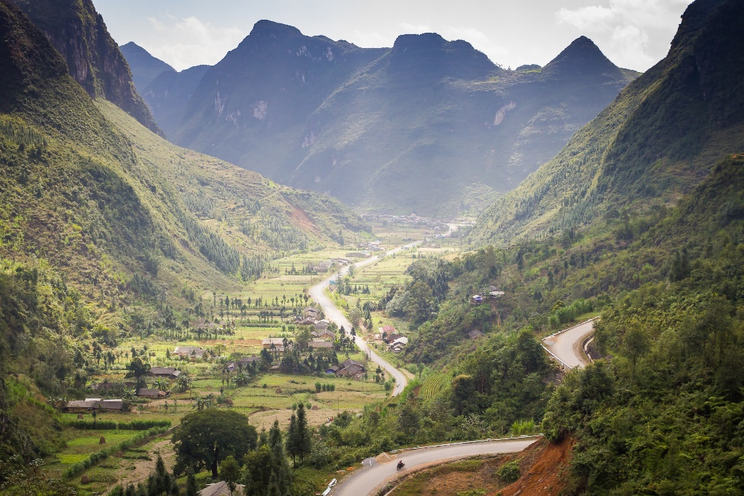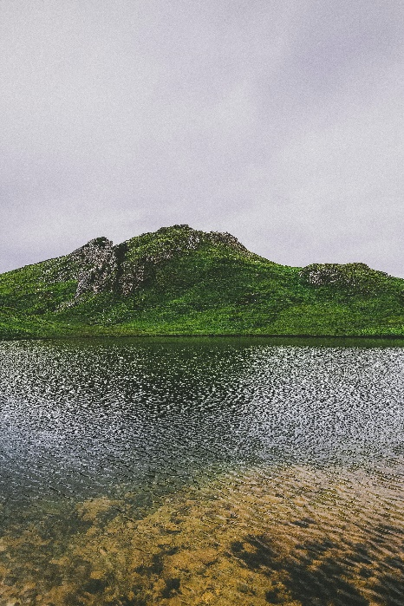

b.

e. ________________

c. ______________

a ridge // a saddle // a hill // a built-up area // a valley

d. ______________

## Listening

1. Before listening to the recording, let’s practise reading grid references.   
   With a partner, write the grid reference for points b) and c) below.   
   Letter a) has been done for you as an example.

Tip: Another name for   
grid reference is grid coordinates.

a) grid reference 366897

c) grid reference

__________

b) grid reference

__________

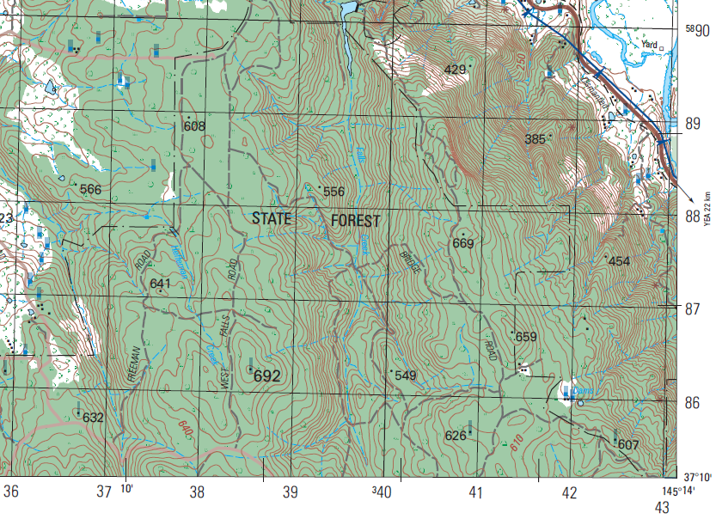



1. Listen to four grid references and choose the correct point they refer to.   
   Letter A has been done for you as an example.

Grid reference  
a

Grid reference

_____

Grid reference

_____

Grid reference

_____



1. Listen to a presentation on how to use a map and compass. As you listen, write in the boxes the things you hear.

R __ __ __

H __ __ __

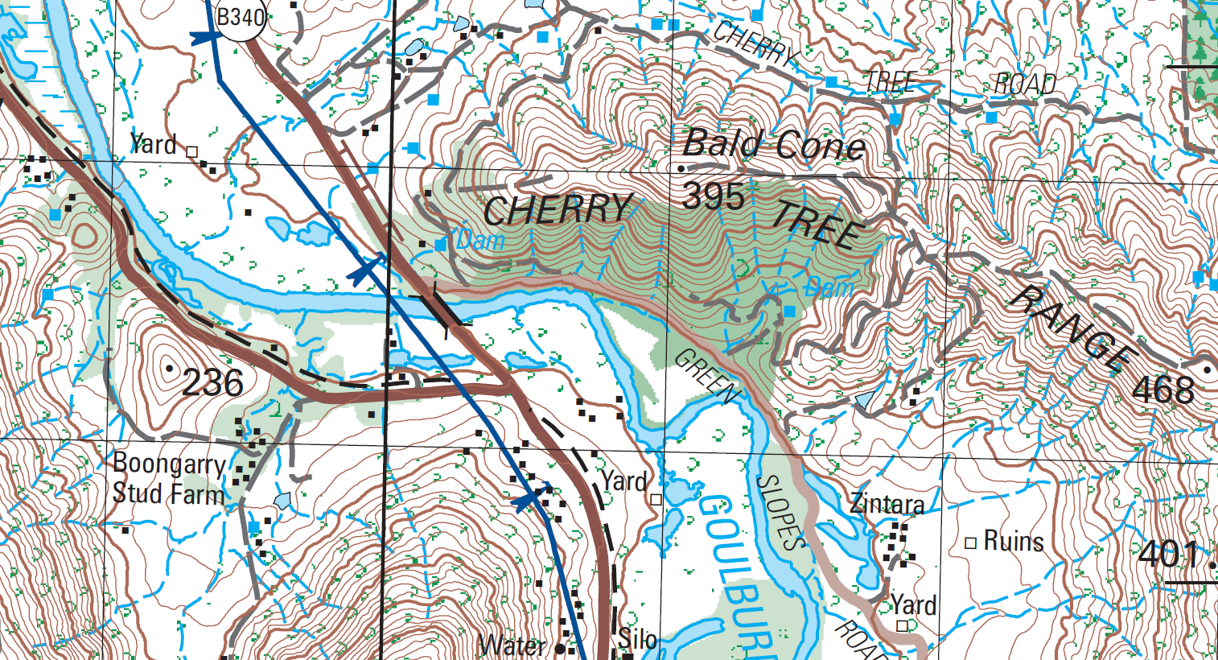

R __ __ __ __

B __ __ __ __ - __ __   
a __ __ __

C __ __ __ __ __ __ l __ __ __ __

V __ __ __ __ __

1. Listen again and answer these questions:
2. What is the distance from one grid line to the other on this map?
3. Which two things have to be in the same direction if you need to orientate the map to the ground?
4. Here is part of a map of Puckapunyal, Victoria. Listen to the rest of the presentation and draw the route on the map.   
   Then listen again to check your answers.

Start here.

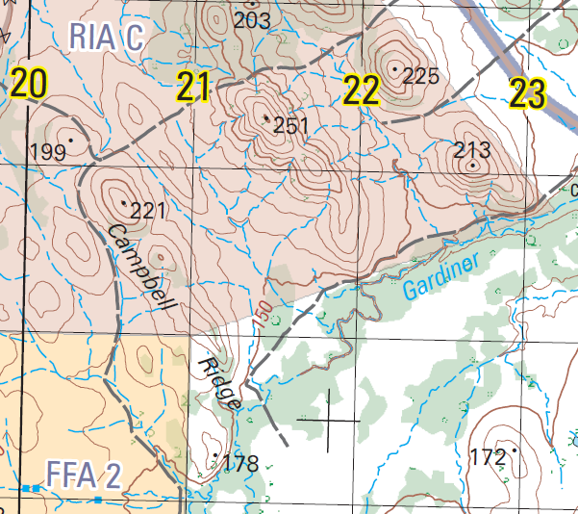

**12**

**11**

**13**

Puckapunyal is a large Army training area in Victoria, located 117km from Melbourne.

It is also the Headquarters of the Combined Arms Training Centre, School of Armour, School of Artillery, School of Transport, Army Knowledge Centre and Joint Logistics Unit.

1. Now let’s listen to the words practised in this lesson. Listen and repeat.

## Practice

1. Work in groups of 2-3. Imagine you‘re going on a patrol with a group of soldiers. The starting point is at grid reference 403903 (marked with an 🡪). Follow the instructions below.
   * Choose a finishing point (RV), anywhere on the map and mark it with a pen/pencil.
   * Draw a route from the start to the finishing point (RV).
   * Take it in turns giving directions from the start to the finishing point. Use grid references and places on the map to help your partners, for example bridges, roads, hills, etc. Use the language box below to help you.
   * At the end check that your partners finishing point (RV) is the same as yours.

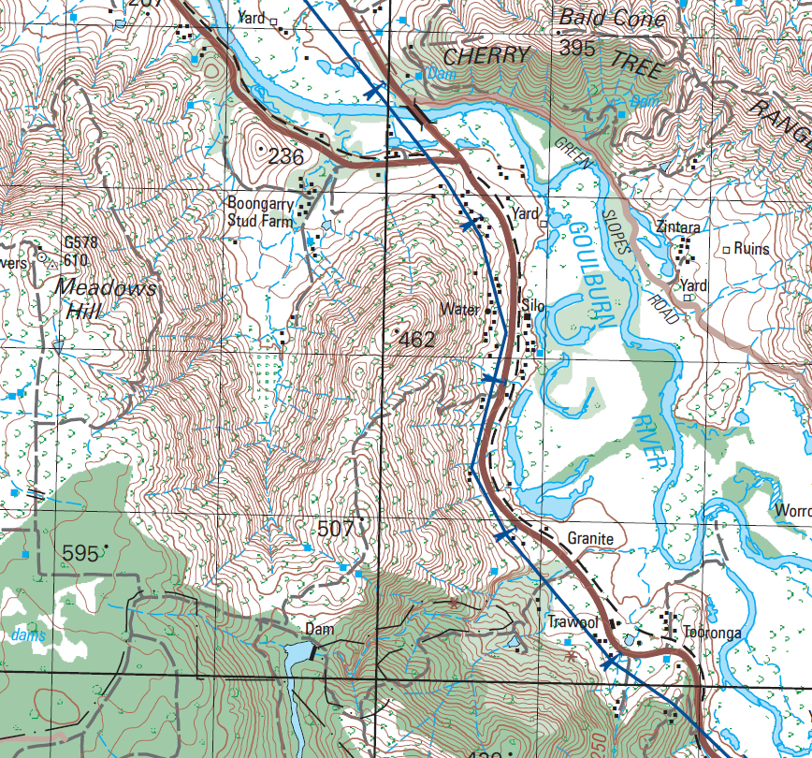

**42**

**41**

**40**

**39**

**38**

**94**

**93**

**92**

**91**

**90**

|  |  |
| --- | --- |
| LANGUAGE BOX | Giving directions:   * We start at grid reference/coordinates... * You should see a hill/saddle/valley/river/road/built-up area/bridge... * Then/after this, head north/east/south/west; north-west, south-west, etc * Keep moving in this direction * Move along the road/the valley/the river * RV is at grid reference…   Asking for clarification:   * I didn’t get that, could you repeat please? * Grid reference _ _ _ _ _ _, roger that. |

* Watch this YouTube video about how to use a map and compass.  
  Type on YouTube [Map Reading - Squared Away - Army Jobs](https://www.youtube.com/watch?v=Z1qRrnzNsAA) or scan the QR Code:

* This lesson links with 🡪 Vocabulary Builder – Compass Points.

© Commonwealth of Australia 2023  
This work is copyright. Apart from any use as permitted under the Copyright Act 1968 (Cth),   
no part may be reproduced by any process without prior written permission from the Department of Defence