# 

**Military English**

Lesson: Military Drones - Listening

**Overview:**   
This lesson practises listening about the context of military drones in the Australian Army and introduces vocabulary related to military drones.

**In this lesson, you will:**

* listen for specific information
* learn the meaning of new words
* use new words in context

## Prepare for Listening

1. Work in small groups. What do you see in each picture?

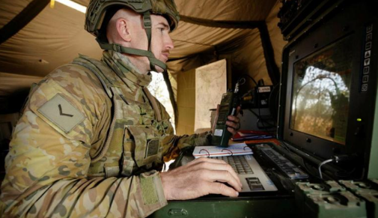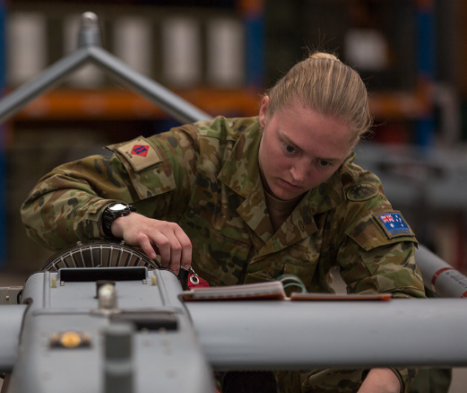

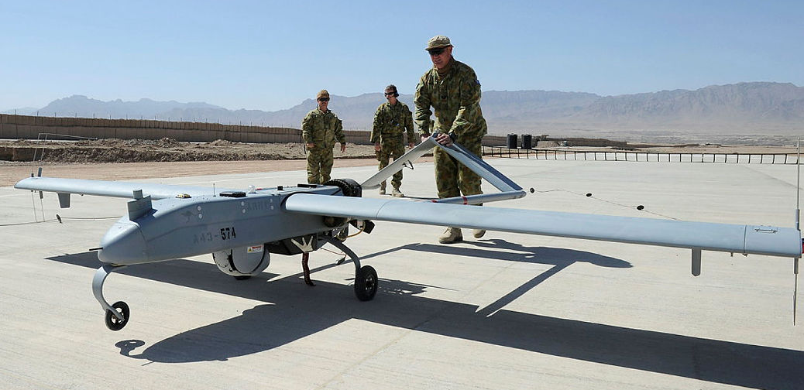

## Listening

1. Listen to the interview. Which job does the soldier have?

|  |
| --- |
| Tank Driver // Education Officer // Medic // Drone Operator |

1. Listen to the interview again. Circle the correct answers.

The Shadow 200 is a medium size military drone. Many countries use it in their defence forces, including Australia,   
Italy,   
Sweden, and the United States.

Which branch does Alice serve in?

Army // Navy // Air Force

How many people need to control the drone and camera?

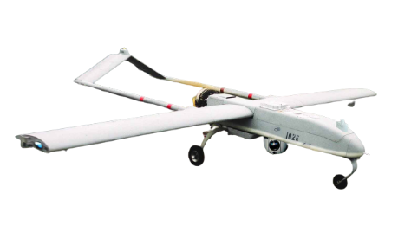1 // 2 // 3

How many hours can the drone fly for?

2 hours // 6 hours // 8 hours

Australian Army Shadows have guns.

True // False

## Learning military vocabulary

1. The words in **bold** in the text are important military vocabulary that you should learn to use. Match the military words on the left to their definitions on the right. Look at the example.

|  |  |  |  |
| --- | --- | --- | --- |
| I’m a **drone operator** (n) | **f** |  | 1. a tool that can take pictures or video of things very far away |
| including a **radar** (n) |  |  | 1. to watch something very carefully and for a long time |
| including a **communication device** (n) |  |  | 1. a machine that can show planes flying in the sky |
| **patrolling** soldiers (adj) / **to go on patrol** |  |  | 1. a place where soldiers, tanks, and planes are fighting |
| a view of the **battlespace** (n) |  |  | 1. a tool that can find warm things, like soldiers hiding in the snow |
| used for **surveillance** (n) |  |  | 1. **someone who flies a small plane with no pilot in it** |
| used for **reconnaissance** (n) |  |  | 1. machines that fly = airplanes, helicopters, etc. |
| they carry **high-resolution cameras** (n) |  |  | 1. a tool that makes it easy to communicate, for example, radio, telephone, and television |
| they carry cameras above **ground troops** (n) |  |  | 1. to move around an area to protect it |
| they carry **night vision cameras** (n) |  |  | 1. soldiers that move on the ground |
| they carry **thermal imaging sensors** (n) |  |  | 1. a machine with a video screen and controls to fly a drone |
| they can **loiter** (v) for hours |  |  | 1. a tool that can take pictures or videos when it is very dark |
| usinga **ground terminal** (n) |  |  | 1. to move quietly, and find the enemy |
| anyone with an interest in **aircraft** (n) |  |  | 1. to stay around a place for a long time |

*Example: drone operator (n) = f. someone who flies a small plane with no pilot in it*

1. Now let’s practise saying the words from exercise 4. Listen and repeat.
2. Circle the correct answer to complete sentences.
3. I can see enemy planes on my *radar* // *communication device.*
4. The *loitering* // *patrolling* soldiers found the enemy hiding in the forest.
5. The *aircraft* // *ground terminal* can fly very high and take clear photos using its *high-resolution camera* // *ground troops*.
6. In the early morning, before the sun came up, I could see the tanks moving with my *night vision camera* // *reconnaissance*.

## Practice

1. In the pictures, you see two drones. Using some of the words from Exercise 4, and the information in the boxes, can you make some sentences? Discuss with your partner.

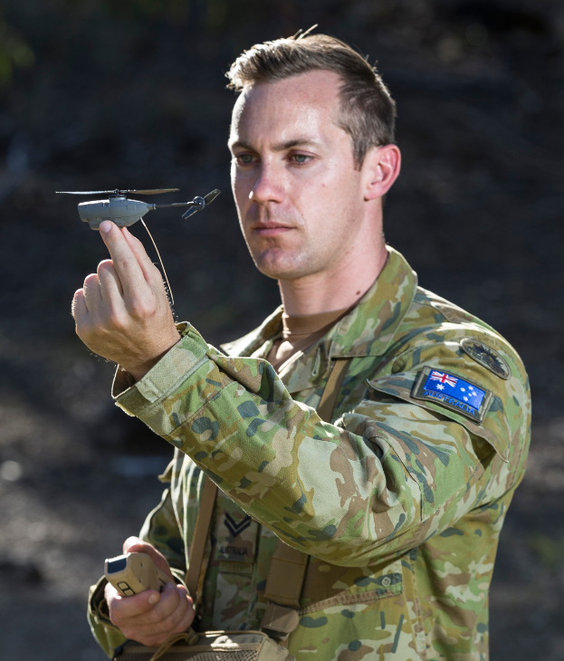

**Triton** /’traɪtən/

Flying time: 24 hours

Range: 3,700 km

Missions: Reconnaissance, Surveillance

Camera: high-resolution, thermal imaging, and night vision

* Used by Royal Australian Air Force

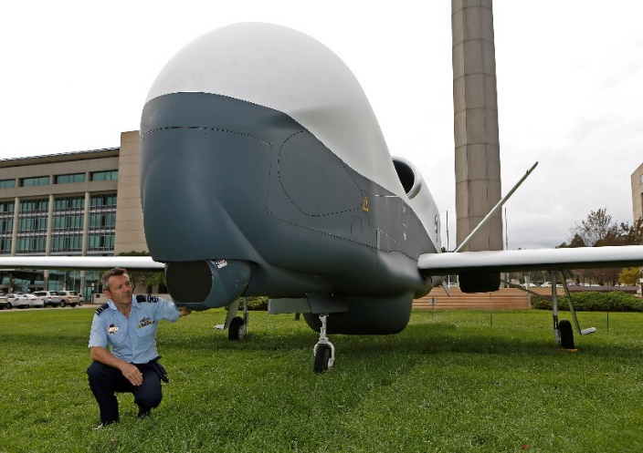

**Black Hornet**

Flying time: 25 minutes

Range: 2 km

Missions: Reconnaissance

Camera: Low-resolution and night vision

* Used by Australian Army

Look at the information in the boxes again. Which drone is better for soldiers on patrol? Which drone can loiter for a very long time? Discuss with a partner.

* This lesson links with 🡪 Vocabulary Builder – Parts of an Aircraft; Lesson – On Patrol
* Watch this video about being a drone operator in the Australian Defence Force.  
  Type on YouTube [Army: Women and Girls in Science](https://www.youtube.com/watch?v=FfBfZbs6sn0) or scan the QR code.

© Commonwealth of Australia 2023  
This work is copyright. Apart from any use as permitted under the Copyright Act 1968 (Cth),   
no part may be reproduced by any process without prior written permission from the Department of Defence.