**New version  
published 03/10/23**



**Military English**

Lesson: Living on a Military Base – Listening

**Overview:**  
This lesson presents vocabulary related to basic facilities in an Australian military base.

**In this lesson, you will:**

* listen and find specific information in a text
* listen for detail
* learn the meaning of new words
* use new words in a conversation

## Prepare for Listening

1. Look at the pictures below and answer the questions with your partner.
2. Are there places (or *facilities*) like this in your unit? How often do you use them?

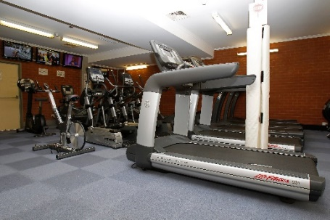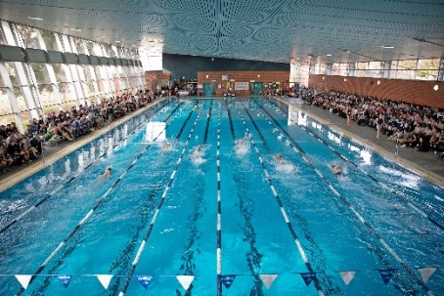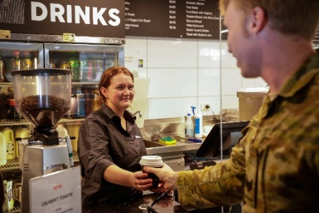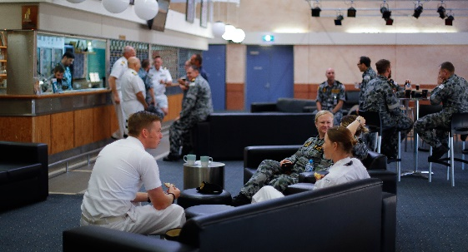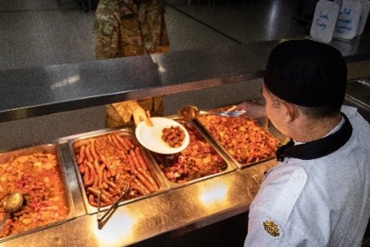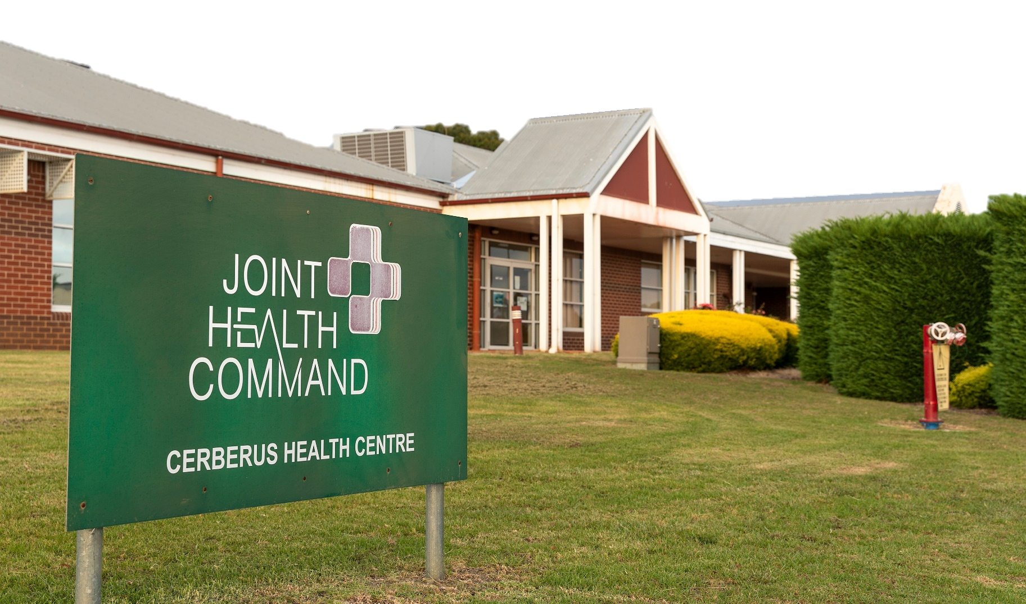

**?** fa __ __ l __ __ i __ s = buildings, equipment or services; for example, all the places in the pictures on this page.

## Listening

1. Listen to an International Seconded Officer giving a base tour and circle the places on the map below that you hear them visit.

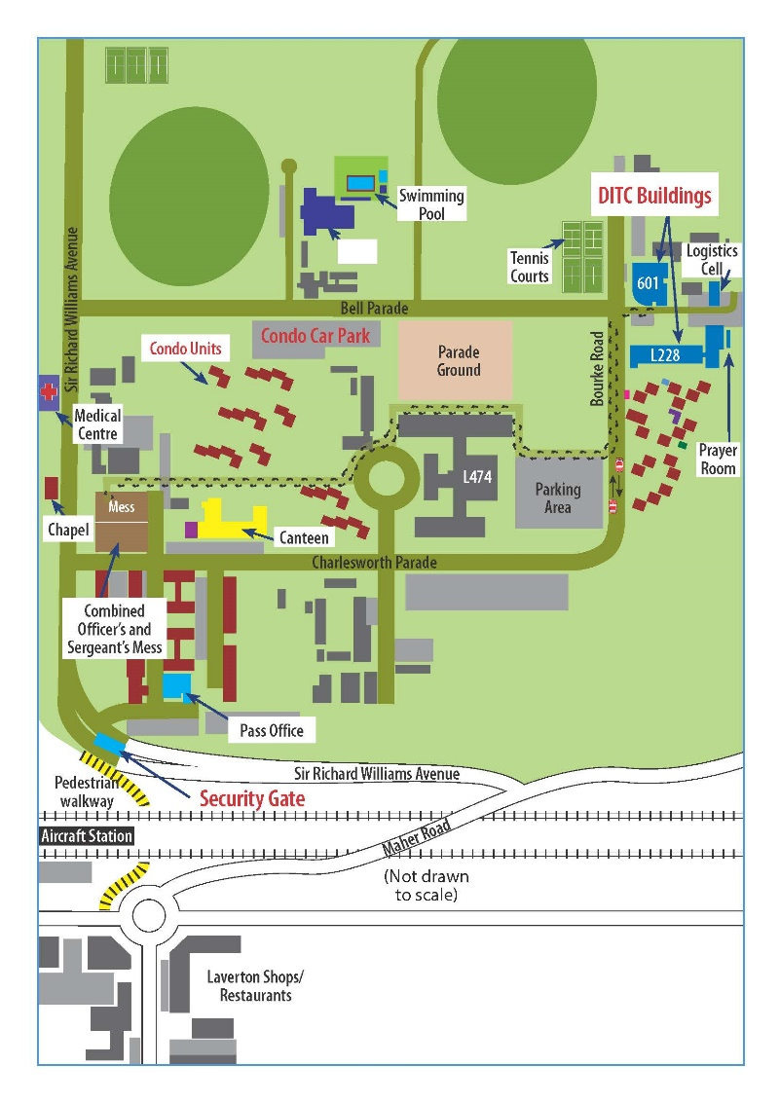

Gym

Starting Point

*

**RAAF Williams**

1. Listen again and complete the table below.

|  |  |  |
| --- | --- | --- |
| **places** | **purpose (what they’re used for)** | **opening time** |
| Parade Ground |  | – |
| Gym | to exercise, use weightlifting equipment,  play basketball, and swim |  |
| Medical Centre |  | – |
|  | to have some peaceful time and pray | – |
| Mess |  | – |
| Pass Office |  | – |
| Logcell |  | – |

Military time is read differently. For example: 0100 (zero, one hundred) is 1am;

0730 (zero, seven-thirty) is 7:30am;

1300 (thirteen-hundred) is 1pm.

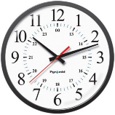

## Learning Military Vocabulary

1. The words in **bold** are important military words that you should learn. Match the military words on the left to their definitions on the right. Look at the example first.

|  |  |  |  |
| --- | --- | --- | --- |
| has a **parade ground** (n) |  |  | 1. Physical Training Instructor - a person who is responsible for physical training (PT) and fitness tests for military personnel |
| I’m now going to **escort** (v) you |  |  | 1. a place where guards give you a security pass to use on base |
| the base **gym** (n) |  |  | 1. a place where personnel of any religion can go for prayer |
| at the **Pass Office** (n) |  |  | 1. the times when military personnel can walk in to see the doctor (without an appointment) |
| speak to the **PTI** (n) |  |  | 1. an area where soldiers practise marching and have parades |
| go to **Sick Parade** (n) |  |  | 1. to go with someone to guard them or to show them the way |
| This building is the **Logistics Cell** /Logcell (n) |  |  | 1. where military personnel have their meals |
| the **Chaplain** (n) |  |  | 1. a military officer who can be a priest, imam or other spiritual leader; they help soldiers when they need it |
| go to the **mess** (n) |  |  | 1. a room, where people sit, talk and relax |
| at the **Medical Centre** (n) |  |  | 1. where military personnel on base go when they’re not feeling well |
| wear a **security pass** (n) | **k** |  | 1. **an official document that shows that you have the right to enter or leave a place** |
| the **chapel** is open (n) |  |  | 1. where you can exercise or play sport |
| the **common room** (n) |  |  | 1. a facility where personnel can get everything they need, for example, equipment and things to use in the office |

*Example: wear a* ***security pass*** *(n)* ***= k****. an official document that shows that you have the right to enter or leave a place*

1. Now let’s practise saying the words above. Listen and repeat.
2. Complete sentences below with words from Exercise 4.
3. After class, students spend their time chatting and relaxing in the _________________________.
4. If you feel sick and need a doctor, you need to go to ____________________________________   
   from 0730-0900 at the Medical Centre.
5. You must wear your __________________________ at all times when on base.
6. If you run out of paper or if something breaks in your room, please contact ____________________.
7. After collecting security passes for the visitors from the _____________________, please ___________________ them to the common room for drinks.

## Practice

1. There is a visitor to your base/unit. Your job is to show them around. Choose four places (facilities) to take them to, and think about:

- what order you will show them

- what the name of the place is

- what it is used for

- when it is open

|  |  |
| --- | --- |
| LANGUAGE BOX | Ordering:   * The first place on the tour is... * The next place is… * After that, I’ll show you… * Third, we’ll go to… * Number four/five… is… * The last place is…   Purpose of each facility:   * It’s used for… * This is (the place) where you… * Here you can…   Telling time:   * It’s open *every day // seven days a week // from 0700-1630*. |

Draw a map of your base to help you talk, if you want. When you are ready, take turns with a partner, to be the visitor or the person showing the visitor around the base.

* This lesson links with 🡪 Vocabulary Builder – Military Time

Lesson – Studying Abroad

Lesson – Recruit Training

© Commonwealth of Australia 2023  
This work is copyright. Apart from any use as permitted under the Copyright Act 1968 (Cth),   
no part may be reproduced by any process without prior written permission from the Department of Defence.