# 

**Military English**

Lesson: Radio Communications (RATEL) - Listening

|  |
| --- |
| **Overview:** This lesson covers a two-part radio communications scenario at a vehicle checkpoint. |
| **In this lesson, you will:**   * read and listen for general information in a text * listen for specific words in a text * learn the meaning of new words * use new words in conversations * speak using radio communications terminology |

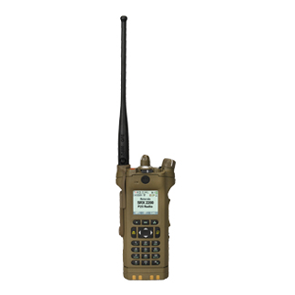**Prepare for Listening**

1. Work in a small group. Discuss the following:
2. What are some basic rules of radio communication? *E.g. Speak clearly*
3. Do you know any radio communication words such as *roger*? Make a list of radio communications words.
4. Look at your list. What do these words mean? When are they used?
5. Look at the pictures below. These are vehicle* checkpoints (VCP). Discuss in your small group:
6. What is a vehicle checkpoint?
7. Are there vehicle checkpoints in your country? Why? Why not?

*vehicle (n) = a truck, bus, car, motorcycle, etc.

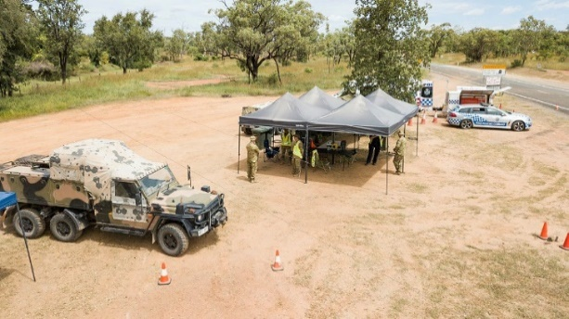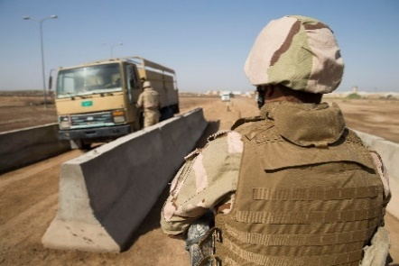

**Listening**

1. You are going to listen to a radio conversation at a vehicle checkpoint. Listen to the first part of the conversation. Discuss in a small group. How many people are there? What happened?
2. Now read Radio Conversation 1 Part 1. Don’t write anything. What do the numbers 10, 11 and 12 mean?

**Radio Conversation 1 - Part 1**

A: 10, this is 11, ________.

B: 11, ­­­________ ____ 10, __­­­­_______, __________.

A: 11, red vehicle approaching VCP at speed. Appears to match suspect vehicle reported earlier. ­­­­­_______ ___ __________, _______.

B: 10, ______, _______.

A: 11, vehicle also appears to be heavy. Suspected VBIED*, _______

B: 10, ________. Stop the vehicle and prepare to search. _______ ____ ________.

12, this is 10, ___________________, ___________.

C: 12, _______, ______________.

B: 10, move to location 2 now, ____________.

C: 12, _____________, _________.

*VBIED = a bomb. This stands for Vehicle Based Improvised Explosive Device

1. Listen again and complete the gaps with the words below. Then check your answers with a partner.

roger // more to follow // send // over // out to you // acknowledge // WILCO // out // this is // ack

1. Now listen to Part 2 and complete the gaps with the words you hear.

**Radio Conversation 1 - Part 2**

Suspect vehicle has arrived at VCP, 12 is in location 2, and 11 is talking with people in vehicle.

C: 10, ___________ ______ 12. Firm and covering in location 2, ___________.

B: 10, ___________, _________ ____ ________.

11, ­­___________ SITREP*, ___________.

A: 10, _______ _______ 11. Vehicle has 1 driver and 1 passenger, both with valid ID. They are taking a radio to the next town for repair. Vehicle is very old and in poor condition, __________ _____ _____________, __________.

B: 10, _________, ___________.

A: 11, made visual search of vehicle interior, and mirror search of under vehicle. Nothing suspect found. Allowing vehicle to pass through. ___________.

B: 10, _________ _______________ all after ‘found’, _____________.

A: 11, allowing vehicle to pass through, ­­­__________

B: 10, ______________________. _______.

*SITREP = situation report **ID = Identification

1. Listen again and check your answers. Then compare your answers with a partner.

**Learning Military Vocabulary**

1. The words in bold in the text are important military words that you should learn to use. Match the military words on the left to their definitions on the right. Look at the example. Then compare your answers with a partner.

|  |  |  |  |
| --- | --- | --- | --- |
| **out** |  |  | 1. Yes. |
| **over** |  |  | 1. The speaker will say more. Please listen for more information. |
| **WILCO** |  |  | 1. Let me know that you received and understood this message. |
| **roger** | **h** |  | 1. I have finished speaking. I need an answer from you. |
| **confirm** (v) militia are present |  |  | 1. Repeat all, or part, of your last message. |
| **send** (v) SITREP |  |  | 1. Continue behaving in the same way (as previously specified) |
| **acknowledge/ack** (v) |  |  | 1. I understand your message and will do what you want me to do. *(Abbreviation for ‘****wil****l* ***co****mply’.)* |
| **maintain** (v) SITREPs |  |  | 1. **I have received all of your last message.** |
| **more to follow** |  |  | 1. I am ready to receive your message/information. |
| **this is** C21 |  |  | 1. Please confirm/check… (clearance, instruction, action, information…). |
| **say again** all after/all before ‘found’ |  |  | 1. I want/require… (clearance, instruction, action, information…). |
| **request** (v) permission to reinforce |  |  | 1. This complete exchange of messages is finished and no response is expected. |
| **affirmative** (adj) |  |  | 1. This message is from the station whose call sign immediately follows. |

1. Now let’s practise saying the words in this worksheet. Pay attention to the word stress (strong/weak parts of words. E.g. **ro**ger, con**firm**). Listen and repeat.

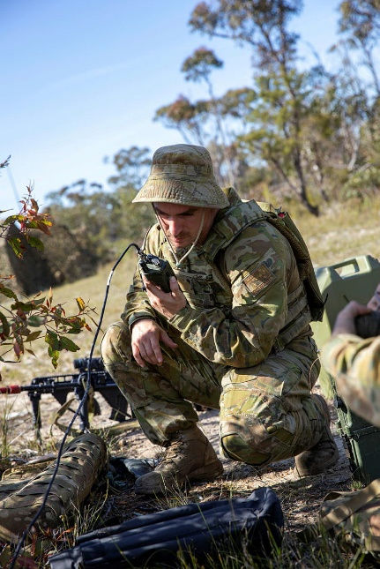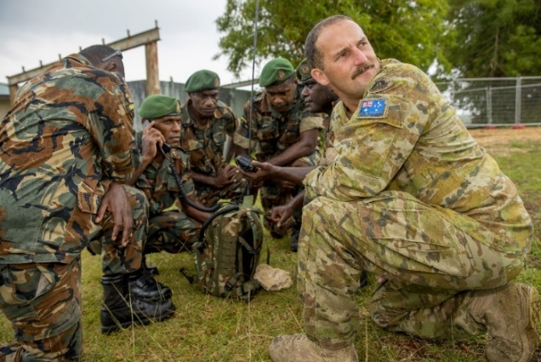

**Practice**

1. Read Radio Conversation 2. Using the words from the vocabulary list, complete the gaps. You do not need to use all the words.

roger // out // over // WILCO // confirm // send // acknowledge or ack // acknowledged // maintain // more to follow // this is // say again // request // affirmative

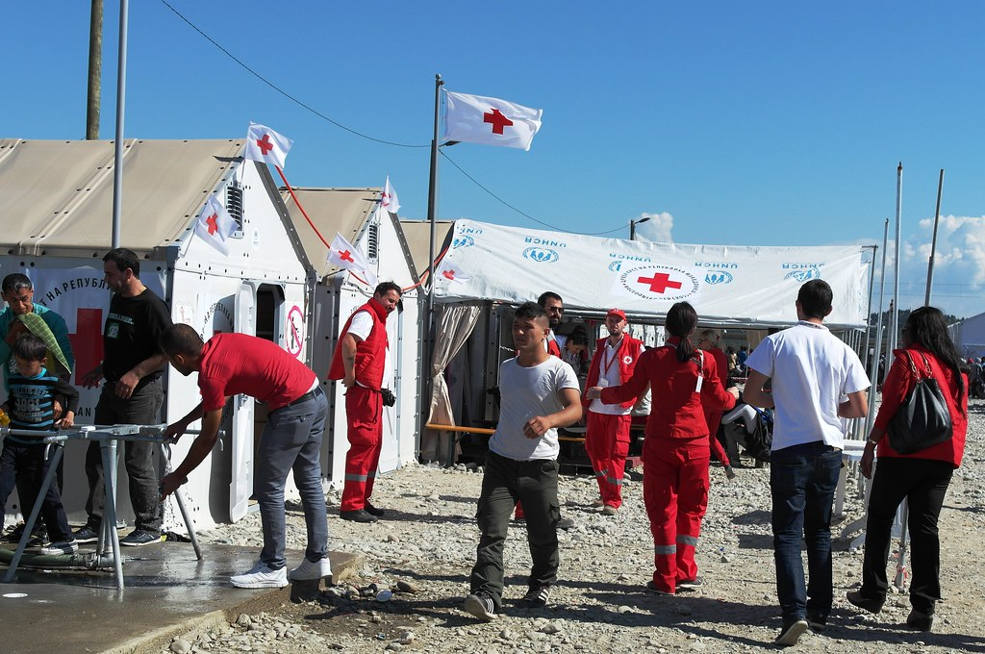

Caroline Haga

**Radio Conversation 2**

A: C20, ________ _______ C21. SITREP, ____________.

B: C20, __________, _________.

A: C21, problem at food distribution point at grid 987624 in Red Cross camp. Security detail* not enough for large crowd. _______________ permission to reinforce, over.

B: C20, _________. __________ militia** are present, _________.

A: C21, ______________. Driver in truck has gun, ___________.

B: C20. __________, join security detail on frequency 45.10. _______________ SITREPs, over.

A: C21, ________, ________.

* security detail – a team of soldiers that has to protect one or more people

** militia – a group of people trained to defend their community or country. They are not part of the army.

1. Compare your answers with a partner – did you get the same answers? Discuss.
2. Practise the conversation with your partner. Then change roles.

* For more information about radio communications, watch this video:

Type on YouTube: [Military Radio Traffic 101- A Machinima How To](https://www.youtube.com/watch?v=y_k6vwUt1dM)   
or scan the QR Code.

* This lesson links with 🡪 Vocabulary – Military Alphabet; Vocabulary – Military Time.

***N.B.*** *The radio words in this lesson may have different meanings and uses depending on their context, the country and/or the service (Army, Navy, Air Force).*

© Commonwealth of Australia 2023  
This work is copyright. Apart from any use as permitted under the Copyright Act 1968 (Cth),   
no part may be reproduced by any process without prior written permission from the Department of Defence.