# 

**Military English**

Lesson: A day in the life of a UN Peacekeeper Officer- Reading

**Overview:**  
This lesson covers an account by an Australian Army Major as part of a UN Peacekeeping mission; and vocabulary related to peacekeeping missions.

**In this lesson, you will:**

* read and find general information in a text
* learn the meaning of new words
* use new words in a conversation

## Prepare for Reading

1. Look at the photos below and answer the questions.
2. What colour hat do UN Peacekeepers wear?
3. What part of the world is the map showing?
4. What countries in this map do you know?

Taken from https://peacekeeping.un.org/en/action-for-peacekeeping-a4p

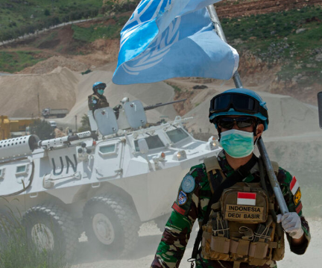

Taken from https://peacekeeping.un.org/en/where-we-operate

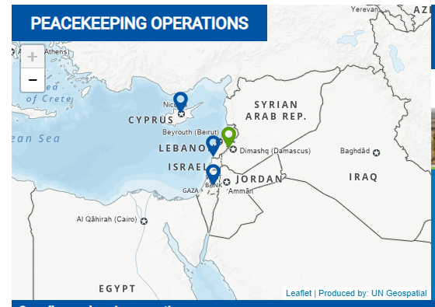

## Reading

1. Before you read the text about MAJ Freya Ballan, an Australian soldier who worked in a UN Peacekeeping Operation (PKO), look at these everyday activities. Which ones do you **think** she usually did in her peacekeeping job?
2. To go out every day to look at what is happening in the area
3. To tell her boss about anything she saw
4. To find water and food for the local people
5. To work with international defence force personnel
6. To take photographs of people in the area
7. To talk to village leaders
8. Now, read the article below and underline the activities she usually did. Check your answers with a partner/a group.  
   Do not use a dictionary yet. You are going to learn the meaning of the words in **bold** in the next exercise.

Tip: When you see a new word in English try to:

* not use a dictionary first, but ask a classmate
* use an English-English dictionary
* use the sentence to help you guess the meaning

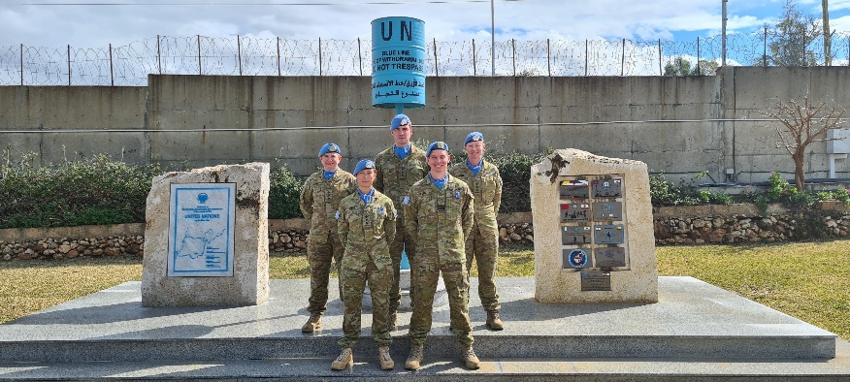

MAJ Freya Ballan arrived in Lebanon in December 2018 as a **Military Observer**. Her team came from countries like China, Russia and New Zealand. They had a clear **UN mandate**: daily **patrols** and **engagement** with local people. She really enjoyed the first month. Her days were always different. She also really liked working with different cultures. There were the Lebanese people, and many international soldiers in her team. She never thought that one day she would work with a Brazilian or Russian soldier! It was exciting to work and spend her free time with them.

Sometimes her team went on **static patrols**. This means they would drive to an **observation point** and stay there for a few days. Her team then described anything unusual to the **chain of command**. At other times she would go out in an **armoured vehicle** with a UN **interpreter** to talk to village leaders. This was her favourite job because the Lebanese people were always friendly and kind. Sometimes they would ask to take pictures with her.

MAJ Ballan says her **deployment** in a UN Peacekeeping **mission** made her a better officer. She thinks this is a good job for every soldier.

1. Read again, but quickly!

Can you find the following (and explain later)?

1. three countries
2. three nationalities
3. one month
4. a year
5. two jobs
6. the name of the officer in this story

## Learning Military Vocabulary

1. The words in **bold** in the text are important military vocabulary that you should learn to use. Match the military words on the left to their definitions on the right. Look at the example.

|  |  |  |  |
| --- | --- | --- | --- |
| to work as a **Military Observer** (n) |  |  | 1. a list of things soldiers can do during a UN mission |
| to have a **mandate** (n) |  |  | 1. when a soldier moves around an area to make sure there is no problem |
| to go on a **patrol** (n) |  |  | 1. to talk to someone so you can be friends |
| **engagement** with local people (n) |  |  | 1. a place where you can watch something happening |
| to go on a **static patrol** (n) |  |  | 1. **an important military job** |
| to drive to an **observation point** (n) |  |  | 1. the way information or instructions in the military go up, for example, from a soldier to his/her boss; or go down, for example, from a general down to a soldier. |
| the **chain of command** (n) |  |  | 1. someone who helps people who speak different languages to understand each other |
| (to go out in) an **armoured vehicle** (n) |  |  | 1. a soldier who watches and listens to what is happening. They report what they see or hear. |
| an **interpreter** (n) |  |  | 1. when a soldier goes to work for a few months in a different place, usually where there is war happening |
| her **deployment** in a UN Peacekeeping mission(n) |  |  |  |
| a UN Peacekeeping **mission** (n) | **e** |  | 1. like a patrol, but instead of moving around, soldiers stay in one place |

*Example: a mission = e. an important military job*

1. Now let’s practise saying the words. Listen and repeat.
2. Now try to use some of the words from exercise 5 correctly in the sentences below.
3. Sometimes MAJ Ballan went on a ________________ in an armoured vehicle.
4. Sometimes her team would stay at an _____________________, without moving around.
5. Military officers can train to become an _________________, so they can help their colleagues understand what international people say in another language.
6. A __________________ with the UN usually means the soldier works as a   
   _______________ _______________. They are not going to war but they watch what is happening and tell their chain of command.
7. Soldiers from Australia travel to many places to help. This job helps _________________ with the people from that place.

## Practice

1. Discuss these questions with a partner:
2. Did MAJ Ballan like her job as a UN Military Observer? Do you remember why she liked/didn’t like it?
3. Would you like to go on a deployment as a Military Observer? Why / why not?



* Watch this video about going on patrol in a Peacekeeping Operation.

Type on [YouTube On patrol with peacekeepers in South Sudan](https://youtu.be/942hdH83tew) or scan the QR code:

* This lesson links with 🡪 Lesson – On Patrol

© Commonwealth of Australia 2022  
This work is copyright. Apart from any use as permitted under the Copyright Act 1968 (Cth),   
no part may be reproduced by any process without prior written permission from the Department of Defence.