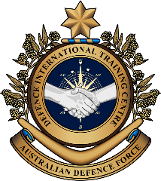

**Military English**

Lesson: MEDEVAC - Medical Evacuation Operations - Reading

|  |
| --- |
| **Overview:** This lesson describes the medevac service, and introduces and practises associated vocabulary. |
| **In this lesson, you will:**   * listen for some general information in a text * read for general and specific information in a text * learn the meaning of new words * use new words in sentences * speak about your own experiences |

## Prepare for Reading

1. Look at the picture. Then watch the very short video and answer the questions. Share your answers with a classmate. Type on YouTube [Aero-Medical Evacuation](https://www.youtube.com/watch?v=K0ojd26Dy94) or scan the code at the bottom of the page.
   1. What is the situation?
   2. What is the job of the speaker?
   3. What things did you see?

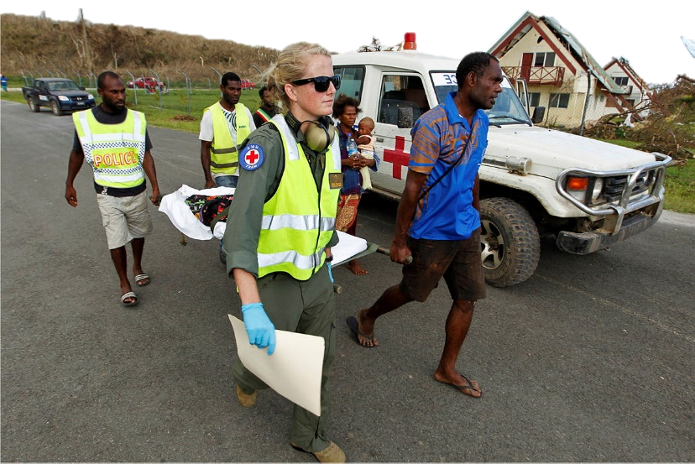



## Reading

1. Read the text as quickly as you can. Don’t stop to check any words. Try to decide what the **main idea** in each paragraph is. Compare your ideas with your partner.

Look at the main ideas in the boxes below and match them to paragraph 1,2, or 3.

____Definition and description of Medevac

____Link to search and rescue, and example

­­­­____Further details (what and who are involved)

1. Read the text again and look at the words in **bold.** Look at the words before and after these, and try to understand the meaning before you use a dictionary.

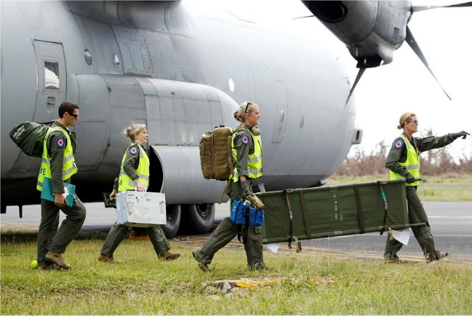**Medical Evacuation – MEDEVAC**

Medical evacuation is also called ‘medevac’. It is used to move people who are sick or **injured** to a hospital for medical **treatment**. This can happen on land, in the air or on water. Medevac uses specialist emergency medical services (EMS) vehicles such as ambulances, helicopters or planes. These vehicles are non-combat*, and unarmed**. They also have a special mark on them to show they are Medevac (e.g. a red cross). Aero-medical evacuation (AME) is a type of medevac. Military personnel must carefully plan and organise medevac operations.

During a medical evacuation, it is important to have **medical supplies** and **equipment** such as **first aid kits**, **stretchers**, and other rescue equipment. **Emergency responders,** and **medical personnel** like doctors and nurses may have to transport the **casualty** to provide more care and support.

Sometimes, search and rescue teams are needed to find and transport the **patient**. Recently, the Australian Defence Force (ADF) supported the Australian Maritime Safety Authority (AMSA) in a medevac operation off the coast of Western Australia. The ADF dropped medical supplies and equipment to a sailing boat and then sailed with medical personnel from the Royal Australian Navy to help **stabilise** and **transfer** the patient while at sea.

*Not used in fighting/warfare **Not carrying weapons/firearms

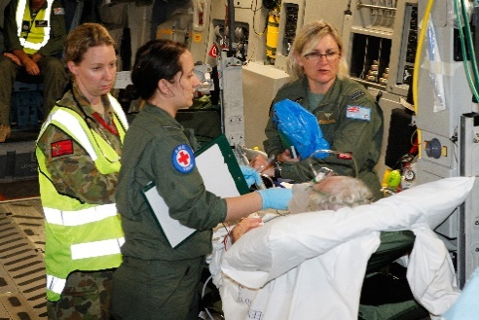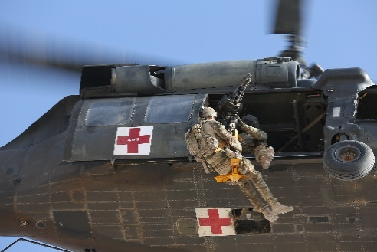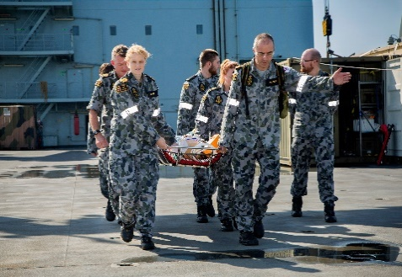

## Learning Military Vocabulary

1. The words in **bold** are important military vocabulary that you should learn. Match them to their definitions on the right. Look at the example and write the answers in the middle column.

|  |  |  |  |
| --- | --- | --- | --- |
| **medical supplies** (n) | **g** |  | 1. A person who is hurt or killed in a war or an accident |
| **medical equipment** (n) |  |  | 1. One of the first people to arrive to help with an emergency e.g. a paramedic, police officer, or firefighter |
| **medical personnel** (n) |  |  | 1. Something that doctors or nurses give to care for their patients so that they feel better |
| an **emergency responder** (n) |  |  | 1. Medical items such as stretchers, wheelchairs, and oxygen tanks, etc. |
| a **first aid kit** (n) |  |  | 1. When someone is hurt |
| transfer a **patient** (n) |  |  | 1. People who give medical care, such as doctors and nurses |
| transport a **casualty** (n) |  |  | 1. **Medical items such as medicines, bandages, antiseptic, and syringes, etc.** |
| a **stretcher** (n) |  |  | 1. A small box or bag with items such as bandages, plasters, and antiseptic to help a sick or injured person |
| people who are **injured** (adj) |  |  | 1. To move something or someone from one  place – or situation – to another |
| to help **stabilise** (v) the patient |  |  | 1. A person receiving medical help from a doctor or nurse |
| for medical **treatment** (n) |  |  | 1. To stop a patient from becoming more sick before they can receive care at a hospital |
| **transfer** (v) the patient at sea |  |  | 1. Equipment used for  carrying patients from one  place to another |

1. Now let’s practise saying the words. Listen and repeat.

Pay attention to the word stress (strong/weak parts of words. *E.g. stabilise, supplies*).

1. Test your partner with some of the words from Exercise 4.

Choose one of the words. Do not say the word. Instead, read the meaning. Your partner must not look at his/her sheet, but try to remember the correct word. Swap.

1. Now try to use the words from Exercise 4 correctly in the sentences below.
2. There are many different types of ____________________________________________ who work in a military hospital.
3. We need to use medevac to ________________ this patient from the disaster site to the local hospital.
4. The _______________________________________ should always be full and ready for use.
5. The soldier was badly _____________________ on his first deployment overseas.
6. The patient’s ___________________________ was successful and she recovered very quickly.
7. The ADF has recently agreed to buy $200,000 of _________________________________________________ for the new army hospital.

If you have time, make sentences of your own to give to your partner.

## Practice

1. With a partner, ask and answer these questions. Add more information to help your partner understand. Be ready to tell other members of the class about what your classmate said. Try to use some of the words from Exercise 4 in your answers.
2. Describe the medical evacuation service in your country.
3. Have you ever participated in a medevac (or similar) operation (real or exercise)?

Describe your experience.

1. Have you ever been in an EMS vehicle, like an ambulance or a helicopter? What was it like?

If not, would you like to? Why/why not?

* Watch this video about MEDEVAC. Type the video title on YouTube or scan the QR code.

[MEDEVAC and CASEVAC : What’s the difference? - YouTube](https://www.youtube.com/watch?v=KKTl4N5N13Y)

* This lesson links with 🡪 Lesson – Humanitarian Aid

Lesson – Disaster Relief

Vocabulary Builder – Parts of a Helicopter

© Commonwealth of Australia 2023  
This work is copyright. Apart from any use as permitted under the Copyright Act 1968 (Cth),   
no part may be reproduced by any process without prior written permission from the Department of Defence.