
Military English
Lesson: Marksmanship Principles - Reading

Overview:
This lesson discusses vocabulary related to marksmanship principles and basic weapons training rules, in an army soldier’s journal.
In this lesson you will practise:
- reading for general information
- reading for specific information
- learning the meaning of new words
- using new words in context

Prepare for Reading
- Look at the pictures and discuss the following questions in pairs or small groups.
- What is the person in the picture doing?
- What knowledge/skills do you need to be a good shooter?

? Marksmanship means the ability to shoot carefully / quietly / accurately
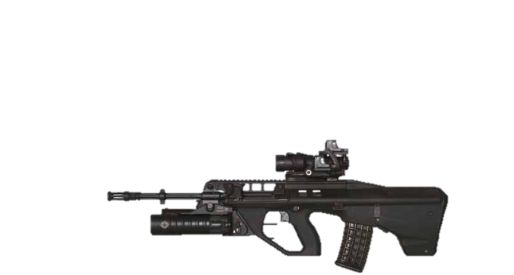
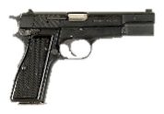
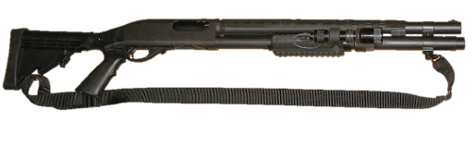
Here are some examples of weapons used by the Australian Defence Force (ADF):
EF88 assault rifle
Browning Mark III pistol
870P shotgun

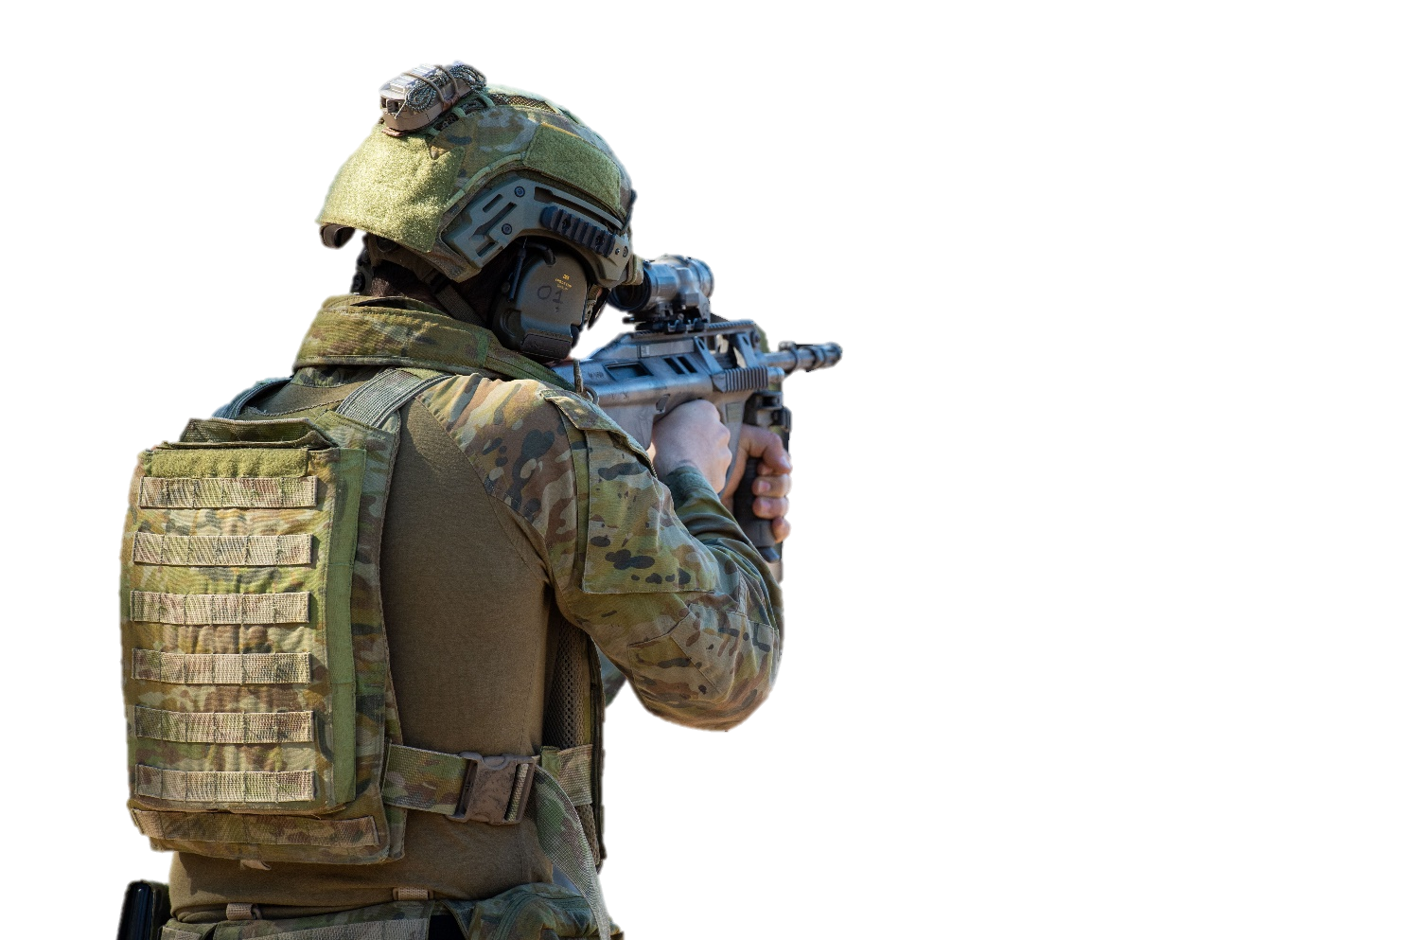
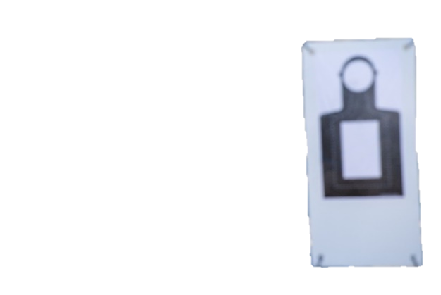

Reading
- Below are a soldier’s notes about what he learned on the first day of weapons training. Quickly read the text. What rules is he writing about? Circle the correct answer.

how to hold a rifle // how to shoot a rifle // how to clean a rifle

Marksmanship principles = basic rules in weapons training
Instructor: SGT Jett Seal
      - firm grip and firing positions = hold weapon tightly and change body to the correct position help shoot better and manage recoil.
      - aim weapon at the target and make sure the body aligns with weapon - weapon and body are facing the same direction!
      - make sight alignment correct = top of front and rear sights
in the same line and front sight in the center of rear sight.
correct sight picture = front / rear
sights and target in the same line.
      - trigger control = slowly and smoothly pull the trigger.
follow through = hold finger on the trigger, stay in firing position after shooting.
Practice, practice and practice!

Next week Simpson Barracks – Weapon Training Simulation System (WTSS)* and live firing at outdoor firing range

rear sight
front sight
target

- Read the journal again. Number the rules in the correct order.

_______ keep finger on the trigger after shooting, without firing
_______ point weapon at the target
_______ hold weapon firmly and correctly, sit or stand to fire
_______ make sure the target, front, and rear sights, are in the same line
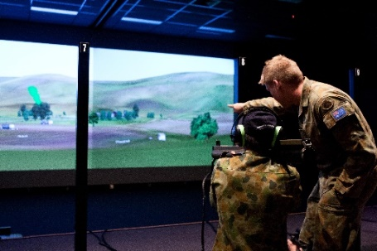
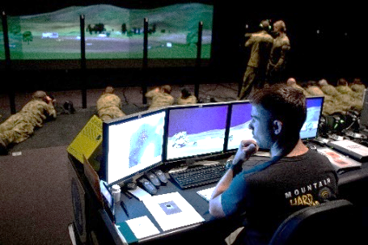
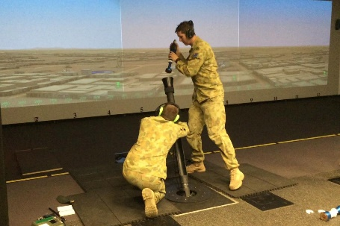

* Weapon Training Simulation System (WTSS) is an indoor training facility. The ADF has many of these facilities for personnel to train in marksmanship and other combat behaviours.
It uses interactive video.

Learning military vocabulary
- Look at the example below. The words in bold text are important military vocabulary you should learn to use. Match the military words on the left with their definitions on the right.

marksmanship principles (n) | d |  | - to make sure your body and weapon are in the same line as the target
a firm grip (n) |  |  | - when a weapon's sights and the target are in the same line
in different firing positions (n) |  |  | 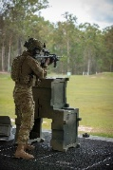  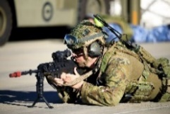  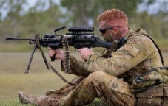  - different ways a shooter can fire their weapon:  sitting  prone  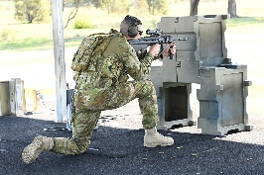  standing  kneeling
manage recoil (n) |  |  | - the ability to shoot well/accurately
aim weapon at the target (v) |  |  | 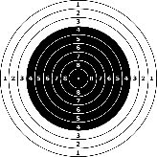  - an object that you want to shoot at
aim at the target (n) |  |  | - the way you hold a weapon with your hands
align weapon and body (v) |  |  | 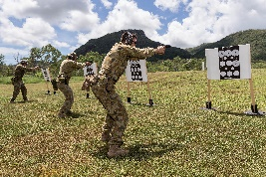  - a place where you go shooting
front and rear sights (n)adjust |  |  | - to point a weapon at an object that you want to shoot
sight alignment (n) |  |  | 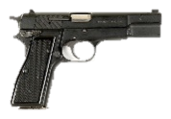  - to be able to smoothly pull the trigger while keeping control over the weapon  trigger
clear sight picture (n) |  |  | - to continue to hold the trigger / aim at the target after firing
maintain trigger control (n) |  |  | - what you see when the sights are in  the same line as the target
follow through (v) after firing |  |  | - the backward movement of a weapon after it is fired  rear sight  front sight  target
outdoor firing range (n) |  |  | 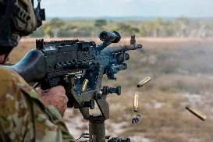  - the parts which help you aim the weapon better

- Let’s practise saying the words. Listen and repeat.
- Complete the sentences with words from Exercise 4.
- Hold the weapon firmly with both hands. Maintain ___________________ by smoothly pulling the trigger.
- The soldiers raise their rifle and ___________ at the _________________, which is 300 metres away.
- You have to __________ your front and rear sights on the target – this is a basic rule of __________.
- There are four standard ______________________: standing, kneeling, sitting, and prone.

Practice
- Discuss these questions with a partner. Use the words you learned in Exercise 4.
- What weapons training have you done? What kind of training was it?
- What are the first marksmanship rules that you learned in the military?
- Which of the marksmanship rules from exercise 2 are you good (or bad) at?
- What other rules can you add to improve your marksmanship?


- Play the weapons training video below. As you watch and listen, write a list of some of the new words you have learned throughout this lesson.
- Click this YouTube link ADF Skill at Arms Combat Shooting Competition 2020,
or scan the QR Code to play the video

- This lesson links with Vocabulary Builder – Parts of an Assault Rifle
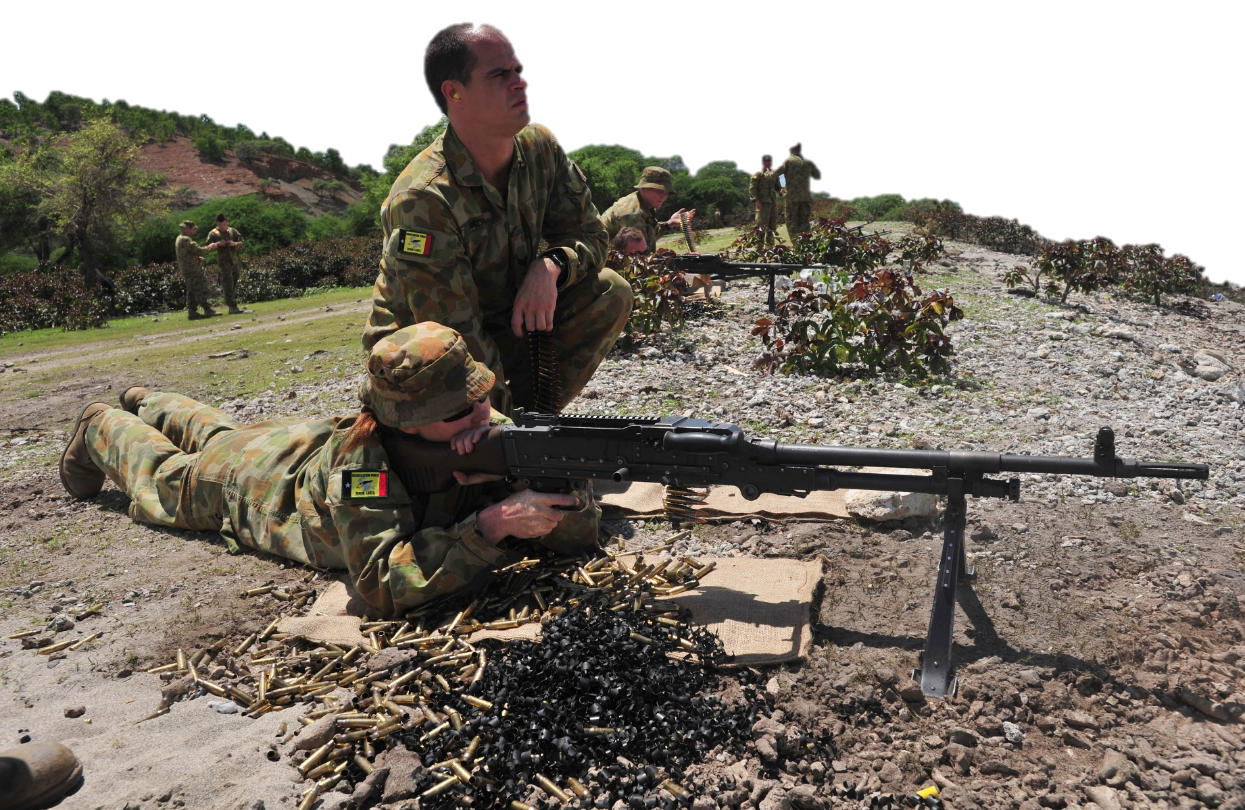
Lesson – At a Firing Range
These Australian soldiers are practising marksmanship skills with Timorese forces at a firing range in Liquica, Timor Leste.

© Commonwealth of Australia 2023
This work is copyright. Apart from any use as permitted under the Copyright Act 1968 (Cth),
no part may be reproduced by any process without prior written permission from the Department of Defence.

