# 



**Military English**

Lesson: Recruit Training in the Australian Army - Listening

**Overview:**  
This lesson involves listening to a description of recruit training in the Australian Army, and learning vocabulary for this situation.

**In this lesson, you will:**

* predict content from an image
* listen to a text for specific information
* learn the meaning of new words
* use new words in a conversation

## Prepare for Listening

1. Look at the photos – what can you see? What will we talk about in this lesson, do you think?

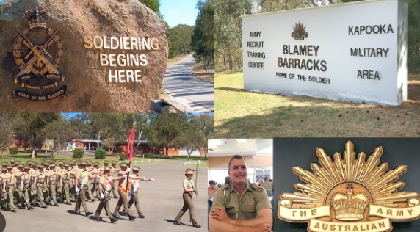

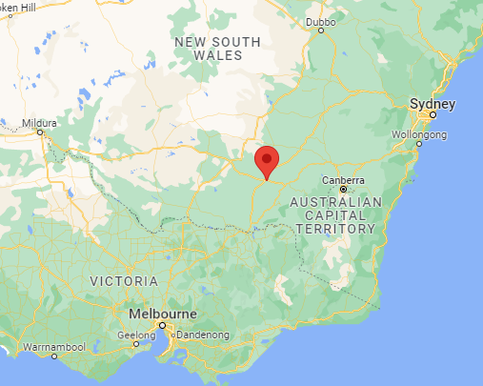

‘Kapooka’ is the Australian Army’s main base for soldier recruit training. It is in the state of NSW, about 250 km from Canberra, the capital of Australia.

* a ‘**recruit’** is someone who is new to the military, and **is / is not yet** fully trained.

1. Watch the quick *“Hello from Kapooka”* video. [Hello from Kapooka - YouTube](https://www.youtube.com/watch?v=BVePJzqn73c)

Listen and watch where the recruits are. Be careful they speak quickly!

Put these places in the order you see them on the video.

One of the places is NOT in the video. *No. 1 has already been done for you.*

* the gym
* the classroom
* the field
* the barracks
* the mess
* the firing range
* **the obstacle course = 1**
* the high ropes course

1. What do you do in these places? Match the places with the activity. Watch the video again, and check your ideas.

|  |  |
| --- | --- |
| **PLACES** | **ACTIVITY** |
| 1. the gym | 1. eat |
| 1. the classroom | 1. get fit |
| 1. the field | 1. learn how to climb walls using ropes |
| 1. the barracks | 1. learn how to climb over and crawl under things |
| 1. the mess | 1. practise field craft |
| 1. the firing range | 1. sleep |
| 1. the obstacle course | 1. learn how to shoot |
| 1. the high ropes course | 1. study |

## Listening

1. Listen to the instructor talking about recruit training in the Australian Army.

Answer the questions, by choosing True (T) or False (F).

Check your answers with a partner/a group.

**True or False?**

* 1. Each soldier in the Australian Army begins training at RAAF Base Williams.
  2. The main aim of recruit training is to increase your health so you can be a good soldier.
  3. All the classes will be outdoors.
  4. Recruit training in the Australian Army is 3 months.
  5. The training is easy.
  6. You learn how to iron your uniform.
  7. The instructors on basic training want you to do well.
  8. Before you leave Kapooka, you’ll also learn some special trade e.g. how to drive a tank.
  9. After you finish the specialist training, you will start working as a soldier in an Army unit.

## Learning military vocabulary

1. The words in **bold** in the text are important military vocabulary that you should learn to use. Match the military words on the left to their definitions on the right. Look at the example.

|  |  |  |  |
| --- | --- | --- | --- |
| **civilian(s)** (n)become soldiers | **g** |  | 1. how to live, travel and operate in the field without the enemy seeing you |
| **weapons handling** (n) |  |  | 1. when you pass an exam or finish a course and can do a job, you have this |
| **combat skills** (n) |  |  | 1. people who teach you |
| **drill** (n) |  |  | 1. the first stage of learning about the military |
| **field craft** (n) |  |  | 1. usually a ceremony to show you have finished your study |
| **basic training** (n) |  |  | 1. to give someone a job or be sent to a workplace |
| the aim of **instructors** (n) |  |  | 1. **someone who is NOT military** |
| **graduation** (n) from recruit training |  |  | 1. to learn how to hold and use a rifle |
| learn their **trade / profession** (n) |  |  | 1. the things you learn so you can fight in a war |
| a **qualification** (n)to help them |  |  | 1. to practice or rehearse fighting in a war; practice marching |
| **assigned to** (v)an Army unit |  |  | 1. more than the basics; a job in the military |

*Example:* ***civilian(s)*** *= g. someone who is NOT military*

1. Now let’s listen to the words practised in this lesson. Listen and repeat.
2. Now try to use some of the words from exercise 5 correctly in the sentences below. Fill in some spaces with information about your country/ school.
   1. In my country, ___________________ enter the military and begin basic training when they are ______ years old.
   2. I joined the army to get a ________________________ and learn some special skills about repairing motor vehicles.
   3. If my ____________________ thinks we did something wrong, we go onto the parade ground to practice __________________ for many hours, or we have to _____________________________.
   4. When will we finish this training and have our _______________________? It’s on _____________.

## Practice

1. Ask questions in a group. On the line, write the name of a classmate who gives you a ‘yes’ answer*.

Find someone who……

Is your father in the military?

1. *has a father **not** in the military ________________________
2. enjoys/enjoyed basic training _________________________
3. has a favourite instructor _____________________________
4. likes being out in the field ____________________________
5. can handle a weapon _______________________________

Can you handle a weapon?

*\* this question needs someone who will answer ‘no’*

* This lesson links with 🡪 Lesson – Life on a Military Base; Lesson – Studying Abroad.
* Watch these videos about basic military training in the Australian Army. Type the video titles on YouTube or scan the QR codes.

[What is Kapooka?](https://www.youtube.com/watch?v=VMPL0CjLQnI)  [Life at Kapooka](https://www.youtube.com/watch?v=11TECEYk0ic)

© Commonwealth of Australia 2023  
This work is copyright. Apart from any use as permitted under the Copyright Act 1968 (Cth),   
no part may be reproduced by any process without prior written permission from the Department of Defence.