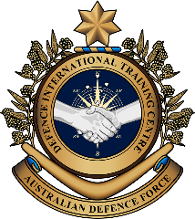

**Military English**

Lesson: Search and Rescue Operations - Reading

**Overview:**  
This lesson involves reading about Search and Rescue Operations of the Australian Defence Force.

**In this lesson, you will:**

* read and find specific information in a text
* learn the meaning of new words from context
* use newly learned words in context

## Prepare for Reading

1. What can you see in the pictures? Discuss in pairs or small groups.

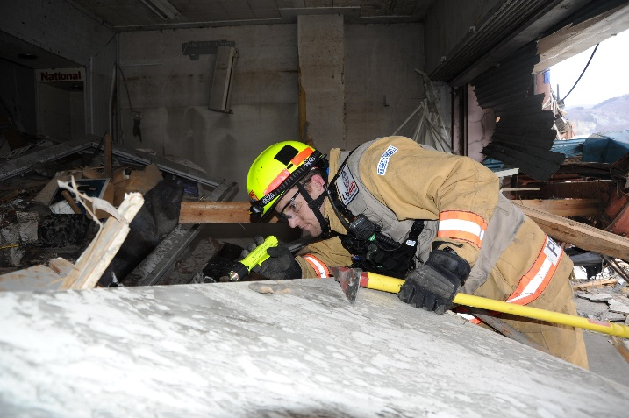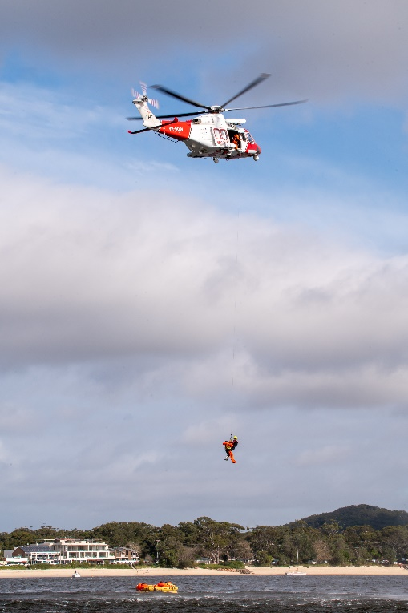



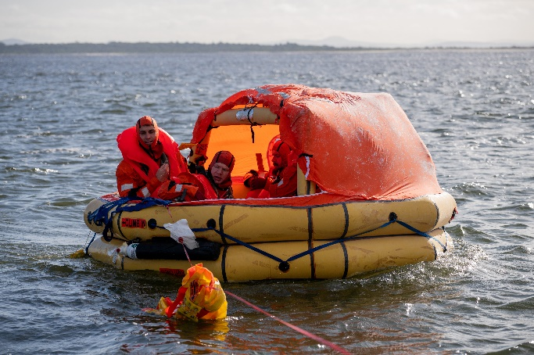

1. Imagine you are part of a team looking for someone who is lost and needs help.
2. What tools and equipment do you need to find this person?
3. What problems will you have?

## Reading

1. The text below describes a search and rescue operation by the Royal Australian Air Force (RAAF).   
   Read the text below and discuss your answers to Exercise 1 and 2 with a partner/a group.

**Do not** use a dictionary yet. You are going to learn the meaning of the words in **bold** in the next exercise.

Tip: When you see a new word in English try to:

* not use a dictionary first, but ask a classmate
* use an English-English dictionary
* use the sentence to help you guess the meaning

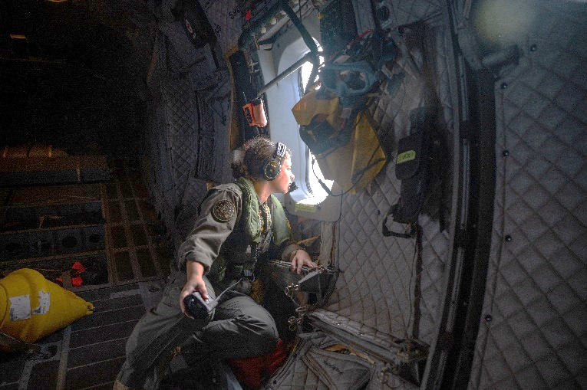

**A Search and Rescue Operation**

“Thank you very much for your **assistance**. I will now be able to spend Christmas with my family and friends.” This is what the captain of the boat *Waigani*, said to a Royal Australian Air Force (RAAF) P-8A Poseidon **crewmember**. The P-8A Poseidon is a **maritime patrol aircraft**. The Air Force used it to find the boat, which was lost in the middle of the ocean.

The fishing boat from Darwin, Australia had a problem with its engine and sent a **distress signal**. The Australian Maritime Safety Authority (AMSA) then started a **Search and Rescue operation** on the morning of 23 December. AMSA **deployed** a P-8A Poseidon to search the area around the boat’s **route**. The aircraft did an **aerial search** using its **radar** and found the boat they were looking for.

After they had **radio contact** with *Waigani*, they knew all four crewmembers of the boat were well. The Search and Rescue team then sent a **patrol boat** to meet them and take them back to port.

“This was a quick and **successful operation**. The sea was calm and the winds were light, but sometimes it can be very different”, said the mission officer Brad McAlister. “Search and Rescue operations in the ocean can take many days. This is a problem, because sometimes there is someone injured on board. I’m glad we found them, and in time for Christmas!”

The P-8A Poseidon is used for military   
missions. Its main job is to find people   
or things in the water, like submarines.   
To help it do its job, the P-8A has special tools   
and equipment, like radars and sensors.

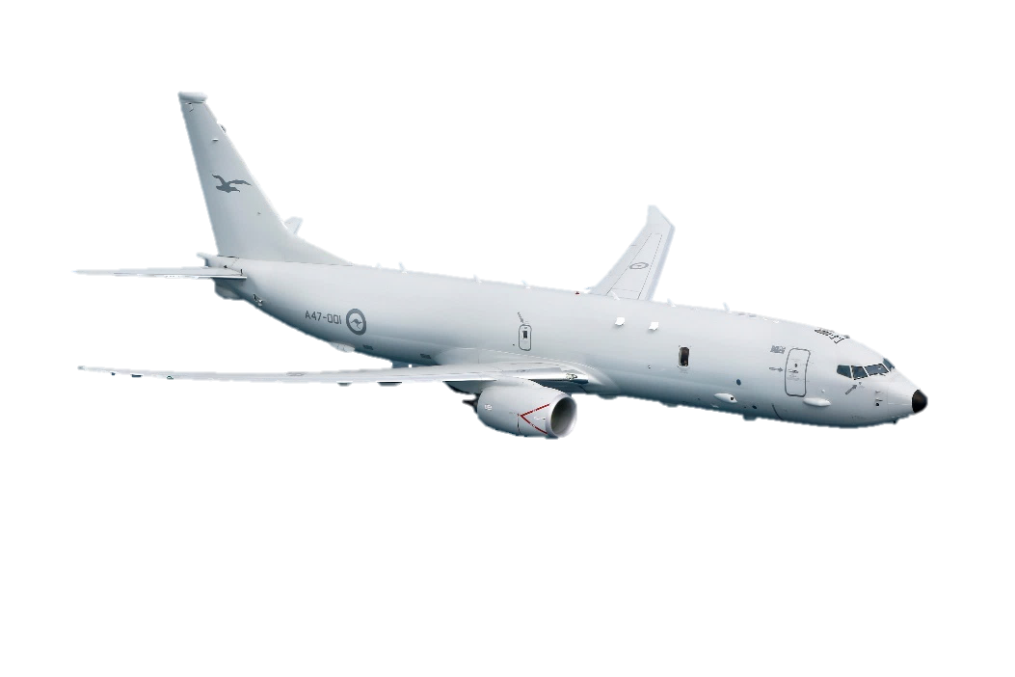

## Learning Military Vocabulary

1. The words in **bold** in the text are important military words that you should learn. Match the military words on the left to their definitions on the right. Look at the example first. Then compare your answers with a partner.

|  |  |  |  |
| --- | --- | --- | --- |
| thanks for your **assistance** (n) |  |  | 1. a person who works on a ship or airplane |
| they had **radio contact** (n) |  |  | 1. a path or a way to travel from one place to another |
| a **maritime patrol aircraft** (n) |  |  | 1. **the military uses this boat to protect and keep areas of water safe** |
| a **crewmember** (n) |  |  | 1. to use an aircraft to look for a lost person or boat |
| a **distress signal** (n) was sent |  |  | 1. to send an aircraft to a certain place for a reason |
| a **Search and Rescue operation** (n) |  |  | 1. a call for help when someone is in trouble |
| AMSA **deployed** an aircraft(v) |  |  | 1. when people talk with someone using a radio |
| the boat’s **route** (n) |  |  | 1. a mission that went well |
| they did an **aerial search** (n) |  |  | 1. help |
| using its **radar** (n) |  |  | 1. looking for people who are lost, injured or in danger |
| this was a **successful operation** (n) |  |  | 1. a piece of equipment that is used to find where things like planes and boats are |
| a **patrol boat** (n) was sent | **c** |  | 1. an aircraft that is used to look for people who are lost, injured or in danger on the ocean |

*Example: a patrol boat (n) = c. the military uses this boat to protect and keep areas of water safe*

1. Now let’s practise saying the words. Pay attention to the word stress (strong/weak parts of words. *E.g. assistance*). Listen and repeat.

## Reading

1. Read the text again and:

* Answer the questions below: Choose the correct answer (a, b, c, or d) to each question.
* Check your answers: Compare your answers with your classmate/s.
* Do you need help? Ask your teacher or classmates.

Questions:

1. Who sent the distress signal?

a. The Australian Maritime Safety Authority (AMSA)

b. The crew of the *Waigani* fishing boat

c. The Royal Australian Air Force (RAAF)

d. Brad McAlister

1. What kind of aircraft was used in the search and rescue operation?

a. A helicopter

b. A patrol boat

c. A P-8A Poseidon aircraft

d. A small radar contact

1. Why did the fishing boat send a distress signal?

a. They were celebrating Christmas.

b. They had a problem with their engine.

c. They were lost at sea.

d. They wanted to spend time with their family and friends.

1. What did the team on P-8A Poseidon aircraft do during the operation?

a. They talked on the radio to the people on the *Waigani*.

b. They sent a patrol boat to meet the *Waigani*.

c. They did an aerial search using a radar.

d. All of the above

1. What did the captain of the *Waigani* fishing boat say to the people of the P-8A Poseidon aircraft after they were found?

a. "Thank you very much for your assistance."

b. "I'm glad we found them in time for Christmas."

c. "This was a quick and successful operation."

d. "Search and rescue operations in the ocean can take days."

## Practice

1. Discuss these questions with a partner. Use the words below in your answers. Cross out the words you use in your answers.

radio contact (n),

assistance (n),

maritime patrol aircraft (n),

crewmember (n),

a distress signal (n),

Search and Rescue operation (n),

to deploy an aircraft (v),

route (n),

an aerial search (n),

radar (n),

a successful operation (n),

a patrol boat (n)

1. What happened to the fishing boat *Waigani*?
2. How did the RAAF help in the Search and Rescue mission?
3. What did the people on the aircraft do after they received radio contact from the fishing boat?
4. What aircraft or boats are used for Search and Rescue operations in your country?

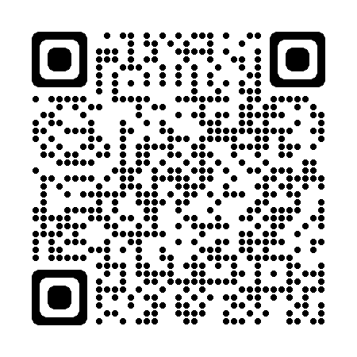

* For more information about Search and Rescue operations, watch this video:   
  Type on YouTube: [P-8 Poseidon crews work together - Talisman Sabre 2021](https://www.youtube.com/watch?v=-FAjapI0K4A) or scan the QR code:
* This lesson links with 🡪 Lesson – Medevac; Vocabulary Builder – Parts of an Aircraft.

© Commonwealth of Australia 2023  
This work is copyright. Apart from any use as permitted under the Copyright Act 1968 (Cth),   
no part may be reproduced by any process without prior written permission from the Department of Defence.