

**Military English**

Lesson: Studying Abroad - Reading

**Overview:**   
This lesson covers an account by an ADF cadet attending the Australian Defence Force Academy (ADFA).

**In this lesson, you will:**

* read and find general information in a text
* learn the meaning of new words
* use new words in sentences

## Prepare for Reading

1. Discuss the following question with a partner.
2. Would you like to study in another country? Why or why not?
3. In the pictures here, where are the students? What are they studying? What is happening in picture 3?

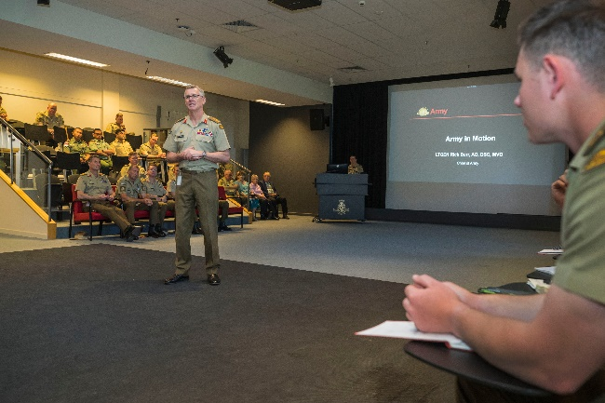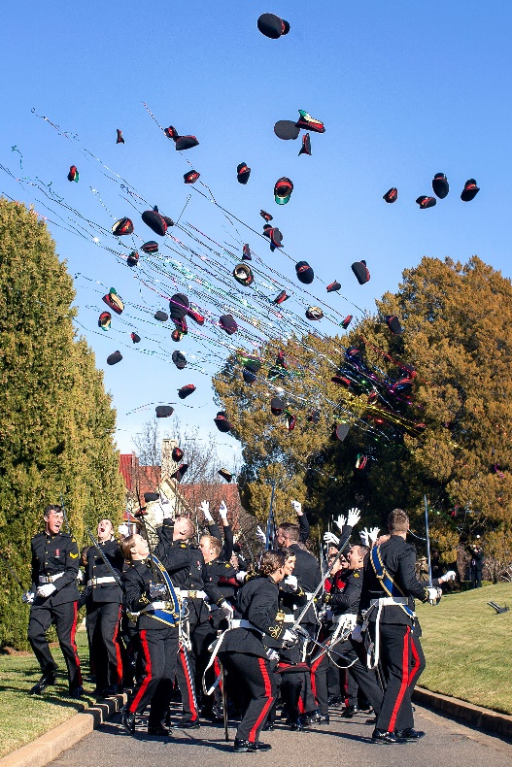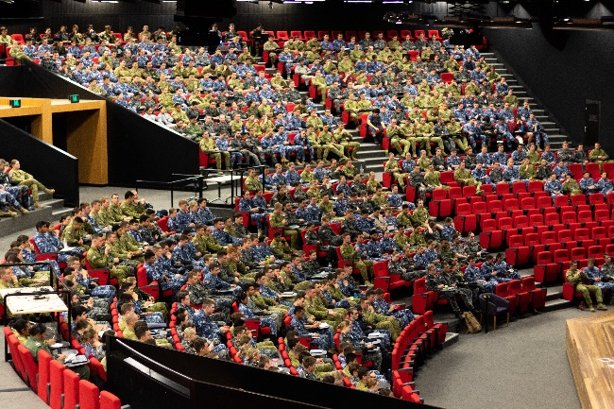

Picture 2

Picture 3

Picture 1

## Reading

1. Fatah, an Indonesian cadet, will study at the Australian Defence Force Academy (ADFA). Siti, his friend, writes an email to him. She gives him some advice. What information will he find in the email?
2. a place to stay
3. how to get to school
4. clothes and uniform
5. important documents
6. homework
7. study schedule
8. where to have meals
9. Now, read Siti’s email below and check your answers. Do not use a dictionary yet. You are going to learn the meaning of the words in **bold** in the next exercise.

**Tip: When you see a new word in English you can try to:**

* **not use a dictionary first, but ask a classmate**
* **use an English-English dictionary**
* **use the sentence to help you guess the meaning**

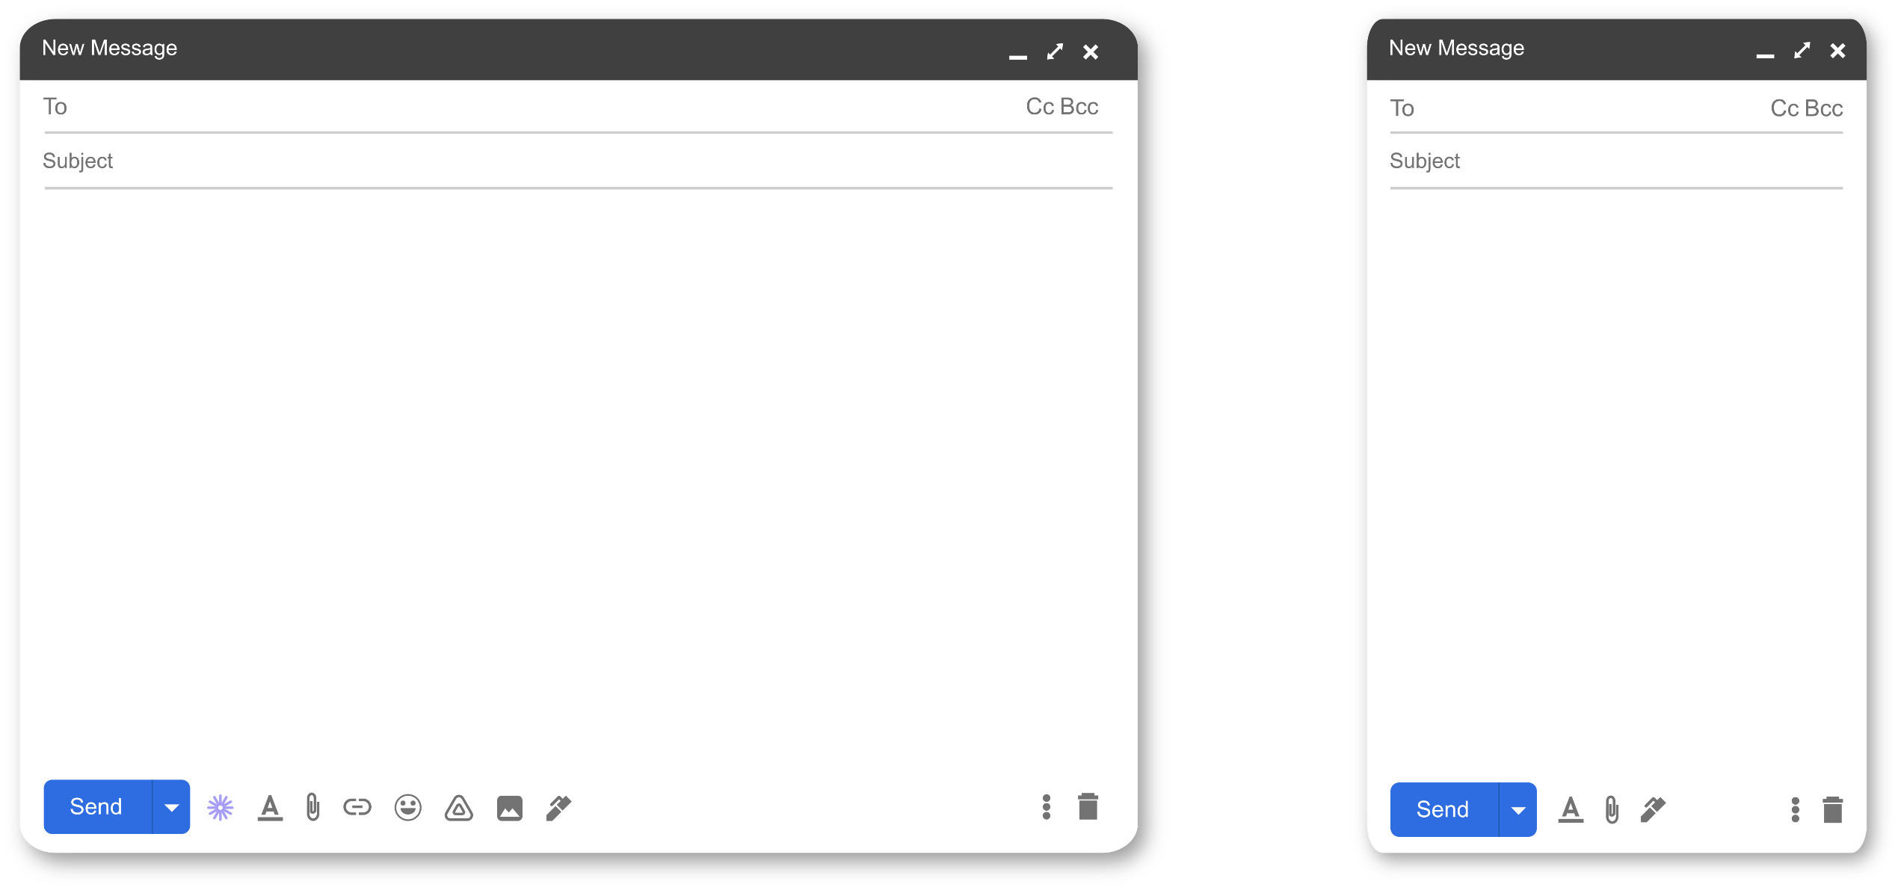

siti@army.gov.au

Life at ADFA

Hi Fatah,

So, you are going to ADFA – congratulations, mate! You wanted to know what life is like at ADFA, so let me tell you a bit about it. The first thing is to read the **Joining Instructions**. They have a lot of information, so it’s important to read them carefully.

**Cadets** start their day early, at 0600. The **cadet accommodation** is very comfortable and everyone has their own room. Each room has a bed, and wardrobe, and a desk to study on. Cadets have one hour to get ready and put on their **uniform**. The **cadets’ mess** serves breakfast at 0700. On Mondays, there is **parade** after breakfast, where we have **uniform inspection**.

Class starts in the **lecture theatre**. We break for morning tea, lunch and then at 1430 there is two hours of **PT**. After PT some cadets study in the **library**. There is at least one **dining-in night** in the year where you have to wear your **mess kit**. At the end of the year, **graduation** is a lot of fun. It’s a big day for us, and our families, of course.

I hope this gives you an idea of life at ADFA – call me if you want more information. Good luck in your studies.

Kind regards,  
Siti

1. Read again and decide if the statements below are true (T) or false (F).
2. Students should always read the Joining Instructions.
3. Cadets have to wake up early to get dressed and have breakfast.
4. Cadets have to share bedrooms.
5. There is uniform inspection every day.
6. There is two hours of PT after lunch.
7. Cadets can study in their room or in the library.
8. On a dining-in night, cadets have to wear a special uniform.

## Learning Military Vocabulary

1. The words in **bold** in the text are important military vocabulary that you should learn to use. Match the military words on the left to their definitions on the right. Look at the example.

|  |  |  |  |
| --- | --- | --- | --- |
| read the **Joining Instructions** (n) |  |  | 1. a room or a building where cadets live |
| the **cadet accommodation** (n) |  |  | 1. a formal [military](https://en.wikipedia.org/wiki/Military) event which includes a dinner, drinking, and other activities |
| a **cadet** (n) | **f** |  | 1. physical training |
| put on their **uniform** (n) |  |  | 1. to check that soldiers wear their uniforms correctly |
| the **cadets’ mess** serves breakfast (n) |  |  | 1. a formal type of uniform used by military personnel |
| there is **parade** (n-unc) |  |  | 1. **a young person studying to become a military officer** |
| have **uniform inspection** (n) |  |  | 1. documents with course details sent to students before the course starts |
| in the **lecture theatre** (n) |  |  | 1. a room or building where cadets have their meals |
| two hours of **PT** (n) |  |  | 1. a place where you can borrow books and study |
| in the **library** (n) |  |  | 1. a [formal](https://dictionary.cambridge.org/dictionary/english/formal) [event](https://dictionary.cambridge.org/dictionary/english/event) for students who pass a [course](https://dictionary.cambridge.org/dictionary/english/course) at a [school](https://dictionary.cambridge.org/dictionary/english/school), [college](https://dictionary.cambridge.org/dictionary/english/college), or [university](https://dictionary.cambridge.org/dictionary/english/university) |
| a **dining-in night** (n) |  |  | 1. clothes that people in the military wear |
| wear your **mess kit** (n) |  |  |  |
| **graduation** (n) |  |  |  |

*Example: a cadet (n) = f. a young person studying to become a military officer*

1. Now let’s practise saying the words in this worksheet
2. Now try to use some of the words from exercise 5 correctly in the sentences below.
3. When you have ____________________ and your uniform is not neat, you will get extra tasks to do.
4. Many universities and schools have ________________ for bigger classes and formal presentations.
5. Cadets can have breakfast, lunch and dinner at the __________________.
6. After breakfast, cadets will have _____________ on the parade ground. They practice this for important events, for example, ANZAC Day and ________________ when they finish the course.
7. 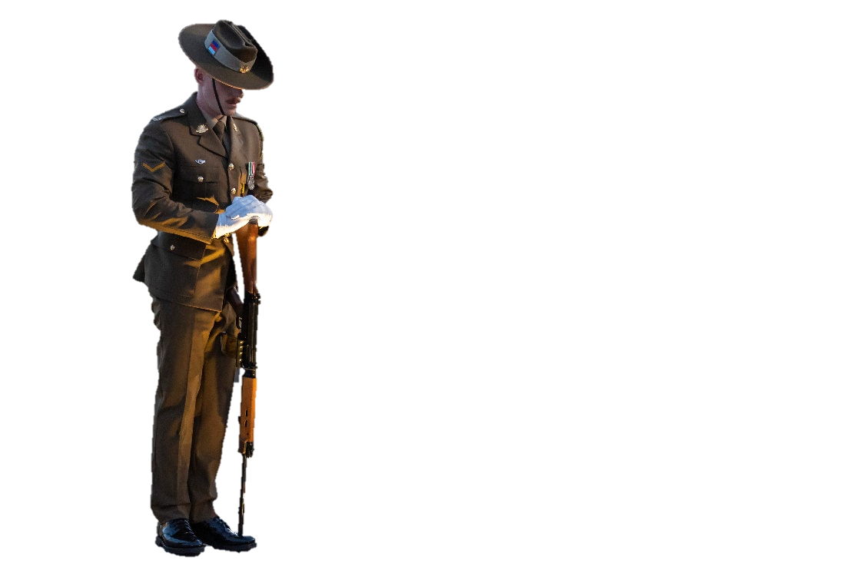In the military, keeping fit is part of your career. You should do ___________ at least three times a week.

ANZAC Day, 25 April, is a special day to remember   
Australian and New Zealand soldiers who died   
during WWI. ‘ANZAC’ means Australian   
and New Zealand Army Corps.

## Practice

1. Discuss these questions with a partner:
2. From Siti’s email, is cadet’s life at ADFA similar or different   
   to a cadet’s life in your country?
3. What information will be useful for international cadets that will   
   study in your country?



* Watch this video to learn more about a cadet’s life at ADFA.   
  Write down the places you can you see from the video.

Type on YouTube [ADFA: A Virtual Tour](https://youtube.com/watch?v=IWI74RY9IlA&feature=shares) or scan the QR code

* This lesson links with 🡪 Lesson – Living on a Military Base.

© Commonwealth of Australia 2023  
This work is copyright. Apart from any use as permitted under the Copyright Act 1968 (Cth),   
no part may be reproduced by any process without prior written permission from the Department of Defence.