**Military English**

Vocabulary Builder: Military organisation



**Overview:**  
This sheet lists vocabulary for organisation of parts of the three services.

**In this vocabulary builder, you will:**

* use vocabulary related to the organisation of a (branch of the) military.

1. Can you fill in the missing words?

In most countries, the military is divided into branches. The three most common branches are:

the A______________ the N____________

the A_________ F________________

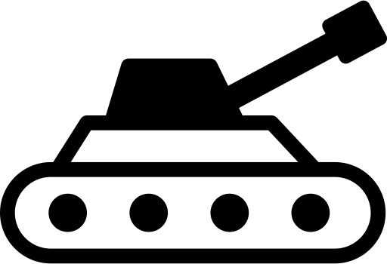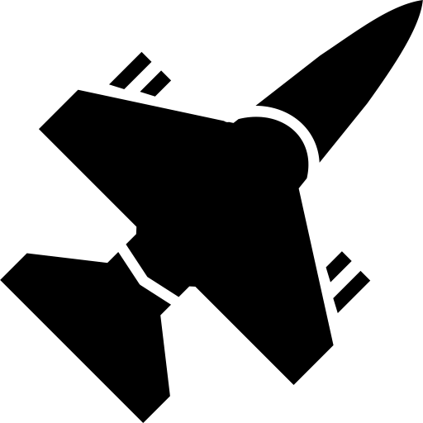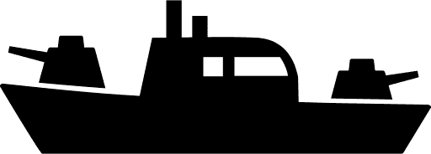

Sometimes, countries might have a different branch for the Coast Guard and Marines.

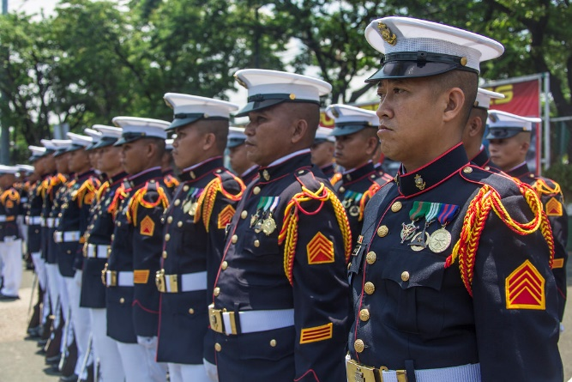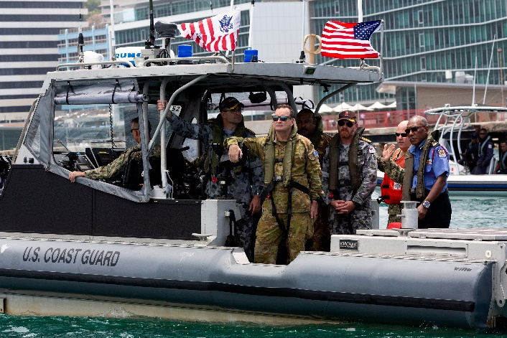

Practice with a partner asking and answering this question:

Which branch of the military do you work in?

I am in the _________________.

1. Each of the services has many parts. In the Army, and especially in the Infantry, there are eight main levels. Can you match the word for the part of the Army correctly, in two different places?

*Look at the examples done for you.*

personnel (n) = people who work for the military. The abbreviation is *pers*.

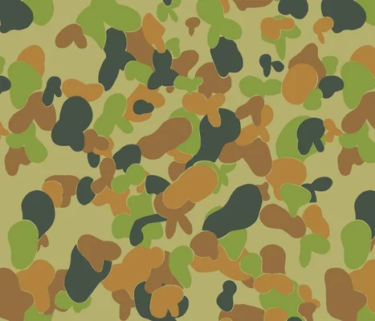

|  |  |
| --- | --- |
| **Army** | * ***division*** (Div) = 10,000 - 20,000 personnel (pers) or about 3 ***brigades*** * ______ _ _(Bde) = 3,000 - 6,000 pers or 3 or more _________________ * _______ (Regt) = 1,000 - 3,000 pers or 3 - 5 ______________ * ______ _ _ _(Bn)_ = 300 – 1,000 pers or 3 - 5 ______________ * ________ __ (Co)_ = 100 - 300 pers or 3 - 4 _______________ * ________ ___ (Pl)_ = 20 - 60 pers or 3 - 4 _______________ * _______ ____ (Sect) = 8 - 12 pers or 2 – 3 _______________ * ***fire team***____ _(FT) _ = 8 - 10 pers |

~~army~~ // section // battalion // ~~brigade~~ // platoon // ~~division~~ // company // regiment // ~~fire team~~

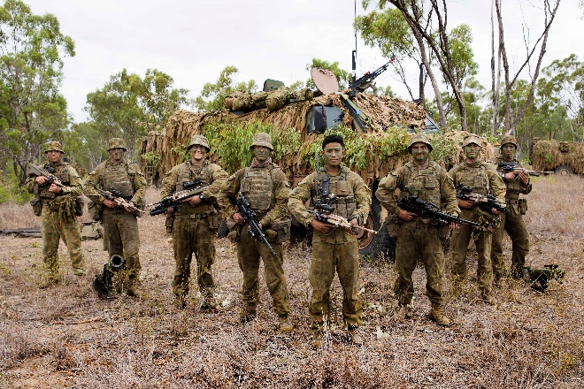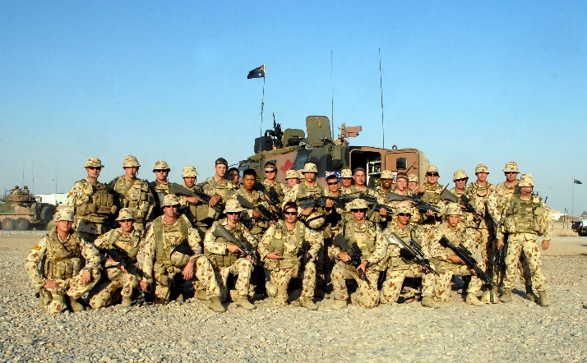

*a section of soldiers a platoon of soldiers*

1. However, the Navy is organised very differently than the Army. A unit could be a ship or a Navy base, or a group of many ships. Match the correct word in the box with the part of the Navy.

a vessel (n) = a ship, a boat, a submarine

|  |  |
| --- | --- |
| **Navy**  image.png | * ***fleet***  = all the vessels in the Navy.* * _________ _ (Sqn) = a group of vessels or aircraft in the Navy. * _________ _ (Div) = A group of 3-4 vessels.      * _________ _ (TF) = a group of vessels working on the same mission or operation. * _________ ___(Flot) = a group of the same type of vessels. |

*The Royal Australian Navy only has 1 fleet. Some navies, like the US Navy, have more than 1 fleet. Sometimes ‘fleet’ is abbreviated as FLT, sometimes F.

~~fleet~~ // squadron // division // task force // flotilla

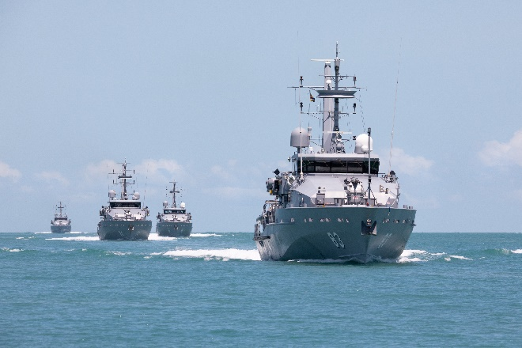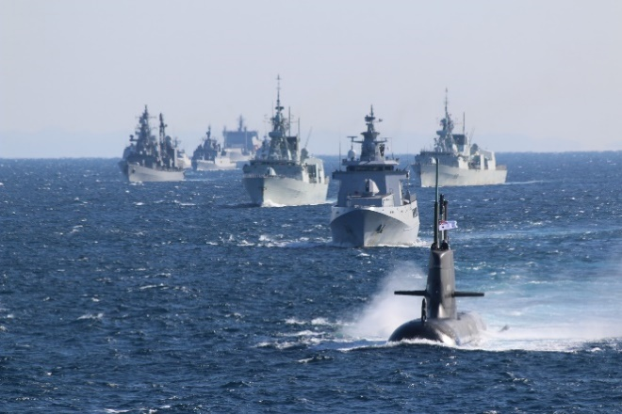

*a flotilla of patrol boats a task force of vessels*

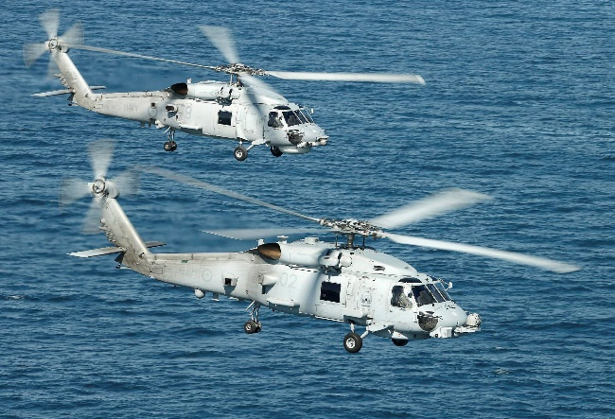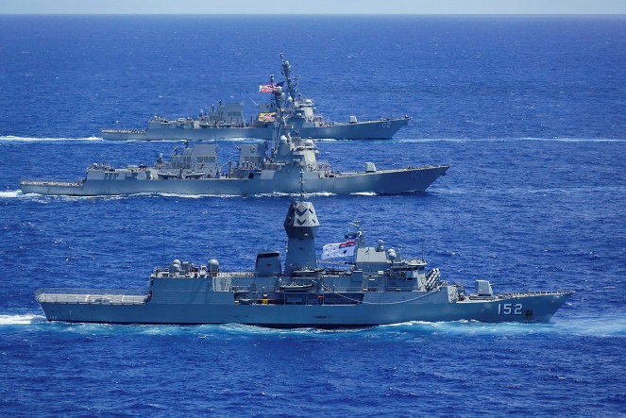

*a division of ships* a *part of a Navy squadron of helicopters*

1. The Air Force is organised like the Army. The biggest unit is called a group. However, there are many kinds of groups in the Air Force. Some have aircraft and some don’t. The RAAF Air Combat Group only has fighter aircraft. Match the correct word in the box with the part of the Air Force.



|  |  |
| --- | --- |
| **Air  Force** | * ***group***  (Grp) = 100 -200 aircraft or 2-4 ______________ * (WG) = about 50 aircraft or 3 – 4 ***squadrons*** * (Sqn) = about 12 -15 aircraft or 3 - 4 ___________________ * (Flt) = 4 aircraft or 2 -3 _______________ * (Sect) = 2 aircraft |

~~group~~ // ~~squadron~~ // wing // flight // section

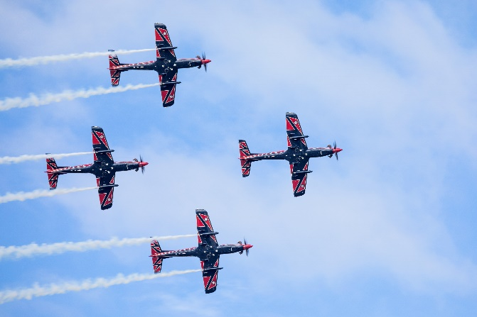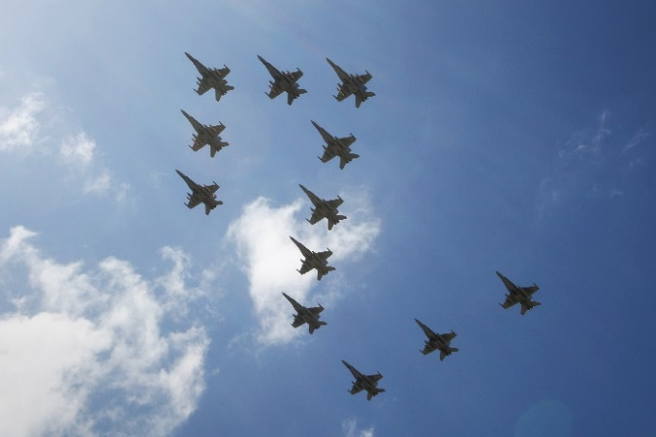

*a flight of aircraft a squadron of aircraft*

1. Now let’s practice saying the words. Listen to the audio and repeat.
2. Practise the words for the military organisation. Play Bingo.

Choose 9 words from this lesson. In each box below, write a different word.

|  |  |  |
| --- | --- | --- |
|  |  |  |
|  |  |  |
|  |  |  |

For example:

|  |  |  |
| --- | --- | --- |
| wing | army | fleet |
| group | task force | battalion |
| squadron | section | flight |

Now listen to your teacher saying the words from this lesson. When your teacher says one of the words from this lesson that you also have in one of your boxes, cross it out. 🗙

When you have three crosses in one straight line (↗, ↓, → or ↘), shout ‘BINGO!’

Tell your teacher the three words you have crossed out, to check.

* For more practice on military organisation, here is a NATO video that explains the personnel and the organisation of an Army. This may be slightly different from the above Australian organisation.  
  Type on YouTube: [Army Units Explained - YouTube](https://www.youtube.com/watch?v=XNY7dAzYOPw) or scan the QR Code:
* This Vocabulary Builder links with: Vocabulary Builder – Military Ranks – Air Force;

Vocabulary Builder – Military Ranks – Navy;

Vocabulary Builder – Military Ranks – Army.

© Commonwealth of Australia 2023  
This work is copyright. Apart from any use as permitted under the Copyright Act 1968 (Cth),   
no part may be reproduced by any process without prior written permission from the Department of Defence