

**Military English**

Vocabulary Builder: Parts of an Aircraft

**Overview:**  
This worksheet lists vocabulary for the parts of an aircraft.

**In this vocabulary builder, you will:**

* practise using vocabulary related to the parts of an aircraft.

1. Label the picture of a transport aircraft. Use the words in the box below.

d. ________________

c. _______________

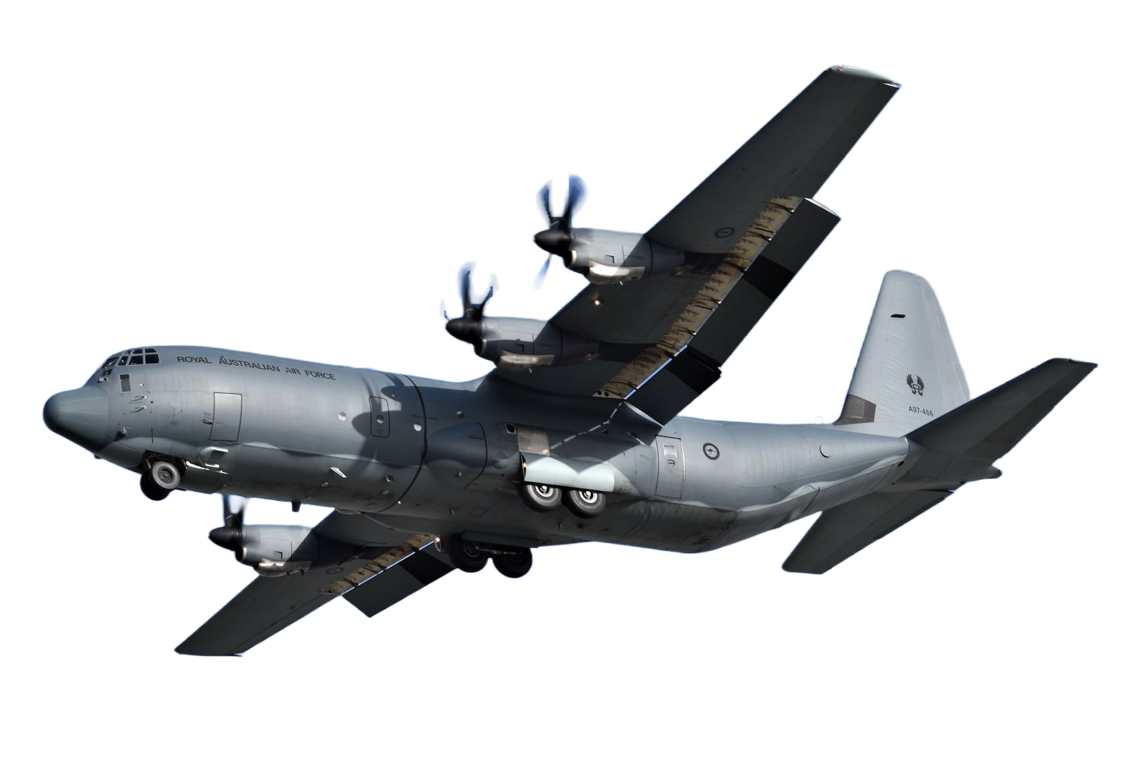

b. _______________

a. _______________

h. ________________

g. ________________

e. ________________

f. ______________

propellers // cargo bay // cockpit // landing gear // wing // vertical stabiliser // flaps // horizontal stabiliser

1. Label the parts of a fighter aircraft. Use the words in the box below.

j. ______________

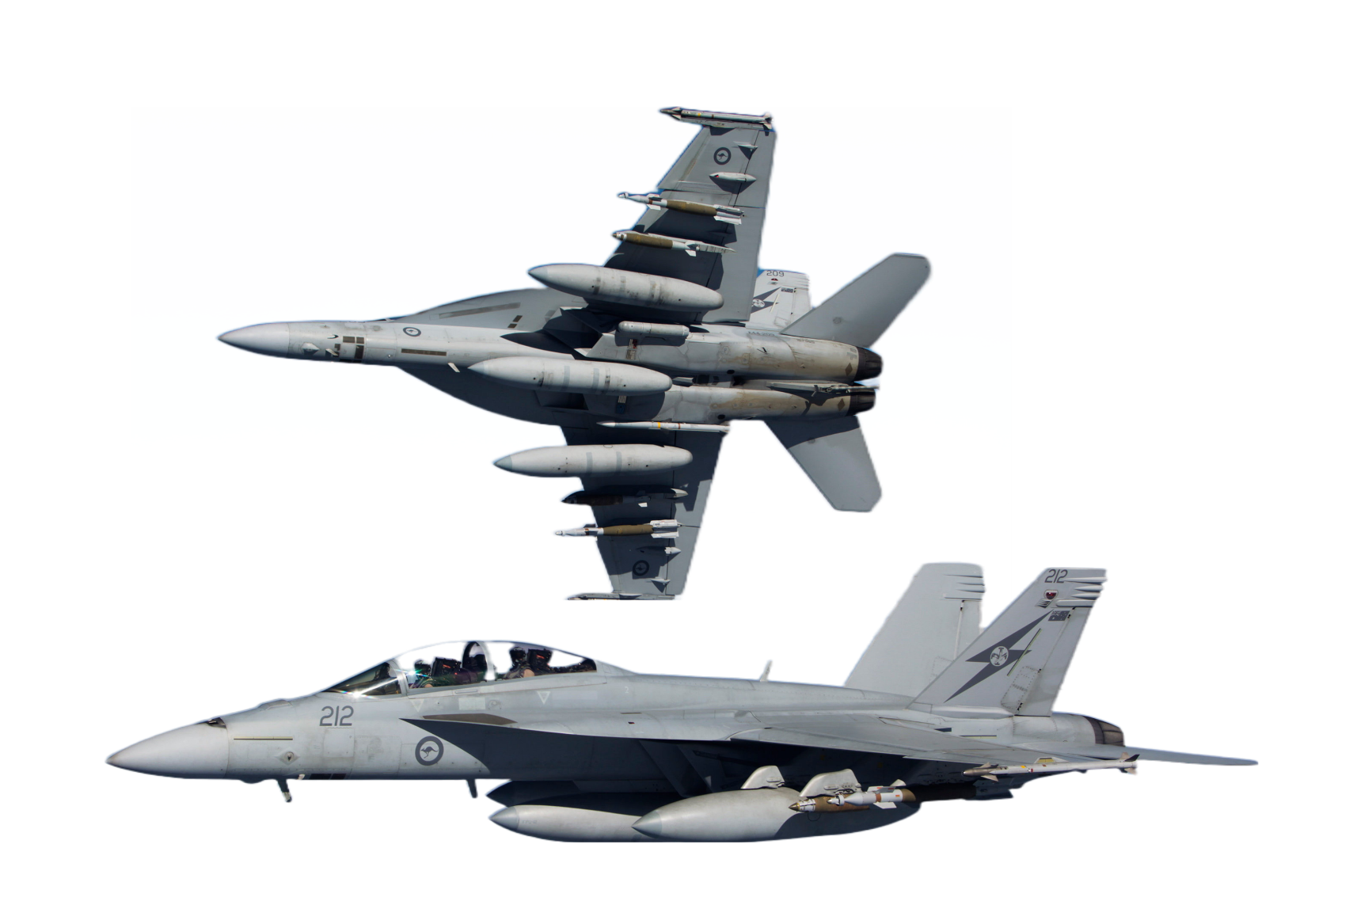

i. _______________

n. ______________



m. _______________

k. ______________

l. ______________

radar // external fuel tanks // cockpit // missile // jet engine // bomb

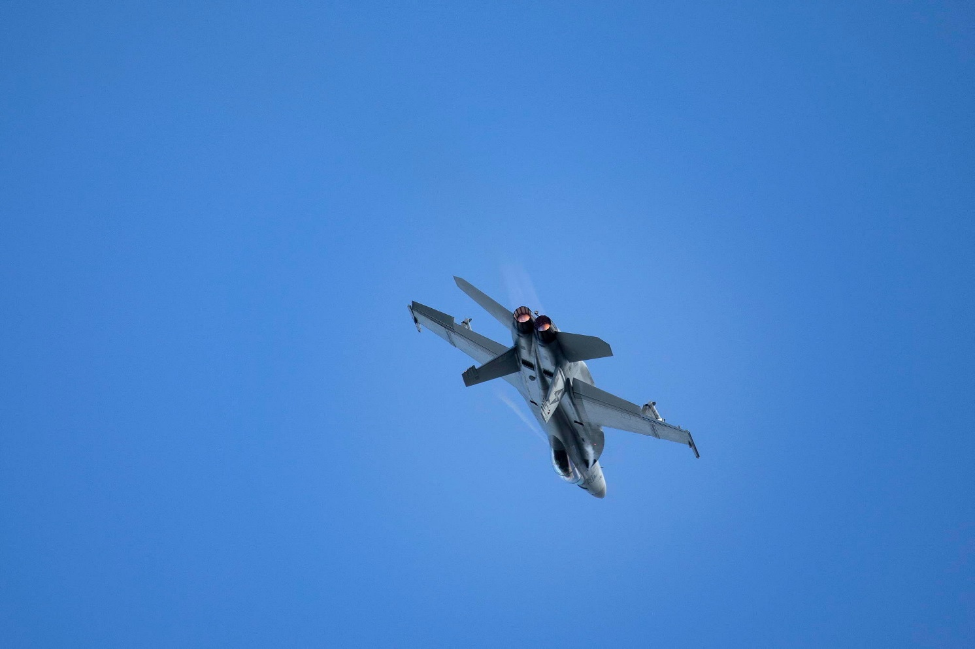

The F-18 Super Hornet can carry guns, missiles, and bombs.   
The RAAF has a fleet of Super Hornets.

1. Now let’s listen to the words practised in this worksheet. Listen and repeat.
2. Find the following words in the puzzle. Words are hiding

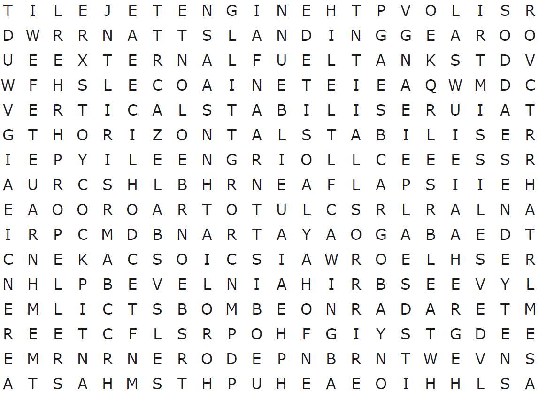

propellers // cargo bay // cockpit // landing gear // wing // vertical stabiliser // flaps horizontal stabiliser // radar // external fuel tanks // missile // jet engine // bomb

* Watch this YouTube video and try to write down what you didn’t see from this lesson.  
  Type on YouTube [plane parts](https://youtu.be/isATVRTV0r4) or scan the QR Code to the right:
* This Vocabulary Builder links with 🡪 Vocabulary Builder – Military Vehicles;

Vocabulary Builder – Parts of a Helicopter.

© Commonwealth of Australia 2023  
This work is copyright. Apart from any use as permitted under the Copyright Act 1968 (Cth),   
no part may be reproduced by any process without prior written permission from the Department of Defence.