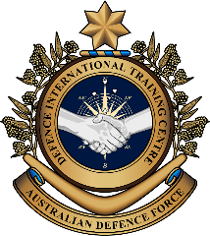

**Military English**

Vocabulary Builder – The Phonetic Alphabet

**Overview:**  
This worksheet lists The (International) Radiotelephony Spelling Alphabet, commonly known as the Phonetic Alphabet, NATO Phonetic Alphabet, ICAO Phonetic Alphabet, or ICAO Spelling Alphabet.

**In this vocabulary builder, you will:**

* practice pronunciation of the Phonetic Alphabet
* use the Phonetic Alphabet

1. Do you know the Phonetic Alphabet, or parts of it? Write what you know in the table below.

|  |  |  |  |  |  |
| --- | --- | --- | --- | --- | --- |
| **Letter** | **Word** | **Letter** | **Word** | **Letter** | **Word** |
| **A** | Alpha | **J** |  | **S** |  |
| **B** | Bravo | **K** |  | **T** |  |
| **C** | Charlie | **L** |  | **U** |  |
| **D** |  | **M** |  | **V** |  |
| **E** |  | **N** |  | **W** |  |
| **F** |  | **O** |  | **X** |  |
| **G** |  | **P** |  | **Y** |  |
| **H** |  | **Q** |  | **Z** |  |
| **I** |  | **R** |  |

1. Here is the complete alphabet, with the correct pronunciation.
2. Compare this table with your answers from exercise 1 – how many did you get correct?
3. Read each word aloud and try to decide where the stress (strong part) is. E.g. ***Al****pha, No****vem****ber*

|  |  |  |  |  |  |  |
| --- | --- | --- | --- | --- | --- | --- |
| Letter | NATO word | Pronunciation |  | Letter | NATO word | Pronunciation |
| A | Alpha | /ˈælfə/ |  | N | November | /nəʊˈvembə/ |
| B | Bravo | /ˈbrɑːvəʊ / |  | O | Oscar | /ˈɒskə/ |
| C | Charlie | /ˈtʃɑːli/ |  | P | Papa | /pəˈpɑː/ |
| D | Delta | /ˈdeltə/ |  | Q | Quebec | /kwɪˈbek/ |
| E | Echo | /ˈekəʊ/ |  | R | Romeo | /ˈrəʊmiəʊ/ |
| F | Foxtrot | /ˈfɒkstrɒt/ |  | S | Sierra | /siˈerə/ |
| G | Golf | /ɡɒlf/ |  | T | Tango | /ˈtæŋɡəʊ/ |
| H | Hotel | /həʊˈtel/ |  | U | Uniform | /ˈjuːnɪfɔːm/ |
| I | India | /ˈɪndiə/ |  | V | Victor | /ˈvɪktə/ |
| J | Juliet | /ˈdʒuːliət/ |  | W | Whiskey | /ˈwɪski/ |
| K | Kilo | /ˈkiːləʊ/ |  | X | X-ray | /ˈeks reɪ/ |
| L | Lima | /ˈliːmə/ |  | Y | Yankee | /ˈjæŋki/ |
| M | Mike | /maɪk/ |  | Z | Zulu | /ˈzuːluː/ |

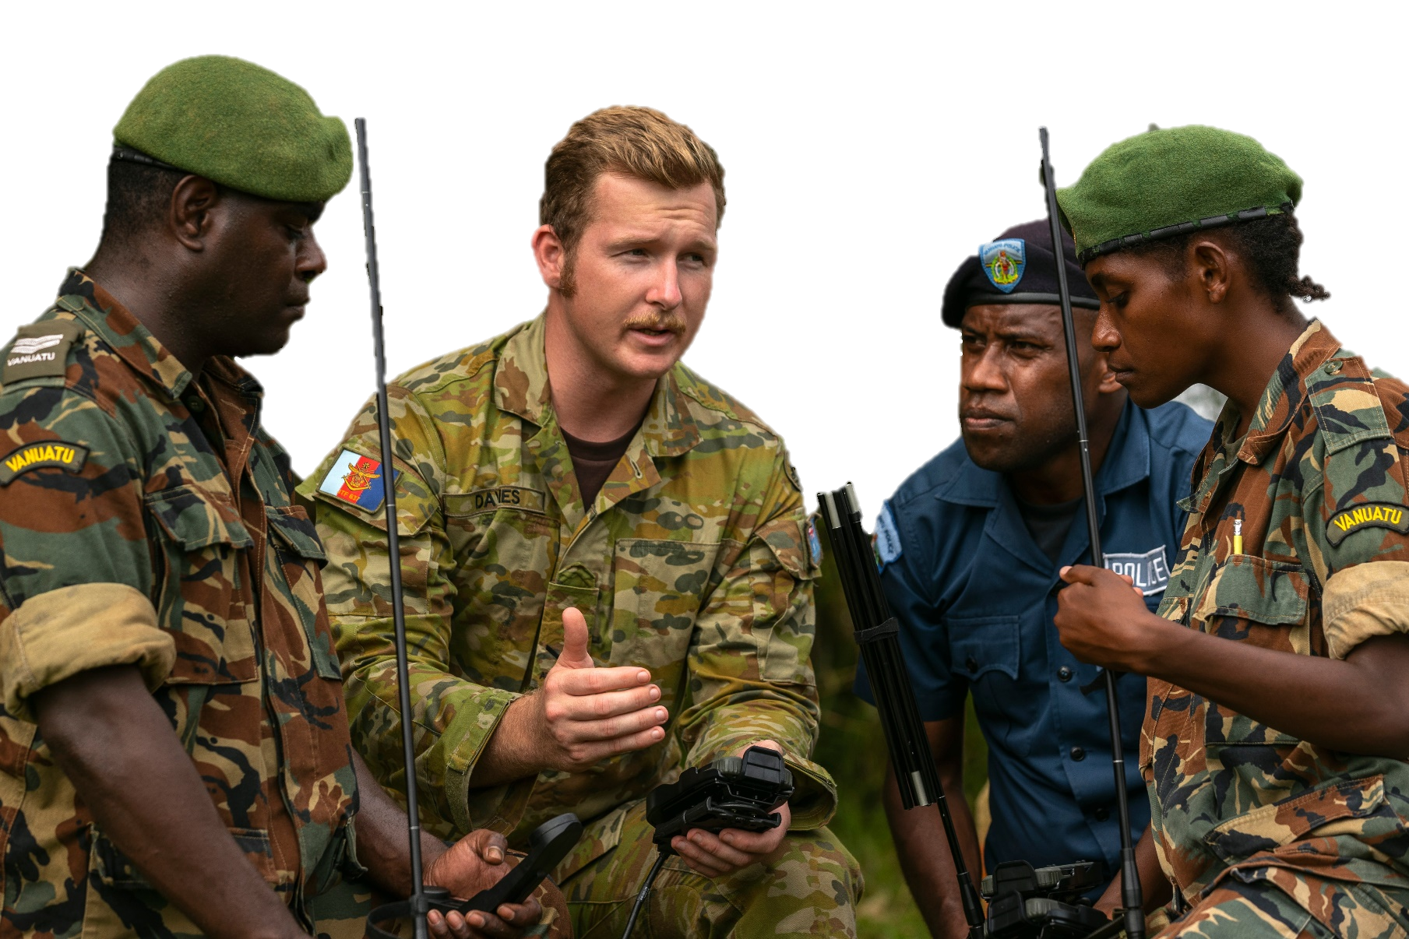

1. Now let’s practise saying the words. Pay attention to the stress (strong/weak parts). Listen and repeat.
2. With a partner, practise saying the words. Give your partner some feedback. Test each other.   
   For example:

|  |  |
| --- | --- |
| A: What’s the word for J?  B: It’s Juliet.  A: That’s right! | A: Do you know the word for Z?  B: Yes, it’s Zebra.  A: This is not correct. It’s Zulu. |

1. Practice activities. Work with a partner.
2. Spell your name(s) using the Phonetic Alphabet.

E.g*. “My name is Sam Jones. That’s ‘S’ for Sierra, ‘A’ for Alpha, and ‘M’ for Mike. Next word: ‘J’ for Juliet, ‘O’ for Oscar, ‘N’ for November, ‘E’ for Echo, and ‘S’ for Sierra.”*

1. Give your partner other words to spell using the alphabet.

E.g. *“Spell table / chair / classroom / window / clock” etc…*

1. 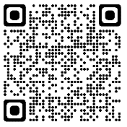Extra information and practice.

* Use this link to listen to the alphabet again. Type on YouTube

[Phonetic Alphabet ~ The NATO Phonetic Alphabet For Teaching](https://www.youtube.com/watch?v=f28fAVRL5Jg) or scan the QR code

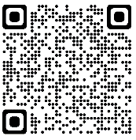

* Use this link to the NATO website to test yourself on the alphabet.

[NATO - Declassified: The NATO phonetic alphabet – Alfa, Bravo, Charlie..., 20-Oct.-2016](https://www.nato.int/cps/en/natohq/declassified_136216.htm?selectedLocale=en)

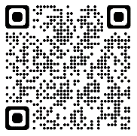

* Use this link to watch a video about the history of the Phonetic Alphabet. Type on YouTube [What is the NATO Phonetic Alphabet? Alpha, Bravo, Charlie, Delta....](https://www.youtube.com/watch?v=nbbRceKGTZQ) or scan the QR code
* This lesson links with 🡪 Vocabulary Builder: Military Time;  
   Lesson: Radio Communications.

© Commonwealth of Australia 2023  
This work is copyright. Apart from any use as permitted under the Copyright Act 1968 (Cth),   
no part may be reproduced by any process without prior written permission from the Department of Defence.