

**Military English**

Vocabulary Builder: Parts of a Uniform

**Overview:**  
This worksheet lists vocabulary for military uniforms.

**In this vocabulary builder, you will:**

* learn and use vocabulary related to the items of military uniform

1. 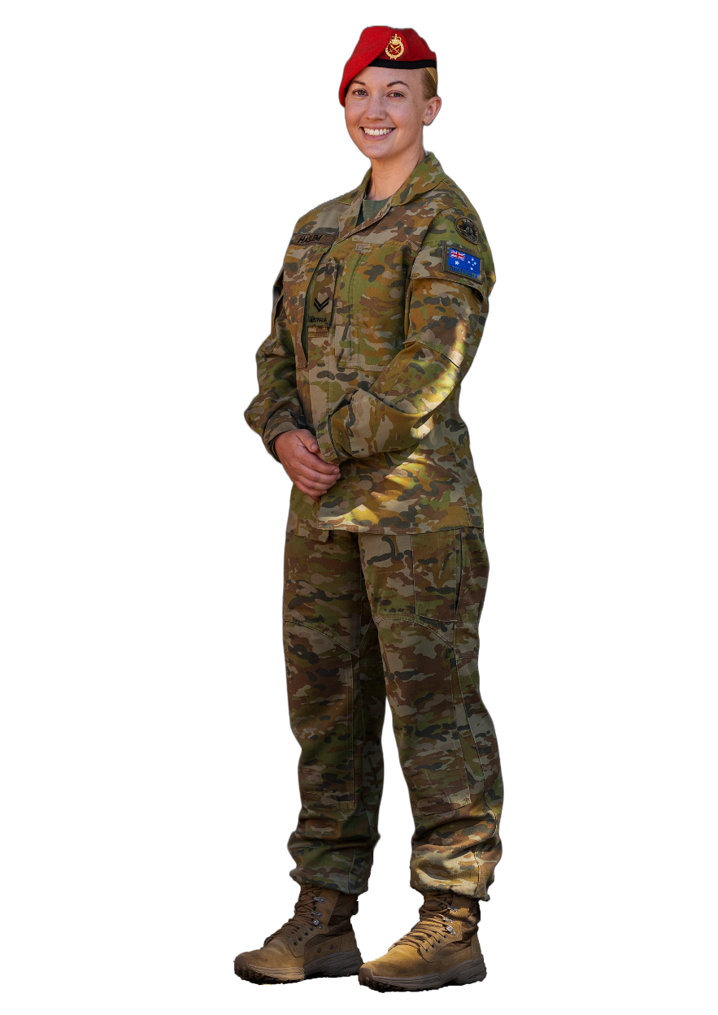Label the picture. Use the words in the box below.

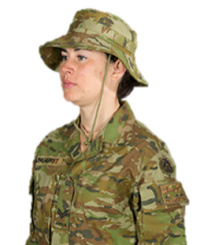

e. ________________

a. _______________

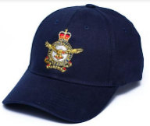

c. ________________  
*(Navy and Air Force)*

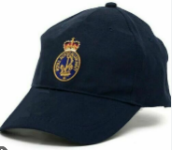

b. ________________

d. _____________________

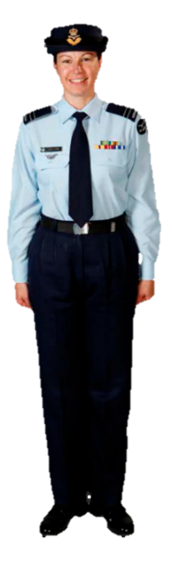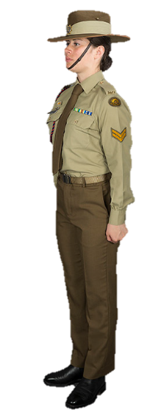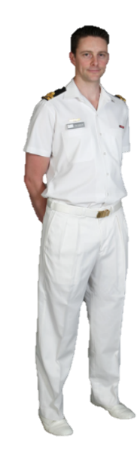

i. ________________

h. ____________________

f. ________________

g. ________________

beret // shoulder patch // camouflage uniform // hat badge // bush hat  
combat boots // rank slide // service dress // ballcap

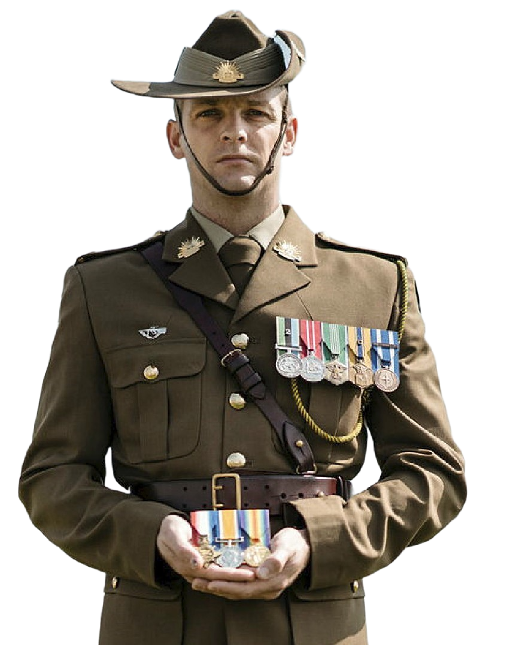

j. This is ____________________ (Army).

o. ________________

n. ________________

p. ________________

k. ________________

l. ________________

m. ________________

q. ________________

p. ________________

chin strap // medals // hat badge // collar badges // lanyard  
badge // slouch hat // ceremonial dress

1. Now let’s listen to the words practised in this worksheet. Listen and repeat.
2. Find the following words in the puzzle. Words are hiding

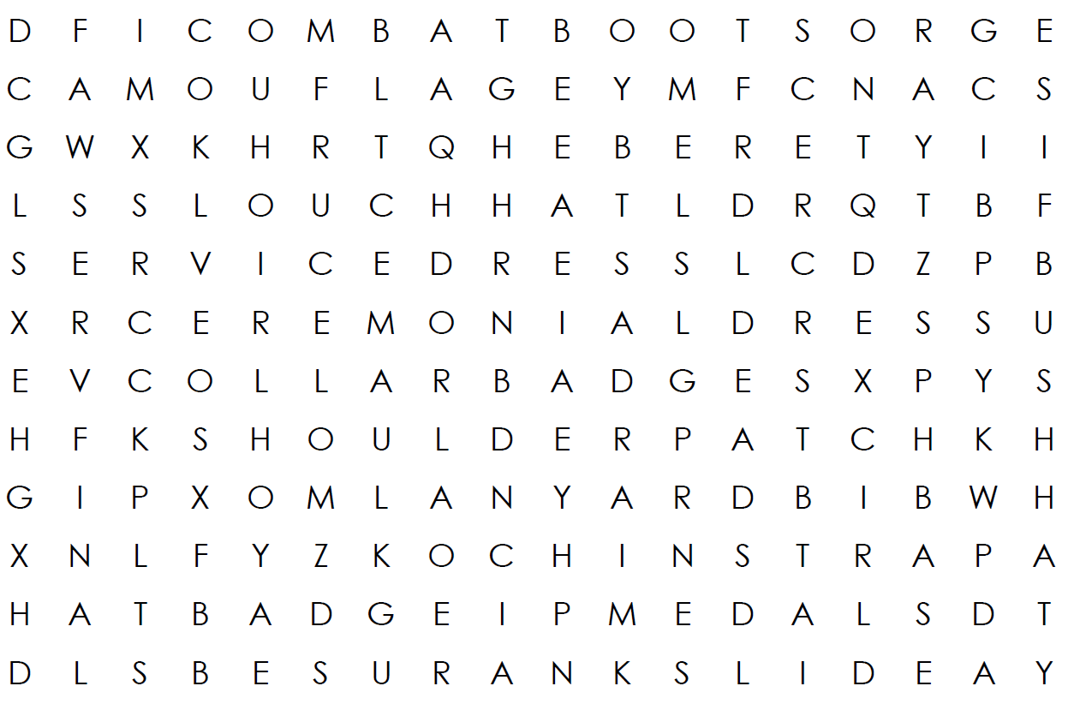

beret

shoulder patch

camouflage

hat badge

bush hat

combat boots

rank slide

service dress

chin strap

medals

collar badges

lanyard

slouch hat

ceremonial dress

1. Some parts of Australia are very cold in Winter, Spring, and Autumn. Can you choose which service uniforms are for Summer and which are for Winter? Discuss with your partners why.

2

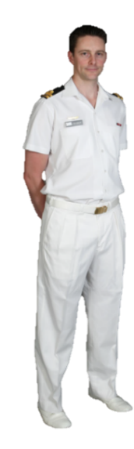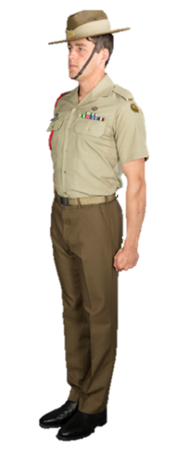

1

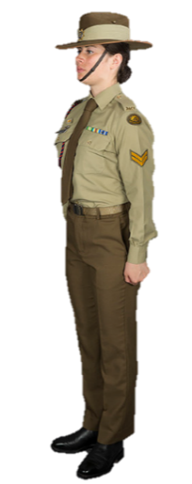

4

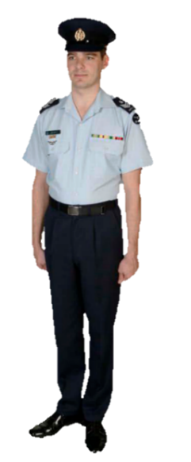

3

This is an Army mess dress (or mess kit). It is used in formal dinners and other formal situations.

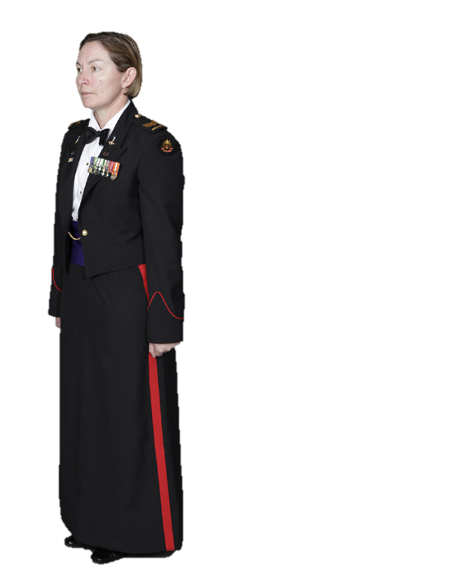

9

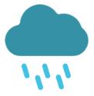

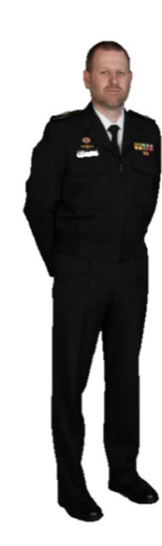

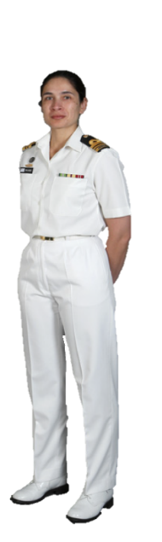

7

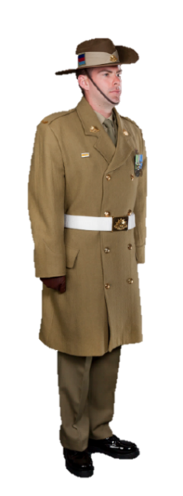

6

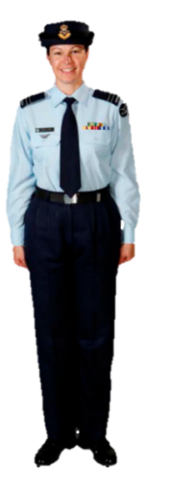

8

5

1. Look again at the uniforms. Can you guess which branch they serve in? Army, Navy, or Air Force? Write the numbers in each box. Discuss with your partners why.

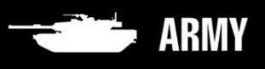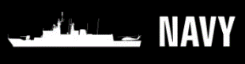

1. Test your partner. Point to different uniform parts below and ask him/her to say what it is.   
   For example:

A: What is number ___? / What is number ___ called?

B: This is a ______________. /   
 I can’t remember! Do you know?

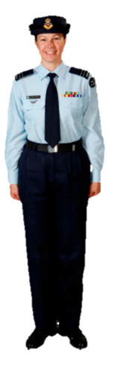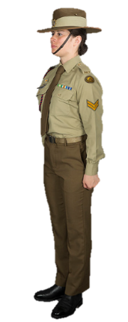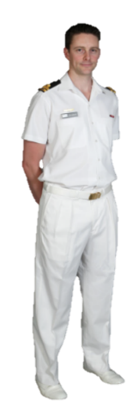

6



13

11

12

14

16

15



1

2

3

4

5

7

8



9

10

**Dress of the Day** is what the Commanding Officer (CO) tells his/her personnel to wear.  
Work with a partner. Can you give examples of dress of the day in your unit/base?   
E.g. *On Mondays and Wednesdays, we have to wear cams.*

* This Vocabulary Builder links with 🡪 Vocabulary Builder - Soldier Combat Equipment.
* 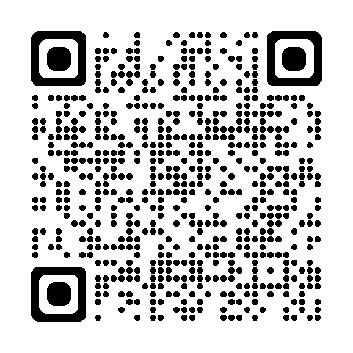Watch this video about the Australian Army combat uniform. Type on YouTube New ADF combat uniform, or scan the QR Code 🡪

© Commonwealth of Australia 2023  
This work is copyright. Apart from any use as permitted under the Copyright Act 1968 (Cth),   
no part may be reproduced by any process without prior written permission from the Department of Defence.