1.

**Military English**

Vocabulary Builder – Military Vehicles

**Overview:**  
This worksheet lists vocabulary for military vehicles from army, navy and air force.

**In this vocabulary builder, you will:**

* use vocabulary related to military vehicles.

1. 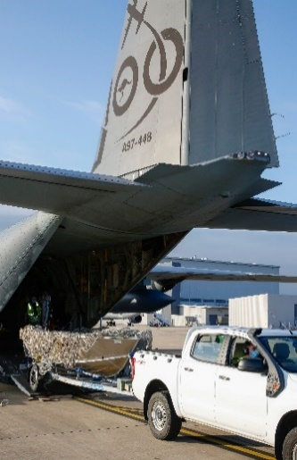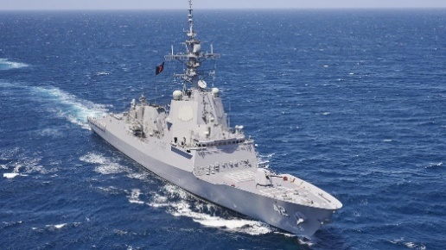Label the pictures. Use the words in the box below (continues next page).

a. ____________________

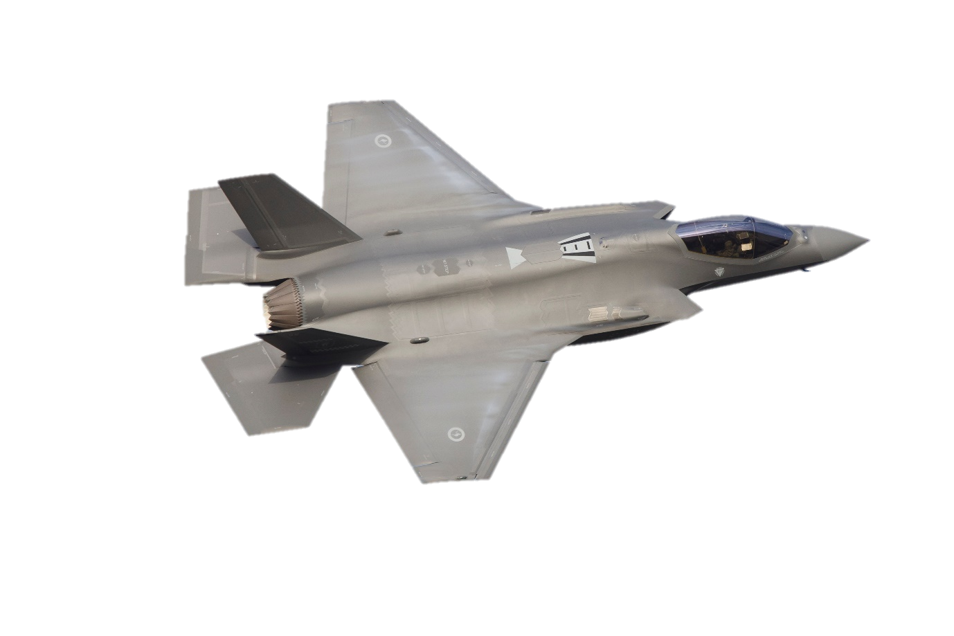

b. ____________________

d. ____________________

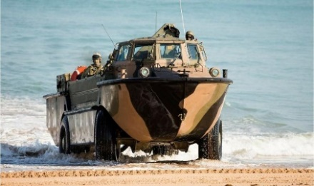

e. ____________________

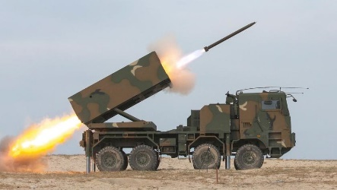



c. ____________________

f. ____________________

transport aircraft // fighter aircraft // rocket launcher // armoured vehicle // amphibious vehicle // warship

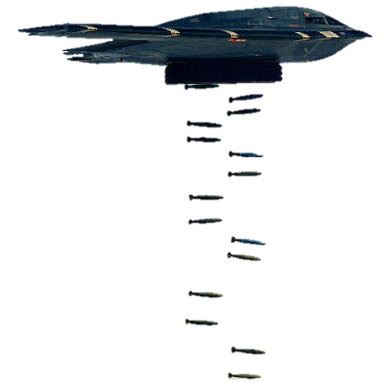

g. ____________________

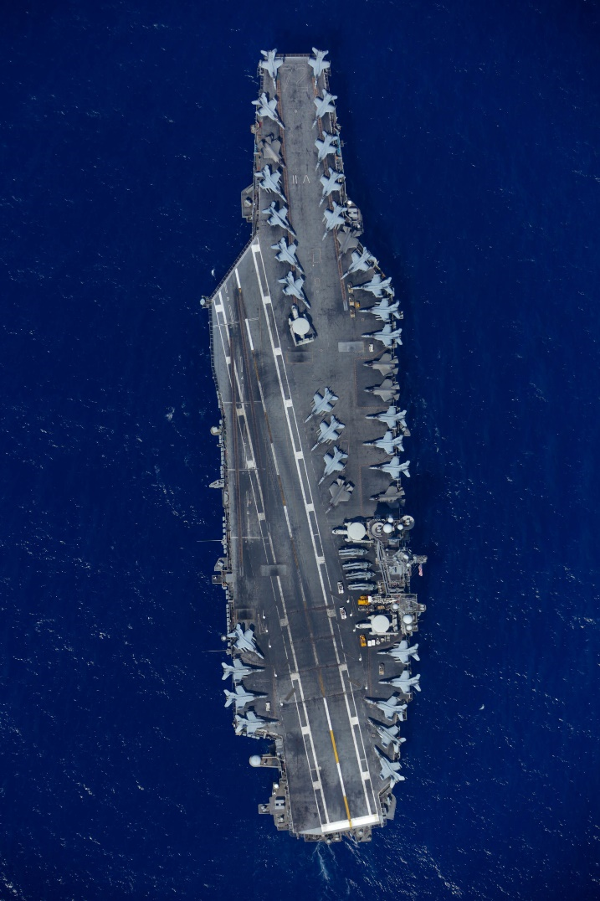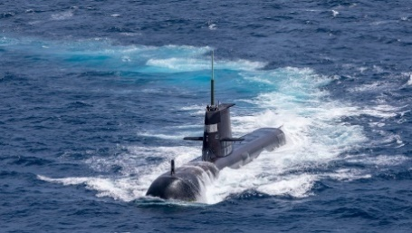

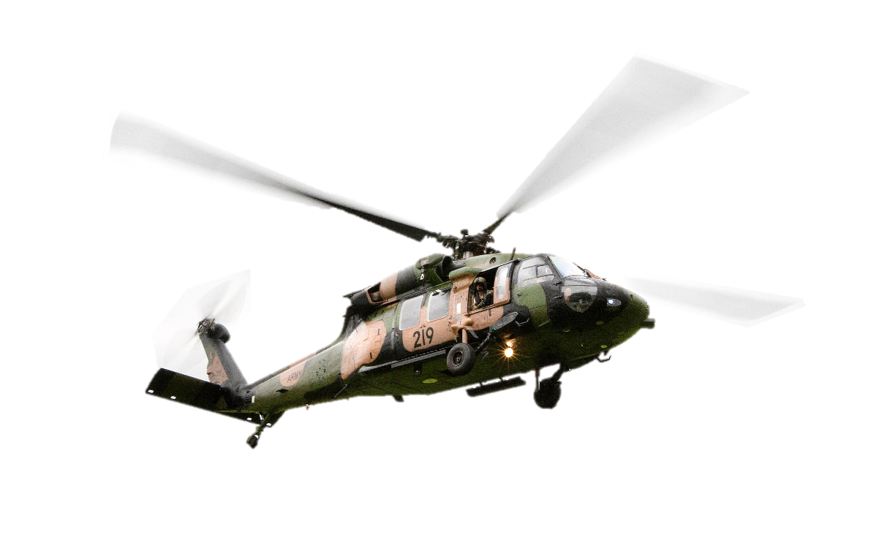

h. ____________________

k. ____________________

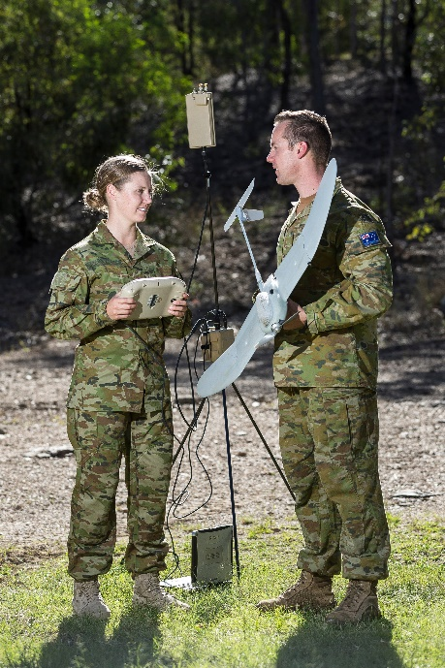

i. ____________________

aircraft carrier // tank // helicopter // submarine // bomber // UAV (unmanned aerial vehicle)

j. ____________________

l. ____________________

1. Now let’s listen to the words practised in this worksheet. Listen and repeat.
2. Complete the sentences. Use the words in the box from exercise 1.
   1. A _________________ is a large ship. It has a lot of weapons.
   2. A _________________ is used to carry soldiers and things to different places by air.
   3. A _________________ is a heavy vehicle that protects the soldiers and attacks the enemy.
   4. A _________________ is a type of underwater vehicle used by the navy.
   5. A _________________ is a vehicle used to fire rockets.
   6. A _________________ is a type of aircraft. It can stay in the same place in the air.
   7. An _________________ is a big ship that can carry many planes.
   8. A _________________ is a fast plane used for fighting other planes.
   9. An _________________ is a heavy, protected vehicle used to transport personnel and things.
   10. An _________________ is a vehicle that can travel on land and water.
   11. A _________________ is a remote controlled aircraft.
   12. A _________________ is a type of plane that drops a lot of bombs.
3. Which of the vehicles from this worksheet can you find in the armed forces of your country? Discuss in groups. For example:

**A: The Army has many armoured vehicles.**

**B: Yes, and the Air Force has about 20 fighter aircraft.**

**A: Does the navy have any submarines?**

**B: I think so.**

* This Vocabulary Builder links with 🡪 Vocabulary Builder – Parts of a Helicopter; Vocabulary Builder – Parts of a Ship; Vocabulary Builder – Parts of an Aircraft; Vocabulary Builder – Parts of an Armoured Vehicle.
* Watch these videos about three military vehicles in the Australian Defence Force. Type the video titles on YouTube or scan the QR codes.

|  |  |  |
| --- | --- | --- |
| [Lockheed Martin F35A](https://www.youtube.com/watch?v=EdGIjnFjWwk)  [Lightning 2](https://www.youtube.com/watch?v=EdGIjnFjWwk) | [Come on board HMAS Armidale](https://www.youtube.com/watch?v=DEMwyMH8IpU) | [Abrams tanks live fire](https://www.youtube.com/watch?v=lunGrsNaoq4)  [Exercise Howling Wolf](https://www.youtube.com/watch?v=lunGrsNaoq4) |

© Commonwealth of Australia 2022  
This work is copyright. Apart from any use as permitted under the Copyright Act 1968 (Cth),   
no part may be reproduced by any process without prior written permission from the Department of Defence

© Commonwealth of Australia 2023  
This work is copyright. Apart from any use as permitted under the Copyright Act 1968 (Cth),   
no part may be reproduced by any process without prior written permission from the Department of Defence.