# 

**Military English**

Lesson: On Patrol - Listening

|  |
| --- |
| **Overview:** This lesson covers English in the context of conducting military patrols. |
| **In this lesson, you will:**   * listen for some general information in a text * listen for some specific information in a text * learn the meaning of new words * use new words in sentences |

## Prepare for Listening

1. In the Australian Defence Force, there are 3 main kinds of patrols.
2. Fighting Patrols – these are patrols to find and fight the enemy.
3. Reconnaissance Patrols (or recon patrols) – these are patrols to hide and watch the enemy.
4. Population Support Patrols – these are patrols to meet and help the local people.

Match the images below with the type of patrol. Write a, b, or c in the square. Check your answers with a partner.

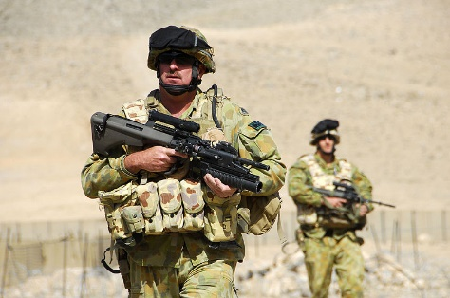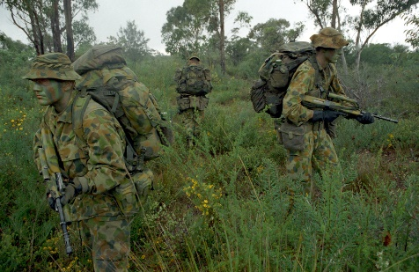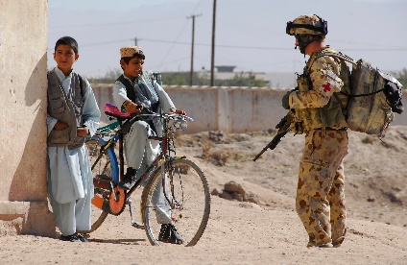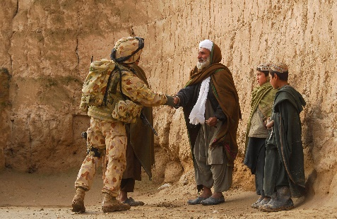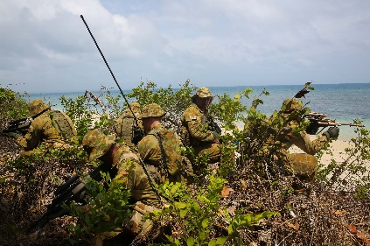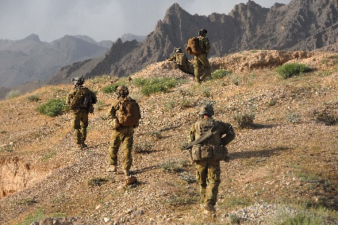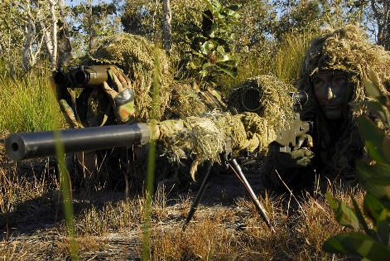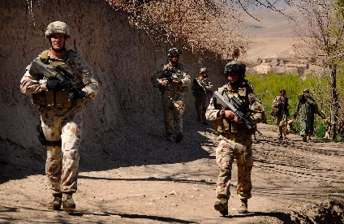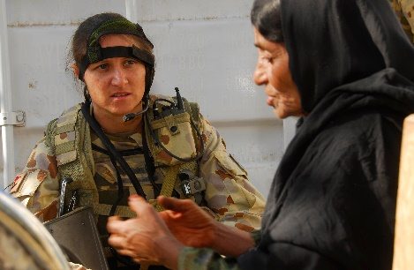

**Listening**

1. Now listen to the patrol mission briefing and choose which kind of patrol from exercise 1 it is.   
   Is it a, b, or c?
2. Now, listen again and

* answer the questions below: Choose the correct answer (a, b, c, or d) to each question.
* after you listen, compare your answers with your classmate/s.

Questions:

1. When did the rebels attack the civilians?

a. 2 days ago b. today c. yesterday

1. How many sections will take part in the patrols?

a. 2 b. 3 c. 4

1. What time will the patrols start?

a. 2200 hours b. 2300 hours

1. Who will lead Alpha section?

a. Corporal Johnson b. Corporal Smith

1. Which path will Bravo section take at the start of the mission?

a. Northern path b. Southern path

1. Will the patrols meet the local people?

a. Yes b. No

1. What time will the patrols join up again?

a. 0200 hours b. 0300 hours

1. What time will the patrols leave the observation post?

a. 0300 hours b. 0700 hours

1. What time will the patrols return to the base?

a. 1100 hours b. 1200 hours

1. Should the patrols walk on the roads?

a. Yes b. No

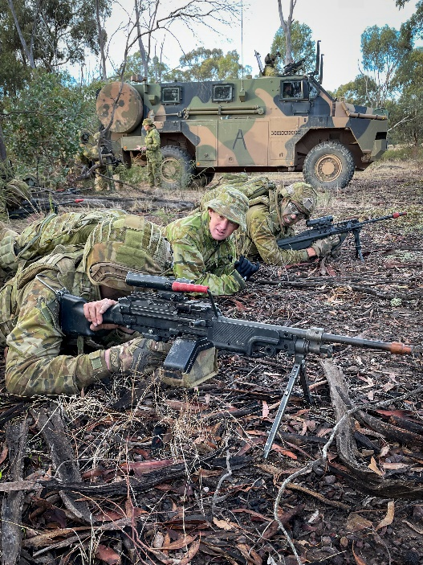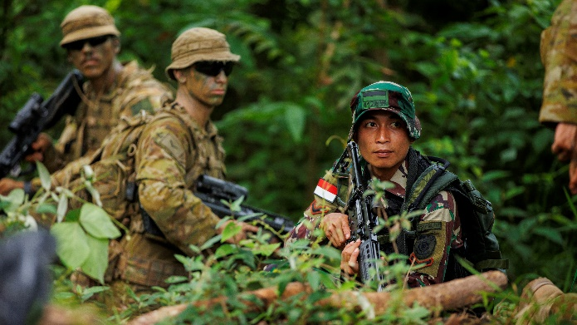

**A patrol can be:**

mounted – soldiers use a vehicle (troop carrier, infantry vehicle, etc) 🡪

🡨 dismounted – soldiers move on foot

**Learning Military Vocabulary**

1. The words in **bold** in the text are important military vocabulary that you will hear in the recording. Match the military words on the left to their definitions on the right. Look at the example.

|  |  |  |  |
| --- | --- | --- | --- |
| our **mission** (n) tonight | **e** |  | 1. to contact headquarters by radio |
| **civilians** (n) were attacked |  |  | 1. one square on a map which gives you a location |
| **rebels** (n) attacked civilians |  |  | 1. to get secret information |
| to **gather intelligence** (v+n) |  |  | 1. a military unit of 8 – 10 people |
| two **sections** (n) will take part |  |  | 1. **a special military task** |
| we will **assign** (v) the sections |  |  | 1. to fight the enemy, to go into battle with the enemy |
| to **engage** (v) the enemy |  |  | 1. to meet someone in a secret way |
| **conceal** (v) yourselves |  |  | 1. a place where you can stay and watch – look out for the enemy |
| use **stealth** (n) |  |  | 1. someone who is not in the police or a military service |
| we will **RV/rendezvous** (v) |  |  | 1. to give a job to someone |
| at **grid reference** (n) 167451 |  |  | 1. to stay out of sight and move quietly |
| set up an **observation post**/**OP** (n) |  |  | 1. someone who is fighting the police and the military |
| be careful with **mines** (n) |  |  | 1. to hide and wait for the enemy, and then attack them |
| try to **ambush** (v) you |  |  | 1. to hide something or someone |
| **radio HQ** (v+n) if you need to |  |  | 1. a kind of bomb that blows up when someone steps on it |

*Example: mission (n) = e. a special military task*

1. Now let’s listen to the words practised in this lesson. Listen and repeat.
2. Circle the correct answer to complete sentences.
3. The *civilians // mines* were afraid and asked the soldiers to help them.
4. The rebels *ambushed // assigned* the patrolling soldiers.
5. The soldiers watched the street from the *observation post // section*.
6. The lieutenant told the patrols to *rebel // rendezvous* at 0900 hours.
7. The *mission // civilian* is to patrol the area near the enemy town and *section* // *gather intelligence*.
8. The enemy was coming, so the soldiers quickly *concealed // engaged* themselves behind a big rock.

## Practice

1. Read these about these three missions and think about which kind of patrol would be most useful; a, b or c. Discuss in a small group. Does everyone in your group agree? Why? Be ready to tell other members of the class why you chose these types of patrols.

|  |  |  |  |  |
| --- | --- | --- | --- | --- |
| **Mission 1**  Rebels attacked a town and burned down a small hospi-tal. Now the rebels have gone far away. Many civilians were hurt and they need help. You need to find out what happened.  **Types of patrols** a) fighting patrol b) reconnaissance patrol c) population support patrol |  | **Mission 2**  The rebels are staying at a camp in the forest. You think you know where they are. You want to find out how many rebels there are. You do not want to fight them. |  | **Mission 3**  Some of the rebels are hiding in the forest, and you do not know where they are. The rebels are very dangerous. You need to find them and fight them. |

* This lesson links with 🡪 Lesson – Map Reading and Navigation; Lesson – Military Drones; Lesson – Jungle Warfare Training.
* Watch these videos about Australian Army patrols. Type the video titles on YouTube or scan the QR codes.

[Darwin Squadron Top End Patrol](https://www.youtube.com/watch?v=VeCtq1dCeqk) [Australian Patrol Bases : Uruzgan Province, Afghanistan. (F09580)](https://www.youtube.com/watch?v=aj-vCBfVWAM)



© Commonwealth of Australia 2023  
This work is copyright. Apart from any use as permitted under the Copyright Act 1968 (Cth),   
no part may be reproduced by any process without prior written permission from the Department of Defence.