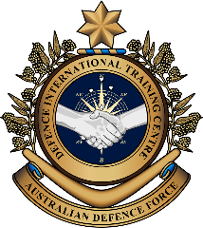
Military English
Vocabulary Builder: Types of Army Vehicles

Overview:
This worksheet lists vocabulary that describes army vehicles.
In this vocabulary builder, you will:
- learn and use vocabulary related to army vehicles.

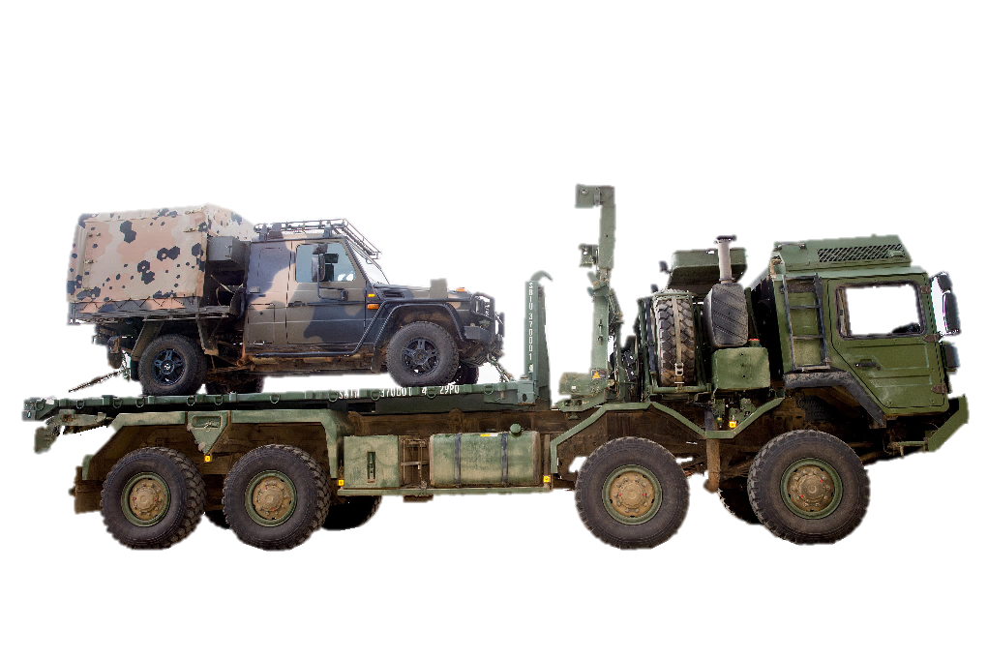

- Label the pictures. Use the words in the box below.

c. _______________________

a. ________________
_________________

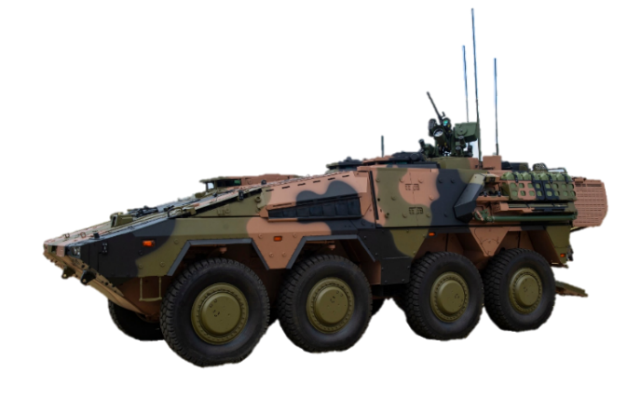
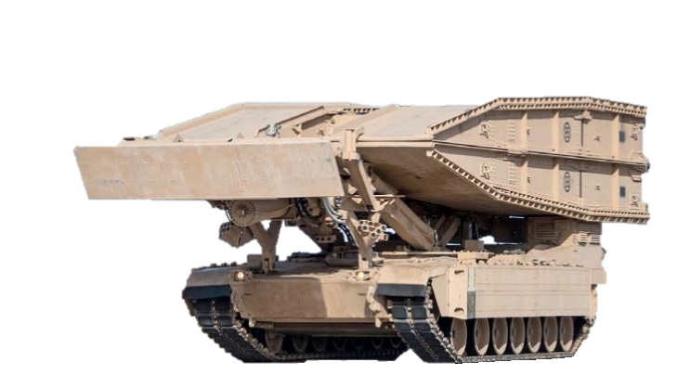
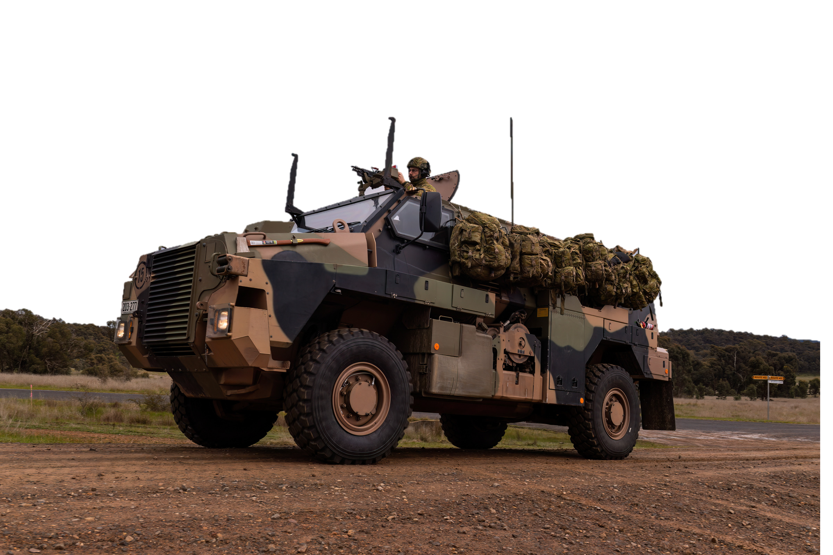
light utility vehicle // armoured reconnaissance vehicle // protected mobility vehicle (Bushmaster) // army truck // armoured bridgelayer

e. ____________________________

d. ____________________________

b. ________________
_________________
Continue to label the pictures. Use the words in the box below.
armoured personnel carrier (APC) // amphibious assault vehicle // armoured recovery vehicle // medical vehicle (ambulance) // self-propelled howitzer // main battle tank

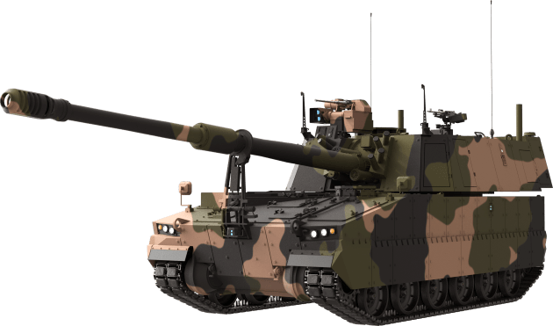
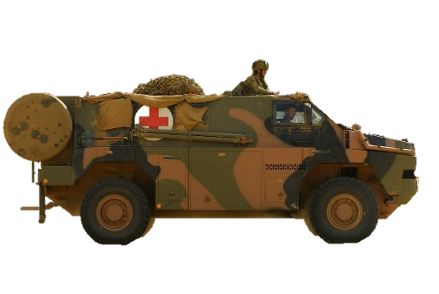

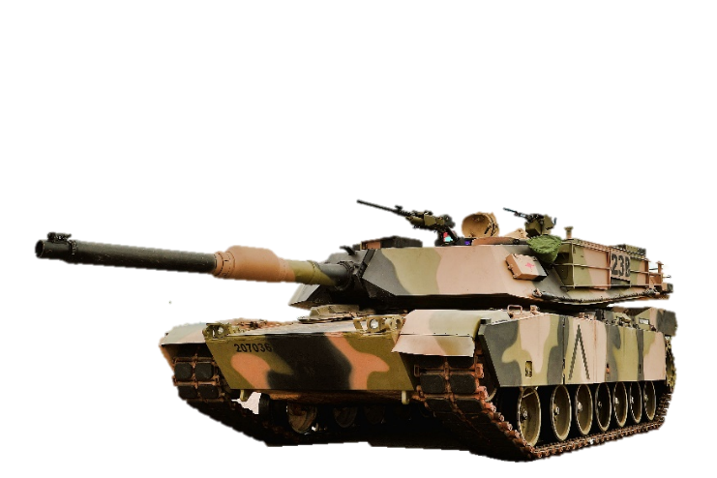

j. __________
____________
____________

f. ____________________________

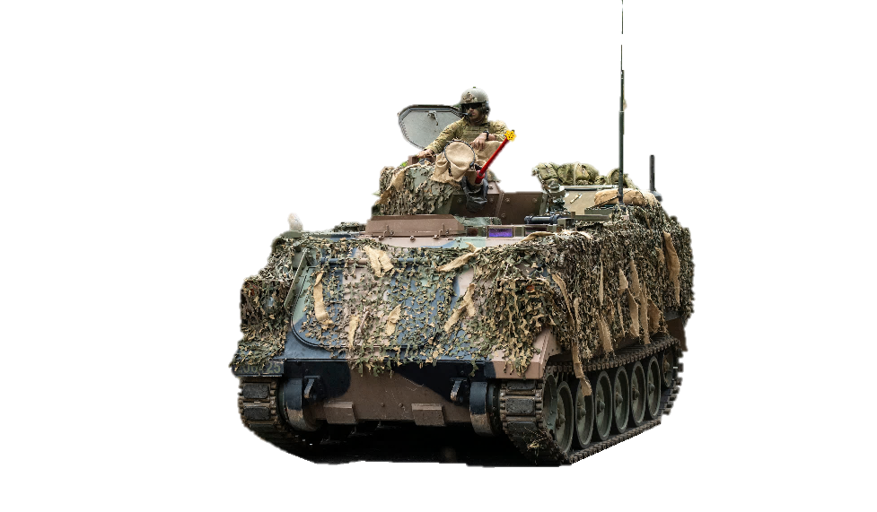

g. ____________________________

k. __________
____________
____________

h. ____________________________
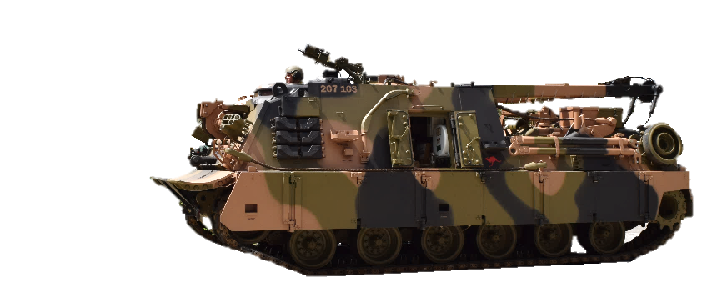


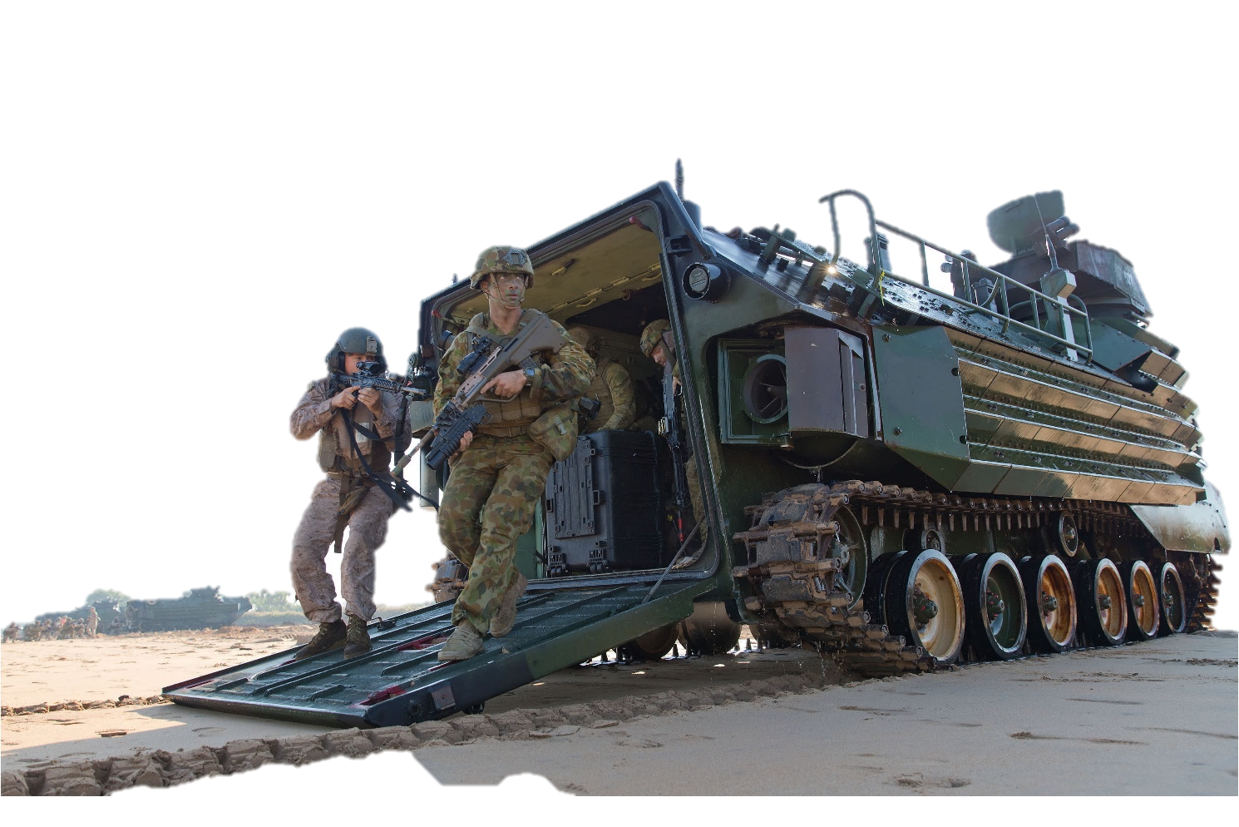
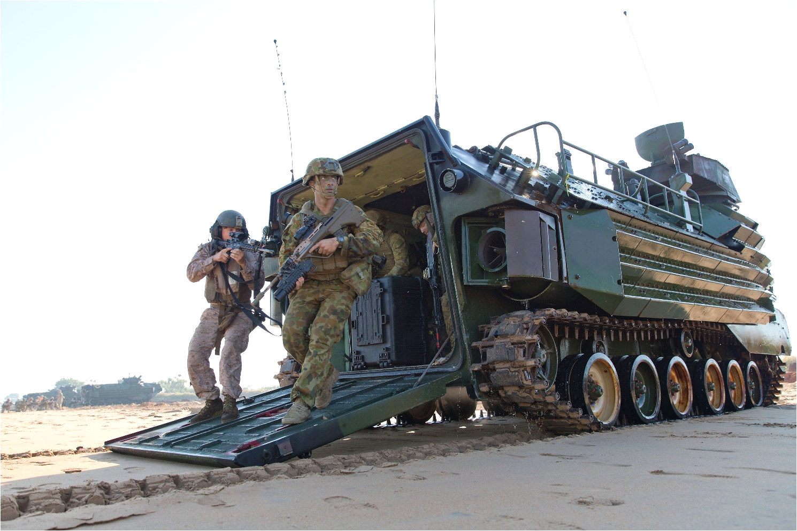

i. _____________
_______________
_______________

- Now let’s listen to the words practised in this worksheet. Listen and repeat.

- Complete the sentences. Use the words below from exercise 1.
armoured (adj) /ˈɑːməd/ – a type of protection for vehicles and ships. It protects them from gun attacks. armour (n)
reconnaissance (n) /rɪˈkɒnɪsns/ – to use a vehicle, boat, soldier, planes, etc to get information about a place.
- The _________________________________ is an armoured vehicle used by the army for reconnaissance missions.
- Soldiers use the _____________________ to move from one place to another safely. It has four wheels and light armour.
- The ___________________________ is used to take soldiers and their equipment to the battlefield. It has heavy armour.
- The _________________________ is a large vehicle used to move heavy equipment.
- The _______________________________ has a powerful gun, it’s big, heavy and very well armoured.
- The ______________________________________ is used for landing soldiers on the beach. It can be used in water and on land.
- The _______________________________ is a vehicle used for moving heavy vehicles such as tanks that are broken on the battlefield.
- A _____________________________ is a special vehicle used to quickly move injured soldiers to receive medical help.
- The ________________ is an engineering vehicle used for quickly building bridges on the battlefield.
- ________________________ is a big gun that can move by itself. It's used by the military to shoot big bullets at the enemy from different places on the battlefield. It is not a tank!
- With a partner, ask and answer these questions. Try to use some of the words from Exercise 1.
  - What type of armoured vehicles do you have in your defence force?
  - What kind of vehicles are used for moving soldiers in the battlefield?
  - Does your defence force use military trucks? Why?
  - Can you name other army vehicles your military uses?

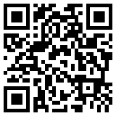
- Watch this video about army vehicles in the Australian Army (start from 2:35 min; stop at 5:50 min). Type on YouTube Equipment and Vehicles of the Australian Army, or scan the QR code to the right

- This Vocabulary Builder links with: Vocabulary Builder – Military Vehicles.

© Commonwealth of Australia 2023
This work is copyright. Apart from any use as permitted under the Copyright Act 1968 (Cth),
no part may be reproduced by any process without prior written permission from the Department of Defence.

