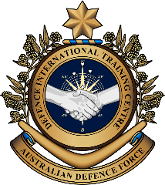
Military English
Vocabulary Builder: Types of Navy Vessels

Overview:
This worksheet presents vocabulary related to the types of navy vessels.
In this lesson, you will:
- use vocabulary related to navy ships

- Let’s learn the names of the different types of navy ships. On this page and the next, choose the correct word for each vessel.
a vessel (n) /ˈvesl/= a ship or large boat
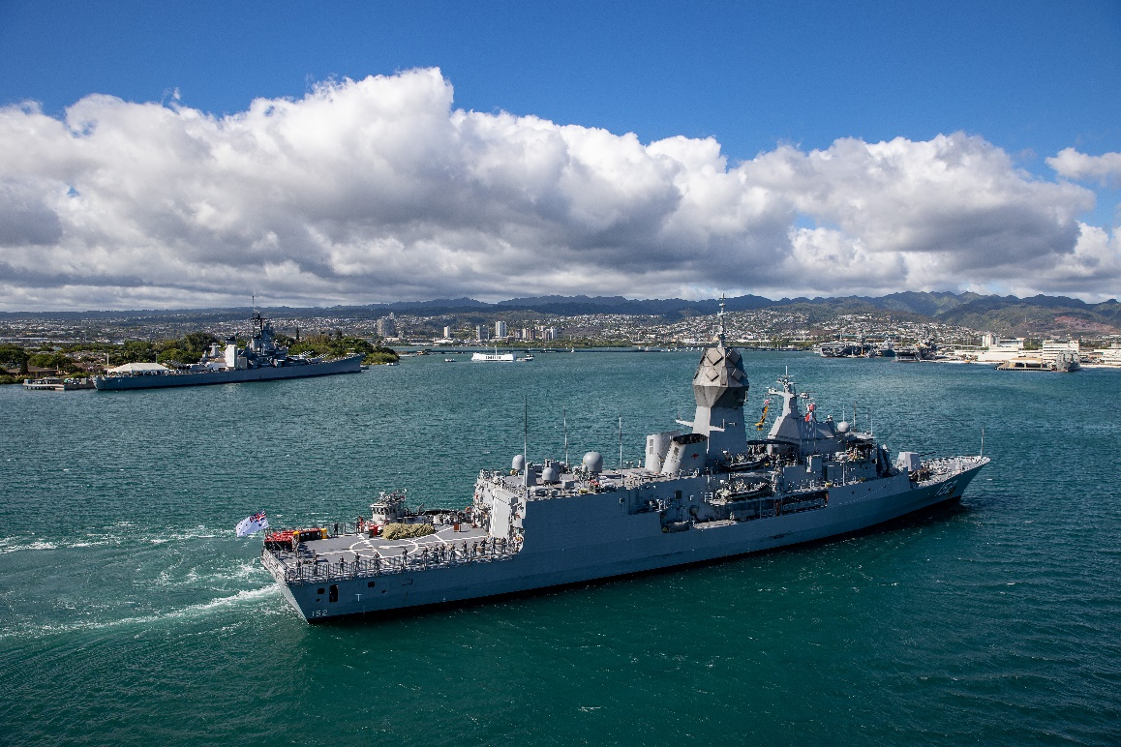
c. _______________________________
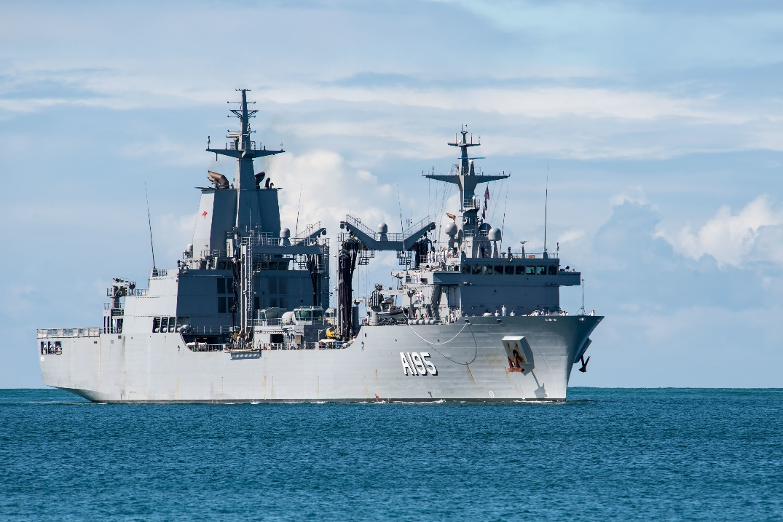

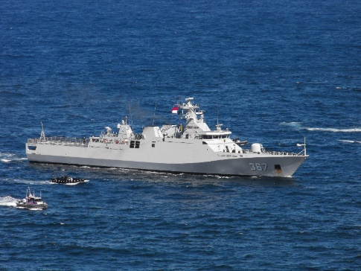
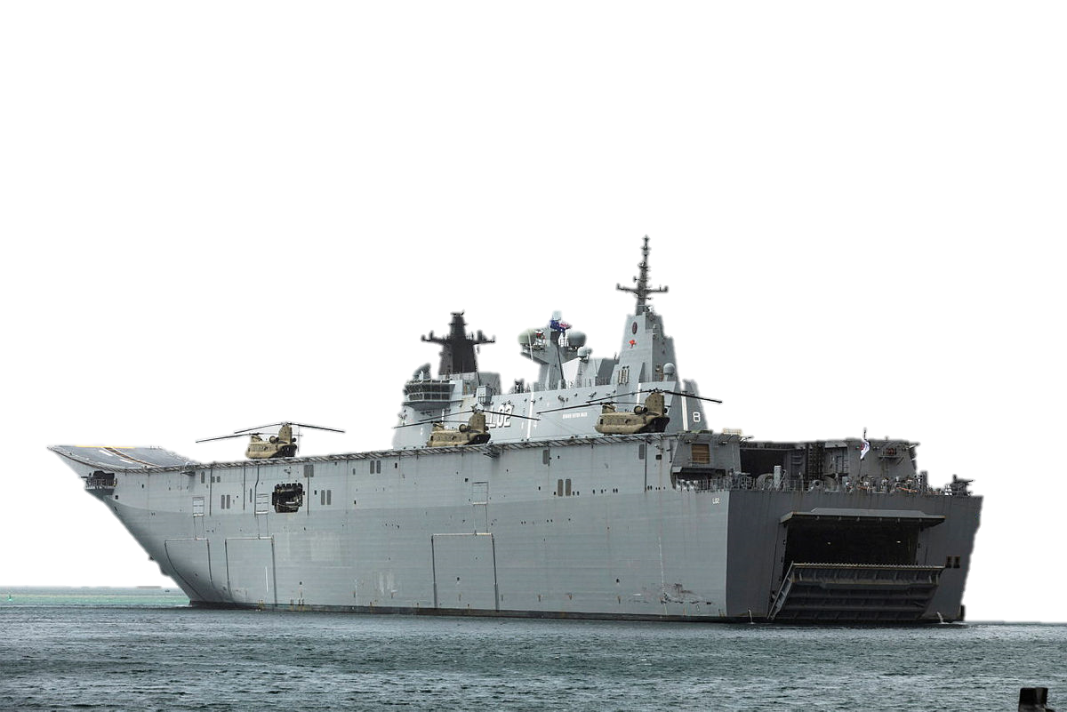
Another name for this type of vessel is Amphibious Assault Ship
d. ___________________
a. ___________________
b. ___________________
_____________________
corvette // landing helicopter dock // replenishment oiler // frigate

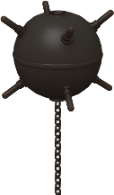
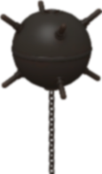


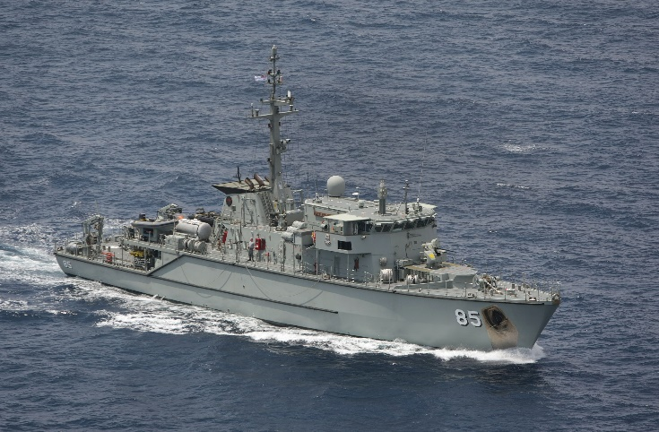

g. ______________________________

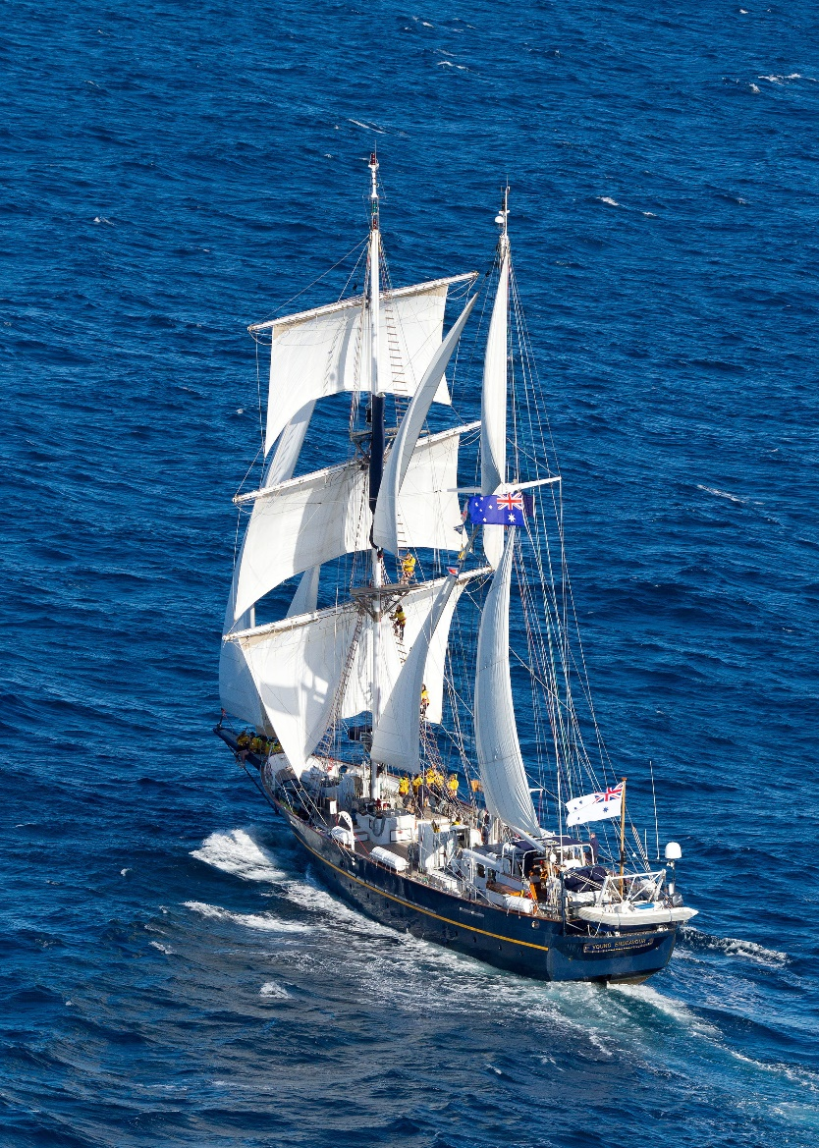
s

e. ______________________________
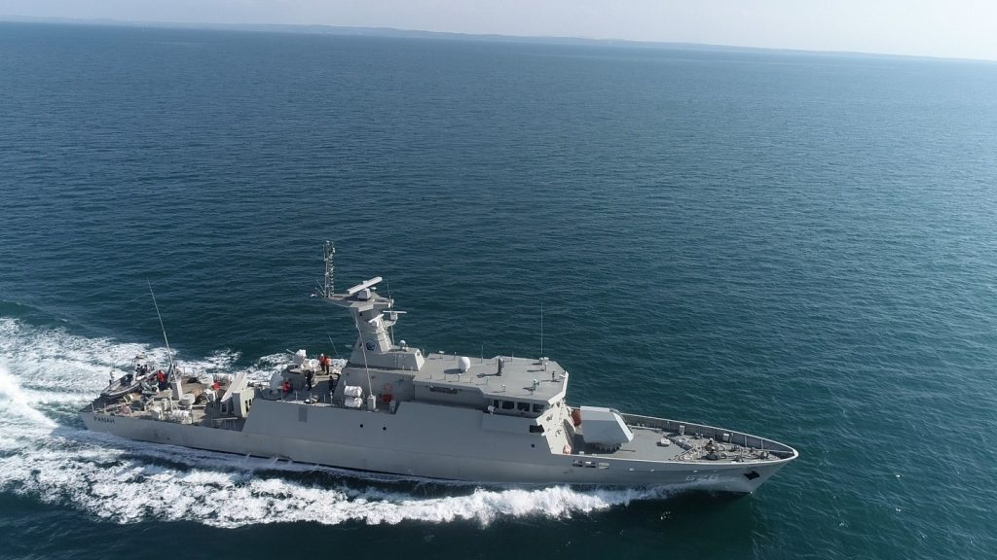

h. ___________________________________________
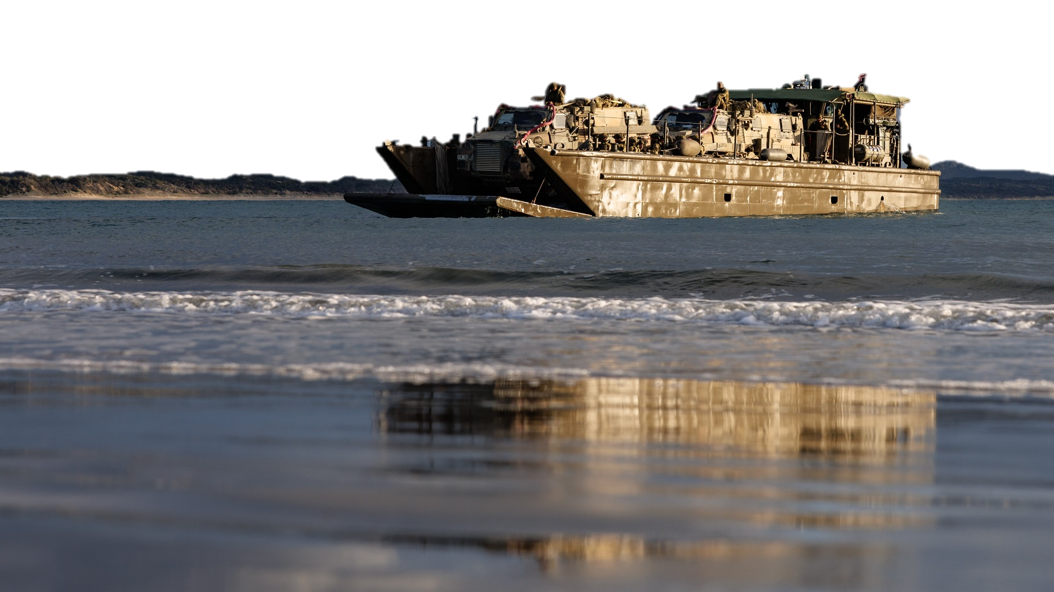
f. ____________________________________
landing craft // fast attack craft // sail training ship // mine warfare vessel

DITC – Military English. Vocabulary Builder: Types of Navy Vessels 3
- Here are more types of vessels. The letters in the boxes are jumbled up. Put the letters in the correct order to form the right words. The first example has been done for you.
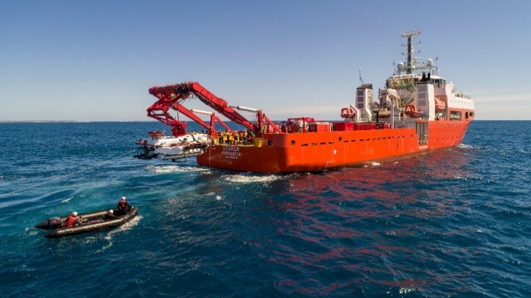
i. S E A R C H A N D R E S C U E
RASECH NDA RUSEEC
l. __ __ __ __ __ __ __ __ __ __
ATPRLO OBAT

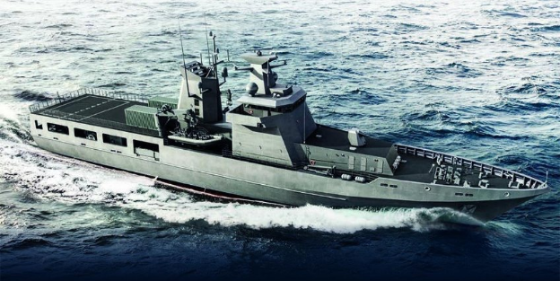

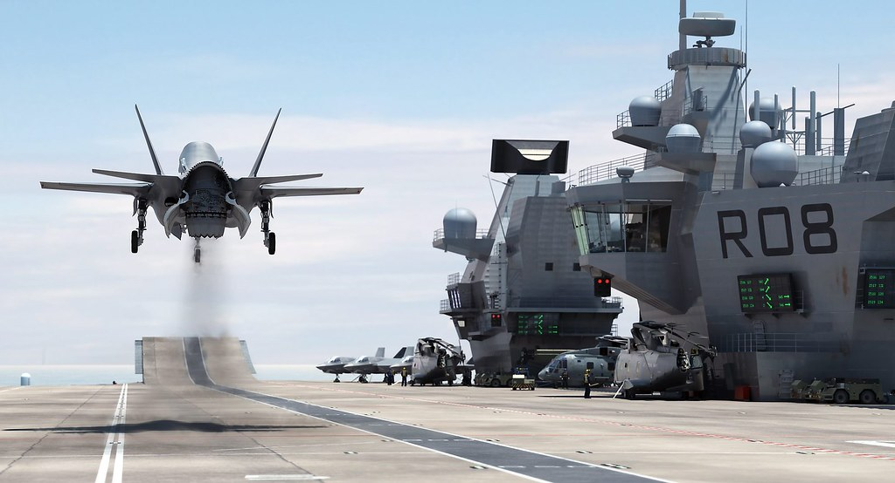

m. __ __ __ __ __ __ __ __ __ __ __ __ __ __ __
ATCARIRF ECIRRRA

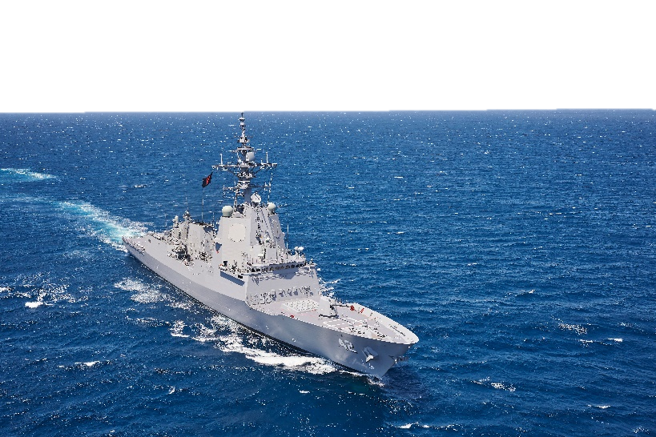

j. __ __ __ __ __ __ __ __ __
EORTDESRY

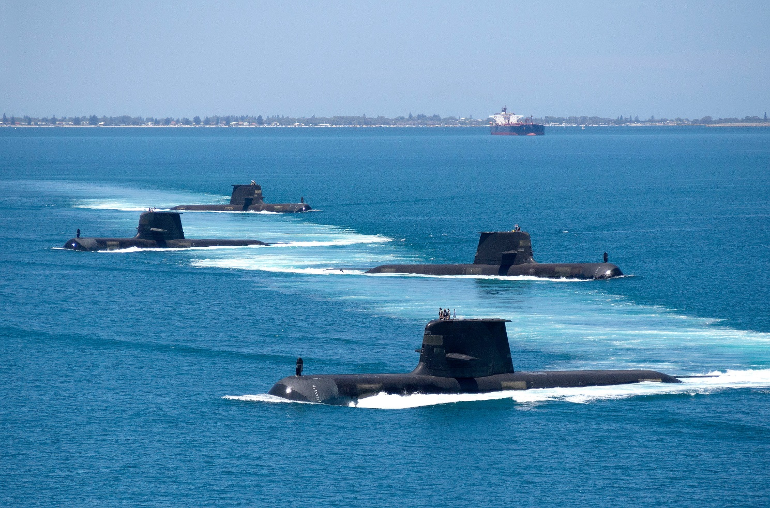

k. __ __ __ __ __ __ __ __ __
ARMIBEUNS

DITC – Military English. Vocabulary Builder: Types of Navy Vessels 4
- Now let’s listen to the words practised in this worksheet. Listen and repeat.

- Complete these sentences with some of the words from exercises 1 and 2.

A __________________ is a vessel, which can move underwater.
Its weapons include torpedos and guided missiles.
The three main types of submarines are: ballistic missile, attack missile, and cruise missile submarines.

Countries like Australia, Indonesia, Vietnam and Malaysia have a ___________ ______________ _________. They are usually used
as a training vessel for junior sailors and cadets.
- A __________________ is a large and fast vessel, used to defend larger vessels, and for support to ground troops. Its weapons can include guns and guided missiles.
- This large vessel has a flat top and can carry a lot of helicopters, tanks, trucks, etc. It has a door at the back for landing craft and other smaller boats to board. Some countries, like Australia and the USA, call it a _________________ _________________ ______________ , but it
is also called an amphibious assault ship.
Above: Destroyer HMAS Sydney fires a Sea Sparrow guided missile.
- A ____________________ is usually smaller than a destroyer. It is a fast vessel which can be used in many different situations.
- If someone or a boat – including a submarine – is in danger or lost at sea, a __________________ ________ _______________ vessel can be used. These vessels have special equipment like radar and sonar.

- Talk to a partner. Answer these questions.

What types of ships does the navy of your country have?

Does your navy have any other types of vessels that are not on this Vocabulary Builder?
Do you know what they are called in English?

Can you think of other types of navy vessels that are not included in this lesson?


- Watch this YouTube video and write down all the types of vessels you see.
Type on YouTube How Powerful Is Royal Australian Navy | Australian Navy | RAN | in English or scan the QR Code to the right:

- This Vocabulary Builder links with Vocabulary Builder – Parts of a Ship.
© Commonwealth of Australia 2023
This work is copyright. Apart from any use as permitted under the Copyright Act 1968 (Cth),
no part may be reproduced by any process without prior written permission from the Department of Defence.

