

**Military English**

Vocabulary Builder - At an Obstacle Course

**Overview:**  
This worksheet lists vocabulary related to activities that military personnel do at an obstacle course.

**In this lesson, you will:**

* learn vocabulary related to actions at an obstacle course
* learn vocabulary of things you will see at an obstacle course
* practise using the vocabulary

1. Look at the pictures – can you match pairs of pictures that show the same action? The first one is done for you.

a. _________________________

c. _________________________

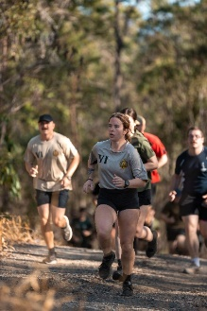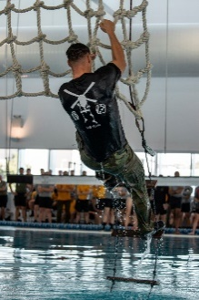

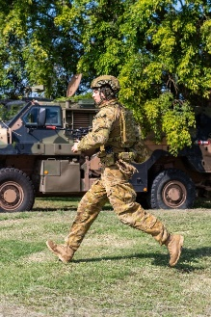

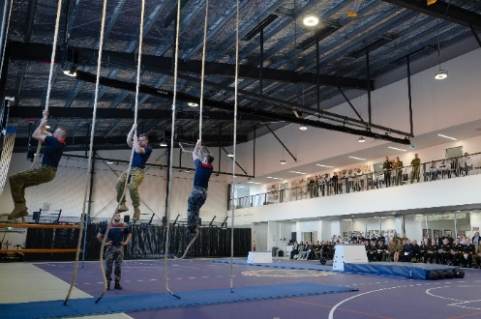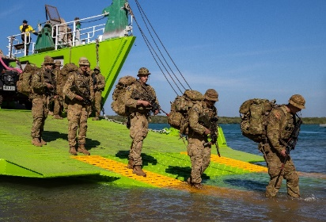

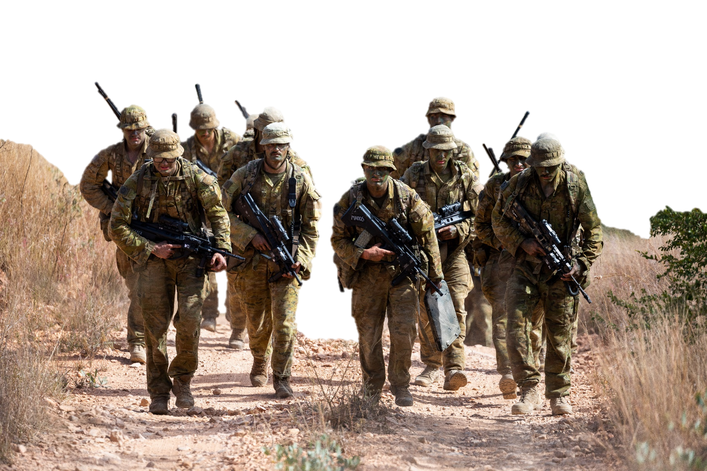

b. _________________________

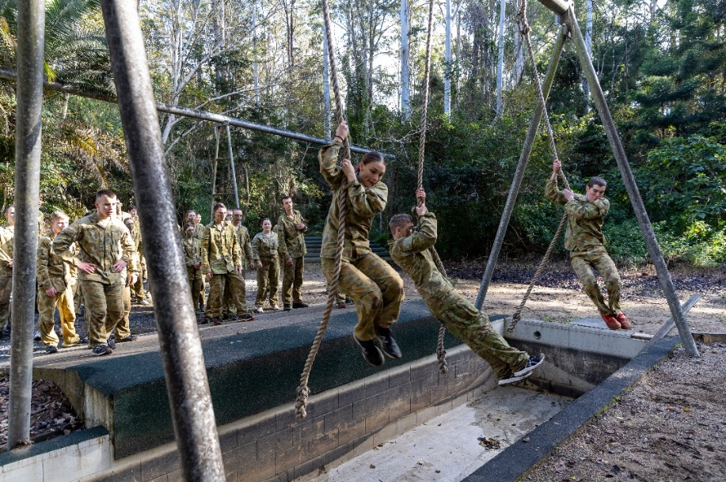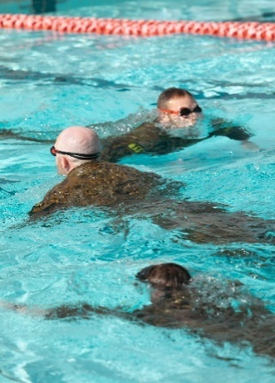

d. _________________________

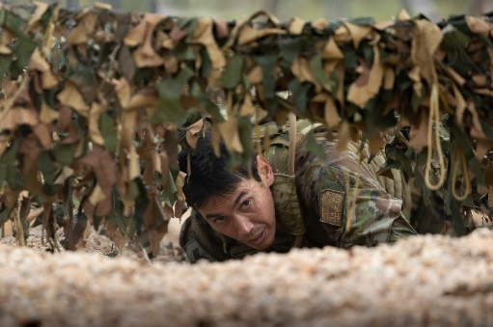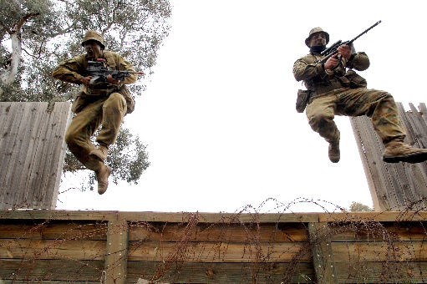

e. _________________________

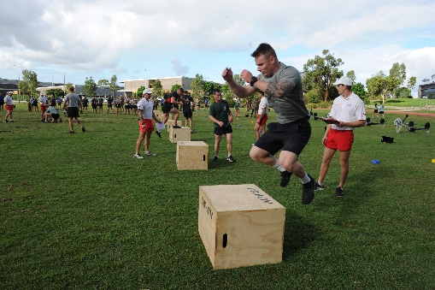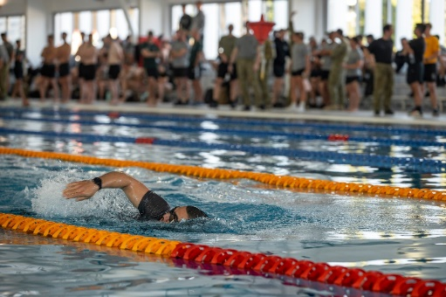

f. _________________________

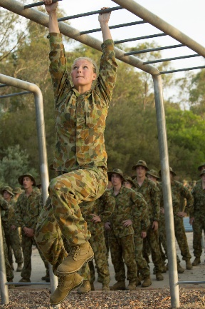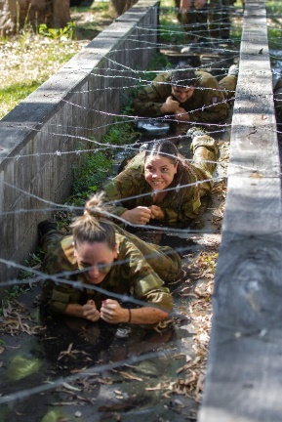

g. _________________________

1. Now write the correct word from the box below into the spaces a-g above.

run // swim // crawl // climb // march // jump // swing

1. Look at the box of words of things you might see at an obstacle course. Match them to the 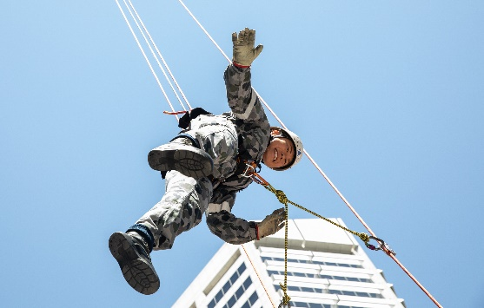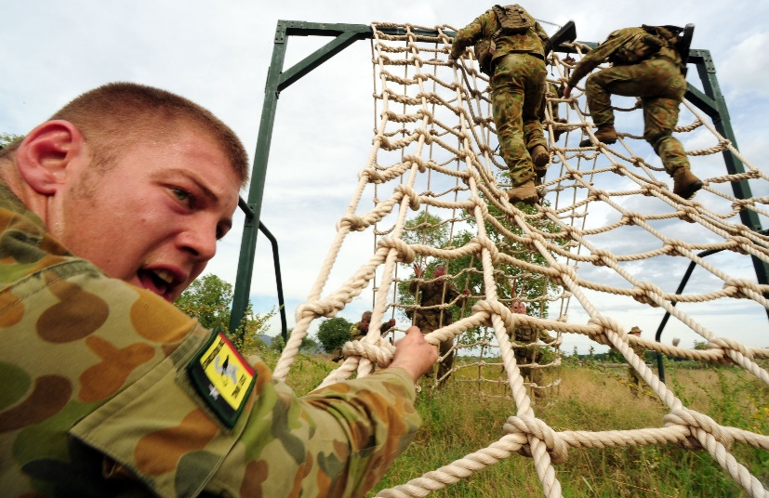correct 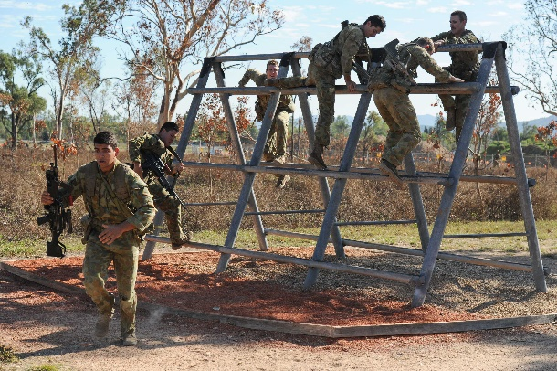picture.

a. ____________________

b. ____________________

c. ____________________

g. ____________________

d. ____________________

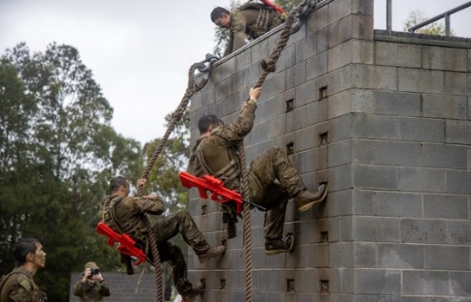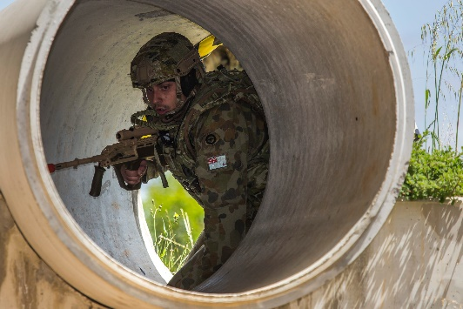

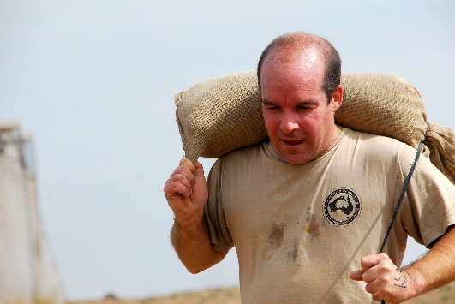

h. ____________________

e. ____________________

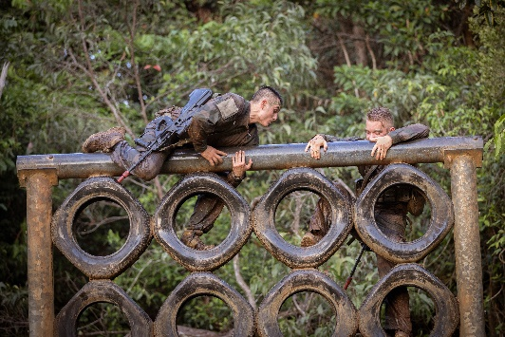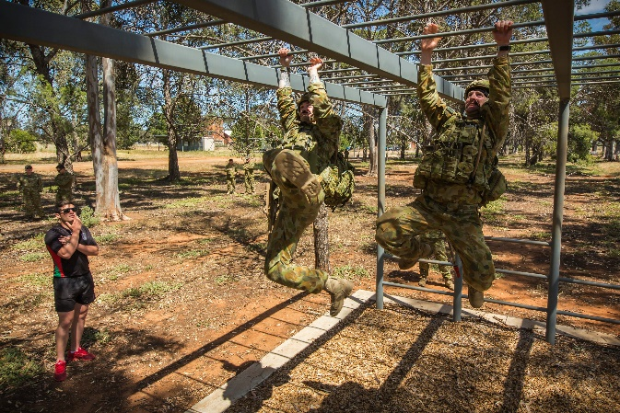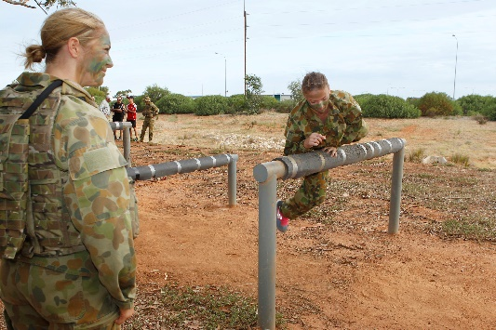

i. _____________________

f. _____________________

sandbag // tunnel // (cargo) net // (high/low) wall // tyres // (monkey) bars //  
 flying fox // (high/low) beams // ladder

* to crawl through a tunnel (= the tunnel is all around you)
* to crawl under a net (= the net is on top of you)
* to crawl across the rocks / the ropes (= the rocks / ropes are under you)
* to climb up/down the cargo net / a tree / the rope
* to swing across the bars (using your arms)
* to run / swim / march to (+ a target e.g. run to the electricity pole)
* to run / swim / march for (+ distance e.g. run for 100 metres)
* to jump into the pool (= you get wet)
* to jump / swing over the water (= you don’t get wet)
* to climb over the hill (= to go up AND down the hill)

**Learn about the verbs and their prepositions**:

1. Now let’s listen to the words practised in this worksheet. Listen and repeat.
2. Read how the instructor describes the obstacle course. Re-write the words in bold so they are spelled correctly. Check your answers with a partner after you have finished.

“I’ll tell you about the obstacle course. First _________________1 through the tunnels, then at the other end, ______________2 to the _________________3 and___________________**4** up,and down the other side. Next,pick up andcarry the_____________________**5** for 100 metres. At the pool, __________________**6** into the water and _________________**7** across to the other side. Out of the pool, ___________________**8** until the low___________________**9**. Jump across, and then finally, ______________________**10** across the ______________________**11** until you get to me. Ready? ...”

1. **lcarw**
2. **unr**
3. **ocrag ten**
4. **lbimc**
5. **sadnagb**
6. **upmj**
7. **wsim**
8. **nur**
9. **ambse**
10. **ginsw**
11. **rabs**
12. With your partner, write about an obstacle course that would be fun to try. Use at least six (6) words from this lesson. Use the description in Ex 5 to help you.
13. Scan the QR code and watch the video [Police Women’s League tackle ADF Obstacle Course](https://youtu.be/5lEqeMZn84g?si=P7X14ocy1w6K5kEW).

Discuss with a partner what you see using vocabulary you learned in this lesson.

© Commonwealth of Australia 2023  
This work is copyright. Apart from any use as permitted under the Copyright Act 1968 (Cth),   
no part may be reproduced by any process without prior written permission from the Department of Defence.