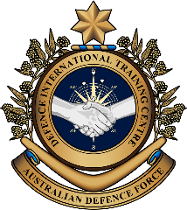

**English for Specific Purposes – Military**

Topic: Military Linguist - Reading

**Overview:**  
This lesson is about an Australian Defence Force personnel talking about his experience as an Army Linguist.

**In this lesson, you will:**

* read and find general information in a text
* learn the meaning of new words
* use new words in a conversation
* practise interpreting skills for a dialogue

## Prepare for Reading

1. Watch the video clip below and answer the questions with a partner.  
   Type learn another language on YouTube (or [www.youtube.com/watch?v=1eknGauMhEw](http://www.youtube.com/watch?v=1eknGauMhEw)), or scan the QR Code
2. What language did the fish use?
3. Why did the cat run away?
4. Can learning another language save your life? Why?
5. Why do some military personnel need to learn a foreign language? Tell your partner what you know about that job.
6. Think about the role of an Australian army linguist and look at the activities listed below (a. to f.). Tick the activities you think a military linguist would usually do.
7. Ask people to speak in English.
8. 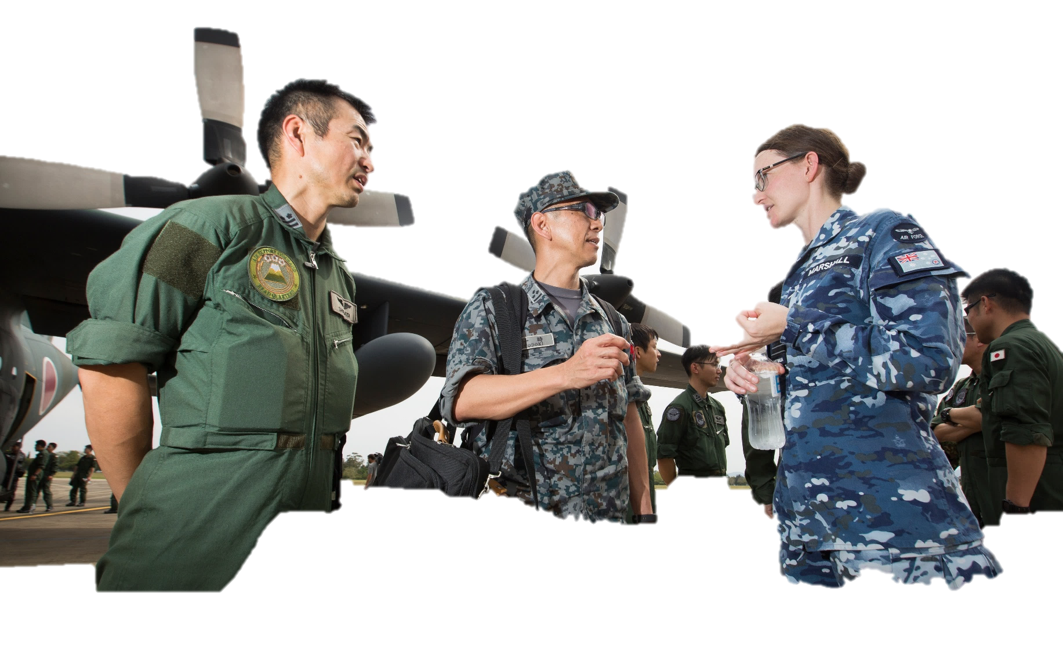Learn a foreign language.
9. Translate documents from one language to another.
10. Work with international defence force personnel.
11. Communicate with military officers from another country in their own language.
12. Talk with local community leaders in a foreign country.

## Reading

1. Read the article below and underline the activities CPL James Rigg usually did. Check your answers with a partner/a group. Do not use a dictionary yet. You are going to learn the meaning of the words in **bold** in the next exercise.

**Tip: When you read a text for the first time, you**

**can try to read it quickly, to get an overall idea of the meaning of the whole text or of the topic of the whole text**

**can try to complete the task that the teacher gives you but try not to worry about the words you don’t understand**

**are usually looking for some key words or key ideas**

|  |
| --- |
| Preview image for assetDuring Exercise Southern Jackaroo, Corporal James Rigg was one of six **Military** **Linguists** working with the Japan Ground Self-Defense* Force. He participated in every **range movement** and **daily brief**.  Japanese is a difficult language to learn. Corporal Rigg studied Japanese at the Australian Defence Force School of Languages for 12 months. He said 12 months was not enough for him to become **confident**. In the year after his language course, the Australian Defence Force (ADF) **posted** Corporal Rigg to Tokyo, Japan. Corporal Rigg said, “This was a great opportunity for some **in-country** language **training** and this made a big difference for my interpreting skill”.  According to Corporal Rigg, “It’s not only about being confident in a foreign language, a Defence Force Linguist also needs to know the culture of the country”. During Exercise Southern Jackaroo, Corporal Rigg explained some Japanese culture to his Australian colleagues, so they could **interact** with Japanese soldiers in a positive way. Corporal Rigg said the hardest part of this job was when he had to be the interpreter for a Japanese Officer who spoke really fast and with a different **accent**. “I really had to concentrate so I could understand what he said”.  Being an **interpreter** and **translator** is a very important job for the ADF’s **mission** to support **peace and stability** in the region. It helps Australia **build relationships** with other countries. Corporal Rigg explained why he loves this job: “As an Army Linguist, I travel a lot, meet new people, learn about other cultures, and be the **point of contact** between Japanese and Australian forces. This is a job I’m proud of”. |

* Please note **“Defense”** is the American spelling. Japan uses American spelling for English words. Australia uses the British spelling: **“Defence”**.

1. Answer the following questions with the information from the text:
2. How many military linguists were in James’ team during Exercise Southern Jackaroo?
3. How long did James Rigg learn Japanese at the Australian Defence Force School of Languages?
4. Where did James continue learning Japanese?
5. How does James’ job as an interpreter help Australia?
6. What was the most difficult part of James’ job?
7. What was the part of the job that James liked the most?

## Learning Military Vocabulary

1. The words in bold in the text are important military vocabulary that you should learn to use. Match the military words on the left to their definitions on the right on tables one and two. Look at the bolded example on table one.

|  |  |  |  |
| --- | --- | --- | --- |
| Table one |  |  |  |
| A **Military Linguist** (n) helps people to communicate when they don’t speak the same language |  |  | 1. moving troops, vehicles, or weapons systems across a training range or battlefield to a new place |
| **range movements** (n) to relocate troops and equipment |  |  | **b. feeling sure about what you can do and be successful** |
| **daily brief** (n) for planning an exercise |  |  | 1. when a student joins a school in another country |
| a **confident** (adj) speaker | **b** |  | 1. to send somebody to work or study in another place, or country |
| The ADF **posted** (v) Corporal Rigg to Tokyo |  |  | 1. an officer who uses language skills for the military. This includes translating words, interpreting what people are saying, or teaching others a foreign language. The main job is to help people in the military understand each other better when they speak different languages. |
| **in-country training** (n)  (in-country language training) |  |  | 1. a short talk or update that happens every day to give information about what's going on |

*Example: confident = b. feeling sure about what you can do and be successful.*

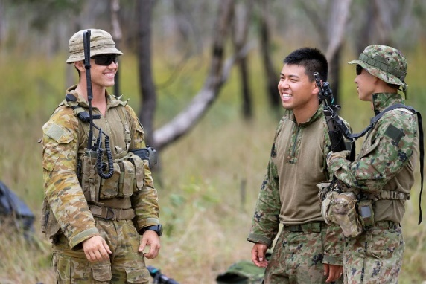

A Military Linguist from the Indonesian Army (centre) interprets a conversation between an Australian (left) and an Indonesian soldier (right) during Exercise Southern Jackaroo.

|  |  |  |  |
| --- | --- | --- | --- |
| Table two |  |  |  |
| **interact** (v) with foreign military forces |  |  | 1. a person who you can speak to in an organisation when you need to talk about work or tasks |
| He speaks with an **accent** (n) |  |  | 1. to make friends with someone by keeping in contact for a long time. This connection can bring benefits to all members. |
| Being and **interpreter** and **translator** (n) is a very important job |  |  | 1. a situation where there is no war or conflict between countries. Countries in the region are friendly with each other |
| a **mission** (n)for supporting peace and stability |  |  | 1. to talk with someone |
| **peace and stability** (n) in the region |  |  | 1. someone who uses a foreign language to help someone talk to another person who does not speak the same language |
| to **build relationships** (n) with foreign countries |  |  | 1. the way somebody pronounces words in their language or a foreign language. For example, American and Australian accents are quite different. |
| A **point of contact** **(POC**)** (n) for future communications |  |  | 1. an important military role/job/task |

*\*\* In the acronym “POC”, each letter must be pronounced “P. O. C.” (Pee Oh See); however, in the written form, you will most often see it written as “POC”.*

1. Now let’s practise saying the words from exercise 5. Listen and repeat.
2. Try to use some of the words from exercise 5 correctly in the sentences below.
3. The __________________ _________________ helped the soldiers understand and communicate in a foreign language.
4. Practising ___________ ________________with other countries’ military forces during exercises is an important way of learning how to safely move troops and equipment in real combat situations.
5. The Commanding Officer (CO) started the meeting with a ______________ ______________ to update all personnel on progress for the combined exercise.
6. Australia wants to _________________ ________________ with countries in the Asia Pacific region to reduce conflict and maintain ________________ _______ __________________ in the region.
7. Their French ________________ was so strong that sometimes it was difficult to understand what they said.
8. The _____________________________ helped people who spoke different languages to understand each other at the UN meeting.
9. If you have any questions about your application, your Administration Officer will be your ________ _____ ________________.
10. If we want to learn how the ADF conducts operations in Australia, it is necessary to join some ______ ________________ _________________________during combined exercises.

## Practice

1. Discuss these questions with a partner:
2. Do you think you can be a ‘military linguist’?
3. Does your defence force have interpreters? What kinds of things do you see them doing?
4. Would you like the job on being an interpreter? Why (not)? What skills will you need to be one?
5. Alternate Practice – Interpreting Role Play (Consecutive Interpreting)

**Situation:** You are a military interpreter during a combined military exercise between your country and the Australian Defence Force (ADF). Your role is to interpret dialogue between your commander and the ADF commander. The ADF Commander is meeting your Commander for the first time in Australia. At the meeting they will talk about preparations and planning for the exercise.

**Roles:**

**Student A**: ADF Commander (speak **English**)

**Student B**: Your country’s Commander (speak your **first language**)

**Student C**: Interpreter (**interpret** dialogue between Person A and Person B)

**Task Instructions:**

* Work in a group of three.
* Each student in the group will take it in turns to be the interpreter, the ADF Commander, and the ‘foreign country’ Commander.
* When the first practice is completed, change roles, and replay the situation. You will do this role play three times.

**Student A** and **Student B**: use the transcript for the conversation. Note: **Student B** will need to translate from English (in the script) and speak only in their first language. Take about 10 minutes to prepare this before you begin.

**Student C** (the interpreter): Interpret and translate the conversation using both English and native language to help the two Commanders communicate.

**Interpreting skills:**

* Always translate dialogue using the ‘first person’ – for example: “I welcome you to Australia…” Not “He said he welcomes you to Australia…”. As the interpreter, you are the voice of the person speaking. You must use the ‘first person’ pronoun (I, my, me) in both languages in both directions of the conversation.
* If you did not catch the meaning of a word, do not pretend to know, or guess the meaning. Always ask for an explanation of the meaning from the person speaking. The person speaking will usually use different words to help you understand.
* When you ask for an explanation from a speaker, always politely tell the other speaker what you are doing. Always include the other speaker. Repeat the information back to the other speaker quickly and efficiently.

**Interpreting task – Role Play**

**Foreign country Commander:** speaks foreign language only

Use the transcript to help you.

**B**

**Interpreter:** speaks English and foreign language

Don’t use the transcript. Listen and interpret.

**C**

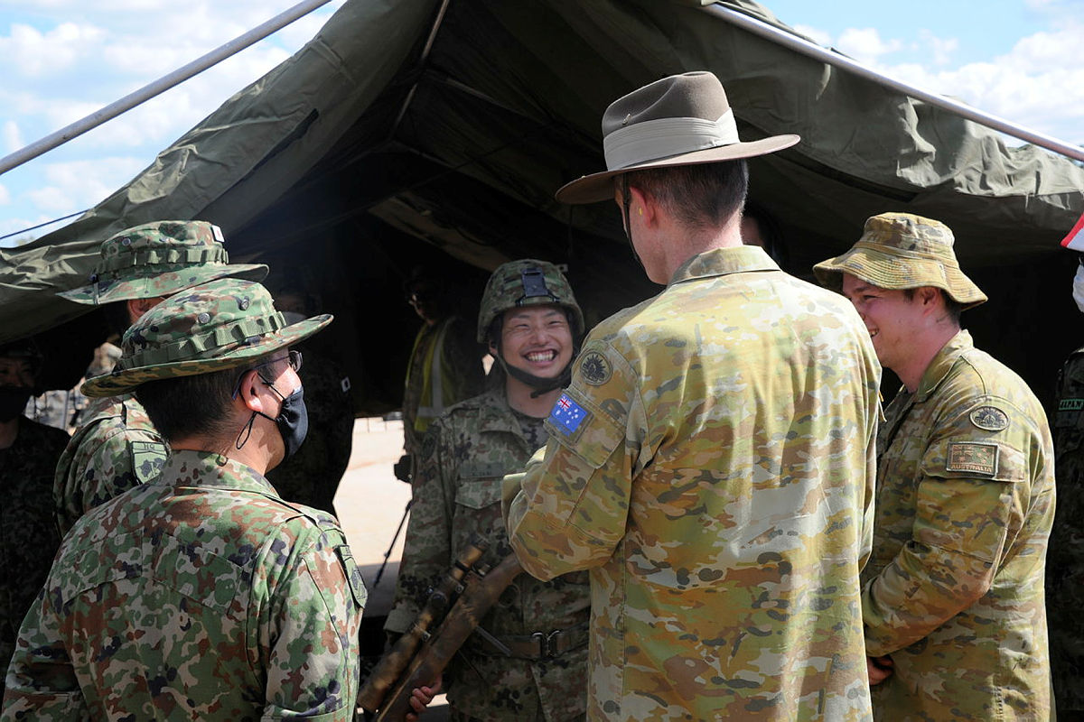

**ADF Commander:** speaks English only

Use the transcript   
to help you.

**A**

**B**

**A**

**C**

English

Foreign language (*your* language)

|  |  |
| --- | --- |
| **Speaker** | **Transcript** |
| A | Good afternoon. How are you? |
| B | Thai: สวัสดีครับ/ค่ะ ท่าน ผม/ดิฉันสบายดีครับ/ค่ะ แล้วท่านล่ะครับ/คะ  Indonesian: Selamat siang Pak, saya baik-baik saja, terima kasih. Bagaimana kabar anda?  Tongan: Malo ho’o lelei kihe ho’ataa ni. ‘Oku ou saipe malo, fefe hake koe?  Vietnamese: Chào ông, tôi vẫn khỏe, cảm ơn ông. Ông có khỏe không?  Khmer: បាទសួស្ដីលោក ខ្ញុំសុខសប្បាយជាទេ​ អរគុណច្រើន។ តើលោកសុខសប្បាយជាទេ?  Lao: ສະບາຍດີຕອນບ່າຍ, ຂ້ອຍສະບາຍດີ. ທ່ານເດສະບາຍດີບໍ່?  Tetum: Boa tarde senhor. Hau diak tebes obrigado. Ita diak ka lae?  Arabic: مساء الخير سيدي، أنا بخير شكرًا لك. كيف حالك أنت؟  Malaysian: Selamat petang tuan, saya sihat, terima kasih. tuan, apa khabar?  Tok Pisin: Gudpela avinun bikman, mi orait tasol, tenk yu. Na yu orait?  *(translation: Good afternoon Sir, I am well thank you. How are you?*) |
| A | I’m fine too, thanks. Are you enjoying Australia? |
| B | **Thai** ครับ/ค่ะ ขอบคุณครับ/ค่ะ ผม/ดิฉันดีใจที่ได้มาประจำที่ประเทศออสเตรเลียและได้ทำงานร่วมกันครับ/ค่ะ  Indonesian: Ya. Saya sangat senang ditempatkan di Australia dan dapat bekerja bersama-sama.  Tongan: ‘Io, malo. ‘Oku ou fiefia ‘aupito ‘i he faingamalie ngaue ko ‘eni ki ‘Aositelelia ‘o malava ai ketau ngaue fakataha.  Vietnamese: Có chứ, cảm ơn ông. Tôi rất vui khi được chuyển công tác đến Úc và làm việc cùng với các ông.  Khmer: បាទ អរគុណច្រើន។ ខ្ញុំពិតជារីករាយណាស់ដែលត្រូវបានបញ្ជូនមកប្រទេសអូស្ត្រាលី និងធ្វើការជាមួយគ្នា។​  Lao: ໂດຍ ຂອບໃຈ. ຂ້ອຍຮູ້ສຶກຍີນດີທີ່ຖຶກສົ່ງຕົວມາປະຈໍາຢູ່ປະເທດອົດສະຕາລີ້ ແລະ ເຮັດວຽກຮ່ວມກັນກັບທ່ານ.  Tetum: Sim,Obrigado. Hau kontente tebes bele mai to Australia no servisu hamutuk.  Arabic: نعم شكرا لك. يسعدني جدًا أن يتم إرسالي إلى أستراليا والعمل معًا.  Malaysian: Ya, terima kasih. Saya sangat gembira ditempatkan ke Australia dan dapat kerja bersama-sama.  Tok Pisin: Ya, tenk yu.Mi amamas tru long kam wok ia long Australia na wok bung wantaim yupela.  *(translation:* Yes, thank you. I am very happy to be postedto Australia and to work together.) |
| A | That’s good to hear. Well, let’s start with our **daily brief**. |
| B | Thai: ก่อนอื่น คุณช่วยอธิบายหน่อยได้ไหมครับ/คะ ว่าเราจะพูดคุยเกี่ยวกับเรื่องอะไรในการประชุมครั้งนี้  Indonesian: Pertama-tama, bisakah Anda jelaskan apa yang akan kita diskusikan dalam pertemuan ini?  Tongan: Ko e me’a fika ‘uluaki, ‘e lava keke fakamatala’i mai ‘a e me’a koia tetau fakataha ki ai?  Vietnamese: Trước tiên, ông có thể giải thích cho tôi nghe về những gì chúng ta sắp trao đổi trong buổi giao ban hôm nay chứ?  Khmer:ជាបឋម តើលោកអាចពន្យល់ប្រាប់ខ្ញុំបន្តិចបានទេថាតើការប្រជុំនេះនឹងនិយាយអំពីអ្វី?  Lao: ກ່ອນອື່ນໝົດ, ຂໍໃຫ້ທ່ານອະທິບາຍກ່ອນວ່າໃນກອງປະຊຸມນີ້ພວກເຮົາຈະລົມກັນກ່ຽວກັບຫຍັງ?  Tetum: Parte dahuluk,bele ita esplika saida mak ita atu koalia iha enkontru ne’e?  Arabic: قبل كل شئ، هل يمكنك توضيح ماهو موضوع الحديث في هذا اللقاء؟  Malaysian: Pertama sekali, bolehkah awak terangkan apa yang akan kita bincangkan dalam perjumpaan ini?  Tok Pisin: Pastem tru, inap yu tokaut klia lo wonem ol toktok bai yumi toktok lo en long dispela kibung?  *(translation:* Firstly, can you explain what we will talk about in this meeting?) |
| A | The aim is to discuss plans for both our forces during the exercise.  Also, we can **build relationships** with officers from each country. |
| B | Thai: รับทราบครับ/ค่ะ ผม/ดิฉันดีใจที่มีล่าม**ทางทหาร**มาช่วยพวกเรา ผม/ดิฉันมีปัญหาในการเข้าใจภาษาอังกฤษสำเนียงออสเตรเลียนครับ/ค่ะ  Indonesian: Ya, itu bagus sekali. Saya senang kita memiliki penterjemah Militer bersama kita disini. Saya agak kesulitan memahami aksen Australia.  Tongan: Faka’ofo’ofa ‘aupito, pea ‘oku sai foki he ‘oku tau kau fakataha moe tokotaha mei’ he tau malui fonua ‘oku’ ne mataotao ‘i he lea. Ko hono ‘uhinga ‘oku faingata’a keu mahino’i ‘a e founga lea faka ‘Aositelelia.  Vietnamese: Ồ, thật tuyệt. Tôi rất vui vì chúng tôi có một phiên dịch viên quân sự ở đây vì tôi gặp đôi chút khó khăn trong việc nghe hiểu giọng Úc.  Khmer:អញ្ចឹង វាពិតជាល្អម៉ែន។ ខ្ញុំសប្បាយចិត្តណាស់ដែលយើងមានអ្នកឯកទេសភាសាយោធានៅជាមួយពួកយើង។ ខ្ញុំមិនសូវយល់តុងអូស្ត្រាលីផង។  Lao: ໂອ້ເປັນເລື່ອງທີ່ດີ, ຂ້ອຍດີໃຈຫຼາຍທີ່ພວກເຮົາມີນັກແປພາສາຢູ່ນໍາພວກເຮົາ. ຂ້ອຍມີບັນຫາກັບການເຂົ້າໃຈສໍານຽງພາສາອັງກິດອົດສະຕາລີ້.  Tetum: Ne’e diak. Hau kontente ami bele iha militar tradutor ho ami. Hau iha diffikuldade komprensaun kona ba Australiano nia acksaun koalia.  Arabic: هذا جيد. أنا سعيد بوجود مترجم عسكري معنا. لانني أجد صعوبة في فهم اللهجة الأسترالية.  Malaysian: OK. bagus. Saya gembira, kita ada pakar bahasa Tentera bersama kita. Saya ada masalah memahami loghat Australia.  Tok Pisin: Em gudpela.Mi amamas olsem mipla igat wanpela ami man i save tanim tok, long wonem mi yet i no klia gud long harim hau ol man na meri bilong Australia i save toktok.  *(translation:* Ok that’s good. I am glad we have a **Military Linguist** with us. I have trouble understanding the Australian accent.) |
| A | No worries Sir! Our interpreter from Headquarters can help us. This will also help us communicate during our range movements. |
| B | Thai: แล้วการฝึก รวมถึงการเคลื่อนย้ายกำลังพลและอาวุธยุทโธปกรณ์จะมีขึ้นที่ไหนครับ/คะ  Indonesian: Jadi, di manakah daerah latihan dan pergerakan pasukannya?  Tongan: Ko fe nai ‘a e feitu’u ‘e fakahoko kiai ‘a e ako tau mo e fe’unuaki ‘i he ngaahi ‘elia?  Vietnamese: Vậy, buổi diễn tập và các hoạt động di chuyển được diễn ra ở đâu?  Khmer: អញ្ចឹង តើលំហាត់សមយុទ្ធ និងការចល័តទ័ពនឹងធ្វើនៅទីណាដែរ?  Lao: ຊັ້ນ, ສະຖານທີ່ໃດທີ່ຈະໃຊ້ໃນການຝືກແອບ ແລະ ເຄື່ອນຍ້າຍກໍາລັງ?  Tetum: ne’e duni, iha ne’ebe mak fatin ida ne’ebe atu halao exersisio ne’e?  Arabic: إذن، أين سيكون موقع الفعالية وميدان حركة الأشخاص والعجلات؟  Malaysian: Jadi, di mana latihan dan kawasan pergerakan akan dilaksanakan?  Tok Pisin: Hamaspla kantri bai istap insait long dispela wokabaot?  *(translation:* So, where will the exercise and range movements be?) |
| A | At the defence training area in Queensland. |
| B | Thai: การฝึกนี้จะมีประเทศเข้าร่วมการฝึกกี่ประเทศครับ/คะ  Indonesian: Berapa banyak negara yang akan terlibat dalam latihan ini?  Tongan: Ko e fonua nai ‘e fiha ‘e kau mai ki he akotau ko ‘eni?  Vietnamese: Có bao nhiêu quốc gia sẽ tham gia cuộc diễn tập lần này?  Khmer: តើនឹងមានប្រទេសចំនួនប៉ុន្មានចូលរួមក្នុងលំហាត់សមយុទ្ធនោះ?  Lao: ຈະມີຈັກປະເທດທີ່ຈະເຂົ້າຮ່ວມໃນການຝຶກແອບໃນຄັ້ງນີ້?  Tetum: Nasaun hira mak sei partisipa iha exersisiu ne’e?  Arabic: كم عدد الدول التي ستشارك في الفعالية؟  Malaysian: Berapa banyak negara yang akan terlibat dalam latihan ini?  Tok Pisin: Hamaspla kantri bai istap insait long dispela wokabaot?  *(translation:* How marny countries will be participating in the exercise?) |
| A | There’ll be eight countries altogether, including your country. |
| B | Thai: ฟังดูแล้วเหมือนจะเป็นการฝึกขนาดใหญ่เลยนะครับ/คะ  Indonesian: Nampaknya ini akan menjadi seperti sebuah latihan besar.  Tongan: Ngali hange nai eni koha akotau lahi eni.  Vietnamese: Có vẻ đây là một cuộc diễn tập quy mô lớn.  Khmer:អូ! ស្ដាប់ទៅ វាហាក់ដូចជា​វាគឺជាលំហាត់សមយុទ្ធដ៏ធំមួយ។  Lao: ເບິ່ງແລ້ວມັນຄົງເປັນການຝຶກແອບທີ່ໃຫຍ່.  Tetum: ne’e hanesan exersisiu ne’ebe bo’ot.  Arabic: تبدو بأنها فعالية ضخمة.  Malaysian: Nampaknya macam latihan yang sangat besar.  Tok Pisin: I luk olsem dispela wokabaot em bai i bikpela.  *(translation:* It sounds like a big exercise.) |
| A | Yes, it is. It’s a good chance for all countries’ armed forces to interact and train together. |
| B | Thai: ครับ/ค่ะ การฝึกนี้เป็นโอกาสที่ดีสำหรับการฝึกในประเทศ แล้วจุดประสงค์ของการฝึกนี้คืออะไรครับ/คะ  Indonesian: Ya, ini adalah kesempatan bagus untuk pelatihan yang dilaksanakan dalam negara tujuan. Lantas, apa fokus misi pelatihannya?  Tongan: ‘Io, koe faingamalie ako eni kihe ngaahi konga kau mei he ngaahi fonua, kenau toe ngaue vaofi ange pea mo akotau fakataha. Koeha ‘a e taumu’a hono fakahoko ‘o e ako?  Vietnamese: Vâng, đây là cơ hội tốt để phục vụ cho hoạt động huấn luyện trong nước. Vậy trọng tâm của nhiệm vụ huấn luyện lần này là gì ?  Khmer:ត្រូវហើយ វាគឺជាឪកាសដ៏ល្អមួយសម្រាប់ ការហ្វឹកហ្វឺនក្នុងប្រទេស។ អញ្ចឹង តើអ្នីទៅគឺជាការផ្ដោតសំខាន់នៃបេសកម្មហ្វឹកហ្វឺននោះ?  Lao: ດີດີ, ນີ້ແມ່ນໂອກາດທີ່ດີໃນການຝຶກອົບຮົມຢູ່ຕ່າງປະເທດ. ດັ່ງນັ້ນ, ຈຸດປະສົງຫຼັກຂອງການຝຶກອົບຮົມໃນພາລະກິດນີ້ແມ່ນຫຍັງ?  Tetum: Sim,ida ne’e oportunidade ida ne’ebe diak iha treinamentu nasaun nian. Tan ne’e, saida mak ita sei foka liu ba misaun treinu ida ne’e?  Arabic: نعم، هذه فرصة جيدة للتدرب داخل البلاد. إذن، ما هو محور المهمة التدريبية؟  Malaysian: Ya. Ini adalah peluang yang baik untuk latihan dalam negara. Jadi, Apa fokus misi latihan ini?  Tok Pisin: Ye, bai igat gudpela luksave ikam long sait bilong trening insait long kantri. Na wonem as tingting tru bilong dispela trening?  *(translation:* Yes, this is a good opportunity for in-country training. So, what is the focus of the training mission?) |
| A | That’s a good question. The main focus is on deploying military personnel and equipment for Humanitarian Assistance in a natural disaster. |
| B | Thai: อ๋อ รับทราบค่ะ/ครับ การฝึกนี้เป็นวิธีที่ดีที่ทำให้ทุกประเทศมีความมั่นใจมากขึ้นเมื่อทำงานร่วมกันในสถานการณ์จริง  Indonesian: Hmmmm, aku mengerti. Ini adalah sebuah upaya yang baik bagi semua negara untuk menjadi lebih percaya diri ketika bekerja sama dalam situasi yang sebenarnya*.*  Tongan: ’Oku ou mahino’i, koe founga lelei eni ke toe mateuteu ange ai ‘a e ngaahi fonua tenau lava ‘o ngaue fakataha ‘i ha hoko mo’oni mai ha me’a.  Vietnamese: Ừm, tôi đã hiểu. Đây là cơ hội tốt để các nước thêm tự tin khi hợp tác cùng nhau trong các tình huống thực tế.  Khmer: អ៊ឺ ខ្ញុំយល់ថា នេះគឺជាវិធីមួយដ៏ល្អសម្រាប់ប្រទេសទាំងអស់ដើម្បីអោយមានទំនុកចិត្តកាន់តែខ្លាំង នៅពេលធ្វើប្រតិបត្តិការណ៍ក្នុងស្ថានភាពពិត។  Lao: ໂອ້ ເຂົ້າໃຈແລ້ວ, ນີ້ເປັນວິທີ່ດີທີ່ເຮັດໃຫ້ທຸກປະເທດມີຄວາມໝັ້ນໃຈຂື້ນເມື່ອຕ້ອງຮ່ວມມືກັນໃນສະຖານະການຕົວຈິງ.  Tetum: Hmmmm, hau komprende. Ida ne’e dalan ida ne’ebe diak ba nasaun hotu atu bele iha konfiansa liu tan bainhira copera hamutuk iha situasaun real.  Arabic: آه، واضح. هذه طريقة جيدة لجميع البلدان لتطوير عامل الثقة عندما تتعاون مع بعض في مواقف حقيقية.  Malaysian: Hmmm. saya faham. Ini adalah cara yang baik untuk semua negara menjadi lebih beryakinan apabila bekerjasama dalam situasi sebenar.  Tok Pisin: Hmmm, mi klia. Dispela rot em i gudpela bilong olgeta kantri long sanap strong and wok bung wantaim long taim bilong trutru hevi i kamap.  *(translation:* Hmmmm, I understand. This is a good way for all countries to become more confident when cooperating in real situations.) |
| A | Yes, that’s right. When there are real humanitarian disasters in our region, we hope to reduce the time for deploying military personnel and equipment. |
| B | Thai: ขอบคุณครับ/ค่ะ ผม/ดิฉันไม่มีคำถามเพิ่มเติมแล้วครับ/ค่ะ การบรรยายสรุปประจำวันนี้มีประโยชน์มากครับ/ค่ะ  Indonesian: Baiklah, terima kasih Pak. Itu saja pertanyaan saya untuk saat ini. Ini merupakan rapat harian yang bermanfaat.  Tongan: Malo ‘aupito. Koe ngata’anga pe ia ‘a eku fehu’i kihe taimi ni. ‘Oku kau eni ia he fakataha faka’aho matu’aki mahu’inga aupito.  Vietnamese: Vâng, cảm ơn ông. Đó là tất cả những gì tôi muốn hỏi lúc này. Buổi giao ban hôm nay thật thú vị.  Khmer: បាទអរគុណលោកច្រើនណាស់។​ ខ្ញុំមានសំណួរតែប៉ុន្នឹងទេ។ នេះពឹតជាបទរាយការណ៍សង្ខេបប្រចាំថ្ងៃដ៏មានប្រយោជន៍មួយ។  Lao: ຂອບໃຈຫຼາຍໆ, ນັ້ນແມ່ນຄໍາຖາມທັງໝົດນັ້ນໃນຕອນນີ້. ນີ້ແມ່ນການລາຍງານຫຍໍ້ທີ່ມີປະໂຫຍດຫຼາຍ.  Tetum: Diak, obrigado senhor. Ida ne’e deit mak hau nia perguntas agora. Ida ne’e ajuda tebes ita nia resumu diaru.  Arabic: حسنا، شكرا لك سيدي. هذه كل أسئلتي حالياً. لقد كان هذا ملخصًا يوميًا مفيدًا.  Malaysian: Baik, terima kasih tuan. itu sahaja soalan saya setakat ini. Ini adalah taklimat harian yang sangat berguna.  Tok Pisin: Tenk yu tru , bikman. Dispela em arere bilong olgeta askim bilong mi.  *(translation:* Well, thank you Sir. That’s all my questions for now. This has been a useful daily brief.) |
| A | No worries. I will be your Point of Contact for the exercise. Please feel free to contact me at any time. See you next time. Bye! |

* 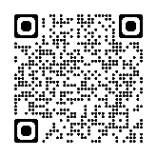Read this article about military linguist for more information: [www.defence.gov.au/news-events/news/2022-12-22/linguists-vital-relationship-building](http://www.defence.gov.au/news-events/news/2022-12-22/linguists-vital-relationship-building)
* Watch the video clip about being a military linguist for the Australian Defence Force. Type on YouTube [How Australian Military Linguists Learn Languages Fast](How%20Australian%20Military%20Linguists%20Learn%20Languages%20Fast) or scan the QR Code to the right.
* 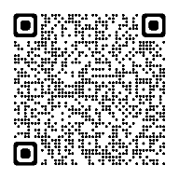For more practice with the words you’ve learned here, scan the QR code.
* This lesson links with 🡪 Lesson – Military Exercises

Lesson – Humanitarian Aid

© Commonwealth of Australia 2023  
This work is copyright. Apart from any use as permitted under the Copyright Act 1968 (Cth),   
no part may be reproduced by any process without prior written permission from the Department