

**Military English**

Vocabulary Builder – Types of Army Weapons (Infantry)

**Overview:**  
This worksheet lists vocabulary for types of weapons used by the army.

**In this vocabulary builder, you will:**

* use vocabulary related to types of army weapons.

1. Label the weapons. Use the words in the box below (continues next page).

**weapon (n)** /ˈwepən/ - Something people use for fighting or protection e.g. a knife, a bomb.

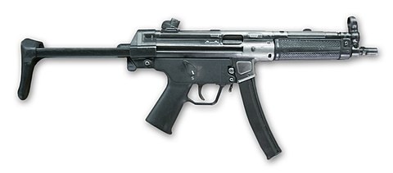

a. _______________________

MP5 9mm

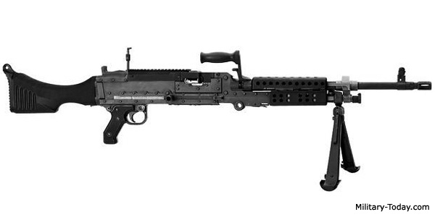

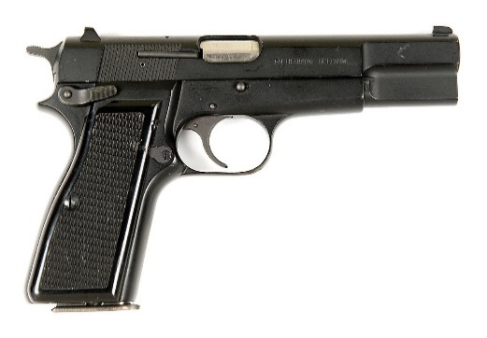

e. _______________________

Browning 9mm Mark 3

MAG58

b. _______________________

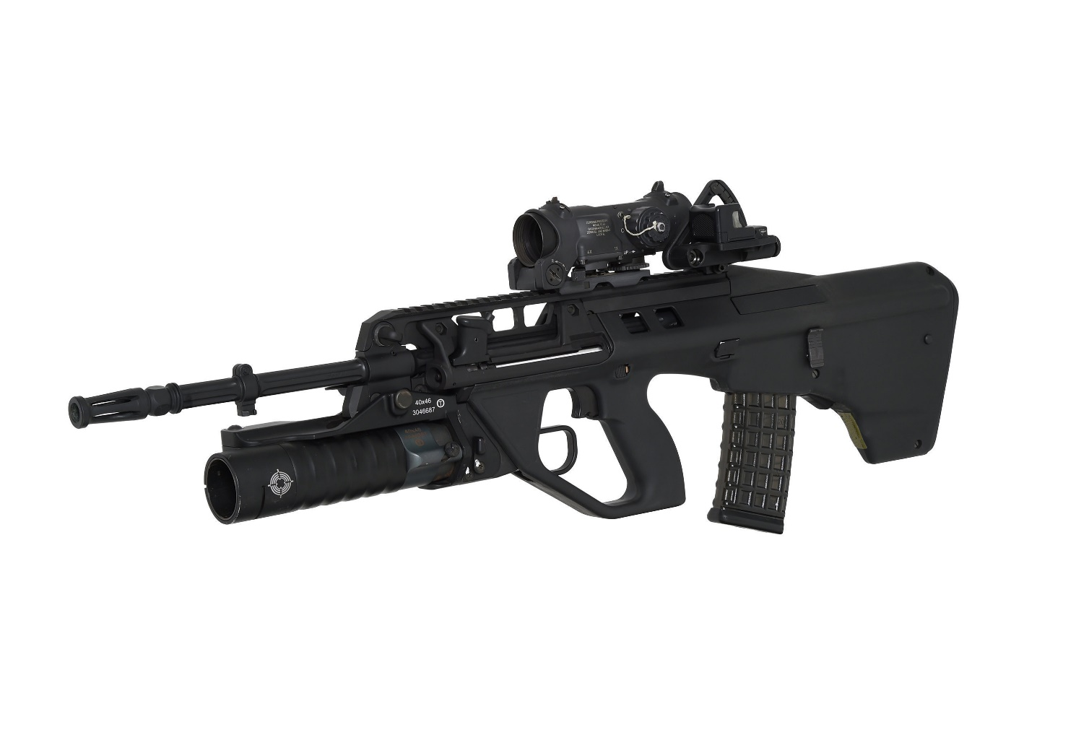

d. _______________________

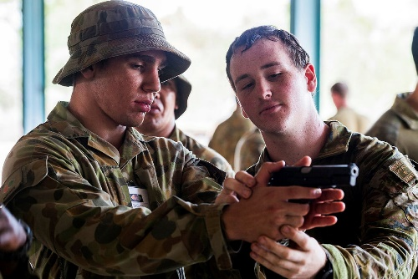

c. _______________________

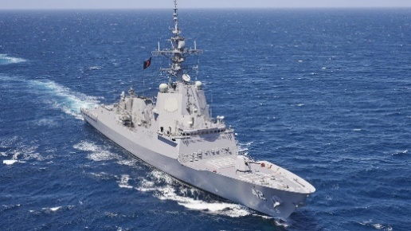

Steyr EF88

SL40

assault rifle // machine gun // pistol // submachine gun // grenade launcher

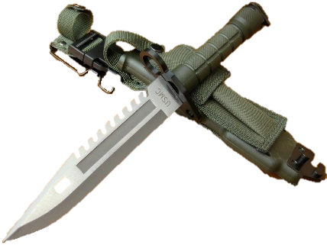

M9

f. _______________________

g. _______________________

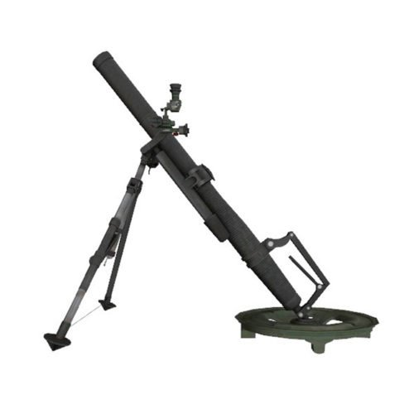

j. _______________________

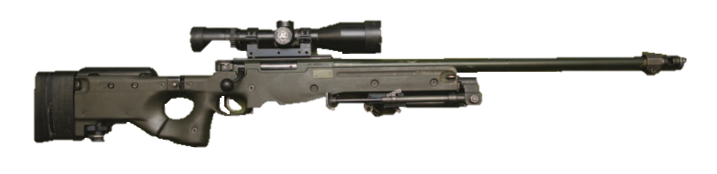

SR98

M224A1

This is also called an **anti-personnel** **mine**.

k. _______________________

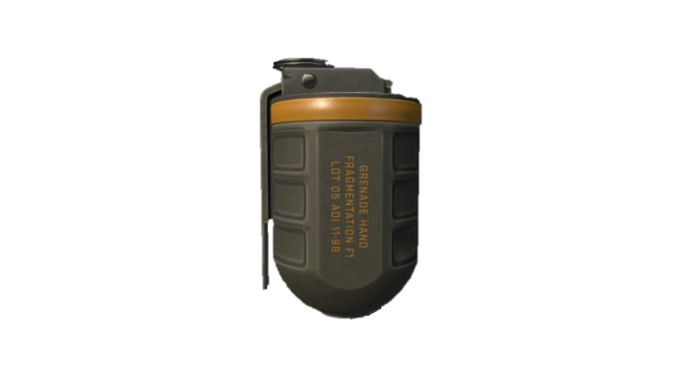

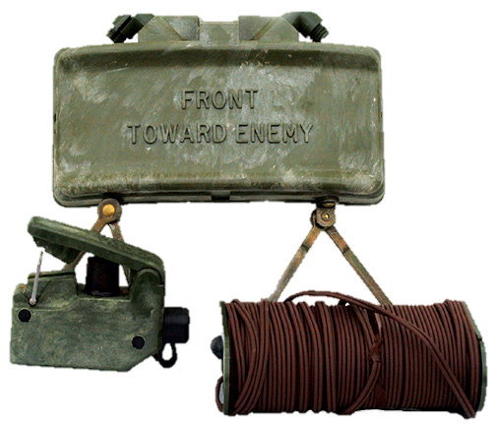

l. _______________________

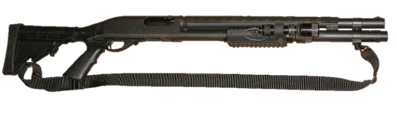

i. _______________________

F1

M18A1

h. _______________________

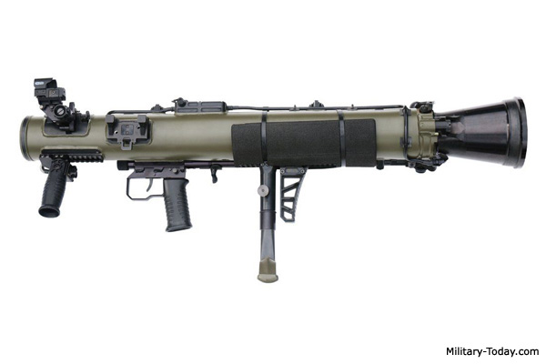

M4 Carl Gustav

Remington 870P

mortar // grenade // claymore // bayonet // sniper rifle // recoil-less rifle // shotgun

1. Now let’s listen to the words practised in this worksheet. Listen and repeat.
2. Can you remember the types of weapons from pages 1 and 2? Unscramble the words under the pictures and write them in the space. Look at the example.

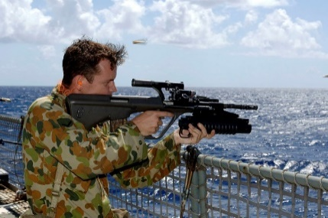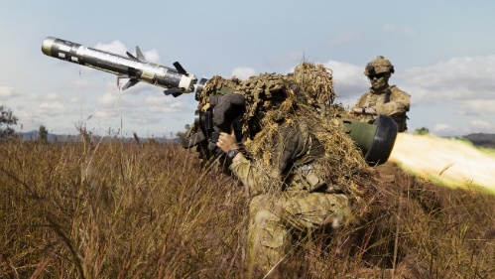

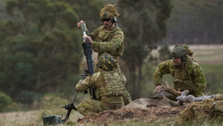

b. __ __ __ __ __ __-

__ __ __ __ __ __ __ __ __

ICOERL-LSSE RLFEI

a. g r e n a d e

l a u n c h e r

DEGNREA LNAHRUCE

c. __ __ __ __ __ __

MTORRA

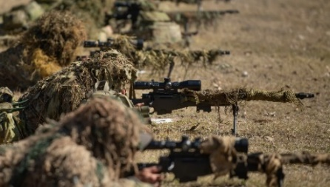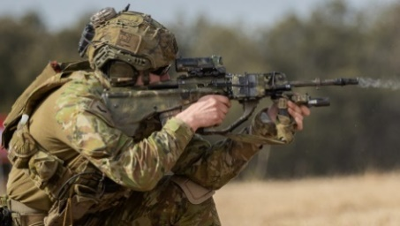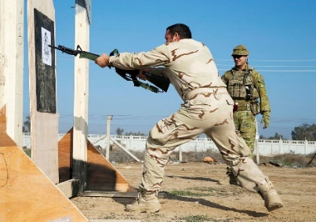

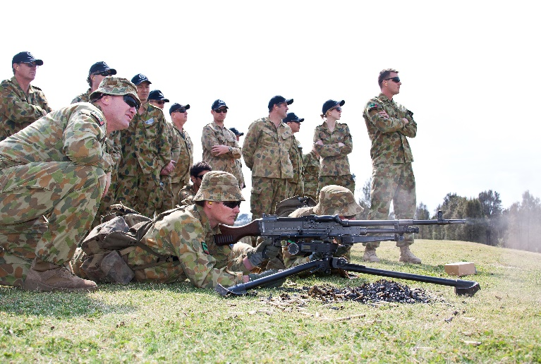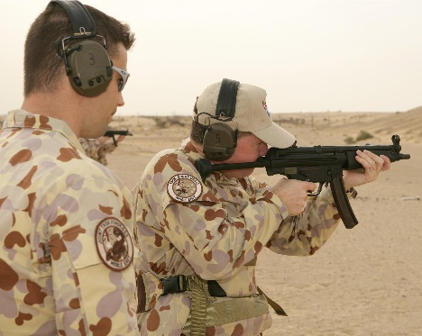

f. __ __ __ __ __ __

__ __ __ __ __

PSRNIE FLERI

e. __ __ __ __ __ __ __

__ __ __ __ __

STSAAUL LRIEF

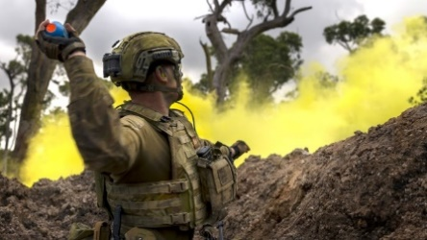

i. __ __ __ __ __ __ __

NGEREAD

h. __ __ __ __ __ __ __

__ __ __

MINHEAC NGU

g. __ __ __ __ __ __ __ __ __ __ __ __ __

HIASUEBMCN UNG

d. __ __ __ __ __ __ __

ONAEBTY

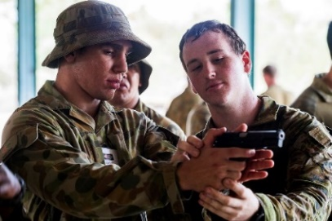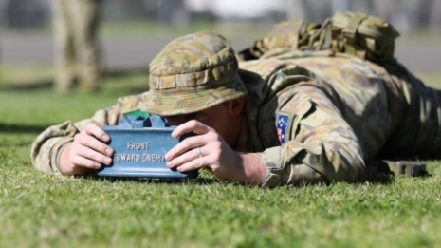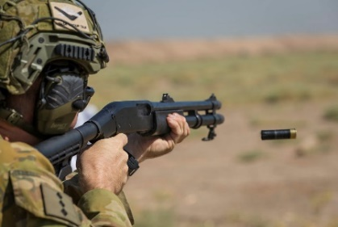

l. __ __ __ __ __ __ __

USNOGTH

k. __ __ __ __ __ __

TOPILS

j. __ __ __ __ __ __ __ __

RECLMAYO

1. Talk to your partners and discuss the questions.
2. Which of the weapons do you know how to use?
3. When and where did you use them?
4. Which have you NOT used before?
5. Which of the weapons from this lesson can you find in the army of your country?

* This lesson links with 🡪 Lesson – Jungle Warfare Training

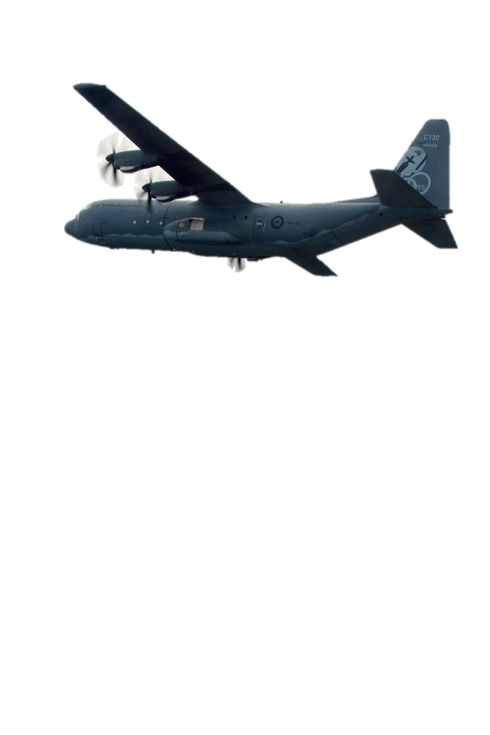© Commonwealth of Australia 2023  
This work is copyright. Apart from any use as permitted under the Copyright Act 1968 (Cth),   
no part may be reproduced by any process without prior written permission from the Department of Defence.