
Military English
Vocabulary Builder – Terrain features

Overview:
This worksheet lists vocabulary related to features of topography (the forms and features of land surfaces) and terrain (the physical features of an area of land).
In this lesson, you will:
- learn vocabulary related to features of land
- practise vocabulary of terrain
- practise using the vocabulary

- Look at the pictures – match the word from the box below with its correct picture. One of them is done for you.
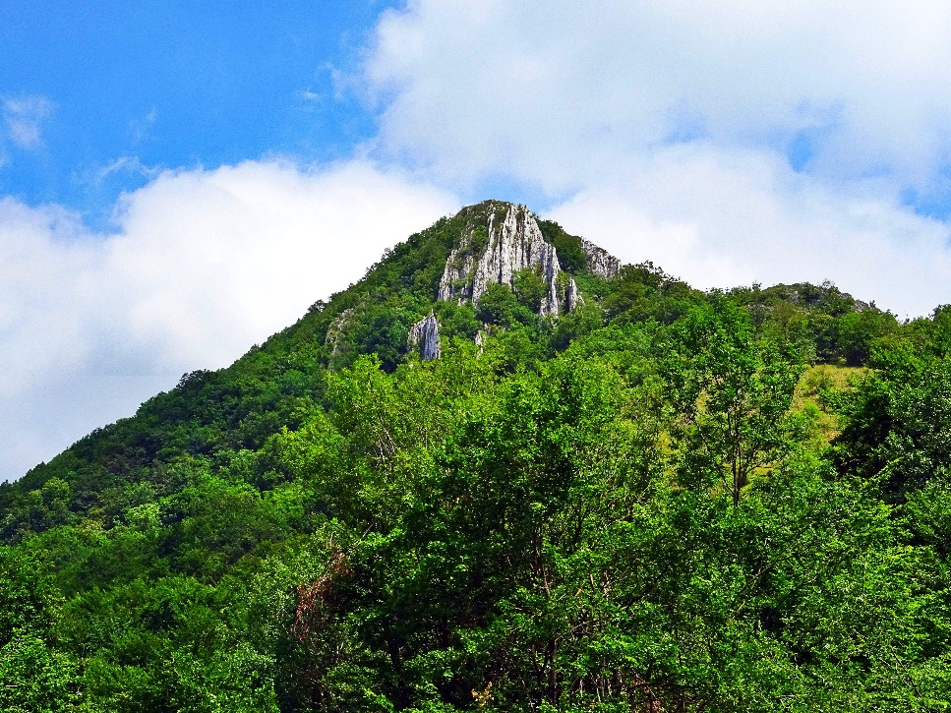
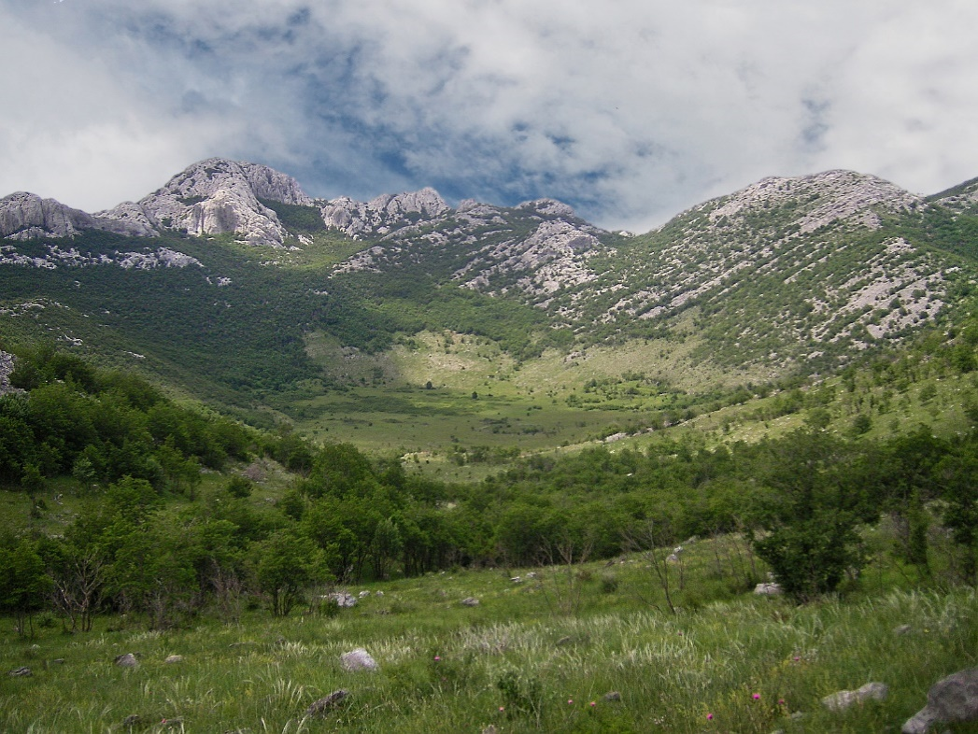

c. _________________________
a. _________________________
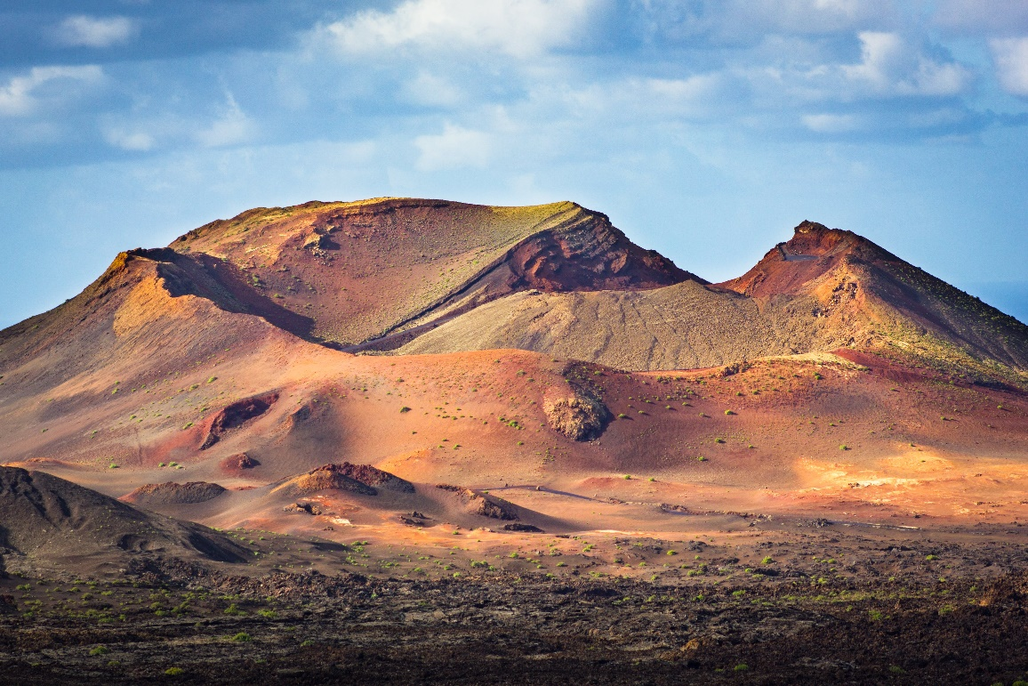
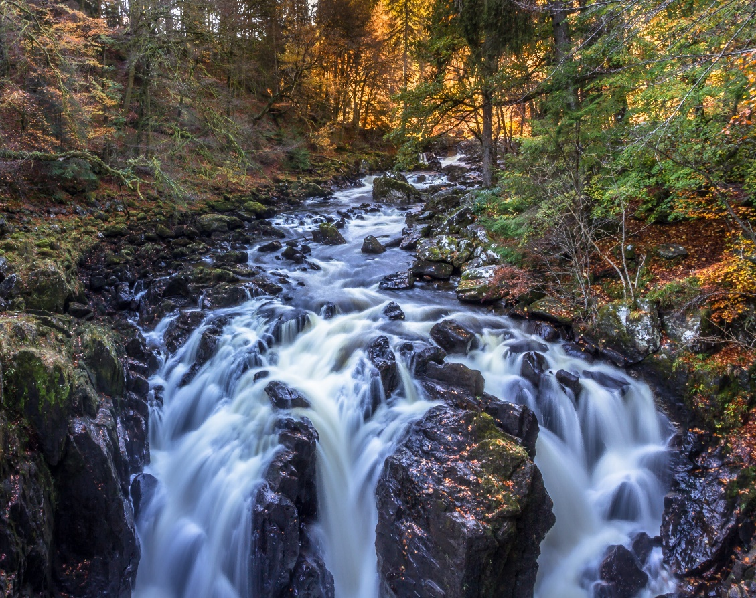

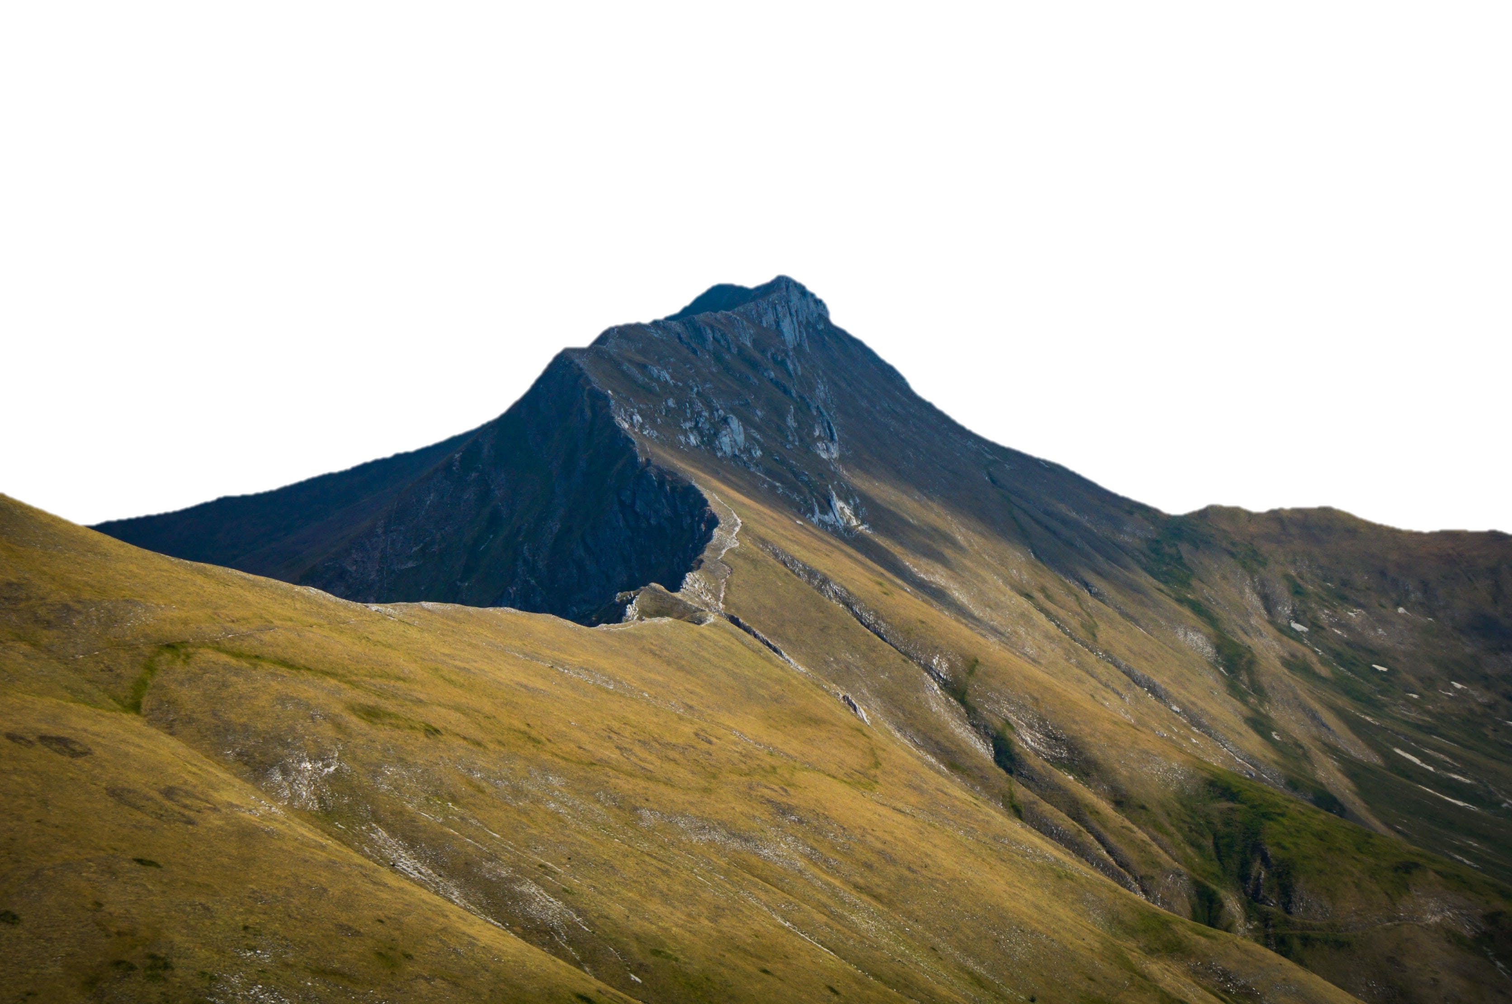
d. _________________________
b. _________________________

e. _________________________
ridge
ridge // hill (or mountain) // depression // saddle // stream

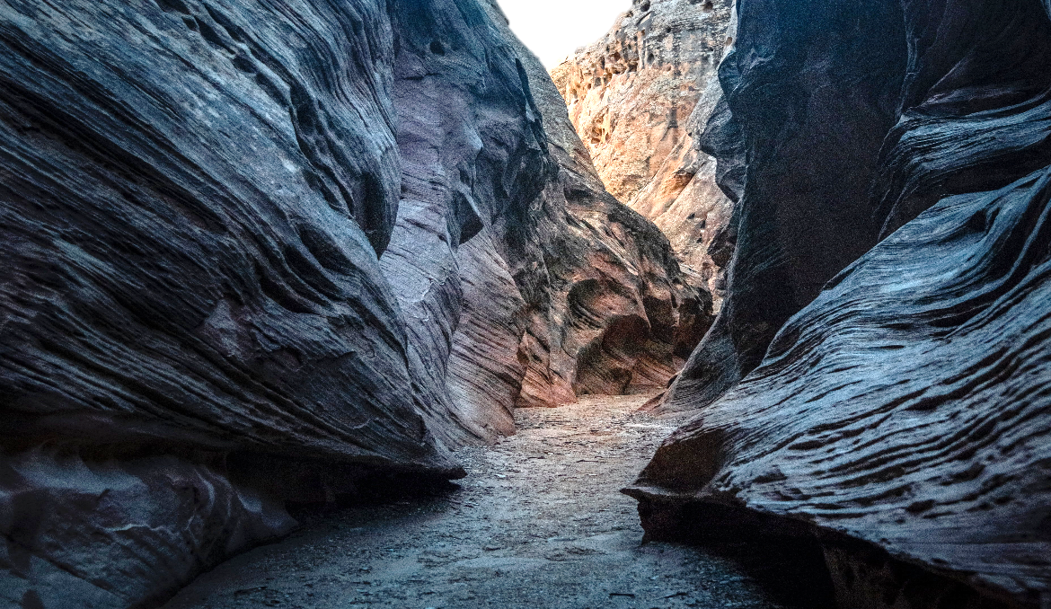
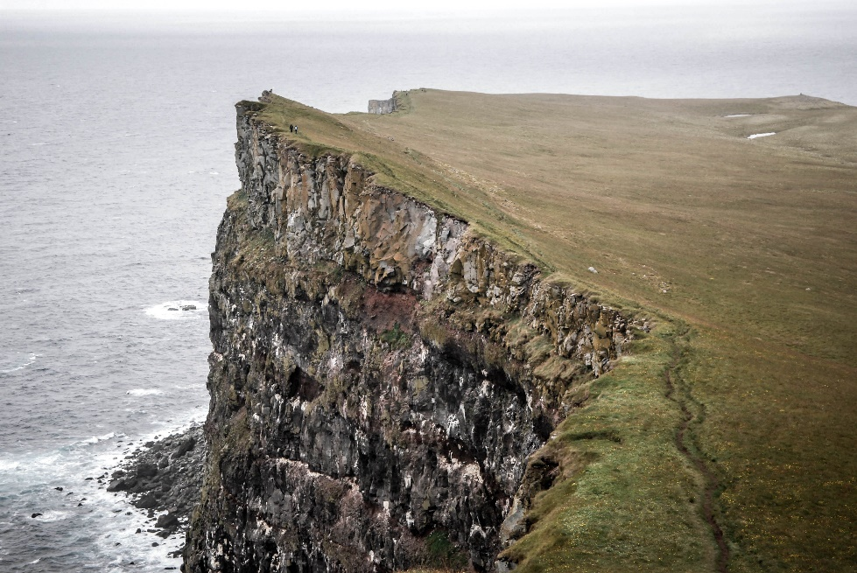
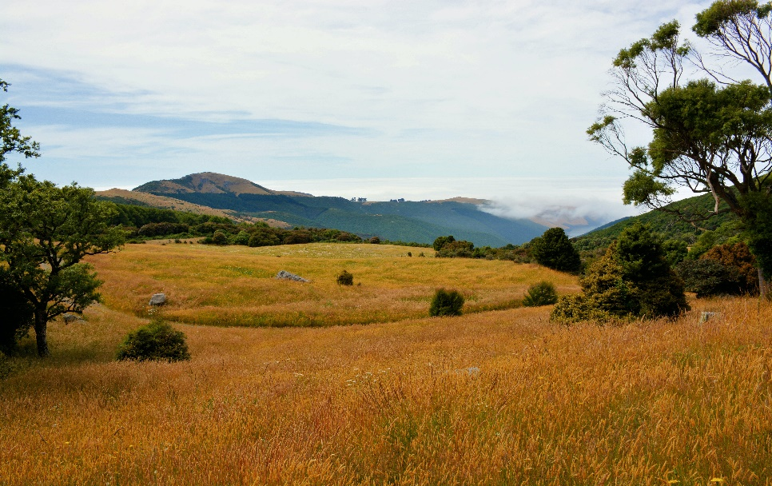
j. _________________________

f. _________________________

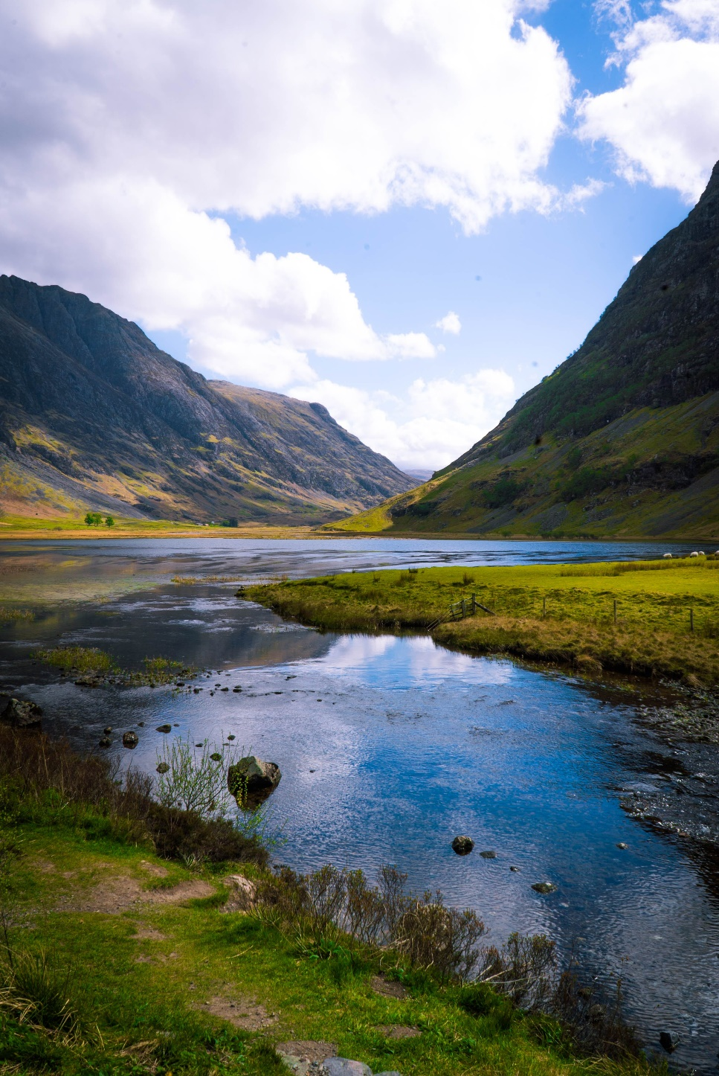

g. _________________________
k. _________________________
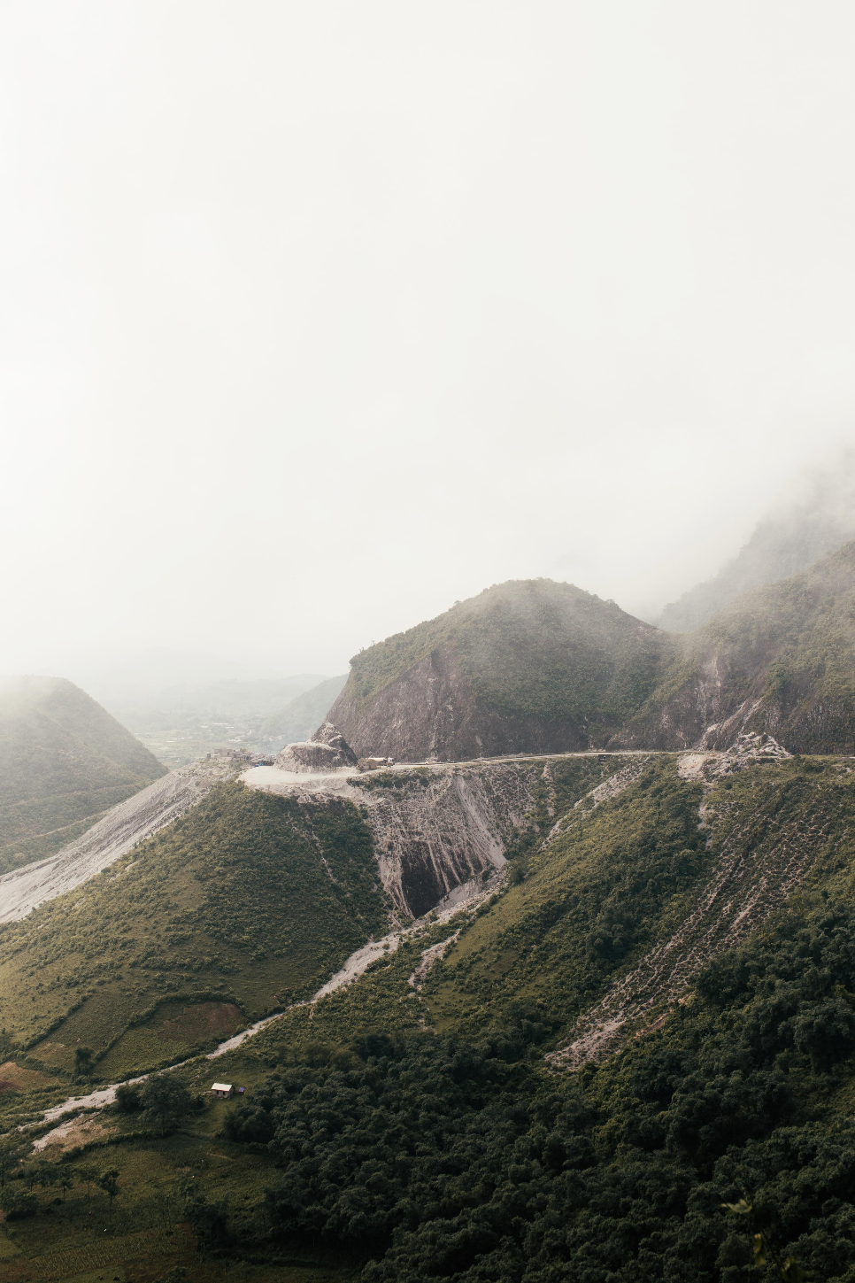

l. ___________________
h. _________________________
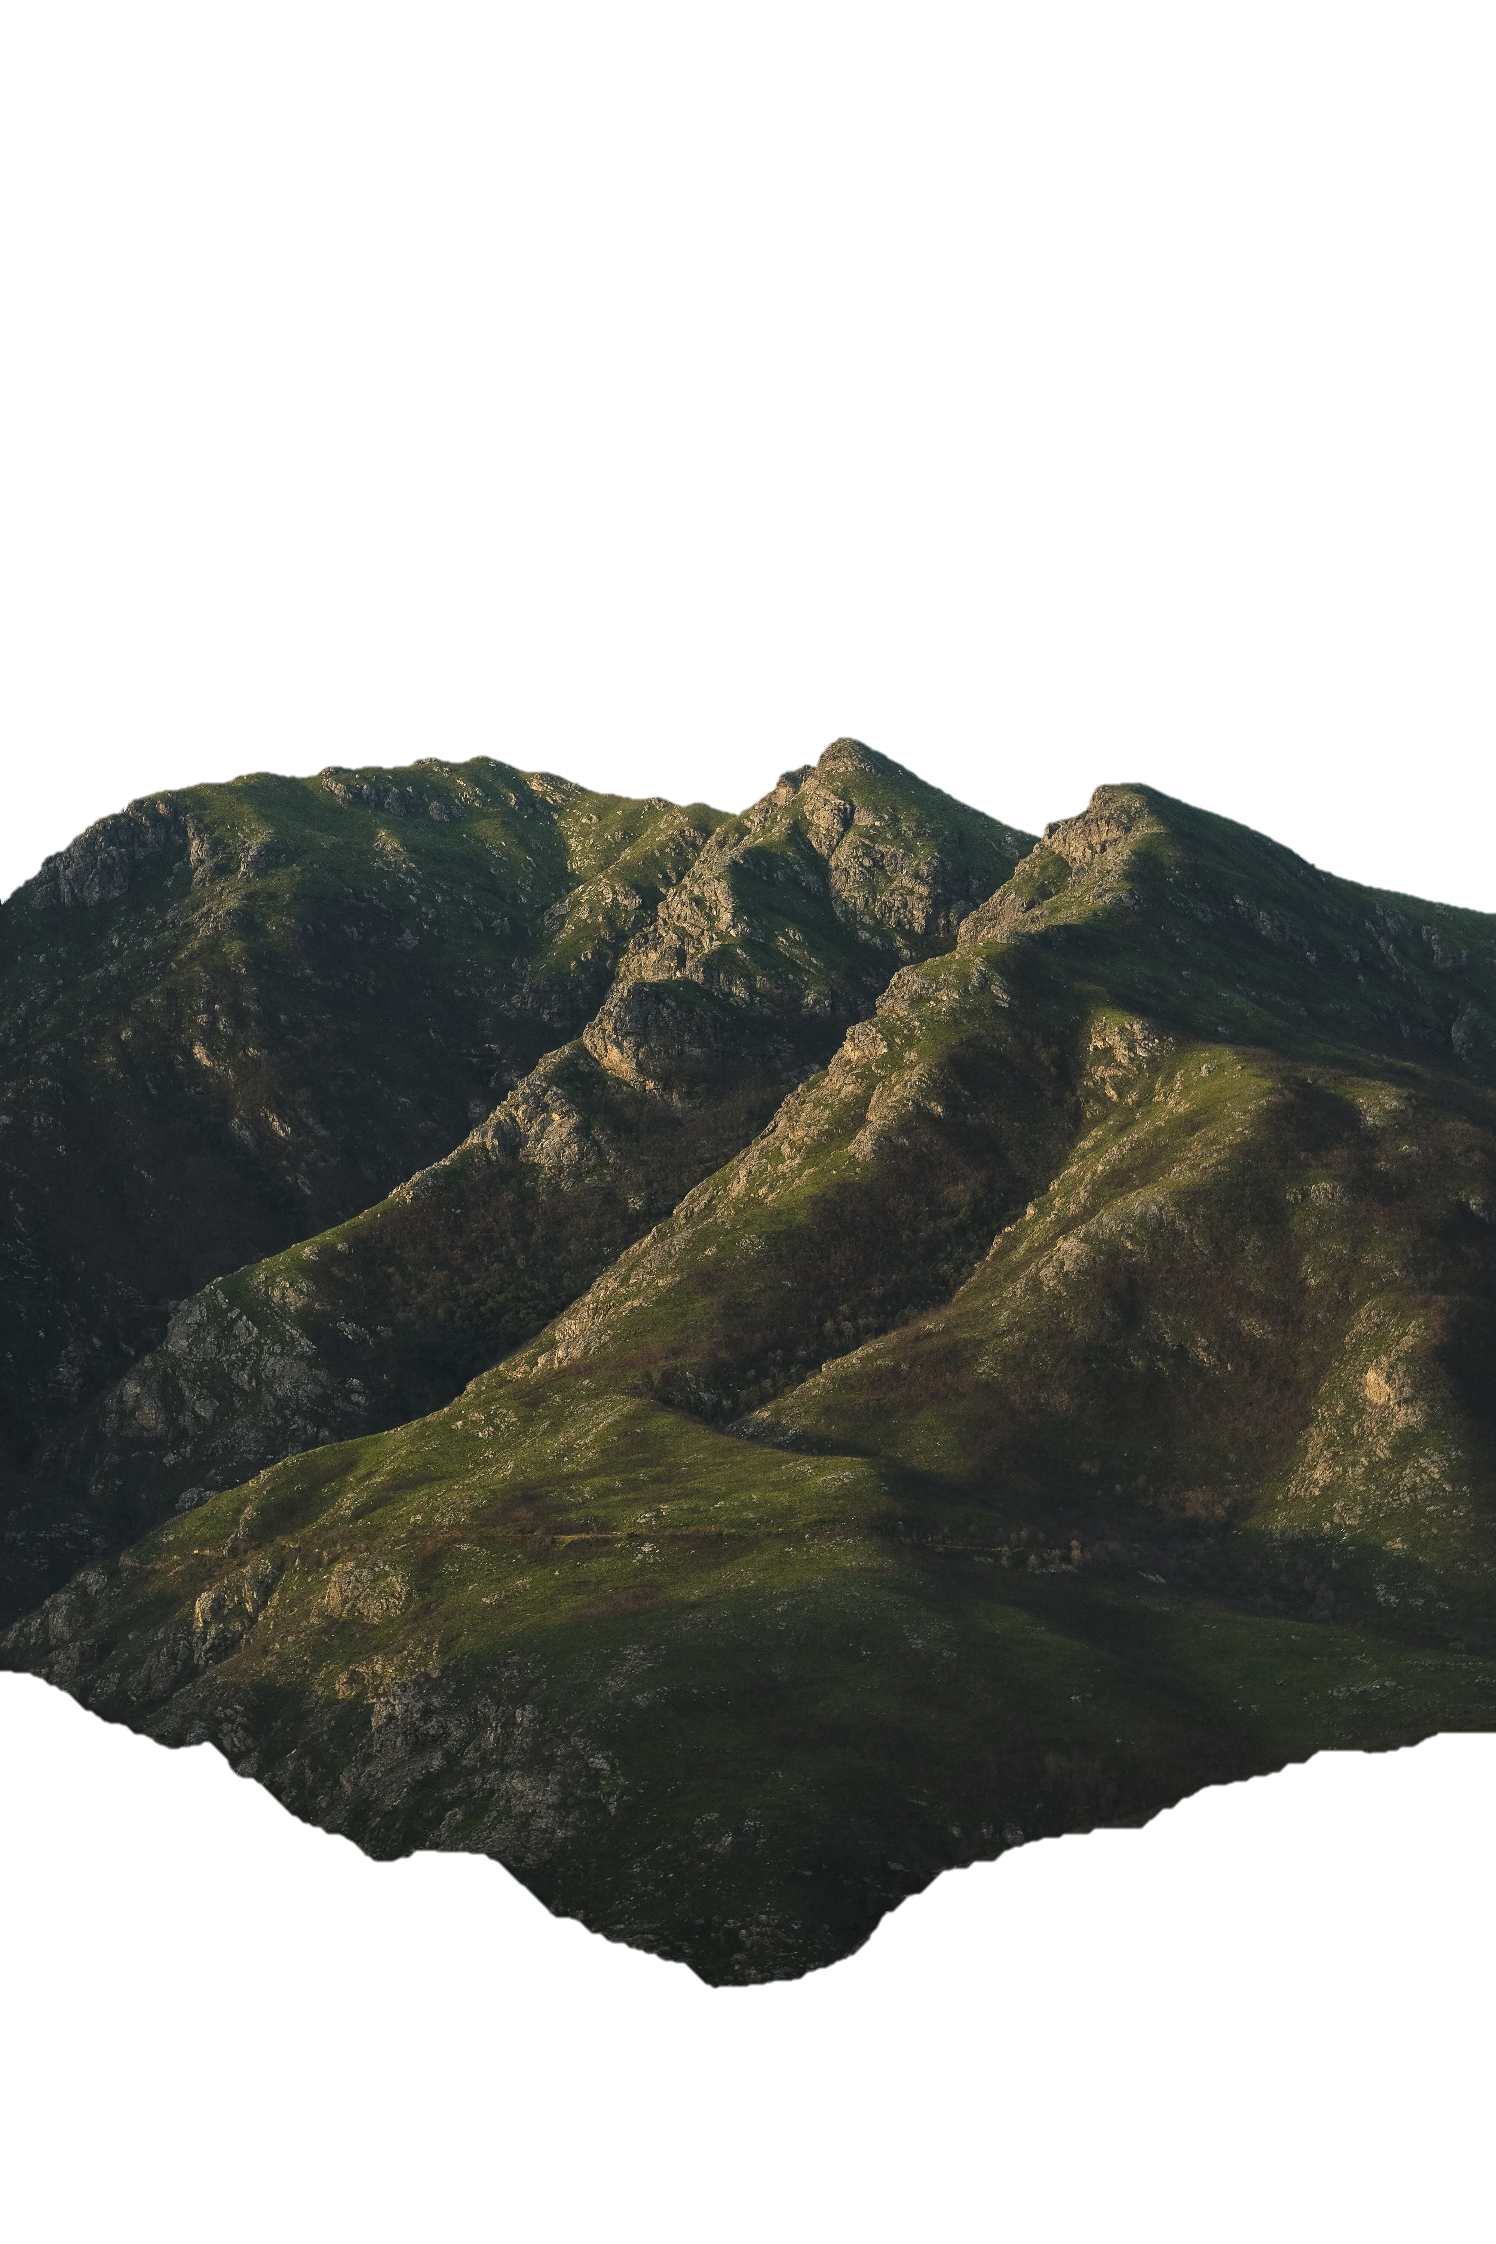

i. _________________________

valley // crest (or peak) // level ground // spur // cliff // ravine // gully
- Now let’s listen to the words practised in this worksheet. Listen and repeat.

- Look at the pictures in this exercise. On the left is how this terrain feature looks on a topographic map using contour lines.
From the same box of words in Ex. 1, write the correct word into the box.
Be careful, you won’t use all the words from Ex. 1
A topographic map shows the types of terrain like mountains and rivers. It uses contour lines to describe how high (or low) the land is, and also what kind of land form it is.

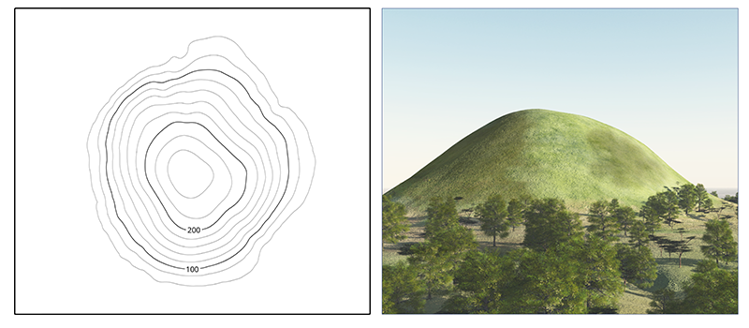

a. _________________________

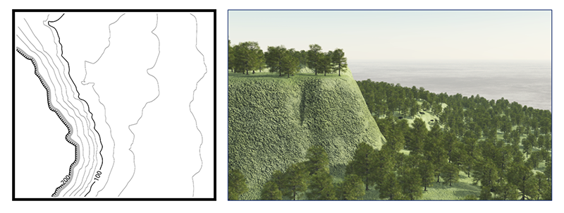

b. _________________________

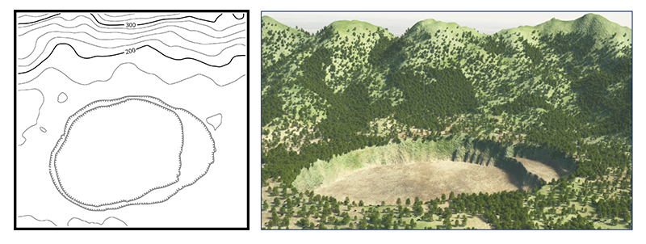

c. _________________________
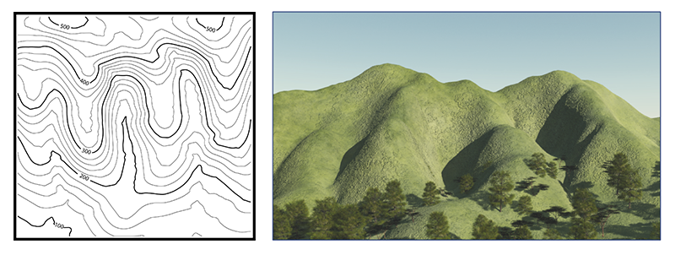
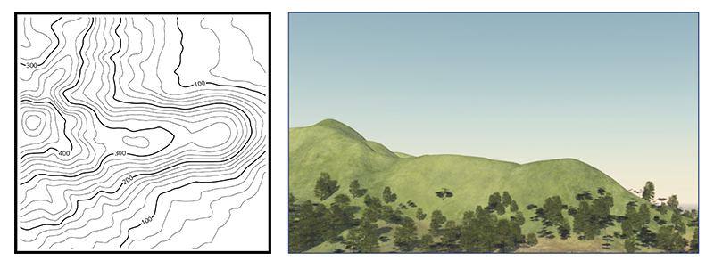
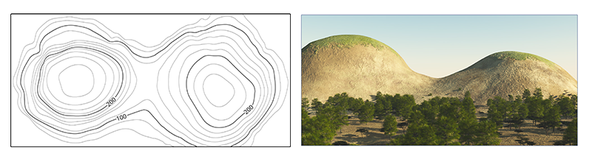
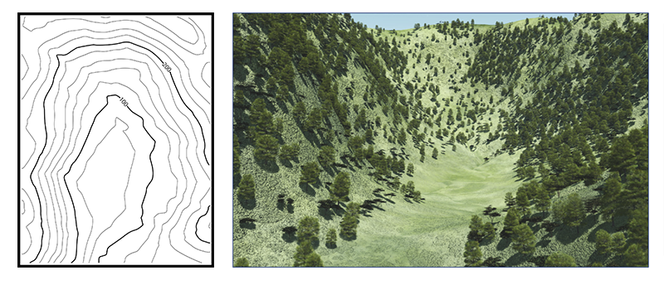
credit (pg 3, 4): NPA NSW
f. _________________________
e. _________________________
d. _________________________
g. _________________________
- Answer these questions about some of the words you matched with the pictures in Ex 1 and 2. Use the pictures to help you. Circle the correct words in bold. The first one is done for you.
hill (mountain)
Is this high ground or level ground?
If you are on top of the hill / mountain, does the land
around you go down or up?

ridge
Is this just one part of a hill (mountain), or more than one?
If you are standing on this, is it wide or narrow?
If you are standing on this, are you at the top of the mountain, or do you need to walk more to the top?

valley
Is this between hills (mountains), or on top of them?
If you are in a valley, does the land around you go up or down?
Does a valley often have water in it? Yes. No.

saddle
Is this a higher point or is it a low point between parts of a mountain?
Which is deeper, a valley or a saddle?

ravine
Is this between hills/mountains or on top of them?
If you are in a ravine, do you have a lot of space around you? Yes. No.

depression
Is this high ground or low ground?
Is this ground lower than the area around it or higher?

stream
Is this land or water?
Is it a little river or a big river?

crest (peak)
Is this low down or up high?
Is it the highest point on the mountain? Yes. No.
Is there anything higher than this? Yes. No.

spur
Is this part of a hill (mountain)? Yes. No.
Does it come out from the hill? Yes. No.
If you are standing on this, is the land around you going down on all sides or only three sides?
level ground
Is this flat or high ground?

cliff
Is this like the side of a hill (mountain)? Yes. No.
Is the side of the mountain going like this: or like this: ?

gully (draw)
Is this like a valley? Yes. No.
Is it small or big?
Does this have water in it? Yes. No.

- Read what the soldiers are saying in the sentences below. Can you use one word instead of all the words in brackets ( )? Look at the example done for you.
Check your answers with a partner after you have finished.

- Let’s meet at 1000hrs at the (top most part of the mountain) crest / peak.
- We will move up this (high ground) _______________________ and across the (low land between the two hills) ________________________, and then split into two groups.
- Two of you patrol on the left side of this (little river) __________________ near the trees, and you other two ……
- We need to meet our interpreter at a town in this (land between the two mountains) _________________.
- Put your fire team on the (hill with the straight sides) _________________ over there.
- That (narrow space between those two mountains) _____________________ looks like a good place to wait.


- Watch a video about terrain features. Type on YouTube Identify Terrain features on a map or scan the QR code to the right (US English).
Tick the words from this lesson that you see / hear in this short video.

- This Vocabulary Builder links with Lesson: Map Reading and Navigation

© Commonwealth of Australia 2023
This work is copyright. Apart from any use as permitted under the Copyright Act 1968 (Cth),
no part may be reproduced by any process without prior written permission from the Department of Defence.

