

**Military English**

Vocabulary Builder: Types of Military Aircraft - Fixed Wing

**Overview:**  
This worksheet presents vocabulary related to types of fixed wing military aircraft.

**In this lesson, you will:**

* use vocabulary related to fixed wing military aircraft.

1. Label the pictures of different types of aircraft. Use the words in the box below.

**aircraft** (plural: aircraft) = a flying machine. There are 2 types of aircraft; fixed wing aircraft = airplanes; rotary wing aircraft = helicopters

training aircraft // fighter aircraft // UAV (unmanned aerial vehicle) // transport aircraft

This is also called   
a **cargo aircraft**.

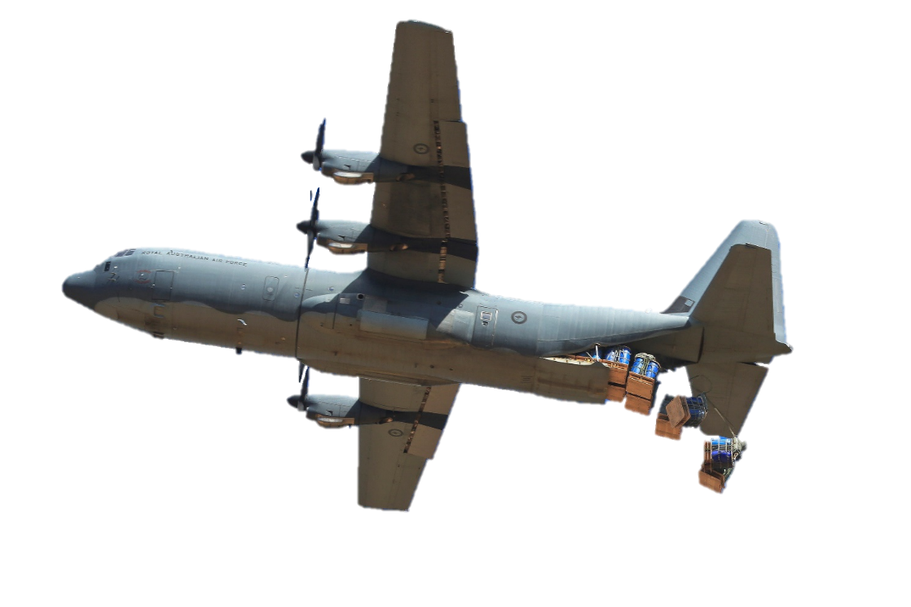

c. ___________________

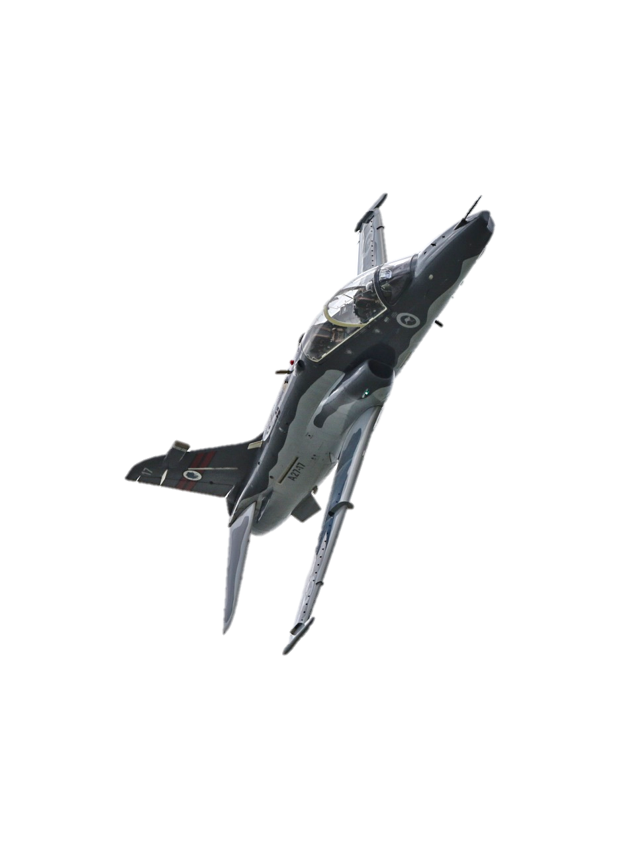

C-130J-30 Hercules

d. ________________________

a. ________________________

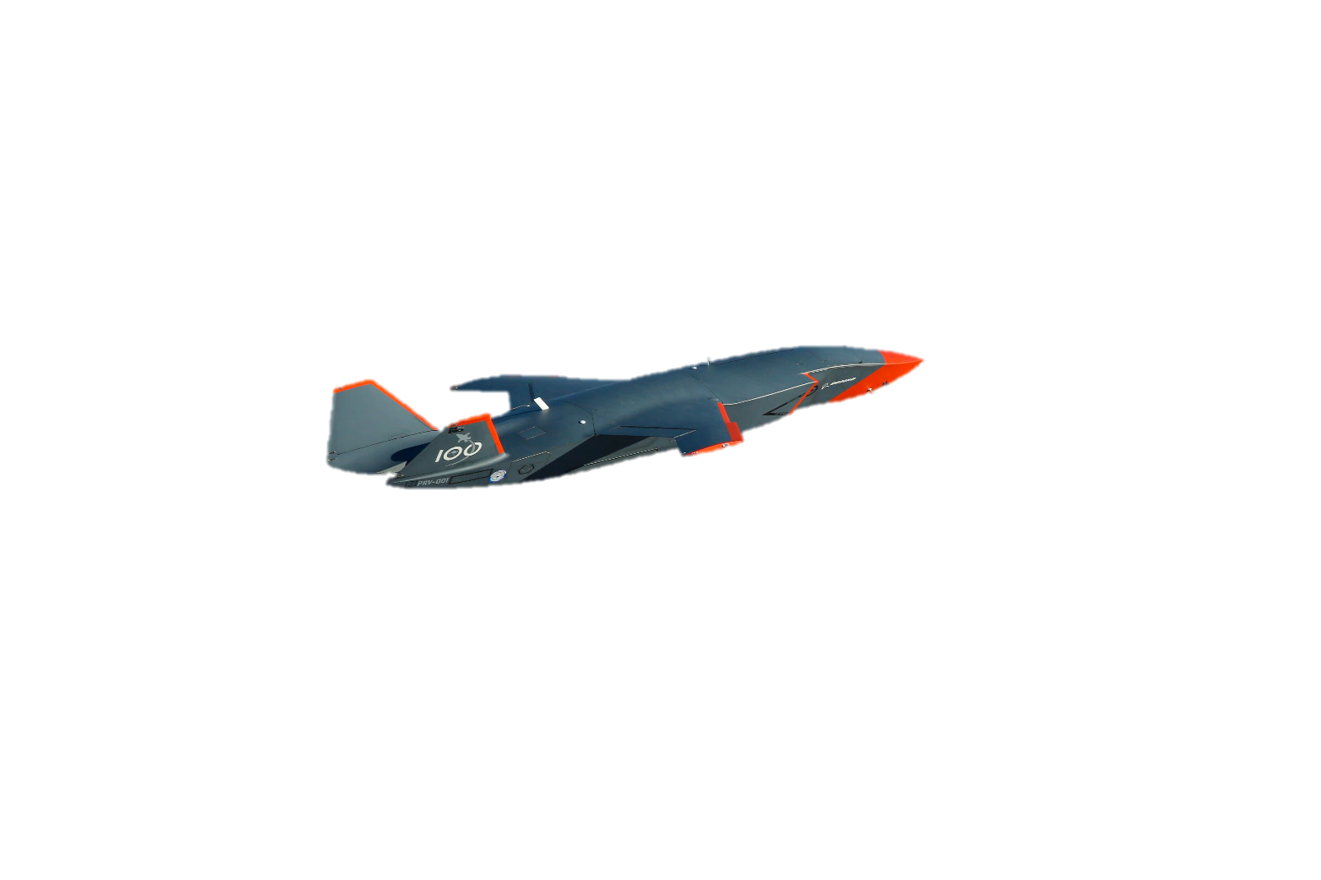

Hawk 127

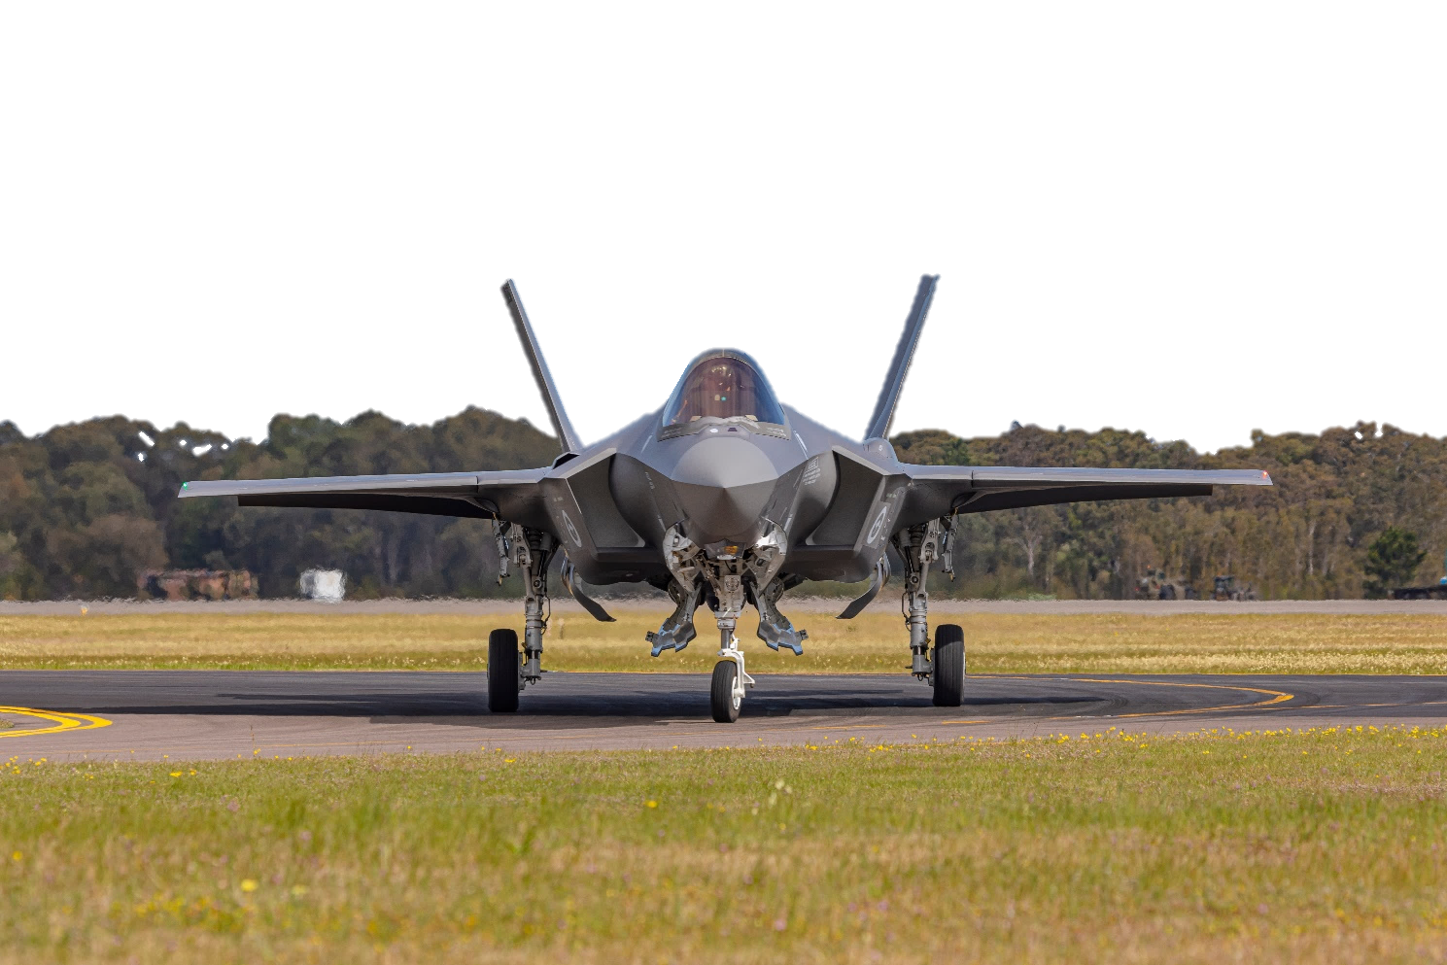

MQ-28 Ghost Bat

F-35A Lightning II

b. _________________________

1. Continue to label the pictures. Use the words in the box below.

airborne early warning and control (AEW&C) // bomber // maritime patrol aircraft //   
light attack aircraft // tanker aircraft // electronic warfare aircraft

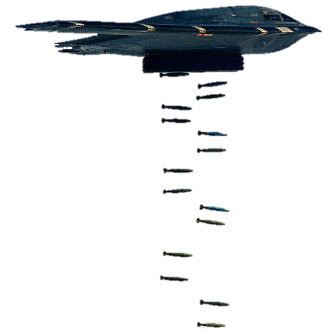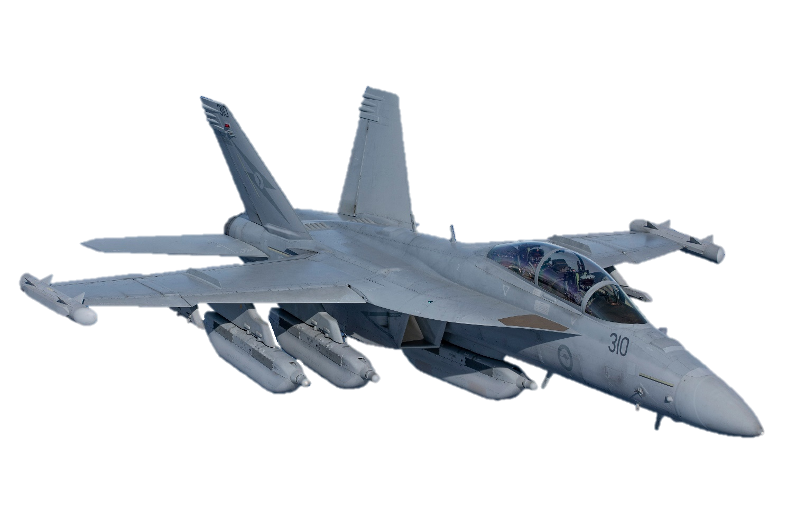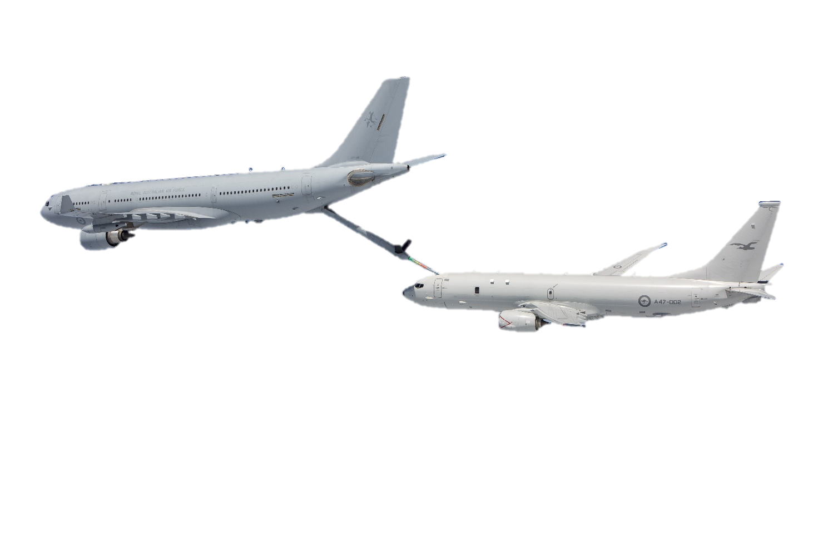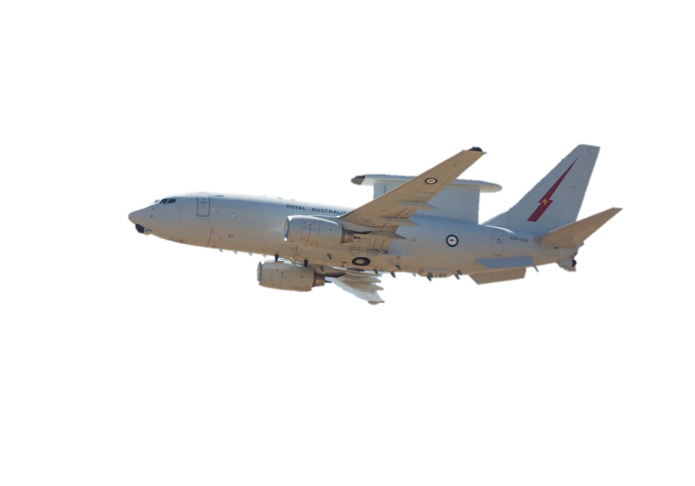

A330 MRTT

E-7A Wedgetail

P-8A Poseidon

EMB 314 Super Tucano

B-2 Spirit

EA-18G Growler

This is a **stealth aircraft**.   
It is very hard for an enemy radar to see it.

e. _________________________

This aircraft can also carry a lot of people.

This is also a surveillance aircraft. **Surveillance aircraft** are used for watching what’s happening over an area. They have cameras, computers and other equipment.

h. ________________________

f. ________________________

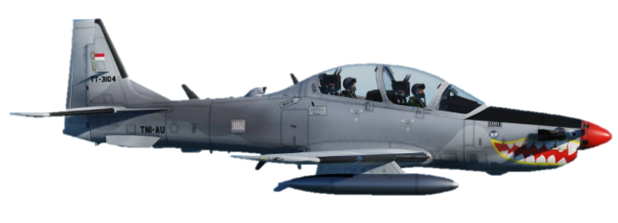

This is also called a **ground attack aircraft**. Australia does not have this type of aircraft. Pictured here is an aircraft from the Indonesian Air Force.

i. ________________________

g. ________________________

j. _____________________________________

1. Let’s practise saying the words from exercises one and two. Listen and repeat.
2. What is each aircraft used for? Write the letter next to the type of aircraft, then check your answers with a partner.

**This aircraft is like a flying fuel tank that can refuel other aircraft in the air.**

**C**



* transport (or cargo) aircraft: _____
* electronic warfare aircraft: _____
* fighter aircraft: _____
* tanker: _____
* light (or ground) attack aircraft: _____

**This aircraft has a lot of weapons and is usually used to destroy enemy aircraft. They are smaller and very fast.**

**A**



**This aircraft has sensors and radars that confuse enemy aircraft. It makes it difficult for enemy aircraft to attack.**

**D**



**This is a smaller aircraft used to attack targets on the ground, usually enemy vehicles like tanks and trucks, and buildings.**

**B**



**This aircraft is like a flying truck. It has a lot of space to carry large and heavy objects. It can also carry a lot of soldiers.**

**E**



1. What about your country? What types of fixed-wing aircraft do army, navy and air force have? Discuss with a partner.

* This lesson links with 🡪 Vocabulary Builder – Military Vehicles

Vocabulary Builder – Parts of an Aircraft

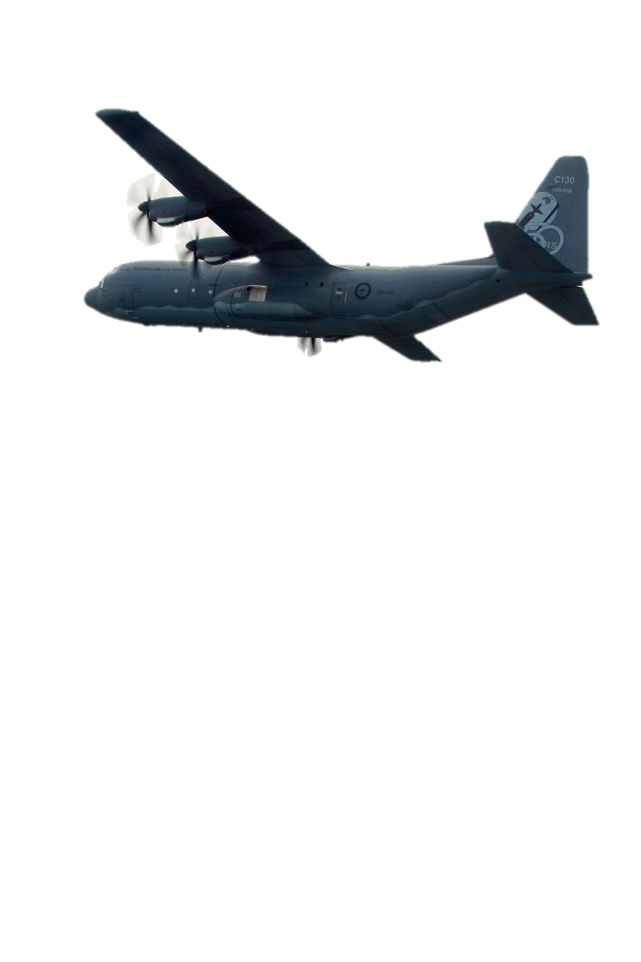© Commonwealth of Australia 2023  
This work is copyright. Apart from any use as permitted under the Copyright Act 1968 (Cth),   
no part may be reproduced by any process without prior written permission from the Department of Defence.