

**Military English**

Lesson: At a Firing Range - Listening

**Overview:**  
This lesson is about vocabulary used at a firing range, especially the words of command that a range Officer in Charge uses.

**In this lesson, you will:**

* practice reading
* listen for gist
* listen for detail
* learn the meaning of new words in context
* practise using new words

## Prepare for Listening

1. Discuss these questions with a partner.

## How often do you do weapons training?

## Which weapons do you use at the firing range?

## Are you a good marksman?

**marksman** (n) – someone (male or female) who is good at using weapons such as:

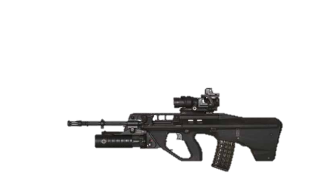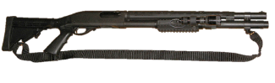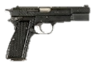

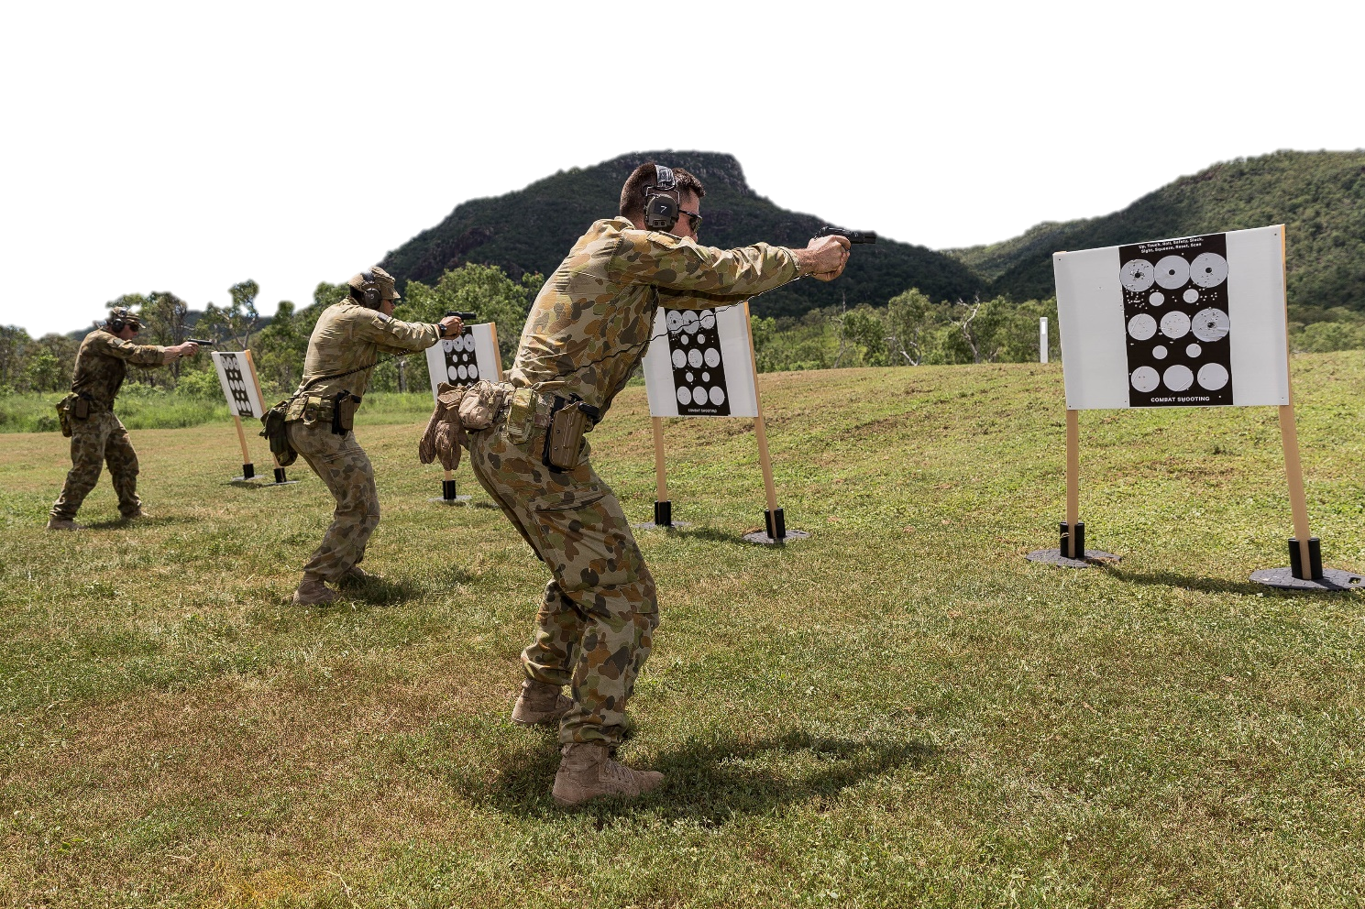

## Listening

1. At a shooting practice, it’s important to listen and follow instructions. Listen and match the instructions you hear to the headings below. The first one is done for you. Then, check your answers with a partner.
2. orders just before shooters start shooting RECORDING ____
3. instructions on how the shooting practice will happen RECORDING ____
4. orders just after the shooting is finished RECORDING ____

1

1. instructions on how to be safe at the range RECORDING ____s
2. Listen to the recording again to check your answers.
3. Listen to the recording one more time and choose the correct answer. Look at the example.
4. Who is speaking?
5. the Commanding Officer
6. the range Officer in Charge (OIC)
7. How many people are doing the practice?

pistol:

assault rifle:

1. 9



1. 25
2. What weapon are the shooters going to use?
3. pistol
4. assault rifle
5. The shooters will have to shoot quickly
6. yes
7. no

## Learning Military Vocabulary

1. The words in bold in the text are important military vocabulary that you should learn to use. Match the military words on the left to their definitions on the right on tables one, two and three.  
   Look at the example.

|  |  |  |  |  |  |  |
| --- | --- | --- | --- | --- | --- | --- |
| Table one |  | |  |  | | |
| we’ll have one **detail** of 5 shooters (n) | |  | | |  | 1. How to Tell if a Gun Safety Is Onto make a weapon safe by pressing a button or lever | |
| we’ll have one detail of 5 **shooters** (n) | | **d** | | |  | 1. = bullets | |
| you don’t take your **weapons** there (n) | |  | | |  | 1. an object such as a knife, gun, bomb, etc. that people use to fight or attack somebody | |
| one magazine of 10 **rounds** (n) | |  | | |  | **d. someone who fires a weapon such as a pistol** | |
| **apply safe** and keep your weapon pointed downrange (v) | |  | | |  | e. a group of shooters (or firers) | |

|  |  |  |  |
| --- | --- | --- | --- |
| Table two |  |  |  |
| if you hear **stop, stop, stop** (v) |  |  | 1. no time limit to fire a weapon; shooters can be as quick or as slow as they want |
| the **rate of fire** will be single shots (v) |  |  | 1. an instruction on how a shooter fires their weapon at the range e.g. single shot (one shot at a time), bursts of 3 shots (three shots at a time), etc. |
| therate of fire will be **single shots** (v) |  |  | 1. when the OIC gives this order, shooters cock their weapon (they move a part of the weapon so that it’s  ready to fire) |
| detail, **action**! (v) |  |  | 1. an order for shooters to make sure there are no rounds in the weapon; after they do this, the weapon is safe |
| you’re going to fire **in your own time** (n) |  |  | 1. when there is danger, the range Officer in Charge (OIC) says this; it means the same as ‘stop firing/shooting!’ |
| detail, **unload**! (v) |  |  | 1. this instruction means the shooter fires one shot at a time e.g. fire, aim, fire again, etc. |

|  |  |  |  |
| --- | --- | --- | --- |
| Table three |  |  |  |
| If a **firer** is injured (n) |  |  | 1. Colt M4 Carbine - For Sale :: Guns.commove the safety catch to fire |
| Detail, **take up** **your weapon**! (v) |  |  | 1. to pull the trigger of a weapon |
| Detail, **instant**! (v) |  |  | 1. someone who fires a weapon (firer = shooter) |
| Detail, **fire**! (v) |  |  | 1. pick up your weapon |
| grab your target and **patch out the target** (v) |  |  | 1. to put stickers on the target to cover the bullet holes. This means another firer can use the same target later.   stickers |

1. Now let’s practice saying the words. Listen and repeat.
2. Now use words from exercise 5 to complete these sentences. Check with a partner when you’re finished.
3. During my weapon practice test there were four _________________ so I had to wait a long time to shoot.
4. During basic training, recruits learn to clean their _________________.
5. When soldiers are not using their weapon, they must always __________________.
6. New _______________ can get quite nervous during their first weapons training.
7. The pistol I use for range practice has a magazine with 13 __________________.
8. The rate of fire in the practice session yesterday was _______________. This means I could fire a round, apply safe, breathe, move my shoulders and prepare for the next shot.
9. A: “What do the words ___________________ and ____________________ mean?

B: “They both have the same meaning; it’s the person who fires a weapon at a range practice.

1. Complete the crosswords on pages 5, 6. Work with a partner and decide who is student A and B. Student A, read the instructions on page 5. Student B, read the instructions on page 6.

**Student A – instructions:**

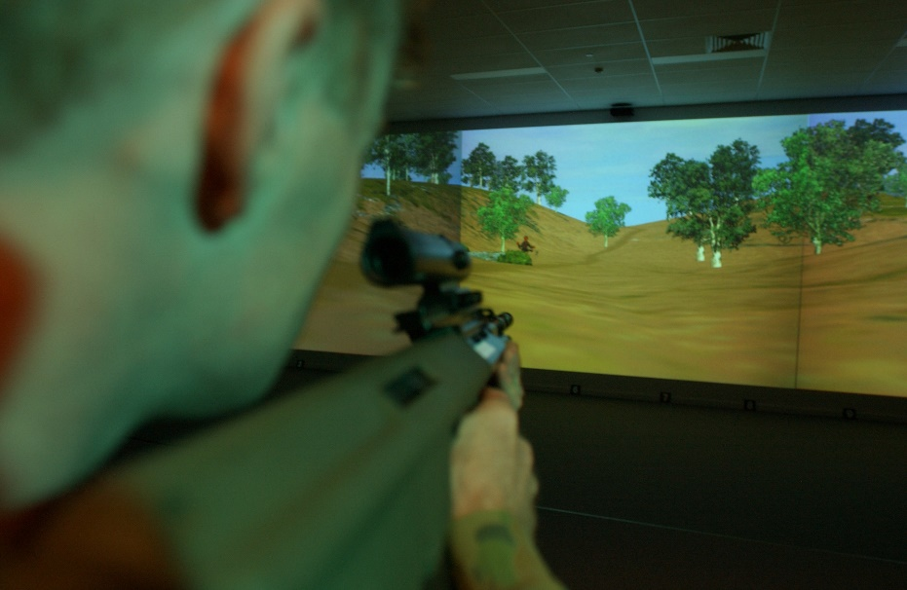

**Australian Defence Force personnel can also train their marksmanship skills on the Weapon Training Simulation System (WTSS), available in several bases around the country.**

**WTSS is pronounced /wets/**

* Stay on this page and don’t turn to page 6
* You will work on clues 1-4 below. Student B will work on the other clues.
* When you and your partner are finished, your partner will read his/her clues to you and you will have to guess the words.
* Then, you will read your clues (not the words, but the clues) to your partner. He/she will have to guess what the words are.
* 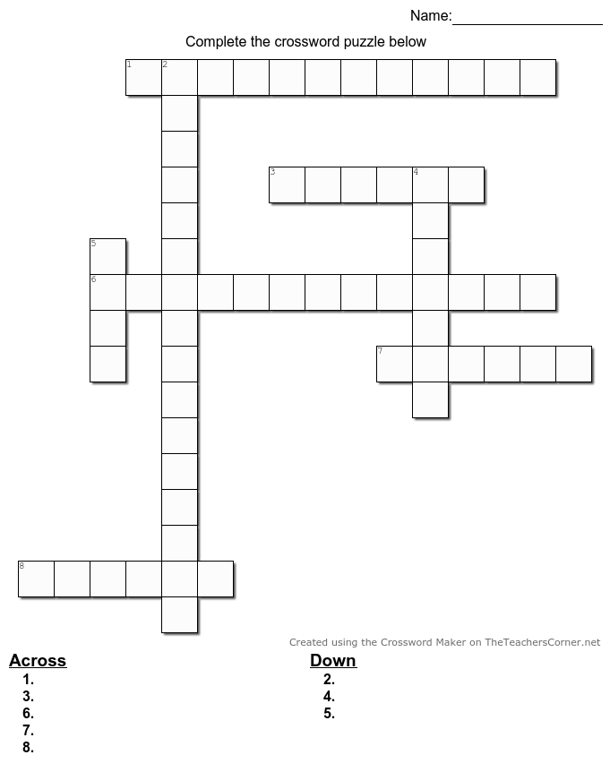Check that you have the same answers.

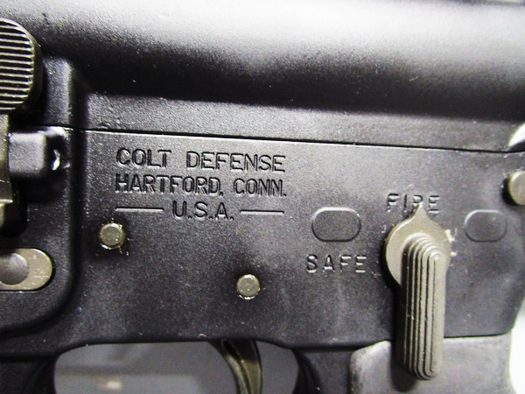

1. the range OIC says this when firers have to stop shooting immediately because of something dangerous happening at the range
2. the range OIC says this when firers have to pick up their weapons from the ground
3. a group of firers
4. the range OIC says this when firers need to set the safety catch to ‘fire’

**Student B – instructions:**

* Stay on this page and don’t turn to page 5
* You will work on clues 5-8 below. Student A will work on the other clues.
* When you and your partner are finished, you will read your clues (not the words, but the clues) to your partner. He/she will have to guess what the words are.
* Then your partner will read his/her clues to you and you will have to guess what the words are.
* Check that you have the same answers.



1. the range OIC says this when firers have to start shooting
2. this means firers don’t have to hurry when shooting; they can shoot as quickly or as slowly as they like
3. to take all the rounds off a weapon so that it’s empty
4. the range OIC says this when firers need to cock their weapons. This is one of the last orders   
   before the OIC says ‘fire!’

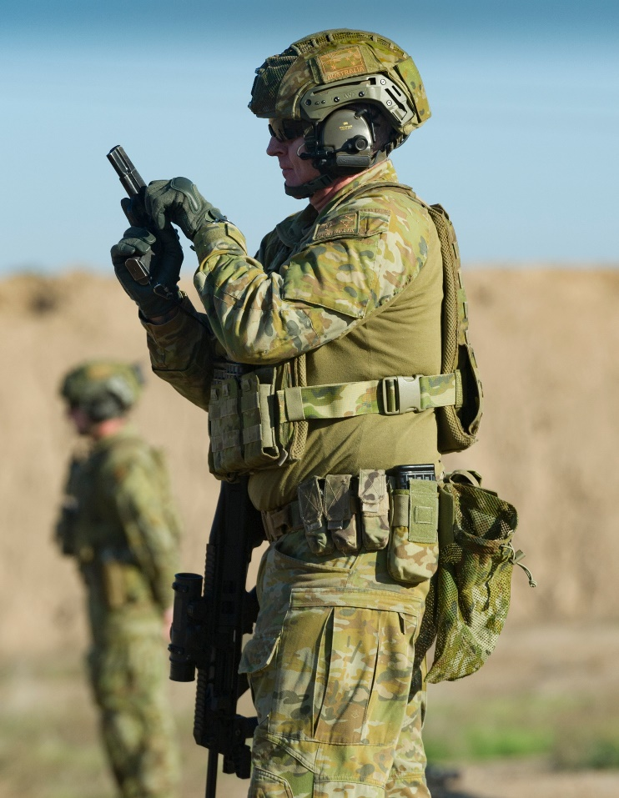

## Practice

1. Work with a partner. Explain what each **word** means in these range commands.

a. **Detail**, with the magazine containing 5 **rounds**, **action**!

b. Detail, **25 metres**, 15 rounds, **in your own time**; **instant**; **fire**!

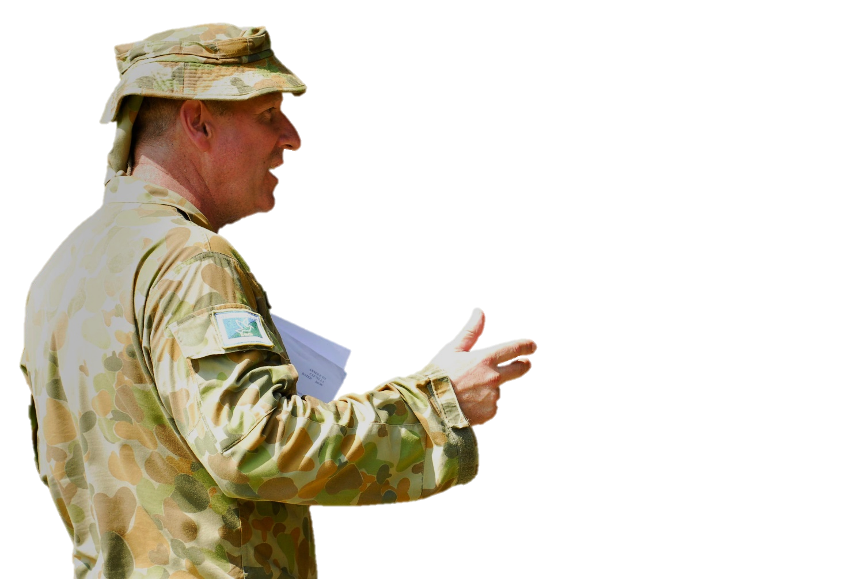

c. Detail, **unload**, and place your weapon on the ground.

1. In small groups of 2-3, discuss these questions.
   1. What’s your favourite weapon to use at a range practice? Why?
   2. What are the differences in commands the OIC gives in firing ranges in your country’s military? For example, the order of the commands, different commands, safety instructions, etc.

* For more practice with the words you’ve learned here, scan the QR code.
* This lesson links with 🡪 VB – Parts of a Firing Range

L – Marksmanship Principles

© Commonwealth of Australia 2024   
This work is copyright. Apart from any use as permitted under the Copyright Act 1968 (Cth), no part may be reproduced by any process without prior written permission from the Department of Defence.