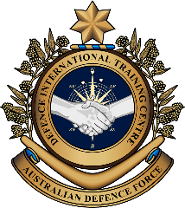

**Military English**

Vocabulary Builder: Types of Military Aircraft (rotary wing)

**Overview:**  
This worksheet presents vocabulary related to types of rotary wing military aircraft.

**In this lesson, you will:**

* use vocabulary related to rotary wing military aircraft

1. Label the pictures of different aircraft. Use the words in the box below.

attack helicopter // utility helicopter // UAV (unmanned aerial vehicle)

**aircraft** (plural: aircraft) = a flying machine. There are 2 types of aircraft; fixed wing aircraft = airplanes; rotary wing aircraft = helicopters

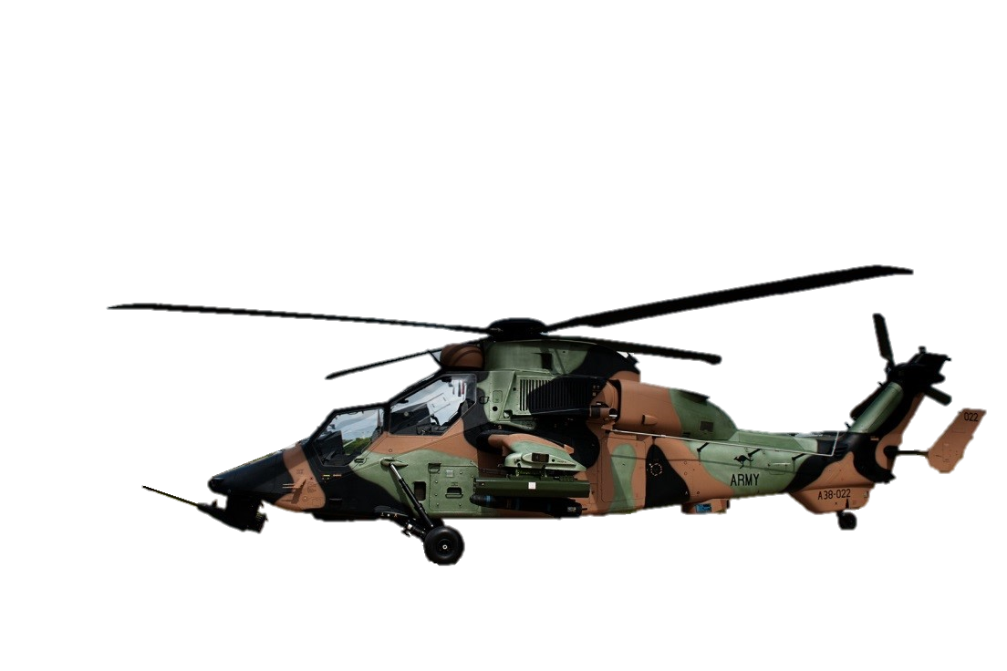

This helicopter can also be called a **reconnaissance helicopter**. It has cameras and other equipment to see what the enemy is doing.

Eurocopter Tiger

a. _________________________

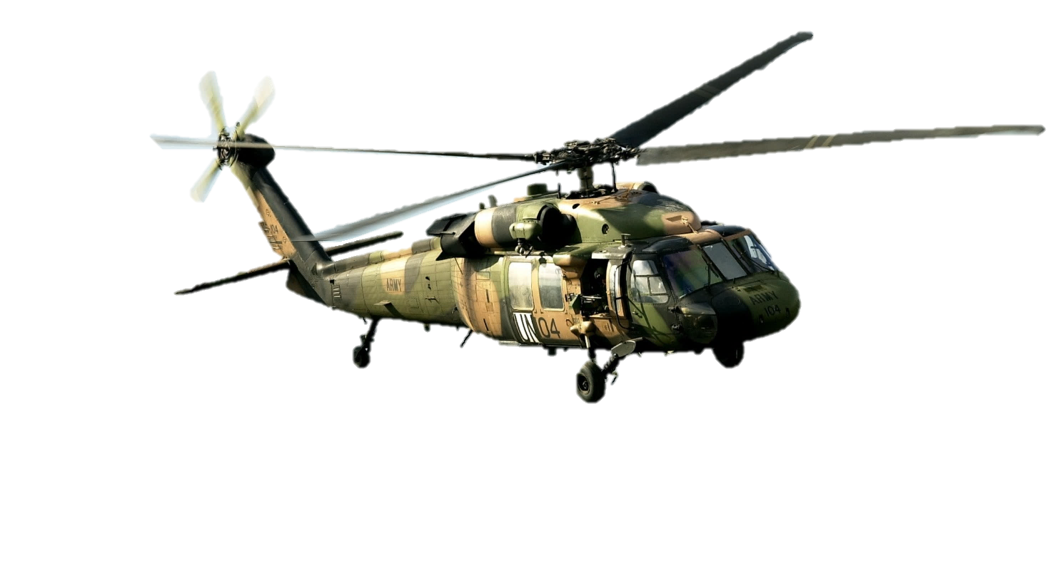

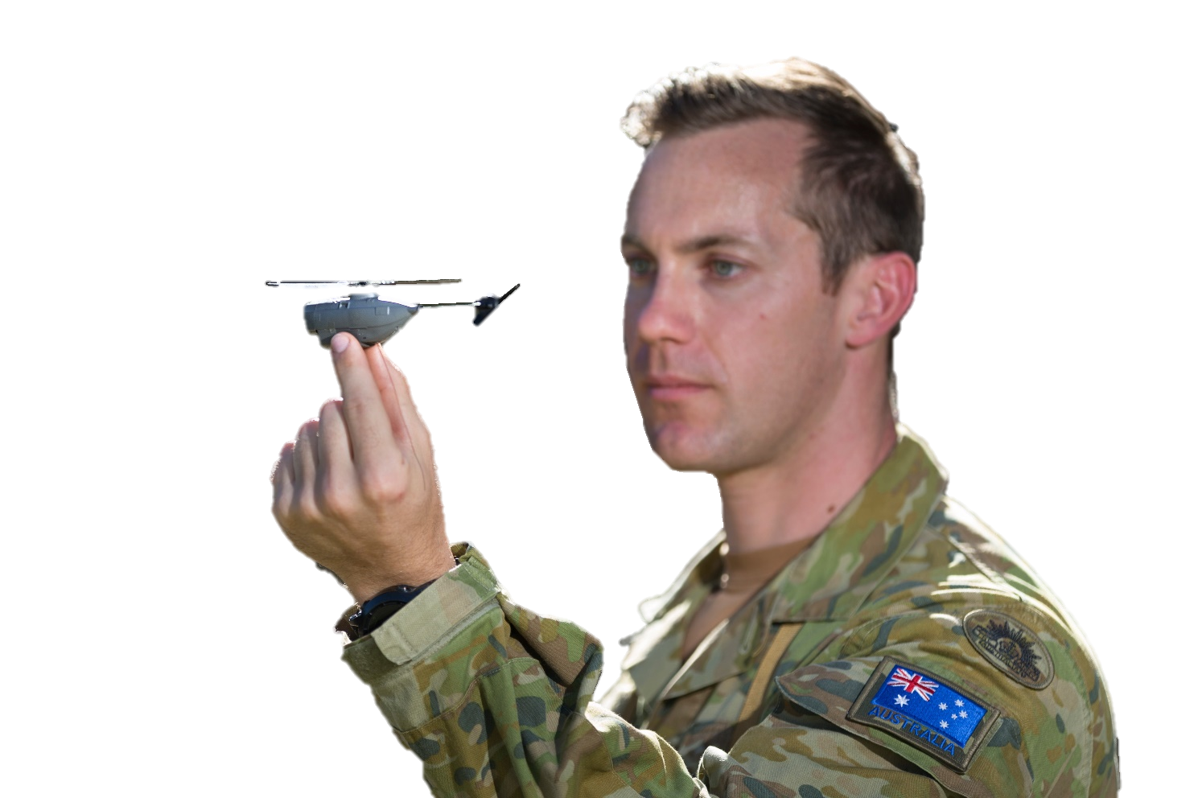

Sikorsky UH-60M Black Hawk

b. _________________________

PD-100   
 Black   
 Hornet

c. _________________________

1. Continue to label the pictures. Use the words in the box below.

transport helicopter // search and rescue helicopter //   
submarine hunter, anti-surface warfare helicopter // training helicopter

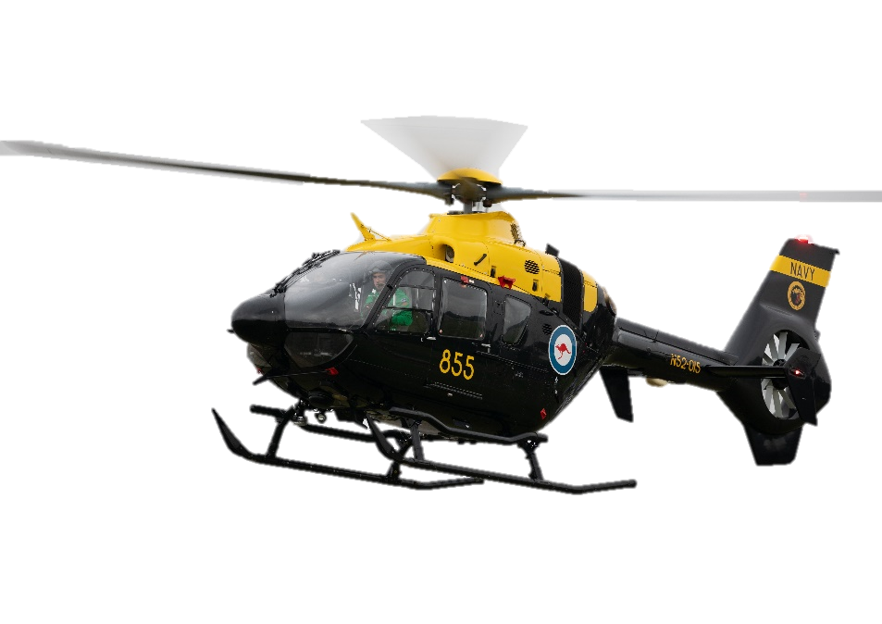

d. _________________________

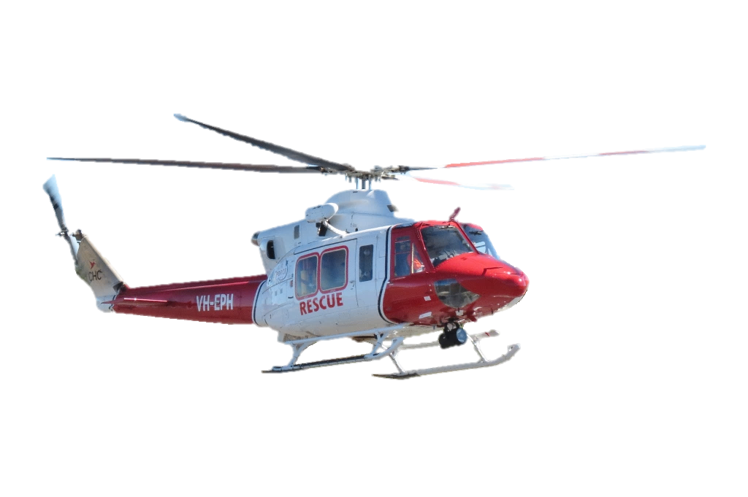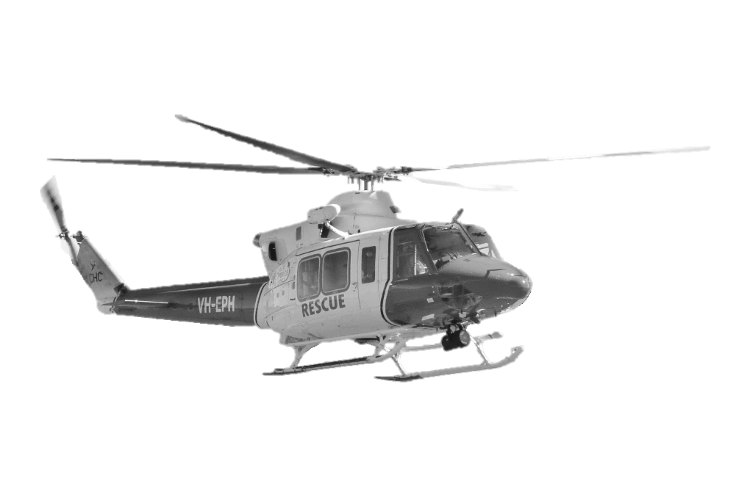

Eurocopter   
EC 135 T2+

Bell 412EP

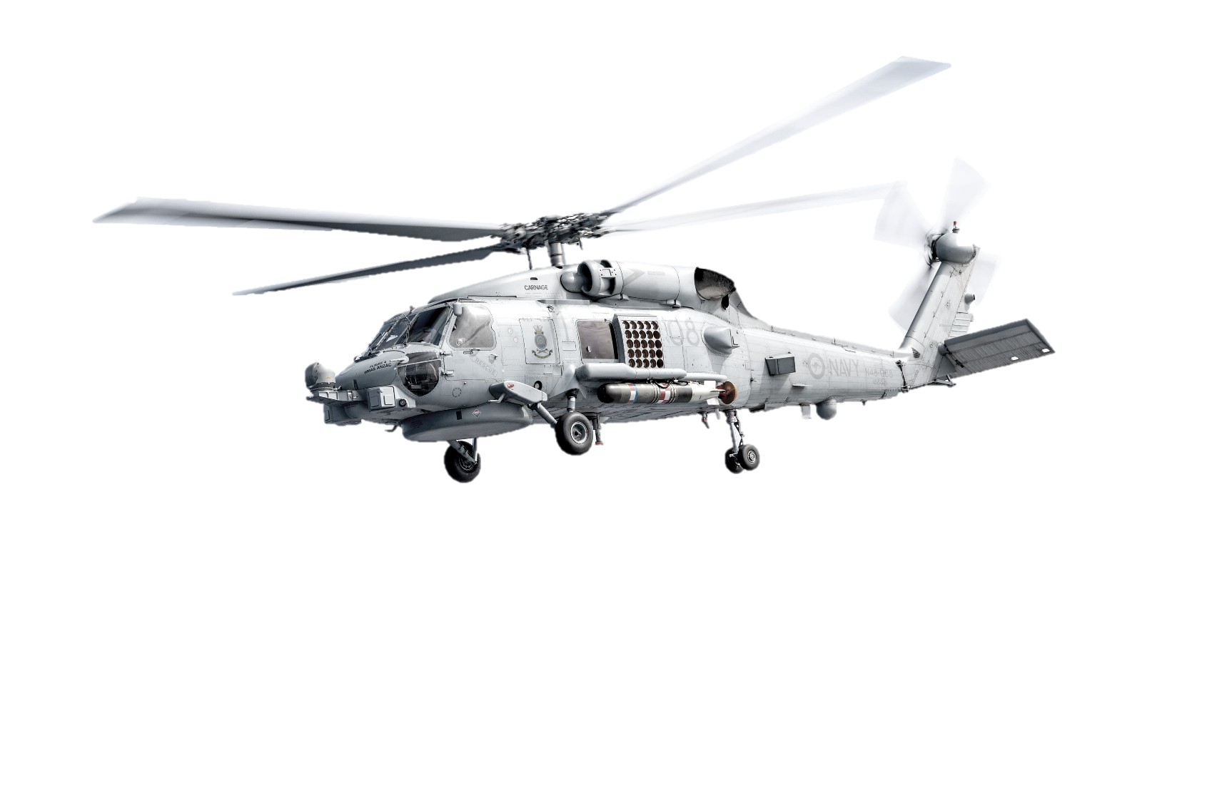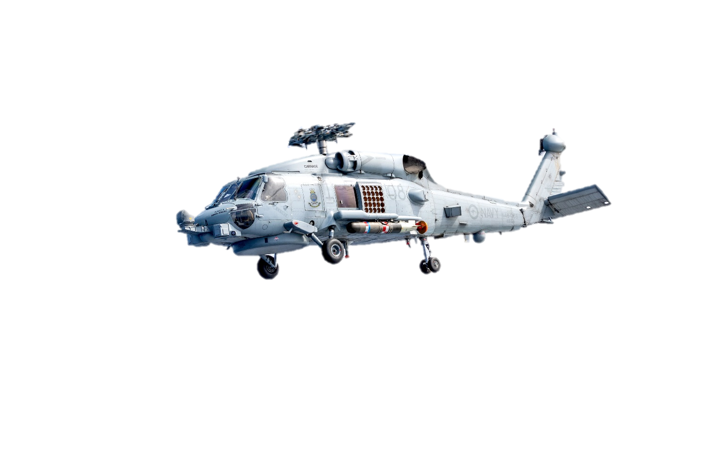

e. _________________________

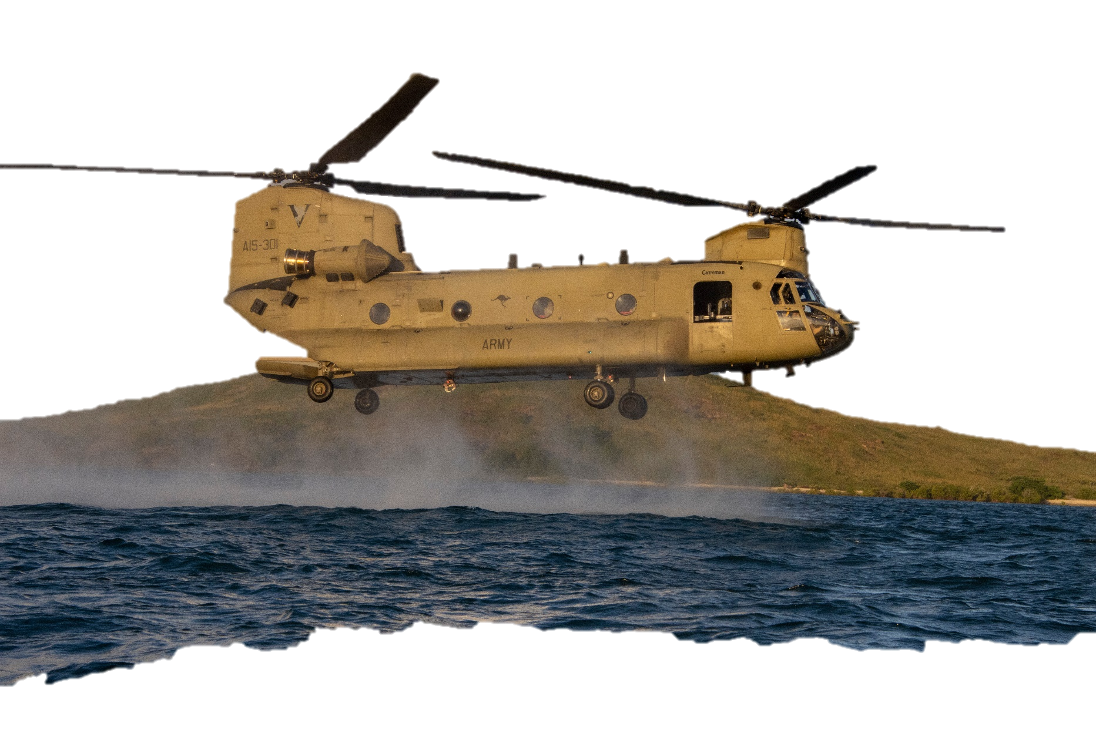

Sikorsky MH-60 Seahawk

f. _________________________

Some people also call this a **heavy lift helicopter**, because they can carry big and heavy equipment.

g. _________________________

Boeing CH-47F  
 Chinook

1. Let’s practise saying the words from exercises one and two. Listen and repeat.
2. What is each helicopter used for? Write the letter next to the type of helicopter, then check your answers with a partner.

**this helicopter is big and can move heavy things like:**

**C**



* training helicopter: _____
* attack helicopter: _____
* heavy lift helicopter: _____
* submarine hunter, anti-surface warfare helicopter: _____
* utility helicopter: _____
* search and   
  rescue helicopter: _____

**this helicopter is used for fighting and shooting at the enemy on the ground**

**D**

**this helicopter is used by the navy to find – and fight – enemy ships such as:**



**A**

**this helicopter is used for many different things e.g. ground attack, moving soldiers or small equipment, etc.**

**E**

**this helicopter is used to look for people or vehicles that are lost or in danger.**

**B**

**this helicopter is used for teaching pilots how to fly**

**F**

1. What about your country? What types of rotary-wing aircraft do your army, navy and air force have? Use the vocabulary from this lesson to discuss with a partner.

* This lesson links with 🡪 Vocabulary Builder – Military Vehicles

Vocabulary Builder – Parts of a Helicopter

© Commonwealth of Australia 2023  
This work is copyright. Apart from any use as permitted under the Copyright Act 1968 (Cth),   
no part may be reproduced by any process without prior written permission from the Department of Defence.