

**Military English**

Vocabulary Builder – Parts of a Parachute

**Overview:**  
This worksheet lists vocabulary for parachutes and parachute training in the army.

**In this vocabulary builder, you will:**

* learn and use vocabulary related to parachute training.

1. Label the parts of a parachute. Use the words in the box below.

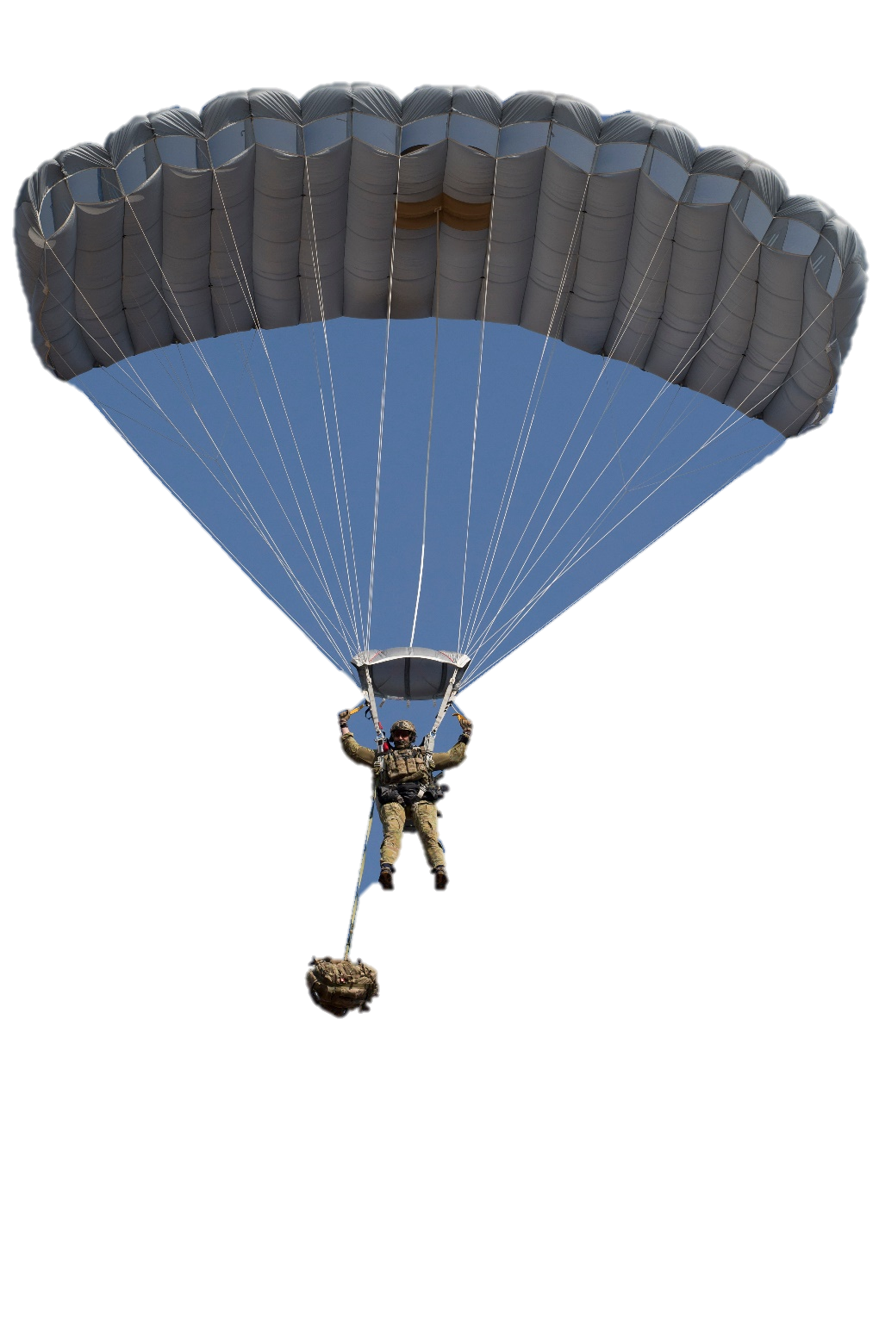

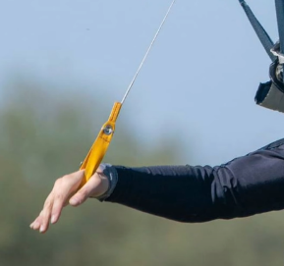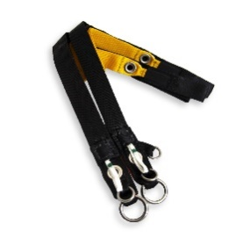

c. ________________________

a. ________________________

b. ________________________

e. ________________________

f. ________________________

d. ________________________

canopy // paratrooper // risers // slider // suspension lines // toggles

1. Now let’s learn words related to parachute jumping. Match the words to the pictures.

a. ________________________

e. ________________________

a. ________________________

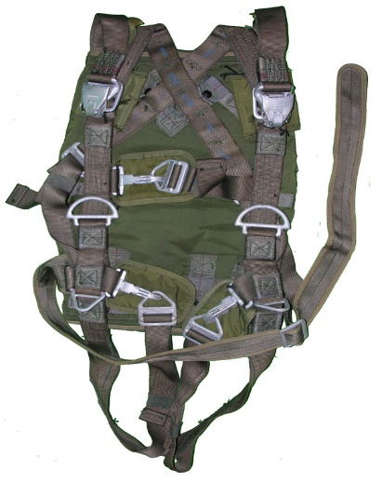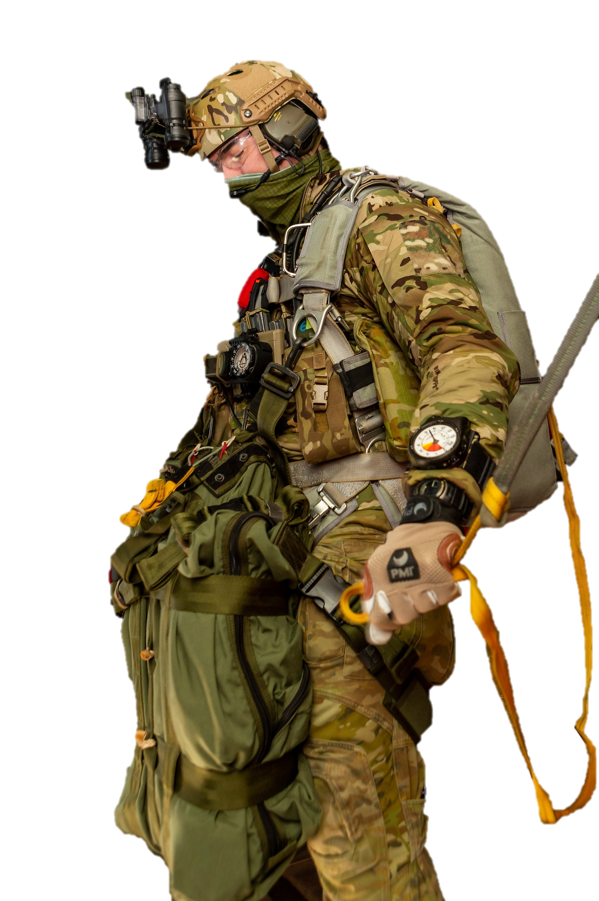

b. ________________________

c. ________________________

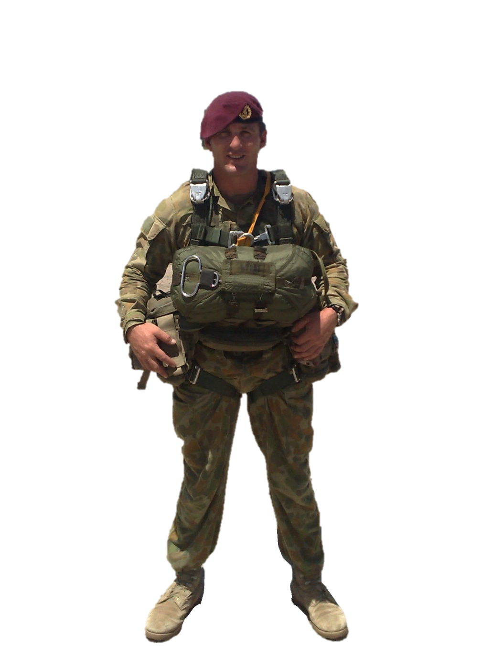

d. ________________________

f. ________________________

gloves // reserve parachute // harness // rip cord // helmet // eye protection

1. Listen to the words practised in this worksheet. Listen and repeat.
2. Find the words in the word search grid. Then check your answers with a partner. Look at the example.

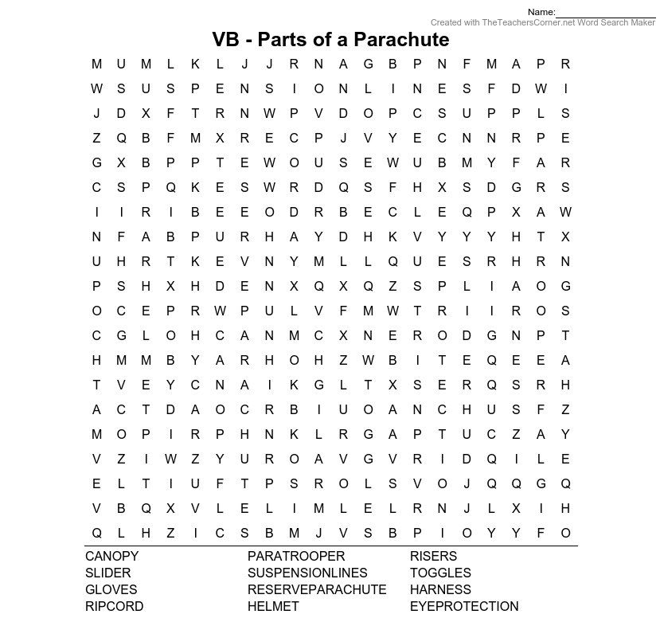

CANOPY

PARATROOPER

RISERS

SLIDER

~~SUSPENSION*LINES~~

TOGGLES

GLOVES

RESERVE*PARACHUTE

HARNESS

RIPCORD

HELMET

EYE*PROTECTION

* This Vocabulary Builder links with 🡪 Lesson: Parachute Training
* Watch this YouTube video. Type on YouTube [ADF Parachuting School delivering personnel parachute training](https://youtu.be/uA7RwRuJfLI?si=m93Hj9yFBcrHaHoM) or scan the QR Code.

© Commonwealth of Australia 2024  
This work is copyright. Apart from any use as permitted under the Copyright Act 1968 (Cth),   
no part may be reproduced by any process without prior written permission from the Department of Defence.