# 

**Military English**

Lesson: Patrol Boats - Reading

**Overview:**  
This lesson gives practice in reading about patrol boats – more specifically the Guardian Class Patrol Boat – and related military vocabulary.

**In this lesson, you will:**

* read and find general and specific information in a text
* learn the meaning of new words
* practice using the new words

## Prepare for Reading

1. In the centre there is a picture of a patrol boat. Around it are some of the jobs a patrol boat (or its crew) does. Discuss what they are with a partner.

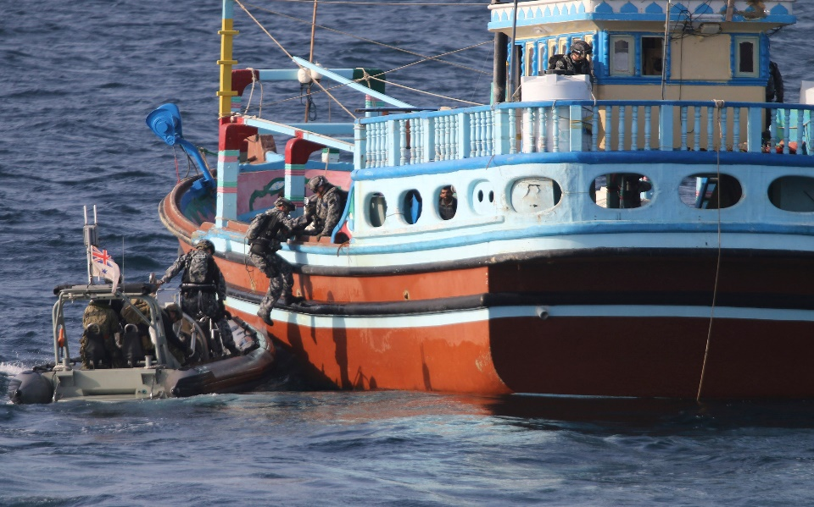 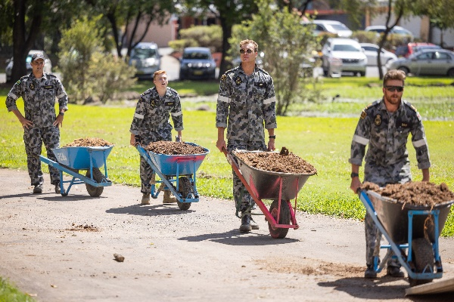

**c**

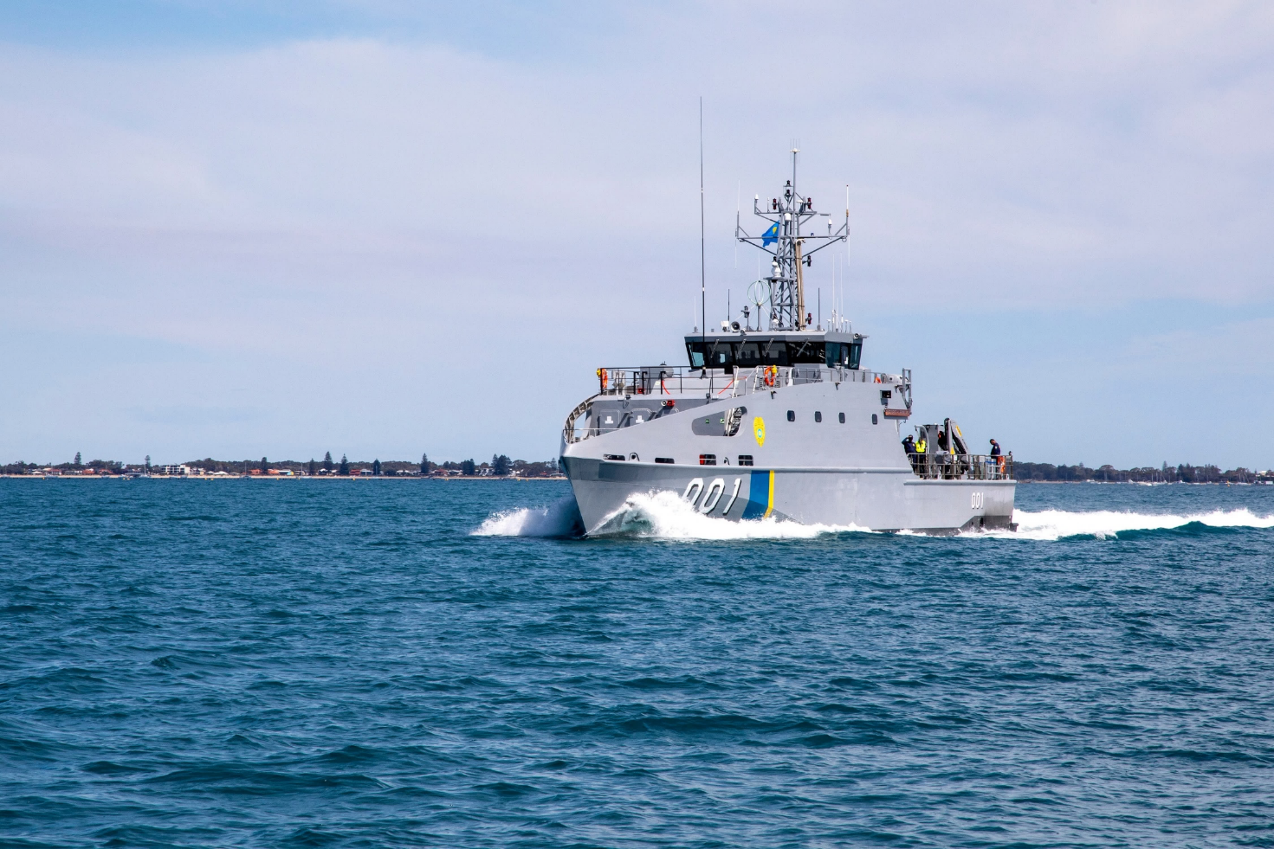

**a**

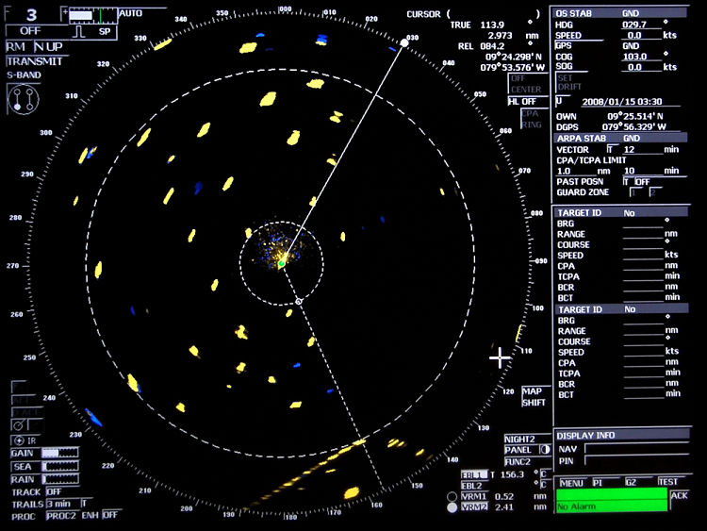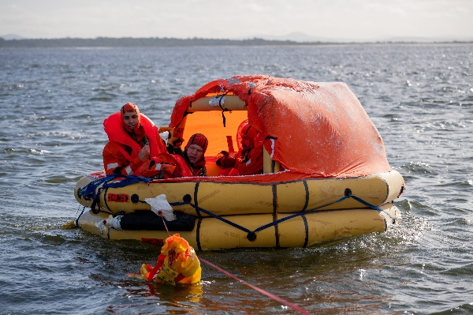

**d**

**b**

## Reading

1. Read **the first paragraph** **only** of the article below and choose the best title for the text. Then check your answers with a partner/a group:

Do not use a dictionary yet. You are going to learn the meaning of the words in **bold** in the next exercise.

1. Timor Leste instructors are arriving in Australia for training.

**patrol boat** (n) – a small ship the navy uses to watch and protect an area of the ocean and make sure it is safe. The navies of Indonesia, Thailand, Vietnam, Timor Leste, Malaysia and Cambodia all have patrol boats.

1. The Timor Leste Defence Force will soon have new boats.
2. 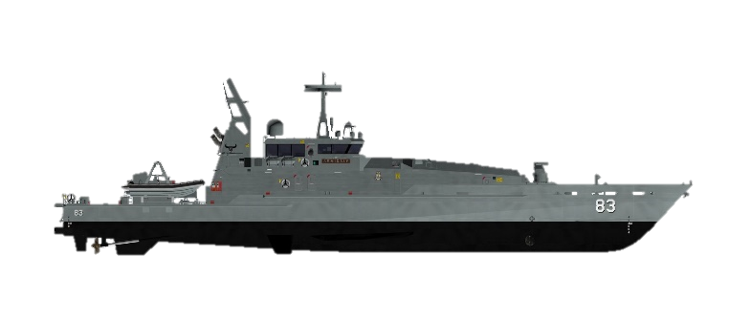The Royal Australian Navy is preparing to arrive in Timor Leste.

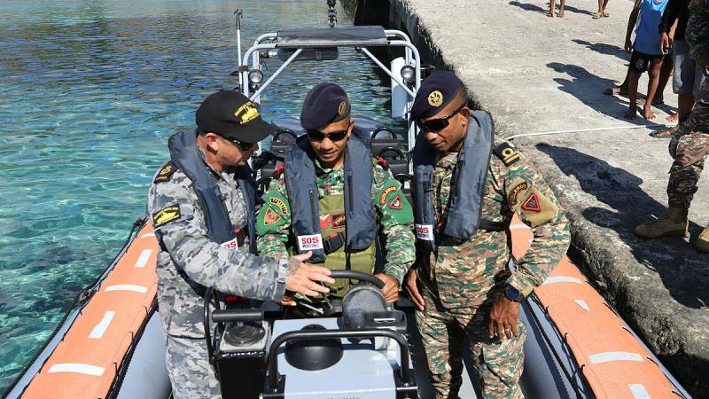The Timor-Leste Defence Force (F-FDTL)   
received **training** from the Royal Australian   
Navy (RAN) to prepare for two new patrol boats,   
Aitana and Laline, which arrive in the second half of next year.

The boats will help protect Timor-Leste's **territorial waters** in the Timor Sea and improve **defence cooperation** with Australia and other countries.

According to a government report, the RAN sent Chief Petty Officer **Boatswain**\* Christian Duncan, one of its best instructors, to conduct the training. Duncan said, "I'm an expert in patrol boats, **boardings** and **seamanship**. The Timorese Guardian **crew members** will need these skills to stop **illegal fishing**."

Australia is giving the boats to Timor-Leste and 12 other countries in the Pacific region, such as Tuvalu and Tonga. The boats are part of the AU$2.1 billion Pacific Maritime Security Programme. The 128-foot patrol boats have a **range** of 3,024 nautical milesat 20 knots and carry 23 crew members. They can have a 30mm **autocannon** and mounted **machine guns**.

The program will improve cooperation between Timor-Leste and Australia, especially in the **maritime** **domain**. It will strengthen their ability to cooperate, conduct **drills** and training, and help each other in **humanitarian aid** **and** **disaster relief**.

* Boatswain can also be spelled Bosun

1. Now read the whole text, but quickly and find the following:
2. the name of two ships: __________________________________
3. an amount of money: ___________________________________
4. the size of a boat: ______________________________________
5. two countries: _________________________________________

## Learning military vocabulary

1. The words in **bold** in the text are important military vocabulary that you should learn to use. Match the military words on the left to their definitions on the right on tables one to three.   
   Look at the example.

|  |  |  |  |
| --- | --- | --- | --- |
| Table one |  |  |  |
| they received **training** (n) |  |  | **a. when a group of sailors work   together to get on board another   ship (see also picture c   on page one)** |
| help protect Timor Leste’s **territorial waters** (n) |  |  | 1. an officer on a ship whose job is to take care of the equipment and the people who work on the ship |
| improve **defence cooperation** (n) |  |  | 1. the area of the sea, rivers, lakes, etc which belong to a country |
| **boatswain** Christian Duncan (n) |  |  | 1. when the defence forces of two or more countries work together as friends |
| I’m an expert in **boardings** (n) | **a** |  | 1. a learning experience to help someone do their job |

|  |  |  |  |
| --- | --- | --- | --- |
| Table two |  |  |  |
| I’m an expert in **seamanship** (n) |  |  | 1. the people who work on a ship, aircraft, tank, etc. |
| the **crew members** (n) |  |  | 1. when people break the law by fishing in a place they cannot catch any fish |
| to stop **illegal fishing** (n) |  |  | 1. the skills someone needs to work on a ship |
| the boats have a **range** of 5,600 kilometres (n) |  |  | 1. a big gun on a ship or  truck that can shoot  bullets quickly |
| the boats can have a 30mm **autocannon** (n) |  |  | 1. how far a vehicle (e.g. ship, car, truck, aircraft, etc) can travel without needing to refuel |

|  |  |  |  |
| --- | --- | --- | --- |
| Table three |  |  |  |
| the boats can have a **mounted** **machine gun** (n) |  |  | 1. a weapon that can shoot bullets very quickly; the word ‘mounted’ means it doesn’t move from its place. |
| improve cooperation in the **maritime domain** (n) |  |  | 1. the help governments and other organisations give when people need help, for example after a tsunami, earthquake, war |
| ability to conduct **drills** (n) |  |  | 1. the areas that include the sea, islands and the coast |
| help each other in **humanitarian aid** **and** **disaster relief** (n) |  |  | 1. military training |

1. Now let’s practise saying the words in this worksheet. Pay attention to the word stress (strong/weak parts of words e.g. training). Listen and repeat.
2. The units of measurement used on boats are different to those on land. Read the table below and fill in the gaps a-c below the table.

|  |  |  |  |  |
| --- | --- | --- | --- | --- |
|  | **nautical units of measurement** | **short form** | **metric system** | **short form** |
| **distance** | 1 **nautical mile** | NM | 1.852 kilometres | km |
| **speed** | 1 **knot** | kn | 1.852 kilometres per hour | km/h  (or kph) |
| **length** | 1 foot | ft | 0.3048 metre | m |

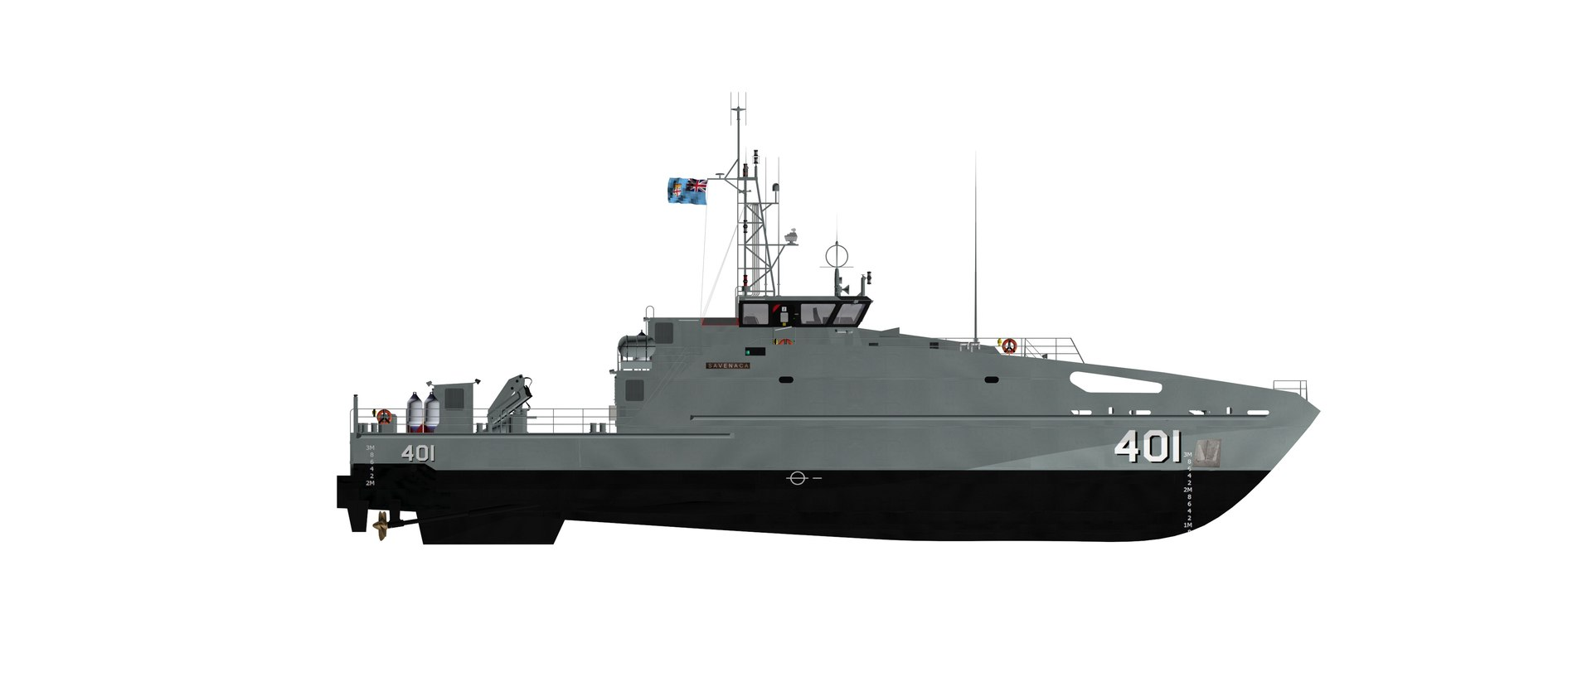

**Guardian Class patrol boat**

a. maximum speed: 20kn or __________

b. range: 3,000NM at 12kn or _____________ at _____________

c. length: 128ft or _________

1. Now try to use some of the words from exercises 4 and 6 correctly in the sentences below.
2. Many South East Asian countries cooperate to keep the _____________________________ safe from piracy and illegal fishing.
3. Patrol boats aren’t very fast, but they carry small boats inside that can travel at up to 40 _________.
4. The Royal Australian Navy teaches basic _______________________ to its cadets so they know how to work on a boat.
5. The _____________________ of patrol boats often do boarding drills, so they know what to do if they have to go aboard a boat.
6. Countries like Indonesia and Australia use both patrol boats and maritime patrol aircraft to keep their ______________________________ safe.

## Practice

1. Discuss these questions with a partner:
2. Would you like to work on a patrol boat? Why?
3. Why do you think patrol boats are important for a country’s navy? How do they help protect a country?
4. What kind of jobs do navy sailors have on a boat like this? Think, for example, about communications, driving the boat, repairing the boat, etc

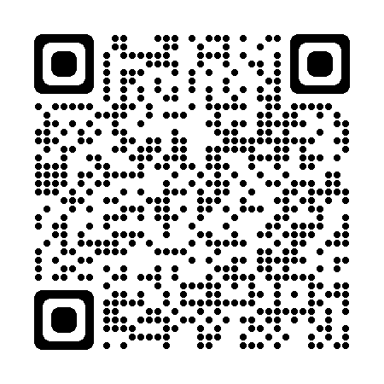

* Watch this video about the Armidale Class patrol boats that are operated by the Royal Australian Navy. Type [Come On Board HMAS Armidale](https://www.youtube.com/watch?v=DEMwyMH8IpU) on YouTube of scan the QR code.

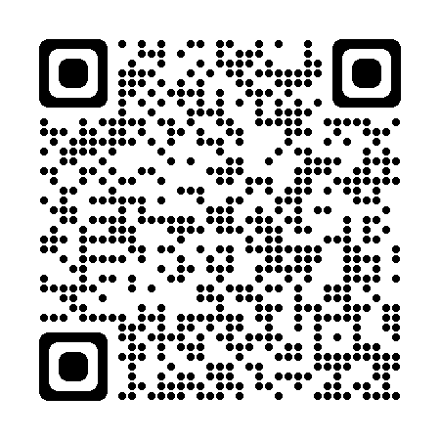

* For more practice with the words you’ve learned here, scan the QR code.
* This lesson links with 🡪 Vocabulary Builder – Parts of a Patrol Boat

Vocabulary Builder – Ranks of the Royal Australian Navy

© Commonwealth of Australia 2024  
This work is copyright. Apart from any use as permitted under the Copyright Act 1968 (Cth),   
no part may be reproduced by any process without prior written permission from the Department of Defence.