
Military English
Lesson: Out Field - Listening

Overview:
This lesson presents some vocabulary around the basics of tactical movements on the battlefield.
In this lesson, you will:
- listen for gist
- listen for specific information
- learn the meaning of new words
- use new words in context

Prepare for Listening
- Look at the pictures and match the place where the soldiers are from the words in the box below.
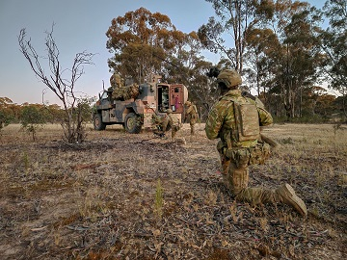

C

D

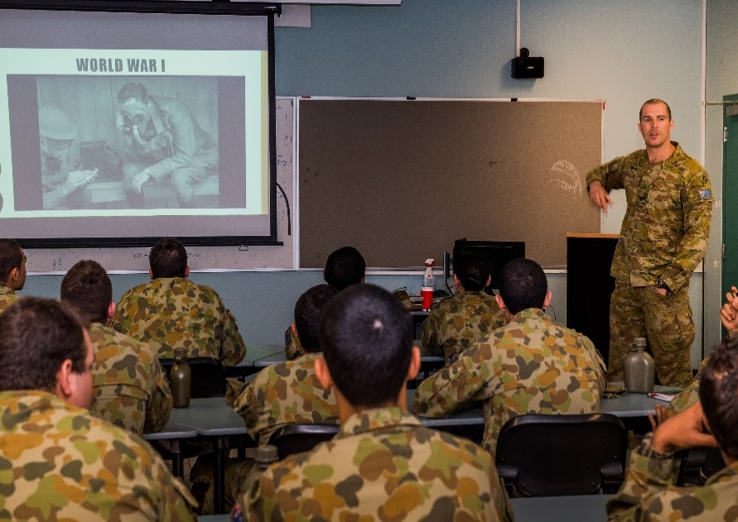
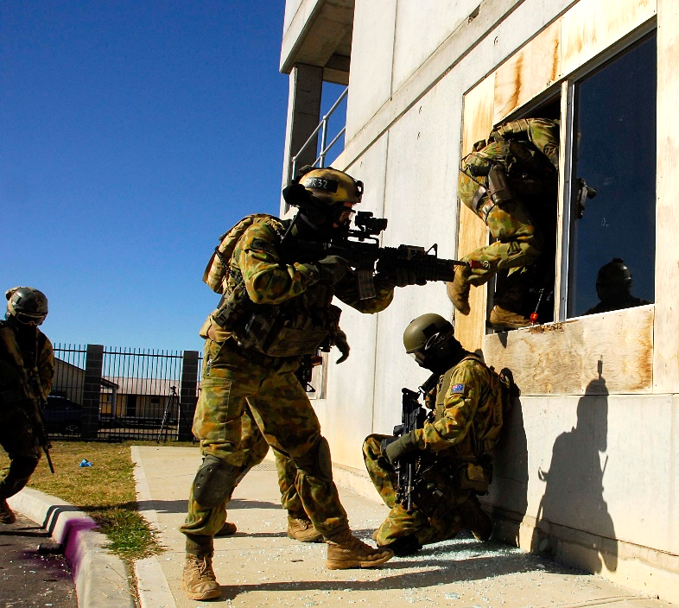
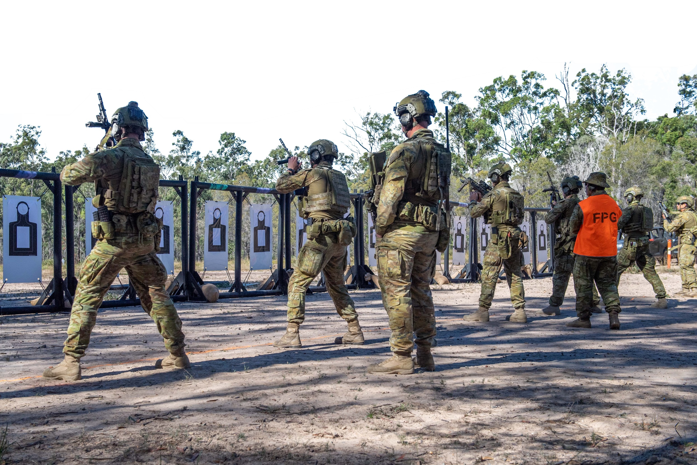

B

A

in an urban area // at a firing range // out field // in a classroom
- To check your answers, ask your partner:

Question:
Where are the soldiers in
A / B / C / D?

Answer:

They are ______________.

- Practise speaking with your partner about his experiences using these questions:
Ask a follow-up question to your partner
to get more information about this event from the past: ↓

Have you been (+ add place A, C or D from Ex 1) before?

When were you there?

What did you do there?

Listening
- Listen to the start of a briefing for some cadet officers. What is the best summary of the main topic of this briefing, a, b, c or d?
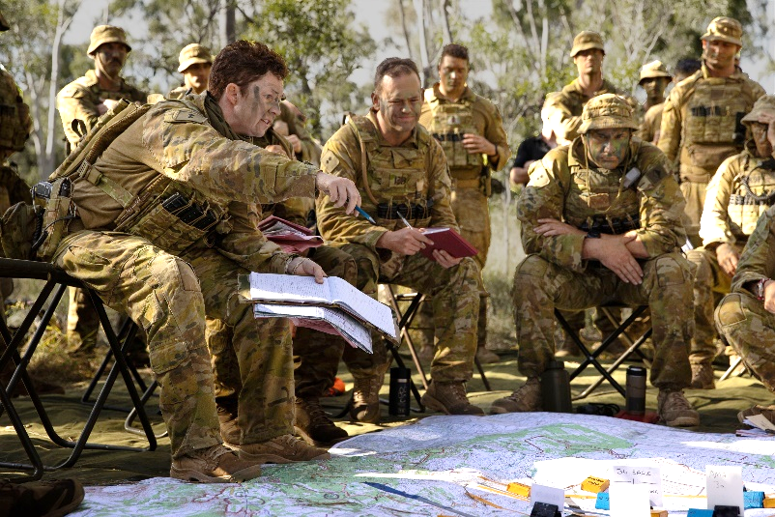
              - platoon leadership
briefing (or brief) (n) - a short talk to tell soldiers what they need to know before doing something e.g. a mission

              - instructions at a firing range
              - movement out field
              - army weapons

- Listen to the whole briefing now. Decide if the statements below are true or false. Circle T (true) or F (false).
After you listen, compare your answers with your classmate/s.

              - The last briefing covered the same general topic as this one. T // F
              - This briefing is going to check the meaning of some important words. T // F
              - Cover means protection from the sun. T // F
              - You can’t use natural features of the land for ‘cover’. T // F
              - You might need cover when your troops are moving. T // F
              - Concealment is something you wear on your face. T // F
              - You need to think about how to conceal yourself in different ways, especially if the enemy uses planes. T // F
              - It’s easier to conceal yourself out field. T // F

Learning Military Vocabulary
- The words in bold are important military vocabulary that you should learn. Match them to their definitions on the right. Look at the example and write the answers in the middle column.
Table one
tactical elements (n) | g |  | - to act against tanks
a small arms team (n) |  |  | - to use our environment as protection from enemy weapons fire
cover (n) |  |  | - a military action against the enemy with the aim to stop them
concealment (n) |  |  | - to check the land around you, to check the shape and parts of the land that will be useful or not to you and your team
…engage the tank (v) |  |  | - a group of soldiers that use weapons like pistols or rifles with small calibre (max calibre for ‘small arms ‘ is 20mm)
anti-armour (unit) (adj) |  |  | - to (not) be able to see (well)
a terrain analysis (n) |  |  | g. planning for battles and the way forces will engage with  each other
to have poor visibility (n) |  |  | 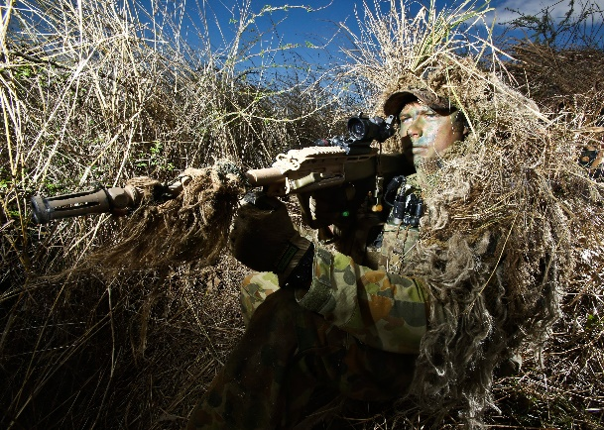  - to use our environment to stop others seeing us

Table two
enemy positions (n) |  |  | - firing weapons to protect a soldier or a team of soldiers that are moving from other small arms fire
covering fire (n) |  |  | - a deep, narrow space between hills or rocks
direct fire (n) |  |  | - to use (armoured) vehicles in your team; to be motorised
other ground troops (n) |  |  | - a low lying area of land
a ravine (n) |  |  | - weapons fire aimed directly at a target within a line of sight
a depression (n) |  |  | - the side of the body / vehicle (not the front or the back)
if you are mechanised… (adj) |  |  | - the location of the enemy (where the enemy is)
attack the tank’s flank (n) |  |  | - military personnel that fight on land (not sea or air)

- Now let’s practise saying the words in this worksheet. Listen and repeat.

- Test your partner. Person A covers the left hand column of Table one so Person B cannot see the words. Person A reads out the meanings of a. – h. Person B must say the correct word. Now swap, person B covers the words in Table two so Person A cannot see them. Person B reads out the meanings i. to p. Person A must say the correct word.
Who said the most correct words?
- Complete sentences below with words from Exercise 4.

- The ship fired directly at ____________________________ of the battle-ship.
- The planes provided ____________________________ air support for the ground troops.
- We climbed up the mountain and used the rope bridge to get across the ____________________________.
- Stay away from the river. Don’t ____________________________ with the enemy in that area.
- As the landing ships arrive, ____________________________ from the right will support our movement off the ships.
- Learn how to use tactics of cover and ____________________________ to help your platoon move on the battlefield.
- ____________________________ infantry use armoured personnel carriers (APCs) to move quickly.
- At night when you have low ____________________________, you must be able to find your way.

Practice
- How many key words from the vocab table can you use to answer these questions? Don’t look at the vocab table – try to remember what you heard in the listening.
- What is ‘cover’?
- What is ‘concealment’?
- Why are cover and concealment important to a military force?

Together with a partner, discuss these questions, using as many words from exercise 6 as you can. Give any examples from your own experience.


- This lesson links with Vocabulary Builder – Terrain features.
- For more practice with the words you’ve learned here, scan the QR code.

- Watch this YouTube video ‘ACF Fieldcraft: Camouflage and Concealment’
or this one, ‘ACF Fieldcraft: Types of Movement’ from the British Army.



© Commonwealth of Australia 2024
This work is copyright. Apart from any use as permitted under the Copyright Act 1968 (Cth),
no part may be reproduced by any process without prior written permission from the Department of Defence.

