

**Military English**

Lesson: Parachute Training – Reading

**Overview:**  
This lesson uses the topic of parachute training to give practice in reading and the vocabulary around this topic.

**In this lesson, you will:**

* read and find specific information in a text
* read and understand general information in a text
* learn the meaning of new words
* use new words in a conversation

## Prepare for Reading

1. Let’s find out how much you know about parachute training. Talk to a partner.
2. What do you know about parachute training?
3. What problems can happen when
   * paratroopers are falling through the air

a **paratrooper** (n) -

to **land** (v) – when the paratrooper arrives on the ground

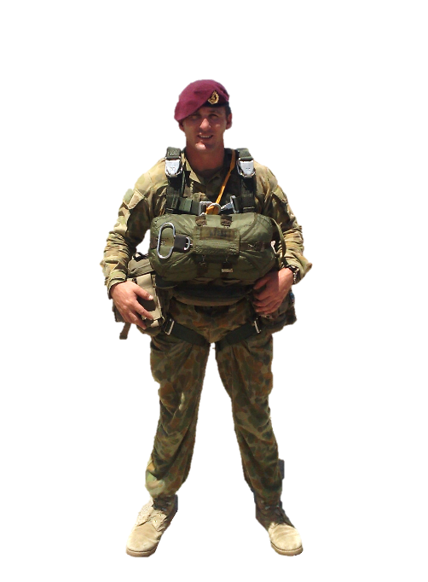

* + paratroopers land on the ground

1. What types of jump are included in the training?
2. Would you like to jump out of an airplane? Why?

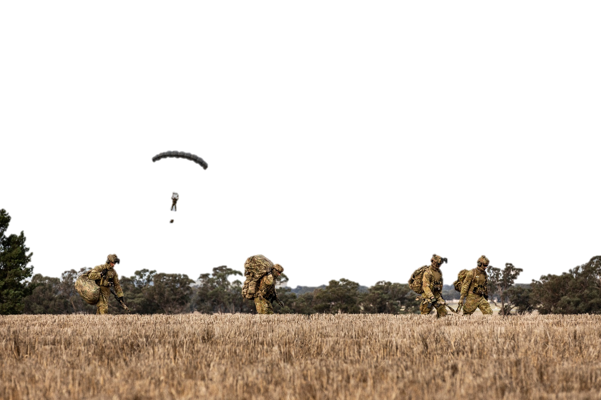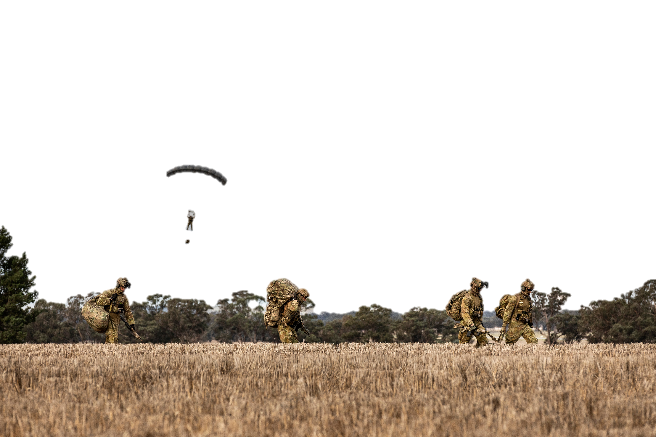

## Reading

1. Read the text about parachute training below quickly.

Check your answers from exercise one. How much did you know about parachute training?

Tip: When your teacher asks you to ‘read quickly’ – the aim at this time, is NOT to understand everything but to get a general overall understanding of the main idea of the text(s). Look at pictures and headings carefully as these things can help you. Run your eyes across the words; try NOT to stop reading.

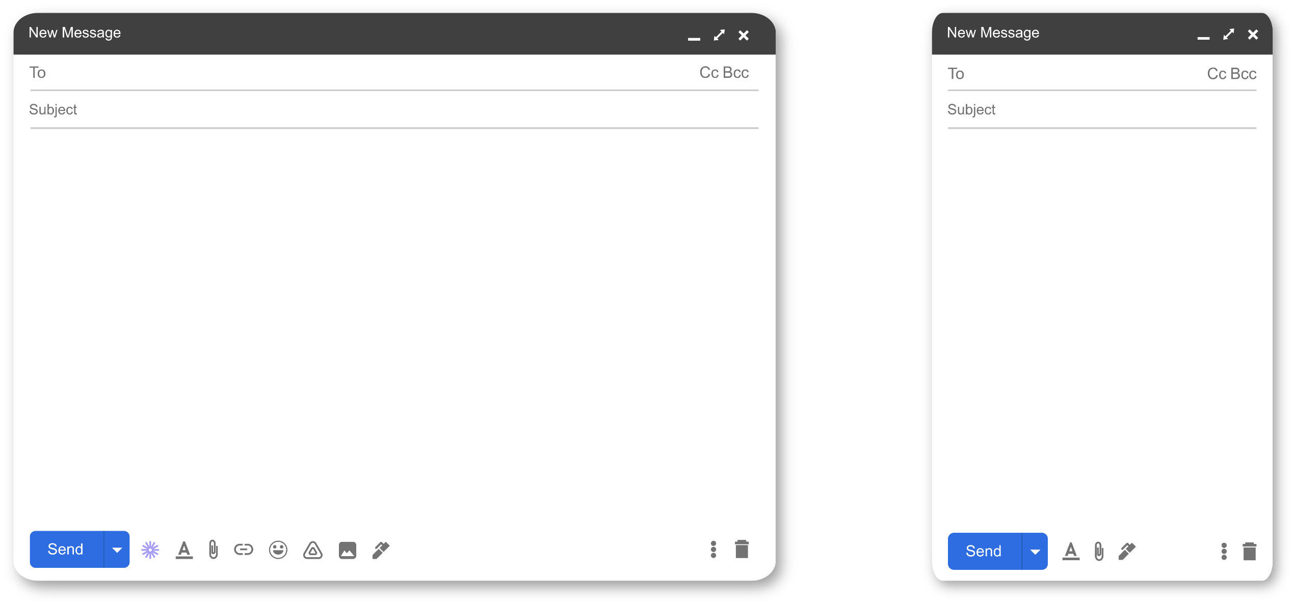

Hi Domingos,

You wanted to know what life is like at the Parachuting School, so let me tell you a bit about it.

Before we jump from an **aircraft**, we do a lot of training on the ground. For example, we learn how to **exit** and how to land safely in aparachute **landing fall**. When we start practising aircraft jumps, we have to be careful of wind **drift**, which can take us away from the **drop zone (DZ)**. Another problem we learn to solve is **parachute malfunctions**.

In the Australian Defence Force (ADF), we have **static line** training at an **altitude** between 800 feet and 1,000 feet. Paratroopers train on different types of parachute, including a **reserve parachute**.

Then there is **free fall** training. In this type of training, we jump from an aircraft from up to 12,000 feet. This is called **High Altitude Parachute Operations** **(HAPO)**. Also, we sometimes jump from aircraft up to 25,000 feet.

We work with **riggers**. They are the people who prepare the parachutes. Riggers also do parachute training.

I hope this gives you an idea of parachute training. Call me if you want more information. Good luck in your training!

Kind regards,

Amir

domingos@army.gov.au

Parachute training

domingos@army.gov.au

Life at ADFA

1. Read the text again and answer the questions. Mark the sentences true or false.
2. Wind drift can be a problem for paratroopers.

TRUE FALSE

1. The ADF only uses one model of parachute.

TRUE FALSE

1. The highest paratroopers jump from is 12,000 feet.

TRUE FALSE

1. Riggers don’t practice parachute jumping.

TRUE FALSE

## Learning Military Vocabulary

1. The words in bold in the text are important military vocabulary that you should learn to use. Match the military words on the left to their definitions on the right on tables one and two (on the next page).  
   Look at the example.

|  |  |  |  |
| --- | --- | --- | --- |
| Table one |  |  |  |
| before we jump from an **aircraft** (n) |  |  | 1. the place (on the ground) where paratroopers land |
| we learn how to **exit** (v) |  |  |  |
| we have to be careful ofwind **drift** (n) | **f** |  | 1. the way paratroopers should land, so that they don’t get hurt |
| It can take us away from the **drop zone** (DZ)(n) |  |  | 1. when there is a problem with a parachute, it doesn’t open properly |
| we have to be careful of **parachute malfunctions** (n) |  |  | 1. to jump out of an aircraft |
| a parachute **landing fall** (n) |  |  | **f. the wind that pushes the paratrooper away from where   they should land** |

**The Parachuting School is where all Australian Defence Force (ADF) members learn to parachute. The school trains personnel from the Australian Army, Royal Australian Navy and Royal Australian Air Force.**

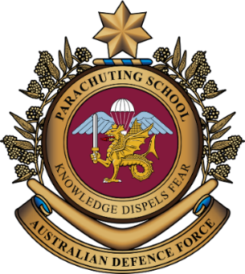

|  |  |  |  |
| --- | --- | --- | --- |
| Table two |  |  |  |
| **static line** (n) |  |  | 1. when paratroopers jump from very high up |
| training at an **altitude** between 800 feet and 1,000 feet(n) |  |  | 1. the extra parachute needed in an emergency |
| **reserve parachute** (n) |  |  | 1. falling from an aircraft   before opening the parachute |
| **free fall** (n) |  |  | 1. height, distance upwards |
| This is called **High Altitude Parachute Operations** (HAPO) (n) |  |  | 1. the people who get the parachutes ready |
| we work with **riggers** (n) |  |  | 1. a line that opens the parachute automatically when a person jumps from an aircraft |

1. Now let’s practise saying the words. Listen and repeat.
2. Now use words from exercise four to complete the sentences correctly.
   1. Two things paratroopers think about when falling are __________________ and ________________.
   2. Paratroopers know how to _____________________________ from different aircraft.
   3. Paratroopers use the ______________________ if there is a problem with the main parachute.
   4. The people that prepare parachutes are called _________________. They have a very important job.
   5. The ______________________ opens the parachute soon after the paratrooper exits the aircraft. It’s usually yellow.

## Practice

1. Talk to your partners and discuss the following questions
2. What are some positives and negatives about parachute training?
3. Do you think parachute training is harder than other training you have done?
4. Do you think parachute training is important for the military? Why?

* For more practice with the words you’ve learned here, scan the QR code.
* This lesson links with 🡪 Vocabulary Builder – Parachute Training
* Watch this video. Type on YouTube [ADF Parachuting School delivering personnel   
  parachute training](https://www.youtube.com/watch?v=uA7RwRuJfLI) or scan the QR code.

© Commonwealth of Australia 2024   
This work is copyright. Apart from any use as permitted under the Copyright Act 1968 (Cth), no part may be reproduced by any process without prior written permission from the Department of Defence.