

Military English

Vocabulary Builder: Parts of a Firing Range

Overview:
This worksheet lists vocabulary related to a firing range and firing practice.

In this vocabulary builder, you will:
- learn and use vocabulary related to a firing range and firing practice.

- Label the pictures. Use the words in the box on page 3.
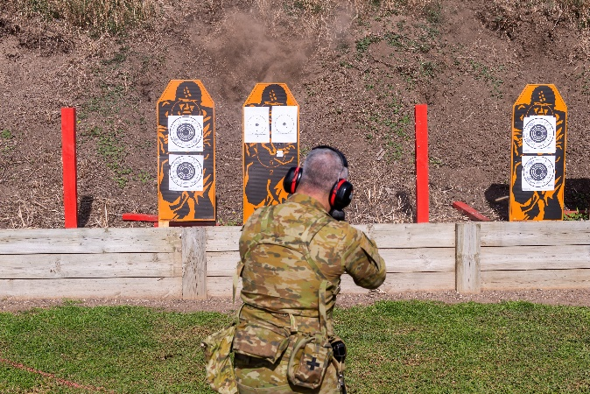
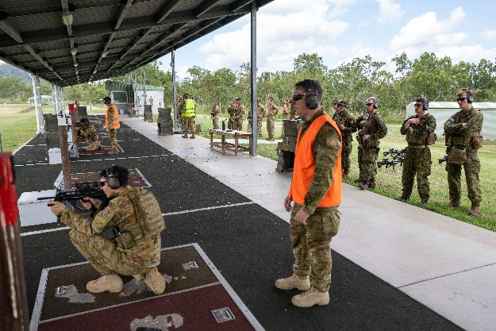
a. ___________________________

b. ___________________________

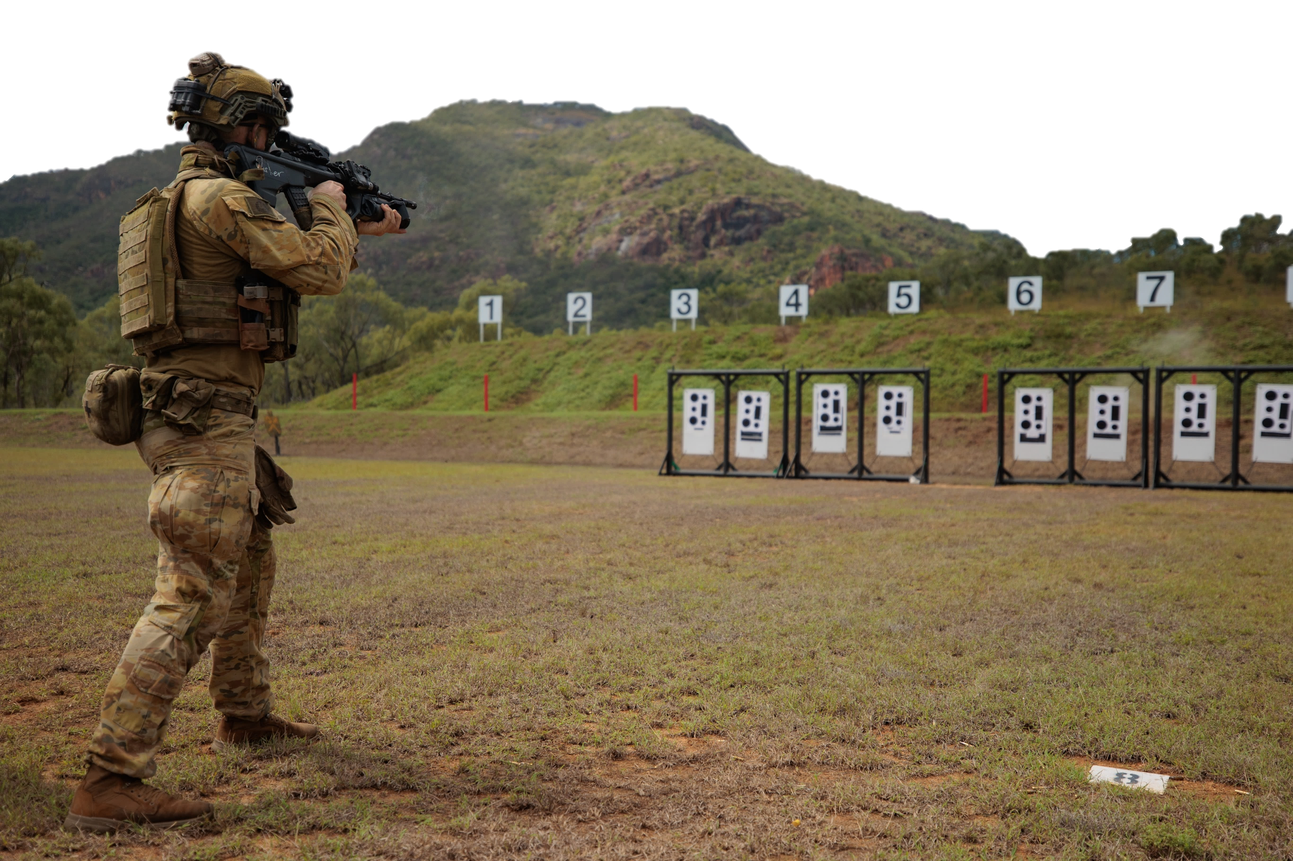

c. ___________________________

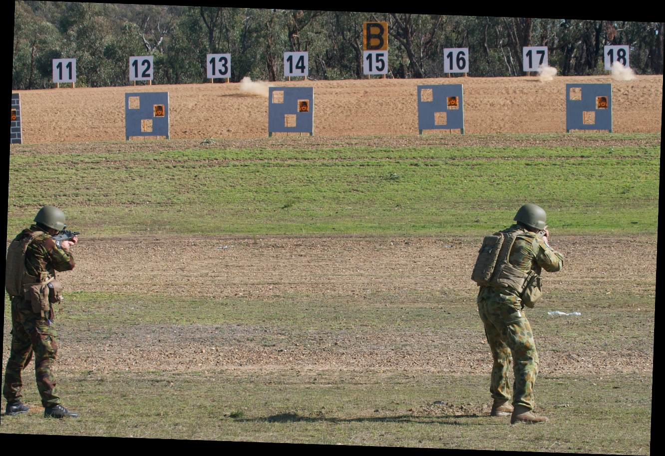
d. ___________________________

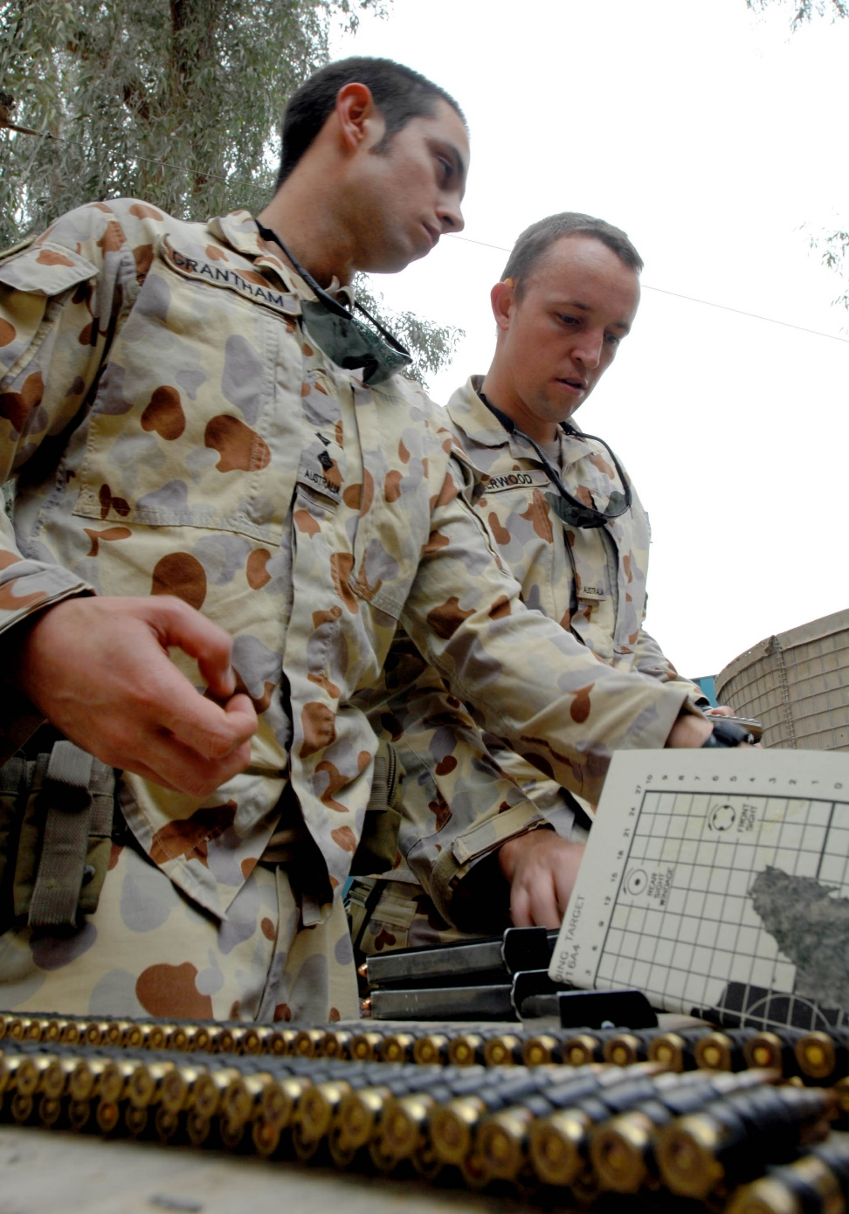

e. ___________________________

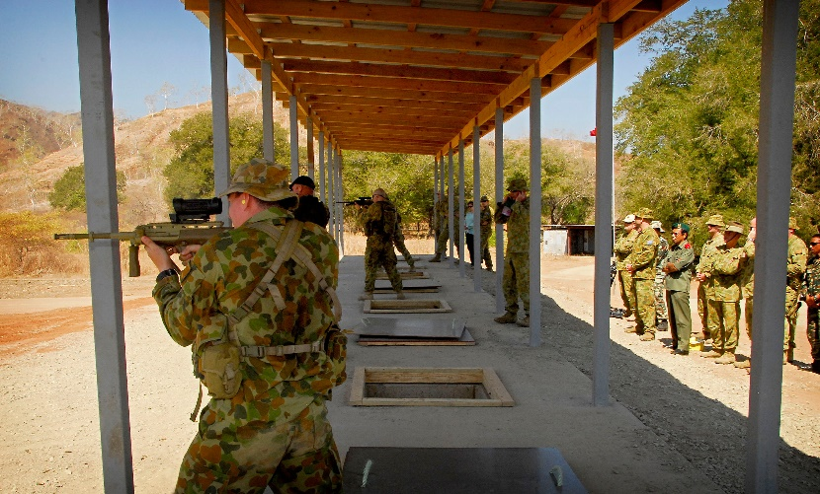

f. ___________________________

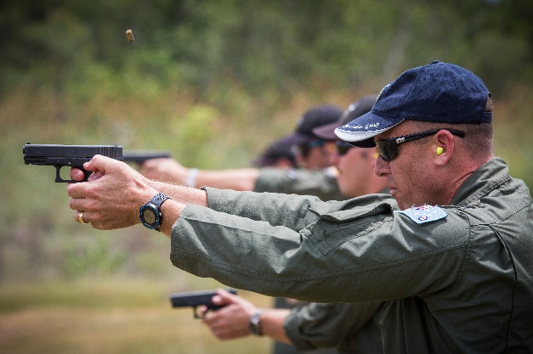
g. ___________________________
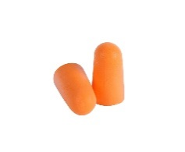

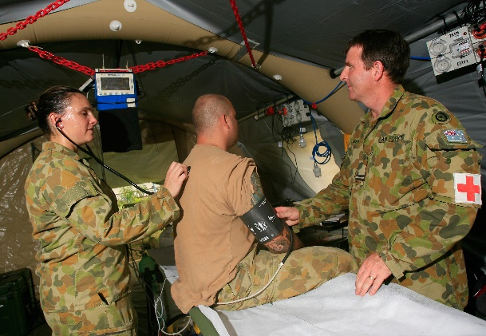
h. ___________________________

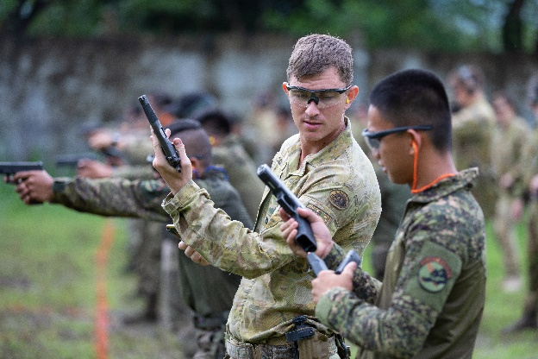

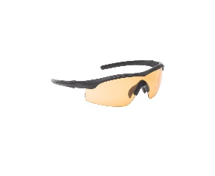
i. ___________________________

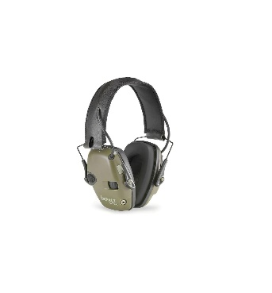
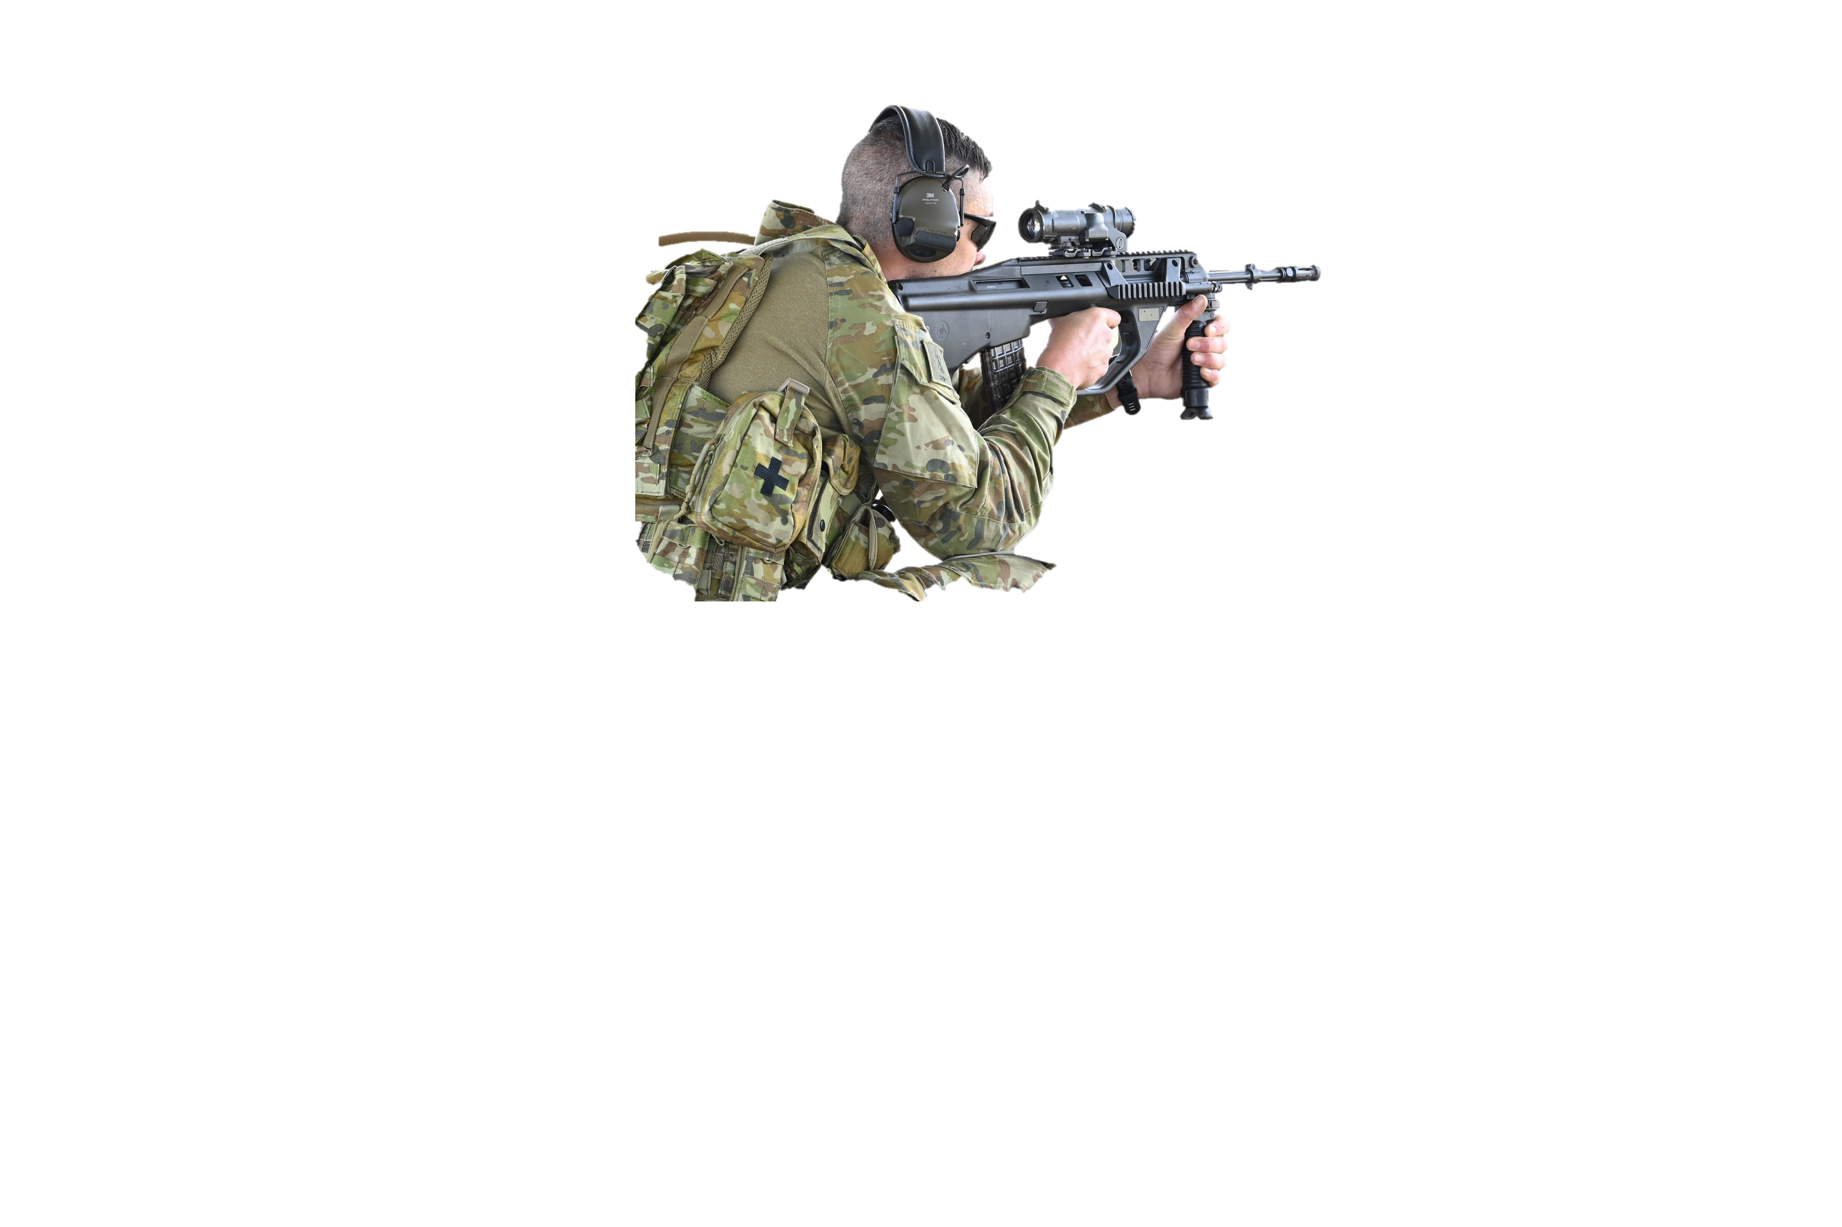

j. ___________________________

arc of fire // ammunition point // soft hearing protection // mound/firing point // eye protection // hard hearing protection // officer in charge (OIC) // medic (first aider) // target // downrange

- Here are some of the types of rounds that the Australian Defence Force use for weapons training. Label the 3 types of ammunition.
A projectile is the object that comes out of a weapon (e.g. pistol, rifle, shotgun) at high speed.
round (n) = bullet (n, countable)
ammunition (n, uncountable) – the material that is fired from a gun or from any weapon e.g. bullets

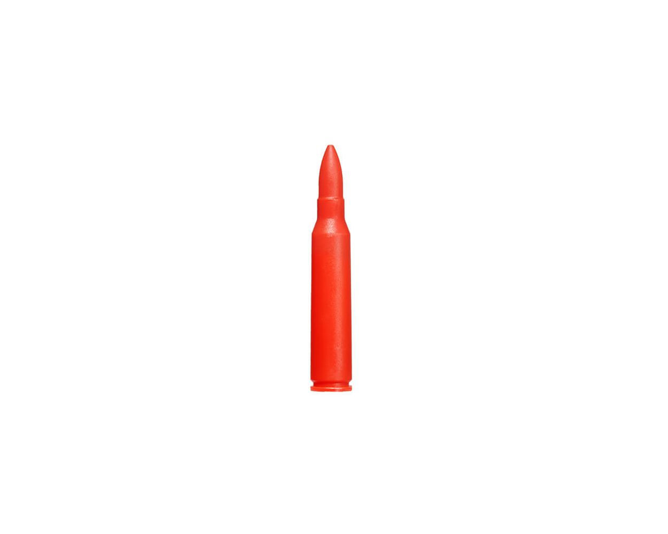
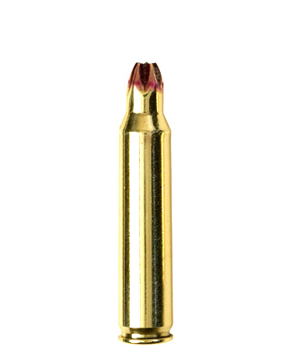
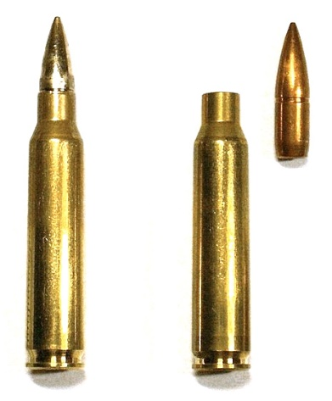
c. ___________________

___________________
b. ___________________

___________________
a. ___________________

___________________

blank round // live round // dummy round

Round Type | Use
live round | It has a projectile. Personnel use it for training  and combat situations.
blank round | It does not have a projectile. It makes the same loud sound as a live round. It is mainly used in tactical military training and ceremonies.
dummy round | It is usually made of plastic. Soldiers use this type of round for weapons handling training, for example to practice loading a magazine.

- Label the 3 types of firing position. Choose from the words in the box.
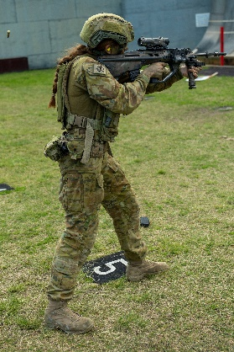
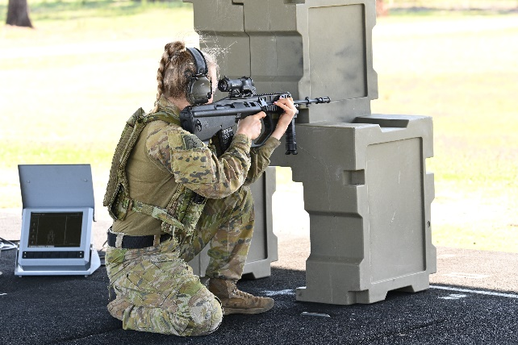
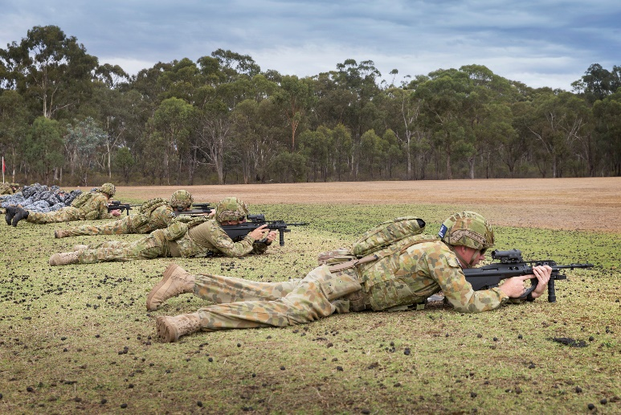
a. ___________________________
c. ___________________________

b. ___________________________

kneeling position // prone position // standing position

- Now let’s listen to the words practised in this worksheet. Listen and repeat.

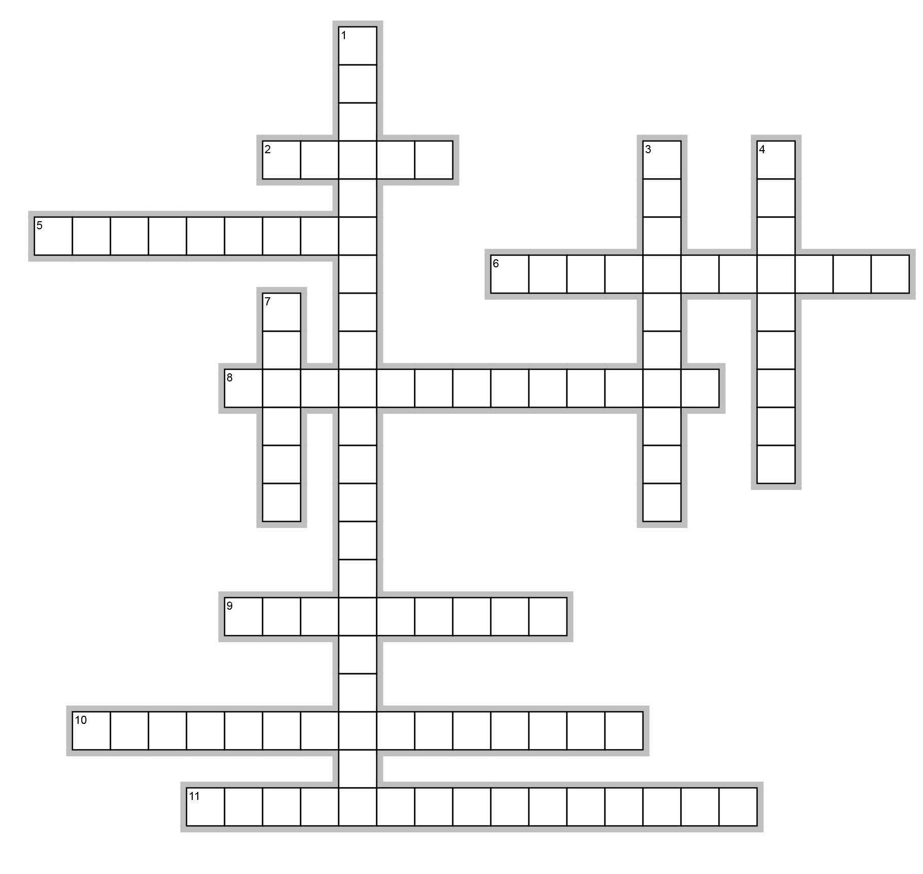
- Complete the crosswords with words from this Vocabulary Builder.

Across
2. A person who treats anyone who is hurt during firing practice at the range.
5. At a firing range, it is the direction that a shooter fires bullets at the targets.
6. The place at a firing range where soldiers fire from.
8. A shooting position that is low on the ground. In this position the whole body of the firer (shooter) is on the ground.
9. A round that soldiers use in target practice and in wars. They are ‘real bullets’.
10. This person is in charge of the range; he/she makes sure everyone is safe and knows what to do. The abbreviation is OIC.
11. Firers go to this place to receive rounds (bullets) to load in their magazine before the firing starts.

Down
1. This item is used to protect our ears from the loud sound of the gun. It looks like headphones.
3. A round that does not have any projectile; it only makes noise.
4. The space from left and right of the target where a firer (shooter) can fire bullets downrange at the target.
7. The object that firers (shooters) aim to hit when they fire their weapons.


- Watch this video about shooting practice.
Type on YouTube Aus Army 3 Brigade Range Day or scan the QR code to the right.

- This lesson links with Lesson: At a Firing Range - Listening

© Commonwealth of Australia 2024
This work is copyright. Apart from any use as permitted under the Copyright Act 1968 (Cth),
no part may be reproduced by any process without prior written permission from the Department of Defence.

