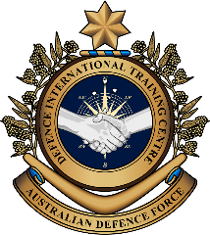
Military English

Vocabulary Builder - Parts of a Bushmaster Protected
Mobility Vehicle

Overview:
This worksheet lists vocabulary related to features of parts of the Bushmaster Protected Mobility Vehicle.

In this lesson, you will:
- learn vocabulary related to parts of a Bushmaster
- practise vocabulary of parts of a Bushmaster
- practise using the vocabulary

- Label the parts of the Bushmaster vehicle. Write the parts in the spaces a-m on pages 1 and 2.

- ____________________________
- ____________________________
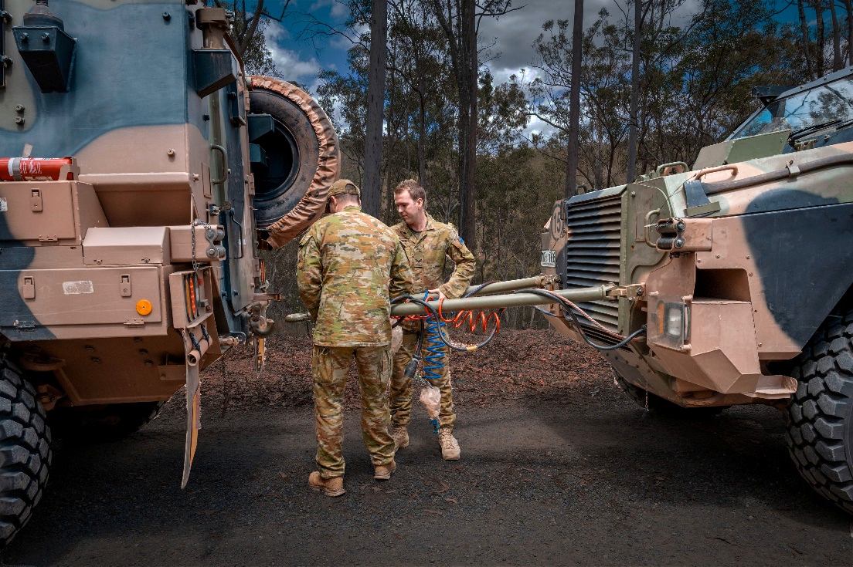
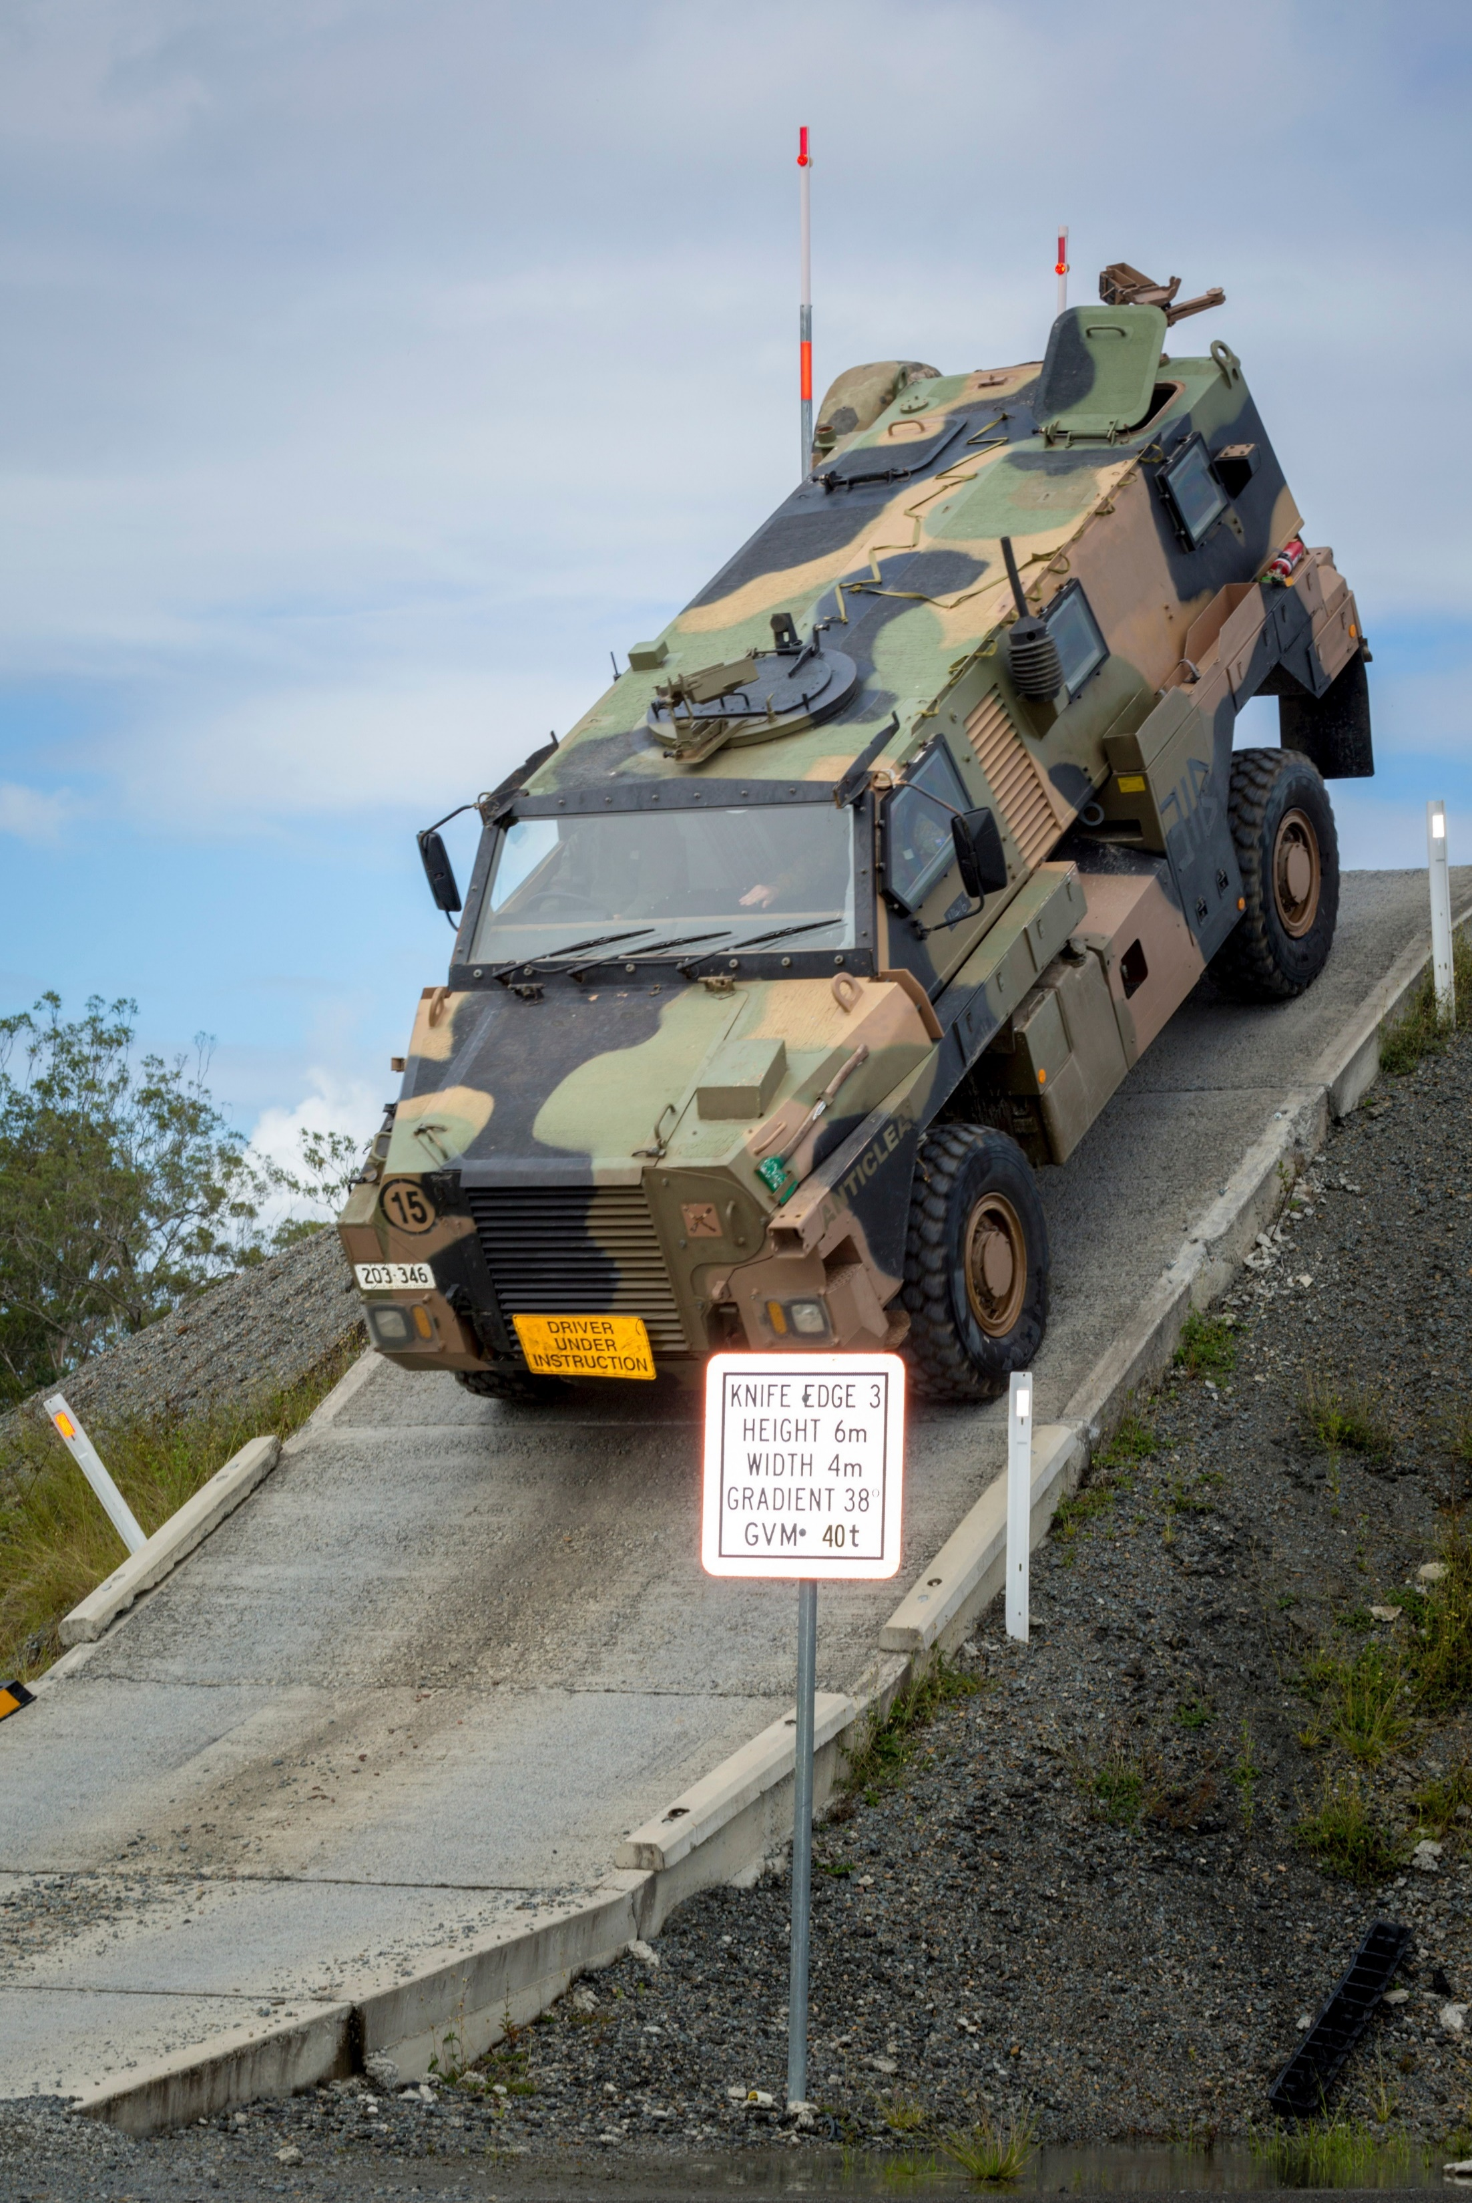
- ____________________________
a
e
- ____________________________
- ____________________________
- ____________________________
- ____________________________

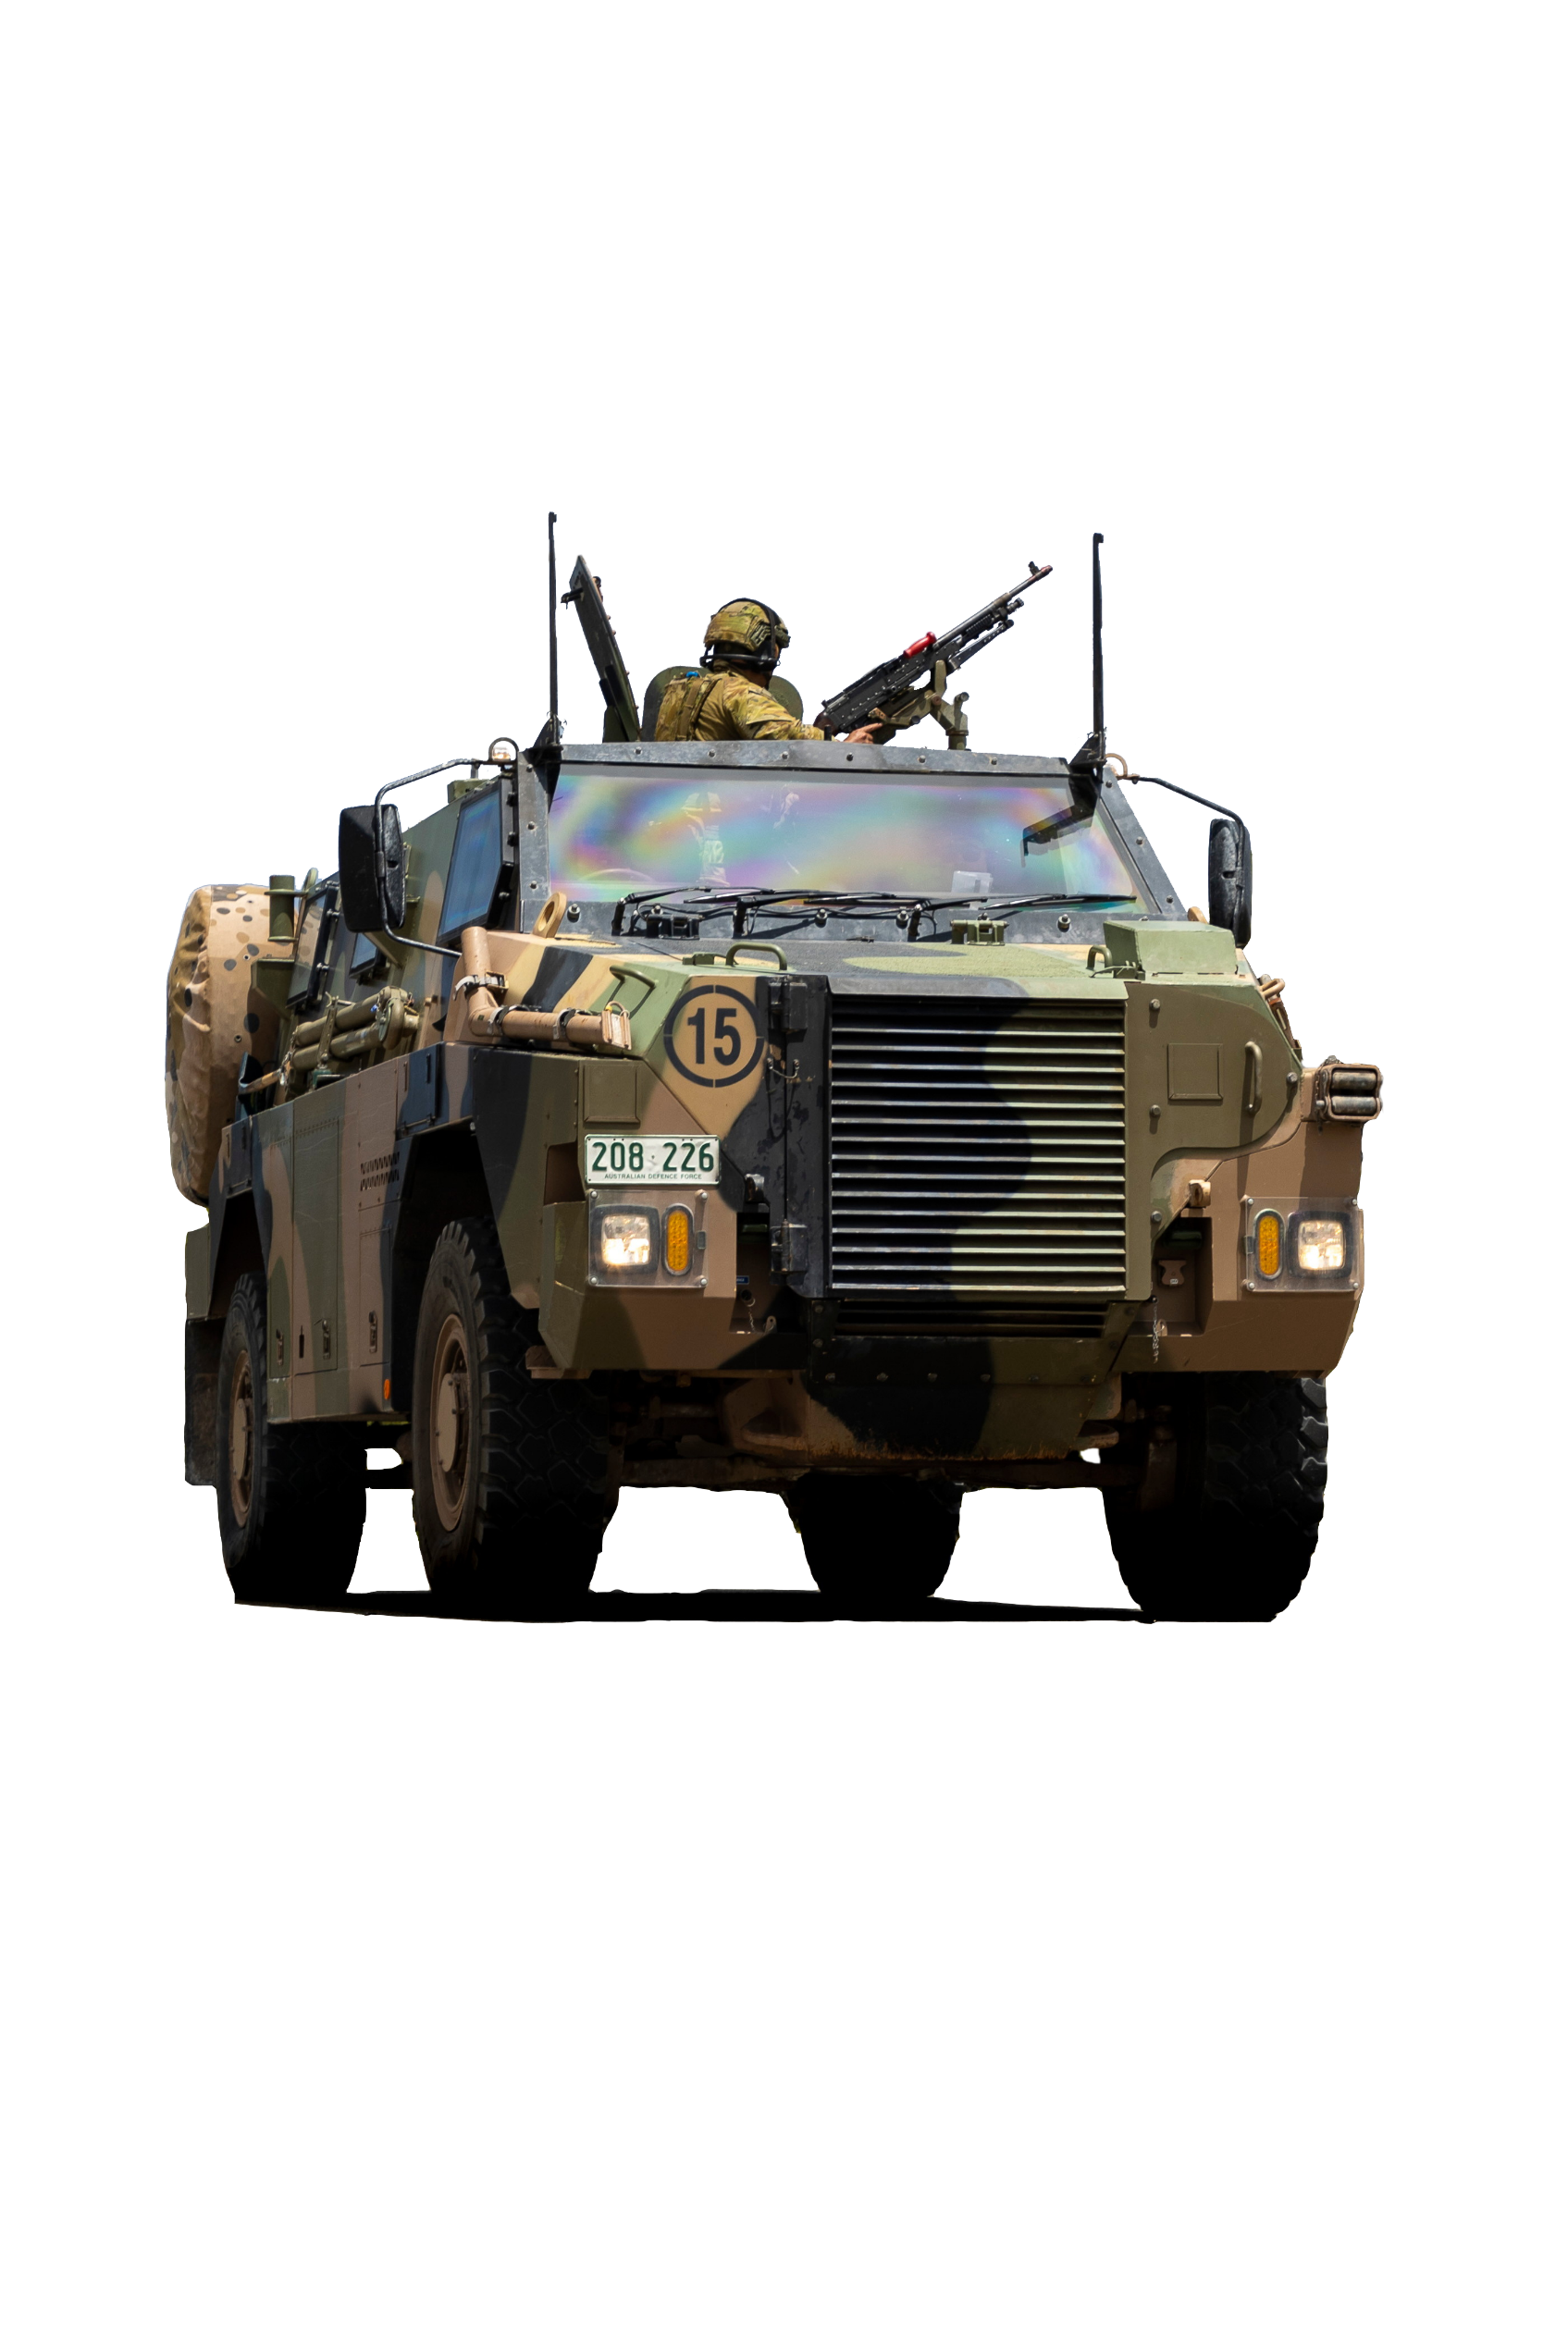
f
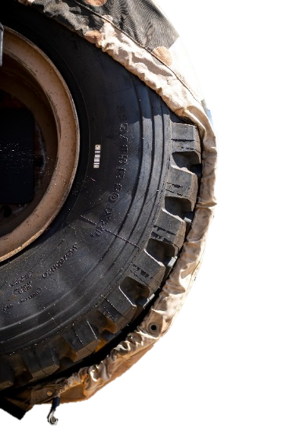
b

This is also called a
pintle mount.

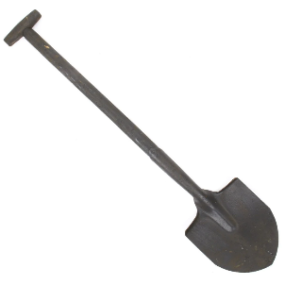
c

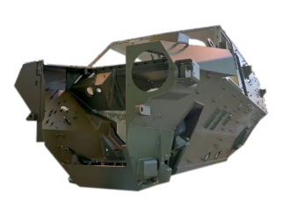

g
d

shovel // hull // towing bar // tyre // gun mount // hatch // spare wheel
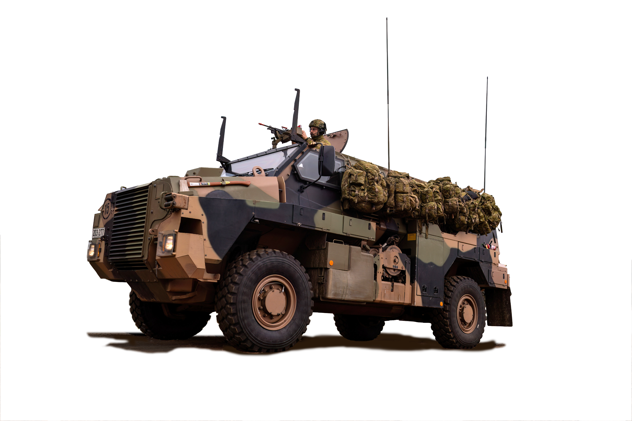
k

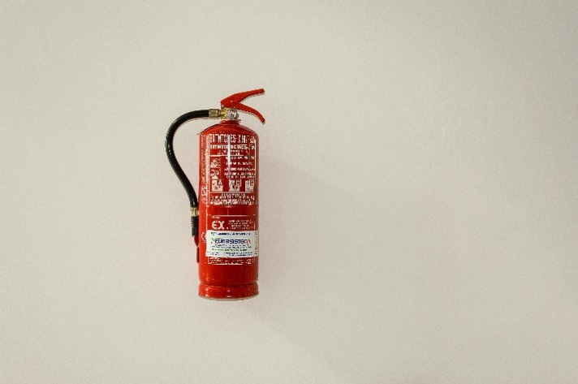

l

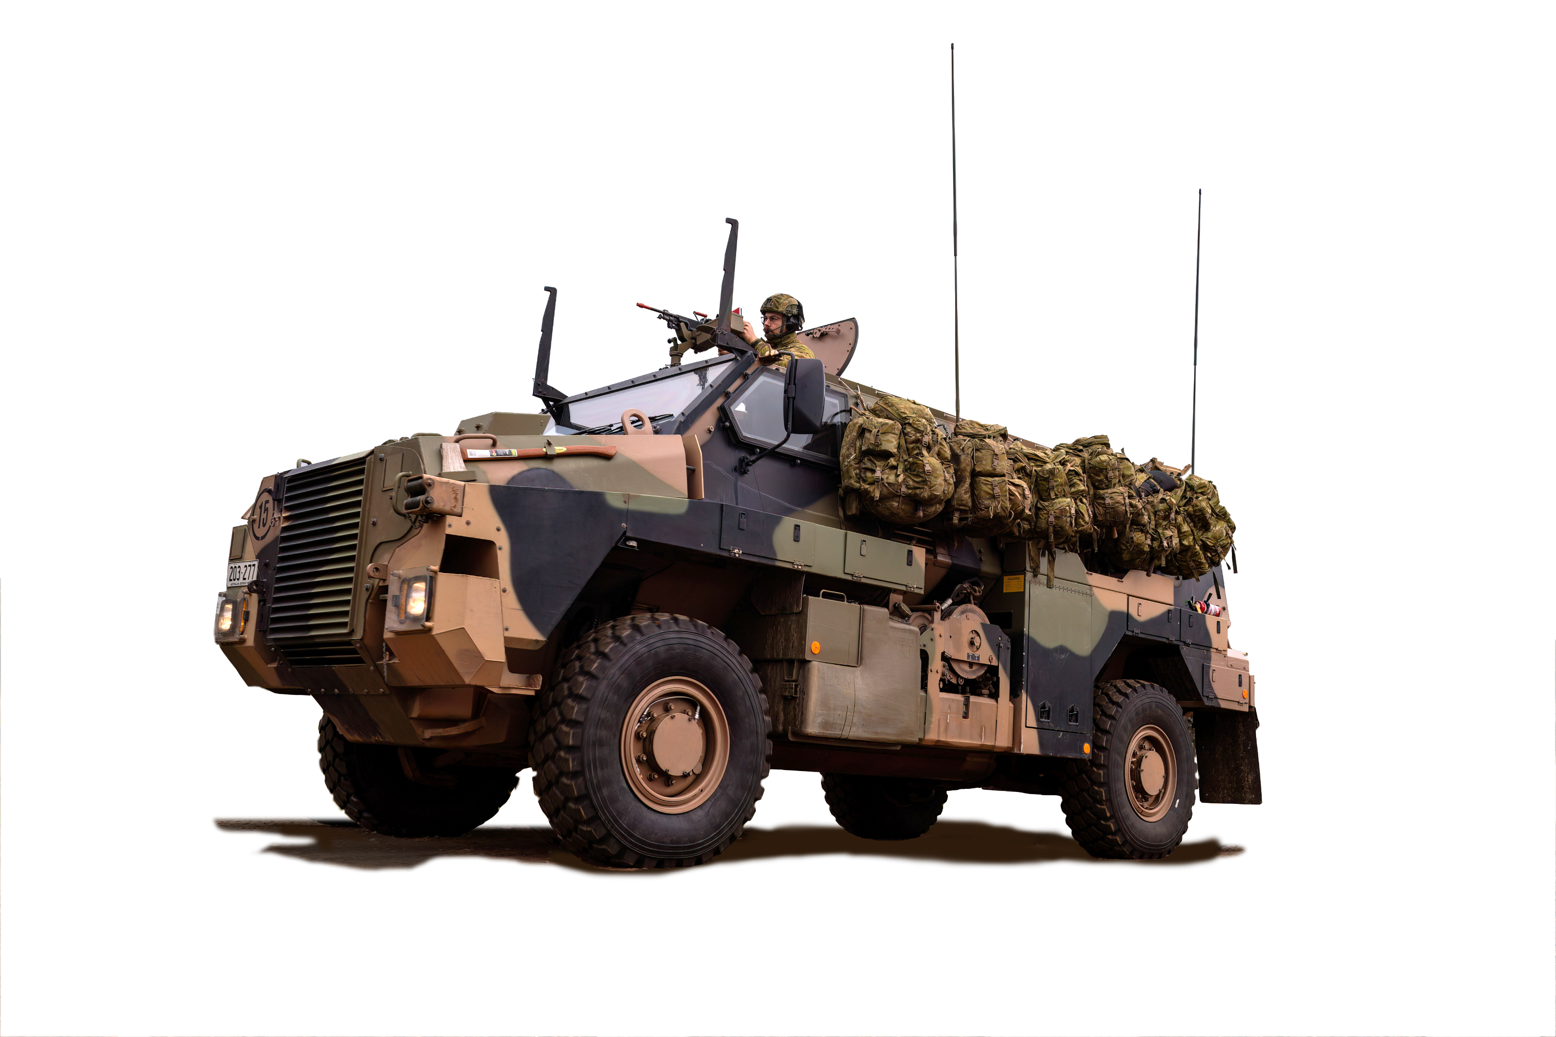
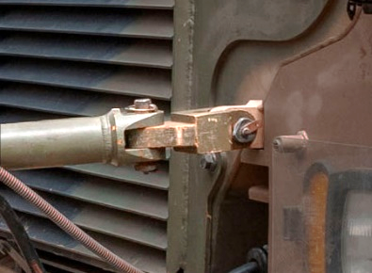
h
m

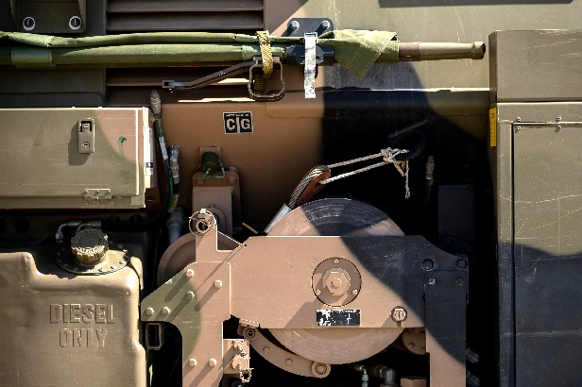
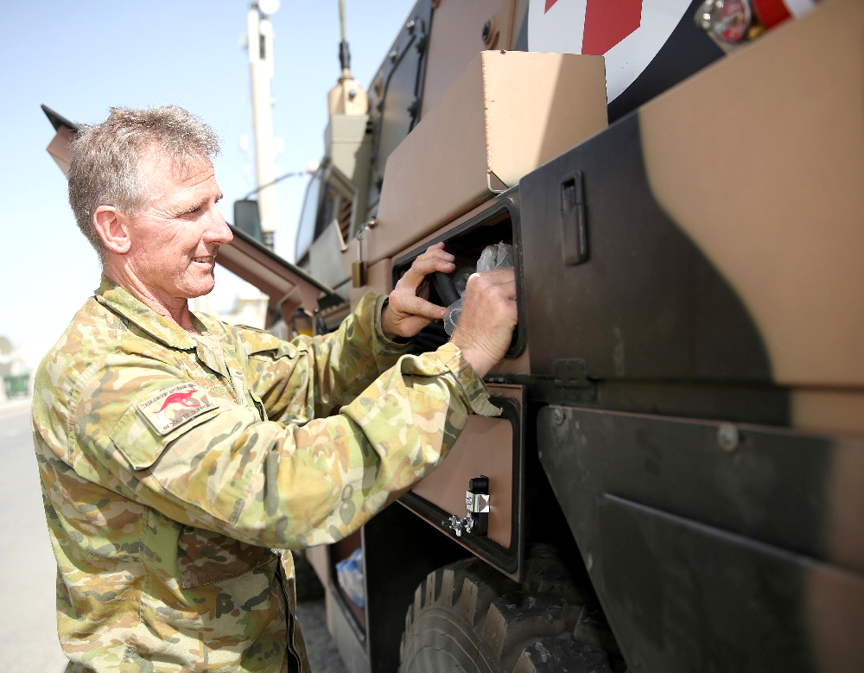

j
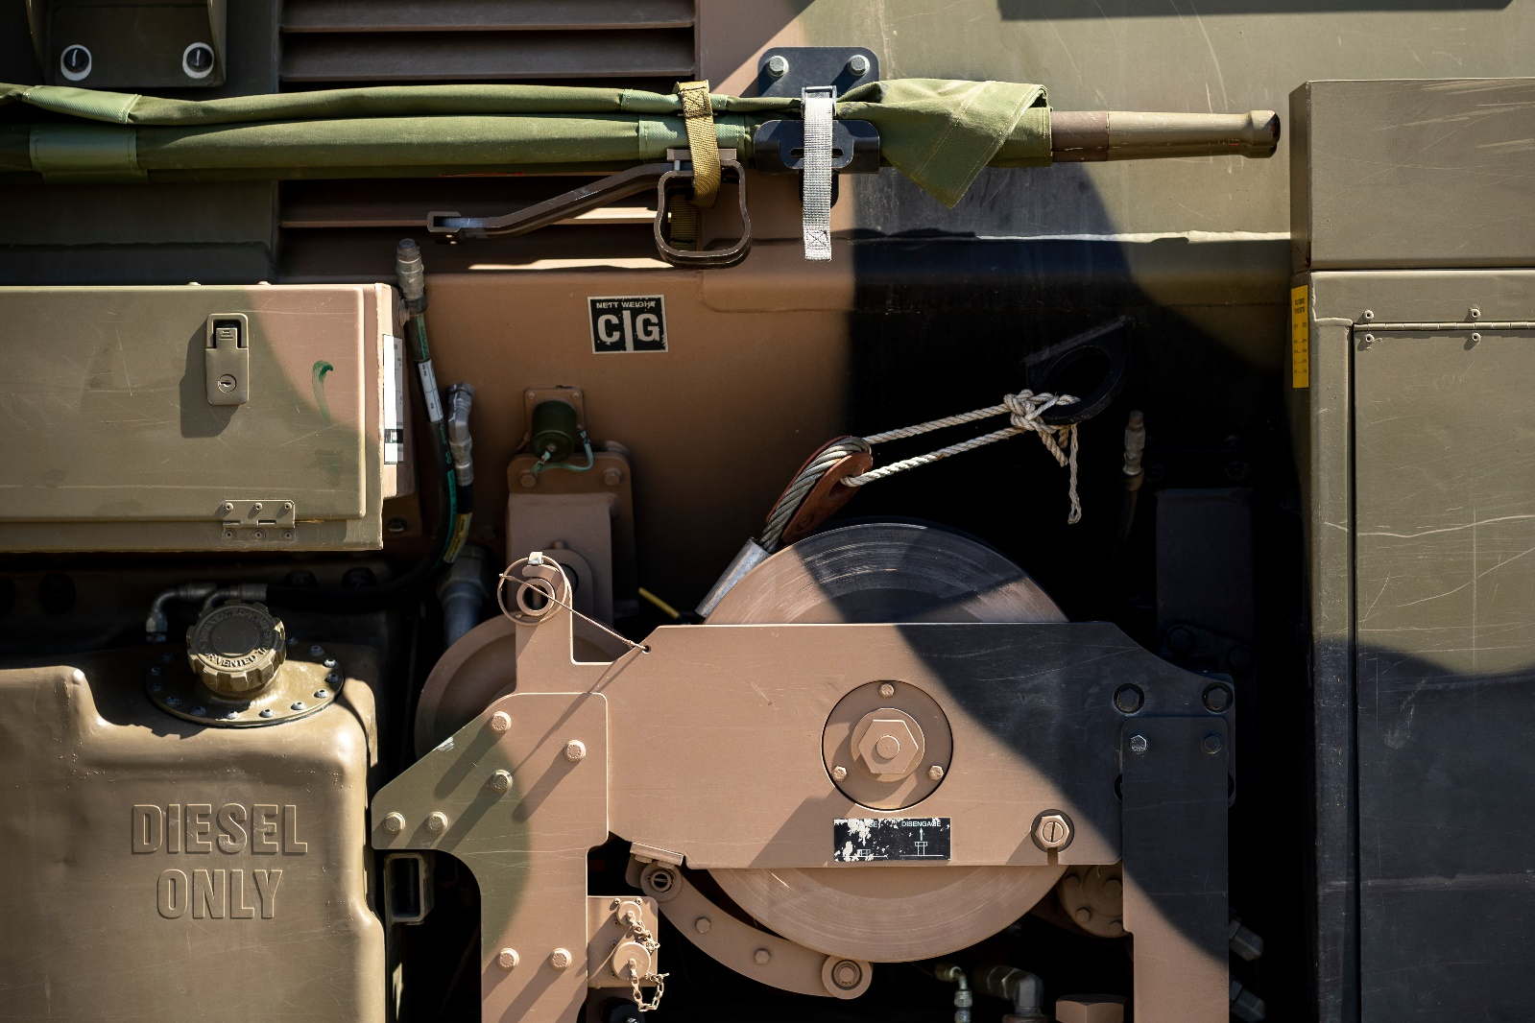
i

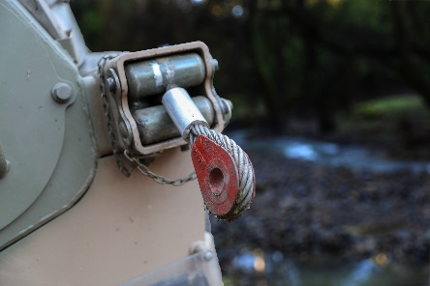

- ____________________________
- ____________________________
- ____________________________
- ____________________________
- ____________________________
- ____________________________

winch // towing lug // fuel tank // locker // fire extinguisher // antenna

- Let’s practise saying the words. Listen and repeat. Pay attention to the stressed syllables/words e.g. locker.

- Complete the sentences below with some of the words from Exercise 1.

- Soldiers open the ________________ on the roof of the Bushmaster when they need to use
a mounted gun.
- The _____________________ of the Bushmaster is the bottom part of the vehicle. It is very strong and has a V shape, to protect it from landmines and IEDs (Improvised Explosive Devices).
- On both sides of the Bushmaster there are ___________________ to store equipment such as tools, ammunition and cooking items.
- The main _________________________ on the Bushmaster can hold 300 litres of diesel.
- The ____________________ is used to pull heavy objects like a truck or another Bushmaster. The model in the pictures in this worksheet has two of them.
- If a Bushmaster breaks down, soldiers connect a _________________________to the towing lug and use another vehicle to move the Bushmaster out of the way.
- If a wheel – or a tyre – breaks, soldiers can use the ____________________________, which is at the back left side of the Bushmaster.
- The Bushmaster can keep going even if a ________________ has no air in it (these are called run-flat).
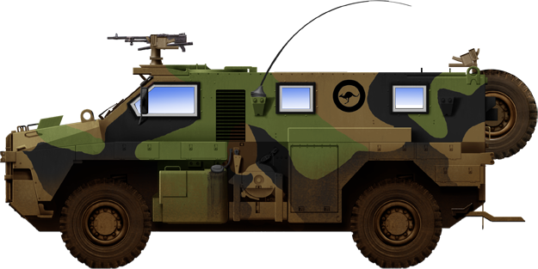
BUSHMASTER SPECS:

- Max speed: > 100km/h
- Operational range: 800km
- Crew: 1 driver and up to 9 soldiers
- Variants: troop carrier, command, patrol, support, weapons deployment, ambulance
- Operators: Australia, Indonesia, New Zealand, Japan, United Kingdom, Netherlands, Fiji, Jamaica, Ukraine
- Some parts of the Bushmaster are also found on other military vehicles. With a partner, take turns to ask and answer the following questions. Which parts are found in each of these three vehicles?
- Use the examples in the blue boxes to help you.
- The red arrows will help you find the parts in each vehicle.

B: No, I can’t see it.
or
B: No, this (ASLAV) doesn’t have one.

B: Yes, I can see a (spare wheel) here. or
B: Yes, this ASLAV has one here.

A: Does the (ASLAV) have a (spare wheel)?
or
A: Can you see a (spare wheel) on this (ASLAV)?



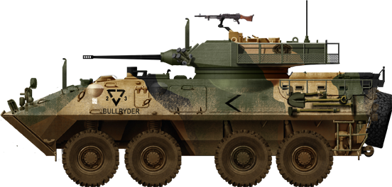
ASLAV – Australian light armoured vehicle
pronunciation: /ˈæslæv/

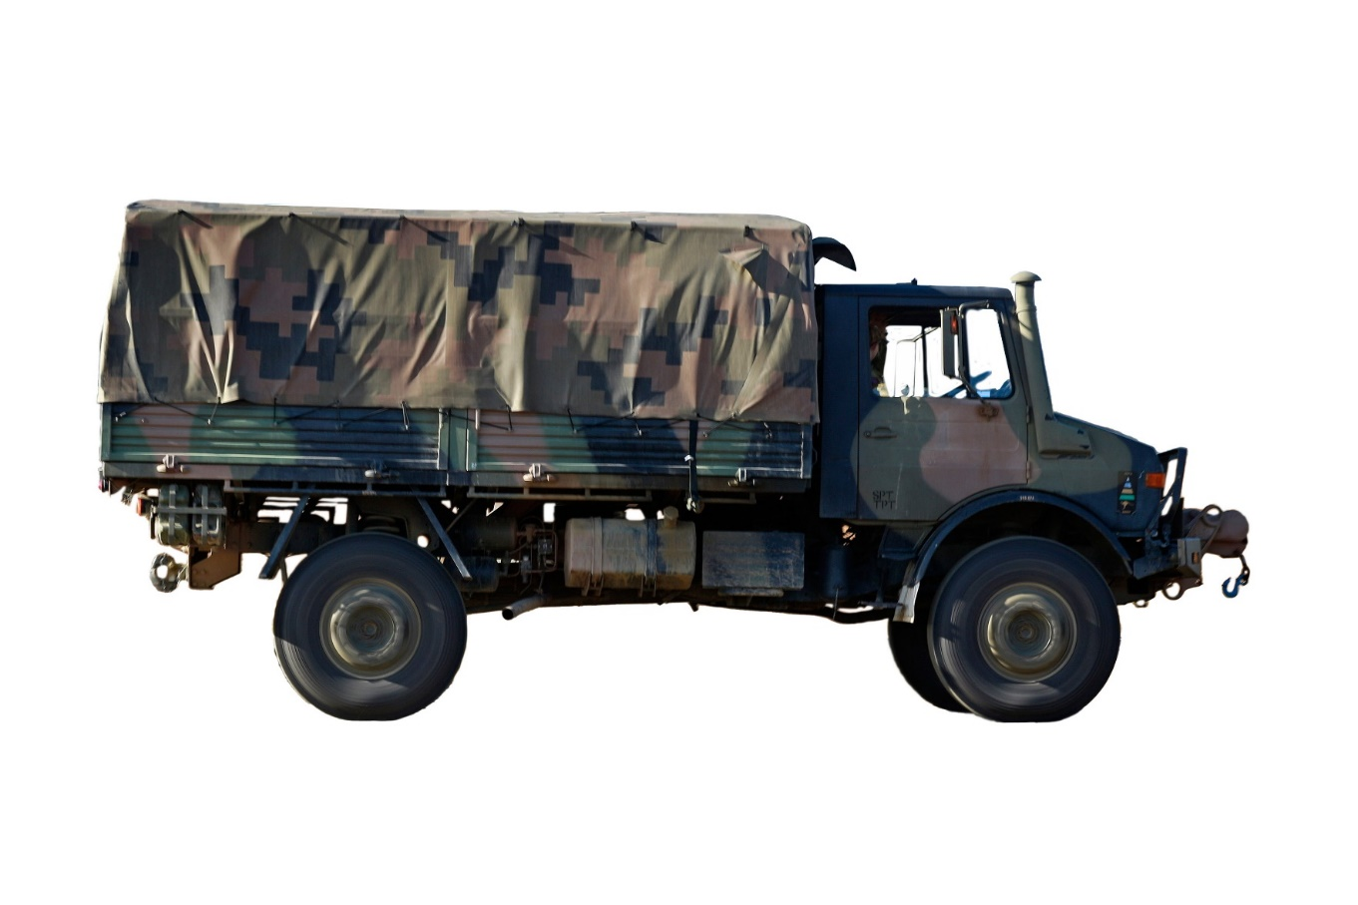

Unimog – military truck pronunciation: /ˈju:nəmɒg/

.
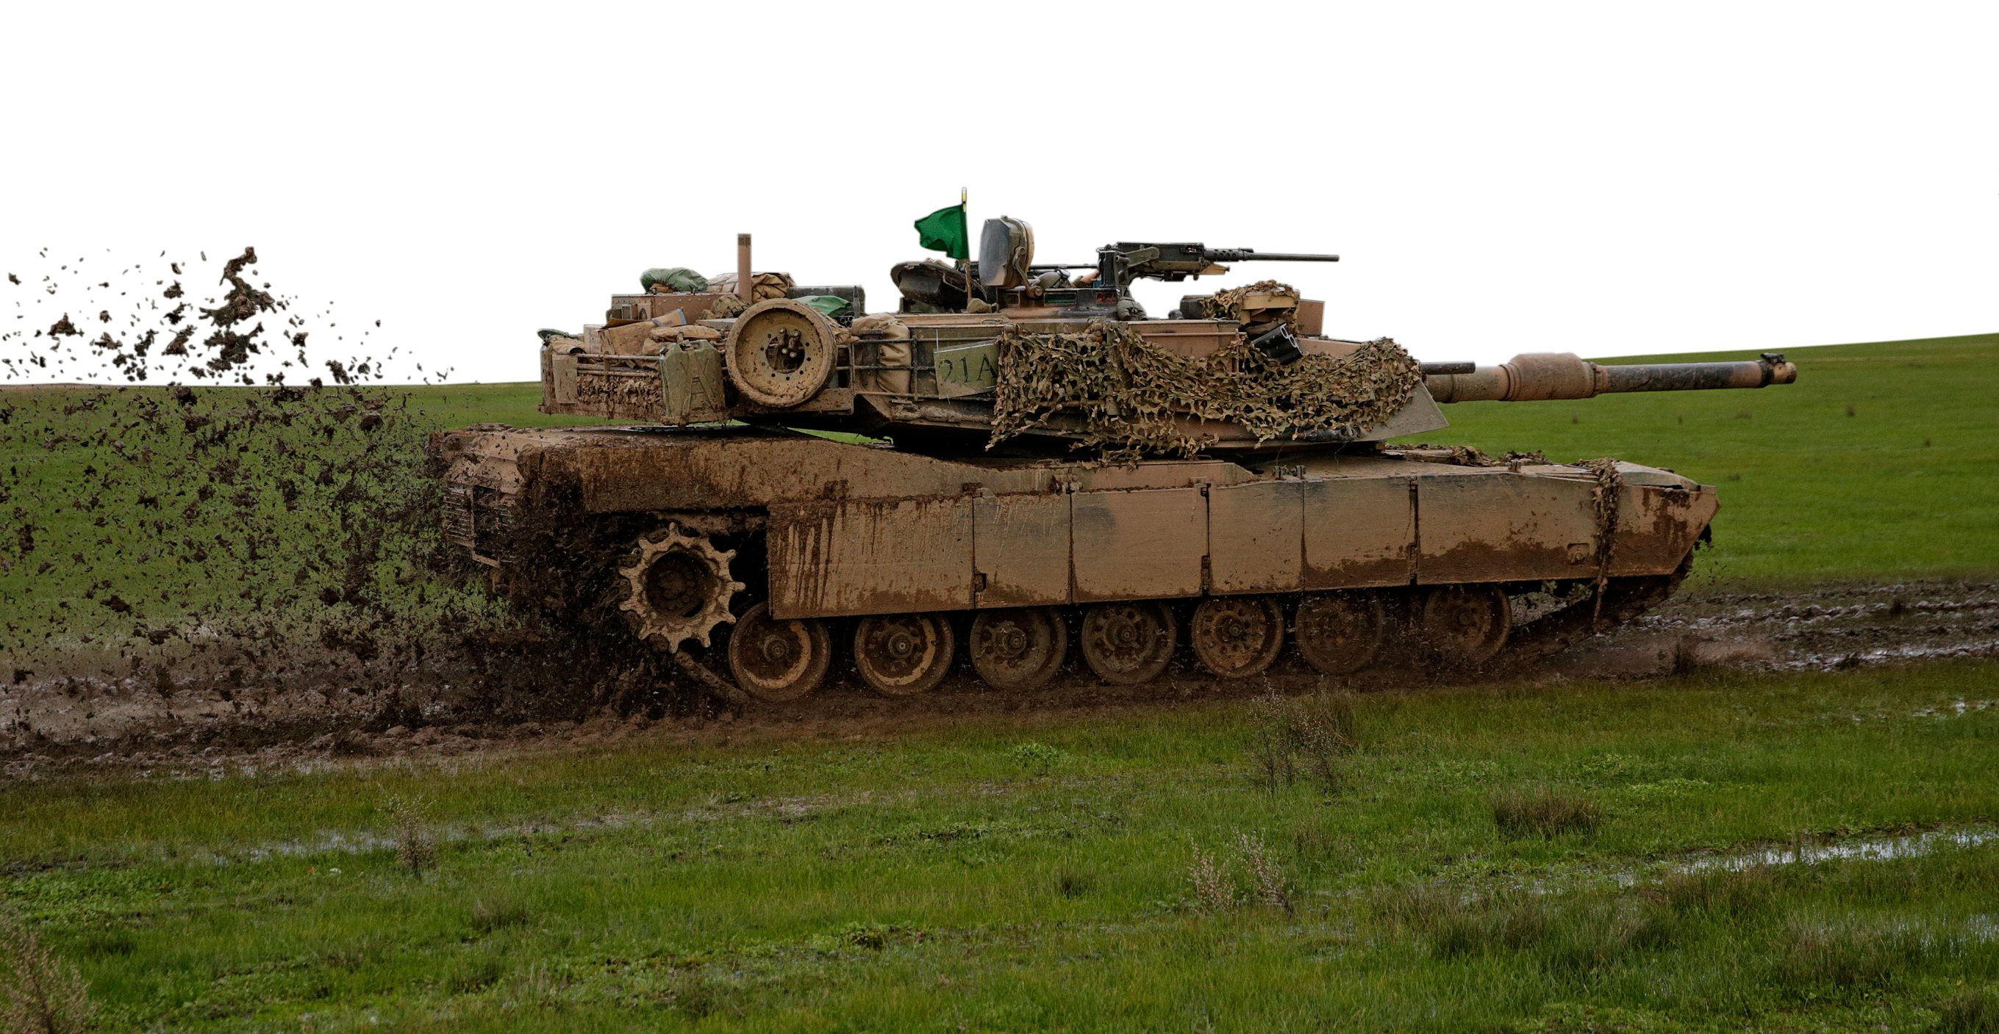

M1A1 Abrams – main battle tank | pronunciation: /ˈeɪbrəms/


• Watch this YouTube video and try to write down the words that you see or hear in the video. Type on YouTube BUSHMASTER: presentation of an Australian success story or scan the QR Code to the right.

• This Vocabulary Builder links with Lesson: A Job in the Army
Vocabulary Builder: Army Vehicles

© Commonwealth of Australia 2024
This work is copyright. Apart from any use as permitted under the Copyright Act 1968 (Cth), no part may be reproduced by any process without prior written permission from the Department of Defence

