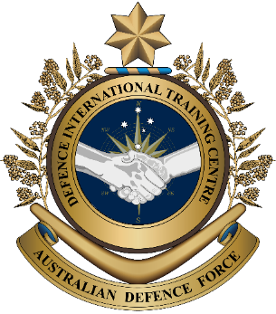
Military English

Vocabulary Builder – Parts of a Patrol Boat

Overview:
This worksheet lists vocabulary related to parts of a patrol boat.

In this lesson, you will:
- learn vocabulary related to parts of a patrol boat
- practise vocabulary of parts of a patrol boat
- practise using the vocabulary

- Label the parts of a patrol boat. Write the parts in the spaces below. Use the same word in question c.

- _____________________________________
- _____________________________________
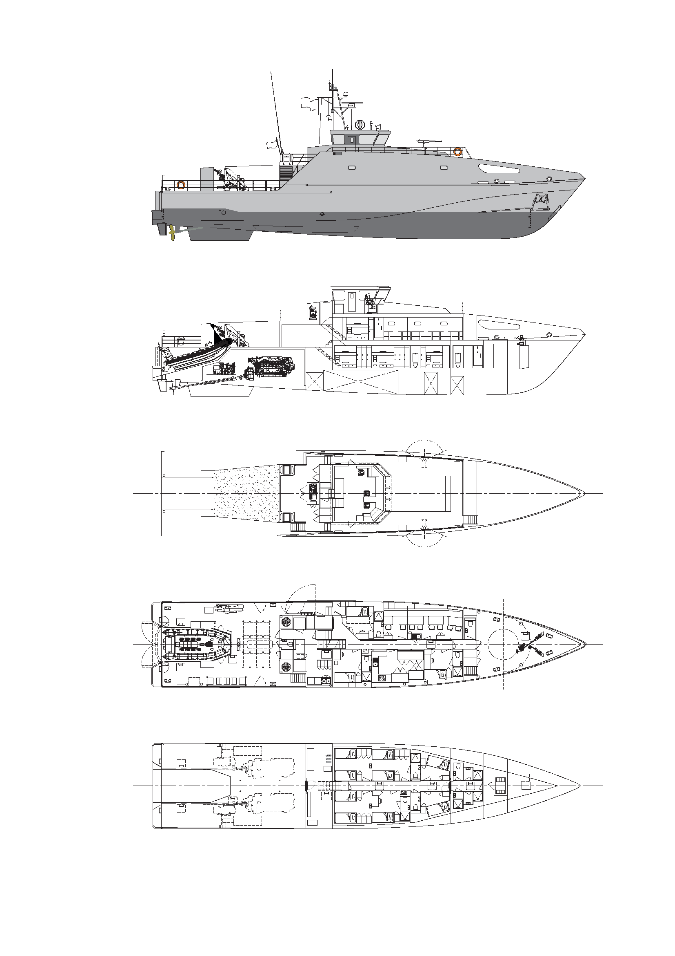
- main _____________; lower _____________
- _____________________________________
- _____________________________________

c
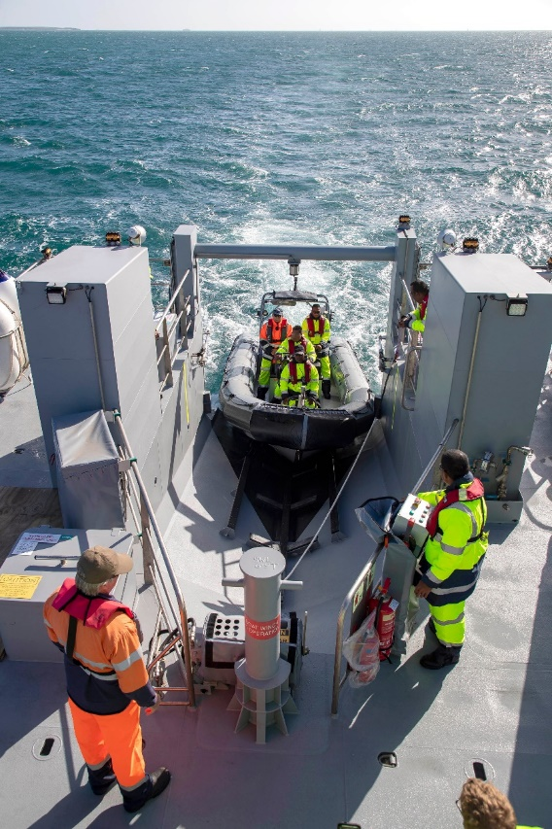
a
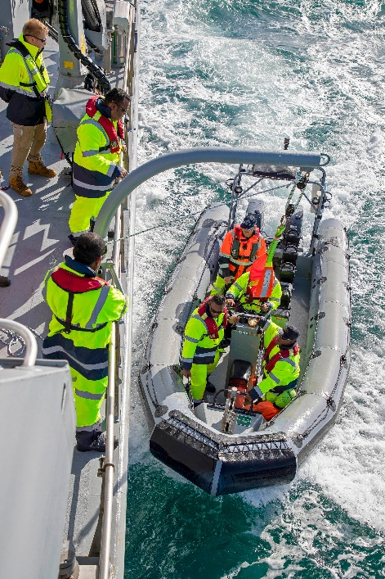
d

e

b
deck // launching ramp // anchor // RHIB (pursuit boat) // propeller

- Let’s learn about some of the compartments on a patrol boat. Read the description below and match the words on the left to the pictures. Look at the example.
MAIN COMPARTMENTS ON A VESSEL (= BOAT)

ENGINE ROOM where the ship’s engine is
BERTH sailors sleep here
BRIDGE officers control the boat from here
HEAD the ‘toilet’ on a boat
GALLEY chefs cook meals here
MESS sailors eat, relax and have meetings here

compartment (n) -
a separate space inside a boat

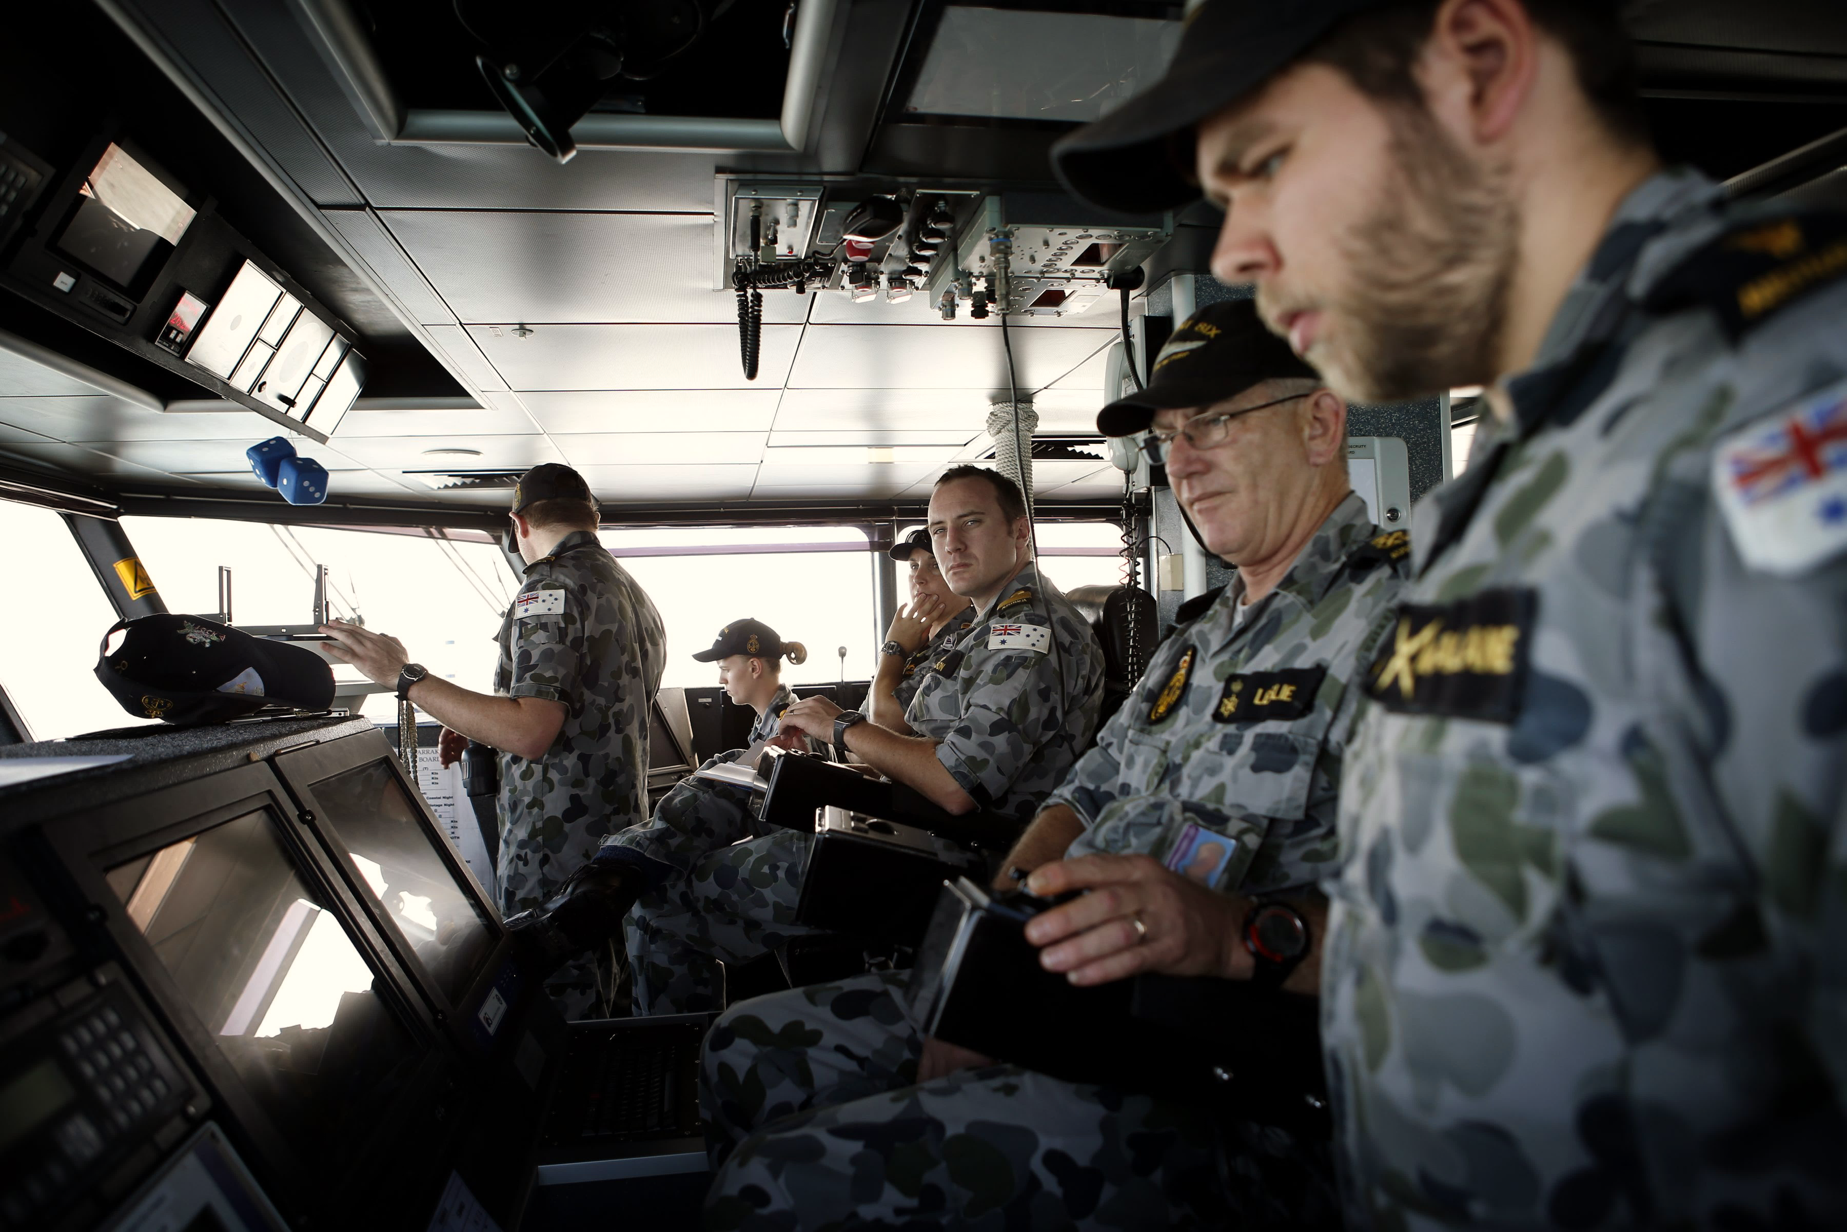
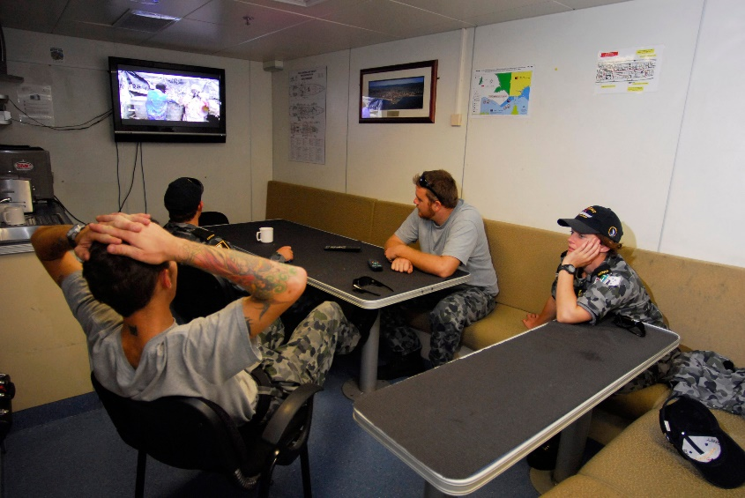
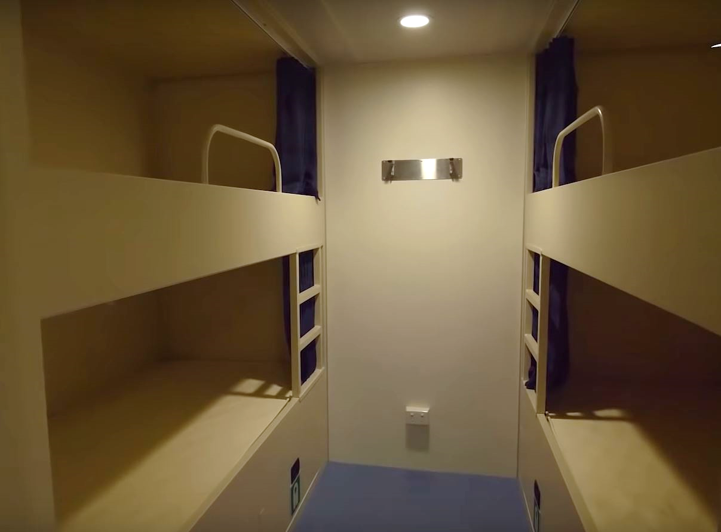
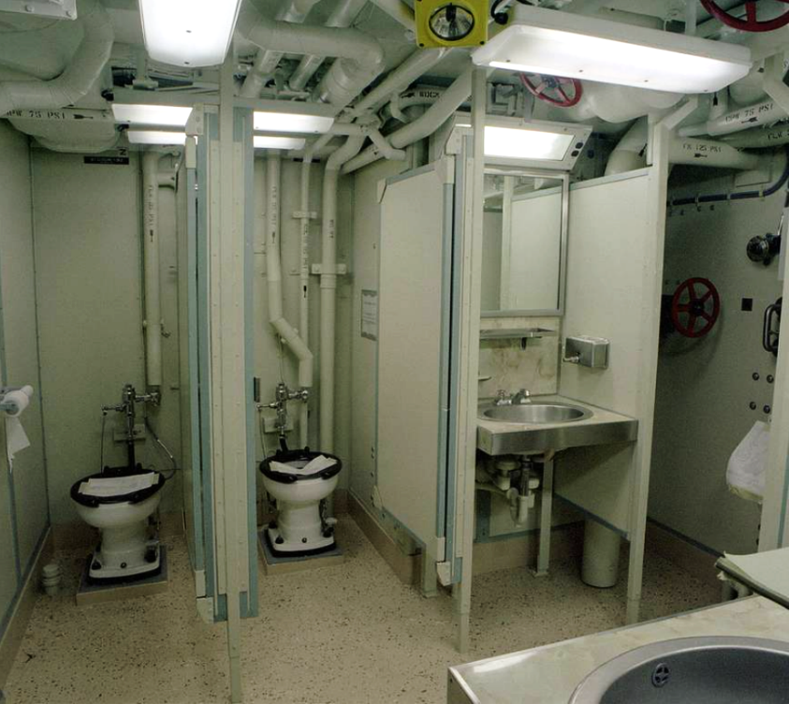
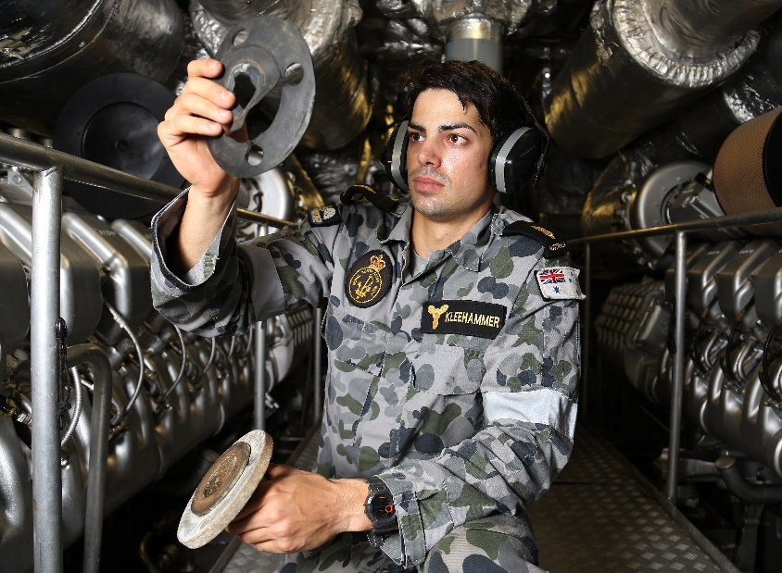
a. berth
e. _________________________
d. _________________________
c. _________________________
b. _________________________

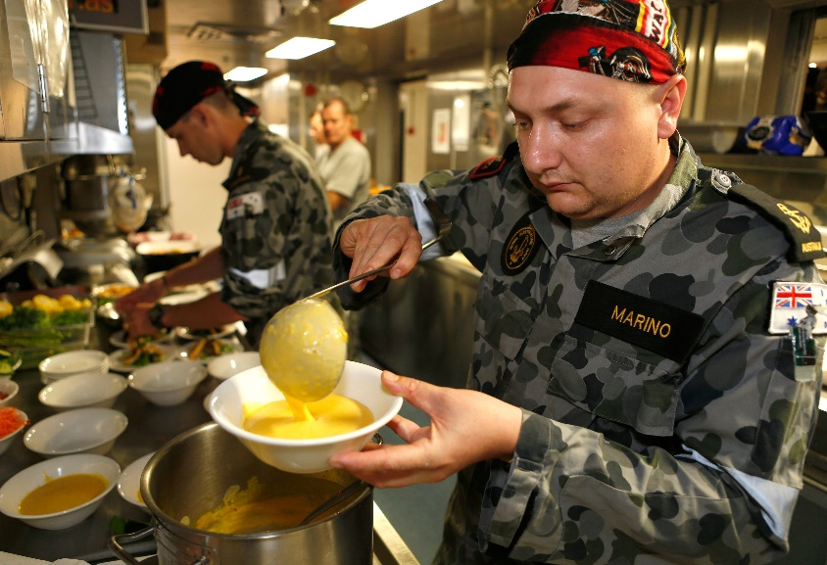

f. _________________________

- Now let’s practice saying the words. Listen and repeat.

- Where are the different compartments on the Guardian Class patrol boat? With a partner, take turns asking and answering questions to find out. Where is each compartment?
- Decide who is student A and student B.
- Student A, go to page 4. Student B, go to page 5.
- Student A, don’t look at page 5; student B, don’t look at page 4.

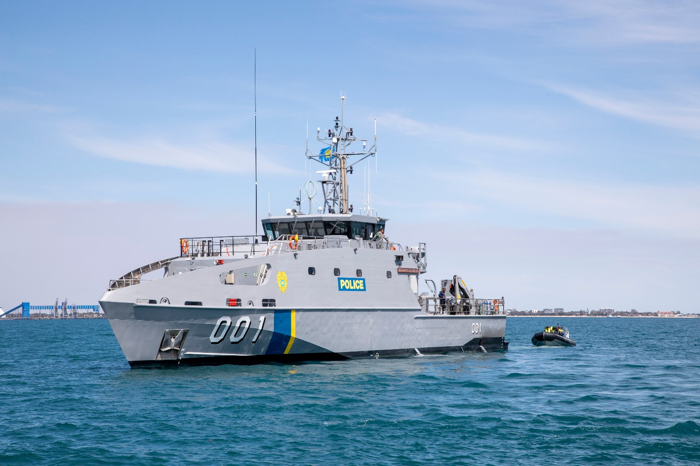
The Guardian Class patrol boat is 128 feet long. Its top speed is over 20 knots and it can travel up to 3,000 nautical miles.

Australia is giving 22 of these boats to countries in the Pacific to help them stop illegal fishing, smuggling and other types of crime.

The boat in this picture was given to Palau.


• Watch this YouTube video. While you watch, write down everything you see that you learned from this lesson. Type on YouTube Austal Patrol 40 or scan the QR Code to the right:

• This Vocabulary Builder links with Lesson: Patrol Boats

© Commonwealth of Australia 2024
This work is copyright. Apart from any use as permitted under the Copyright Act 1968 (Cth), no part may be reproduced by any process without prior written permission from the Department of Defence
Exercise 4 - STUDENT A
Student A, stay on this page. Student B go to page 5.
- To complete your sheet (numbers 1-6), you need information that your partner has.
- You need to ask about these places: bridge, engine room, and head.
- You have information that your partner needs to complete his/her sheet.
- You will ask one question, then your partner will ask you a question, and so on.
- Use the text in the blue boxes to help you ask and answer the questions.

Where is/are the (galley/berths)?
or
What number is/are the (galley/berths)?
Asking:
The (galley/berths) is/are here.
or
The (galley/berths) is/are number XX.

Answering:

main deck

1
3
galley
mess

2
main deck

lower deck

5
berths
4
6
lower deck

Exercise 4 - STUDENT B
Student B stay on this page. Student A, go to page 4.
- To complete your sheet (numbers 1-6), you need information that your partner has.
- You need to ask about these places: galley, mess, and berths.
- You have information that your partner needs to complete his/her sheet.
- You will ask one question, then your partner will ask you a question, and so on.
- Use the text in the blue boxes to help you ask and answer the questions.

Where is/are the (galley/berths)?
or
What number is/are the (galley/berths)?
Asking:
The (galley/berths) is/are here.
or
The (galley/berths) is/are number XX.

Answering:

main deck

1
3

bridge
2
main deck

lower deck

5
4
head
engine room
6
lower deck

