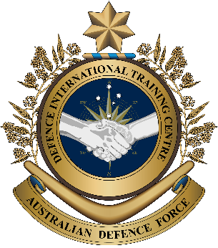
Military English
Vocabulary Builder - Field Medicine - Part A

Overview:
This worksheet presents vocabulary related to Field Medicine.
In this vocabulary builder, you will:
- learn and use vocabulary related to medical terms in a military context.

- Let’s learn words related to people, places and transport in field medicine.
Match the words in the box below to the pictures.
stretcher // ambulance // field medic // nurse

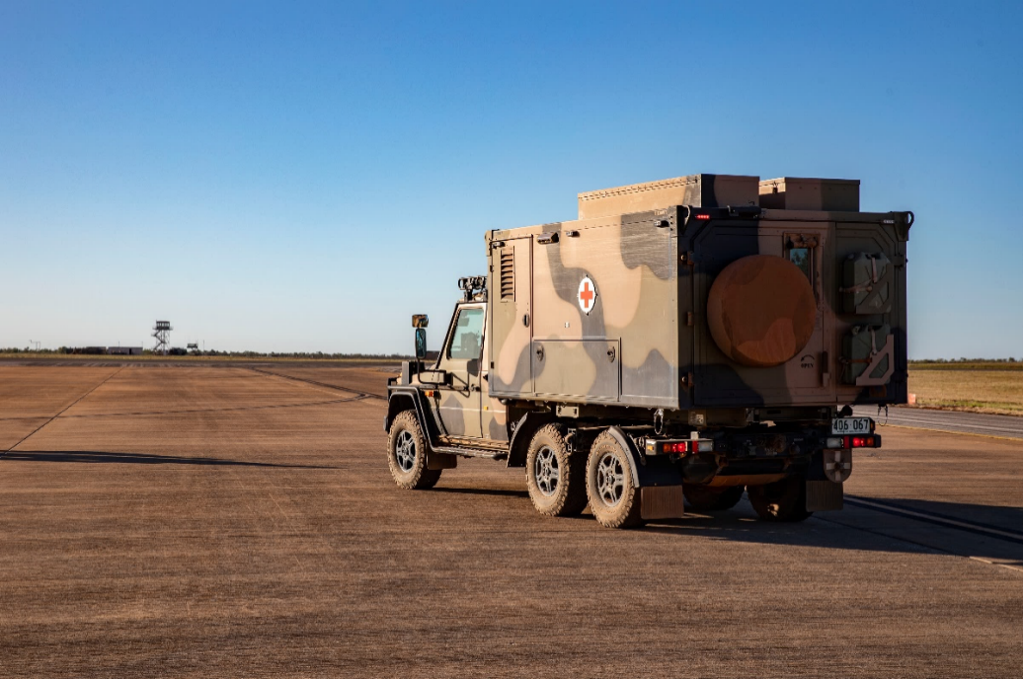
field medicine (n) - when a medic gives first aid to
a soldier in the battlefield
b. ____________________

c. ____________________
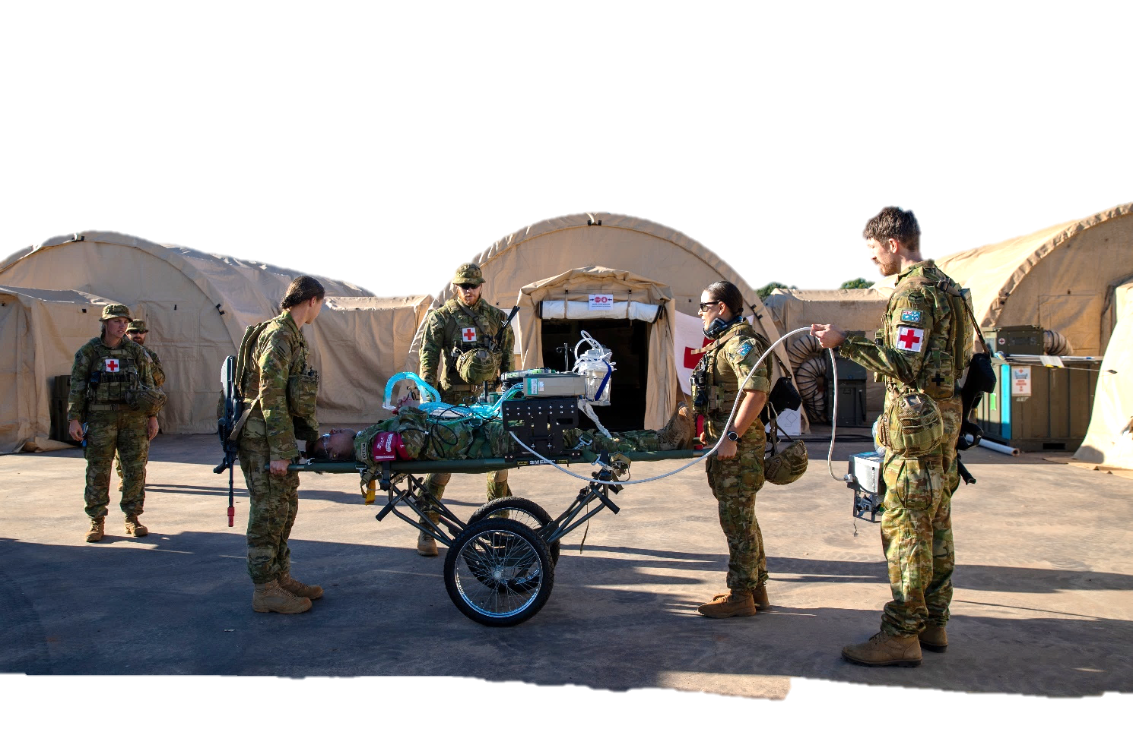
a. ______________________

d. _____________________
- Let’s learn more words related to field medicine. Match the words in the box below to the pictures
on pages 2-3.

first aid kit // medicine // tourniquet // syringe // bandage // injury //
CPR // wound // stethoscope

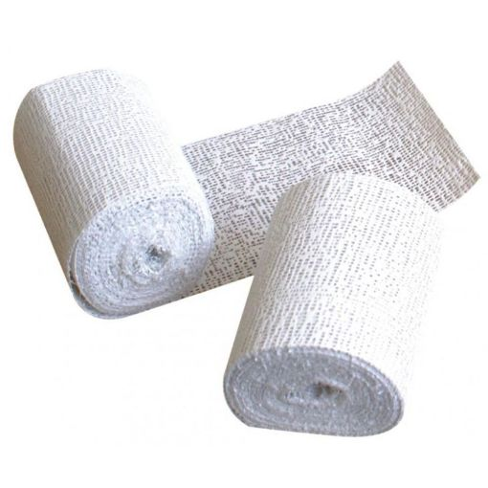

f. _________________________

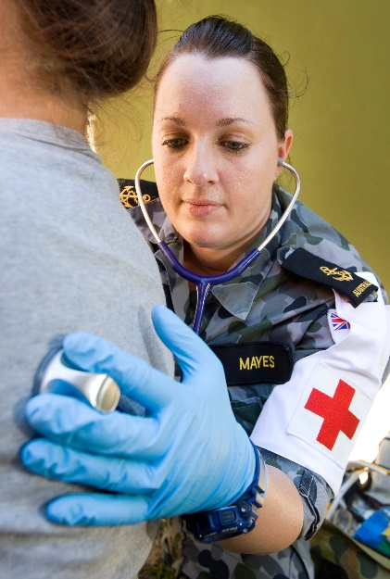

g. _________________________
e. _________________________
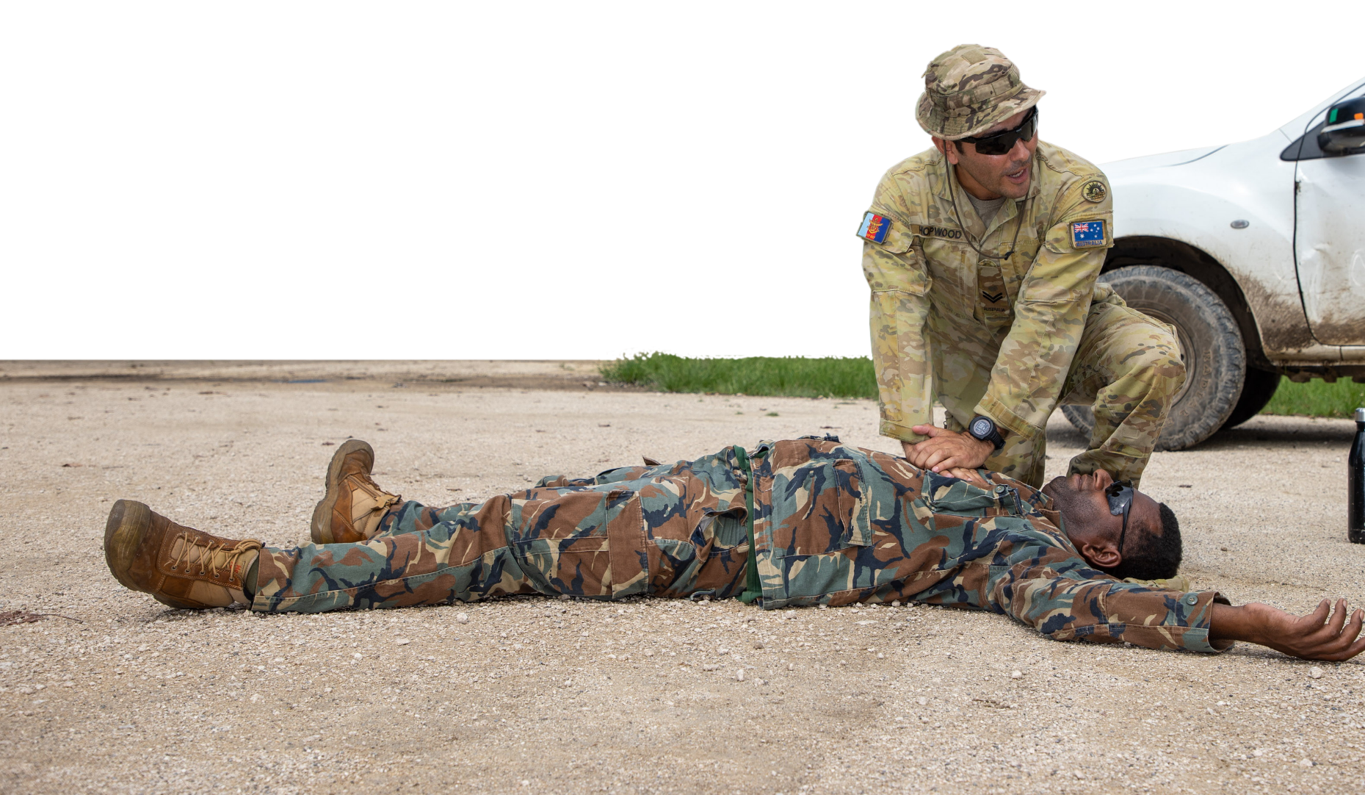

h. _____________________

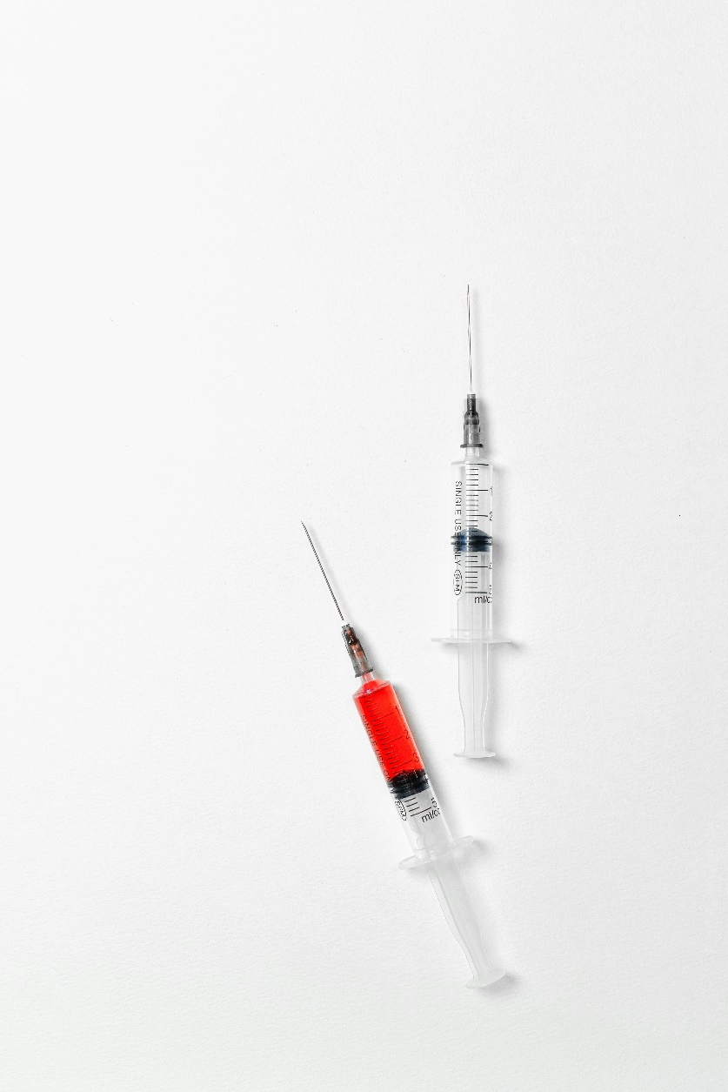

k. _____________________
i. _____________________

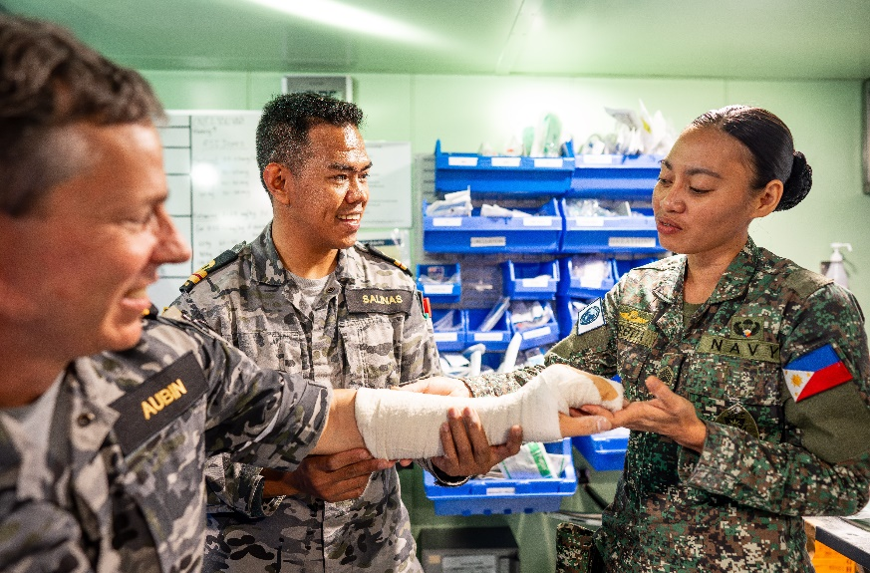
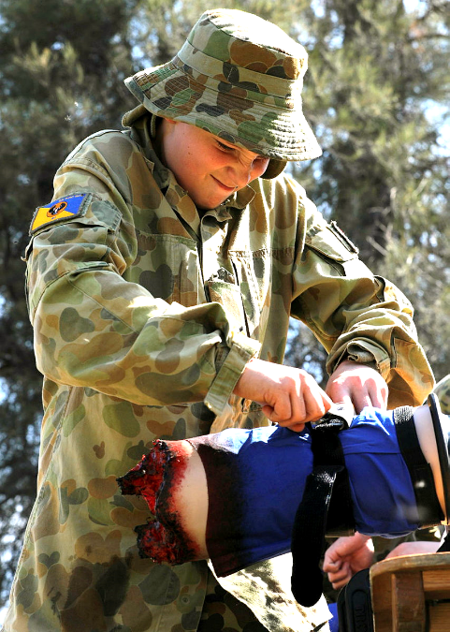
j. ______________________
l. ______________________

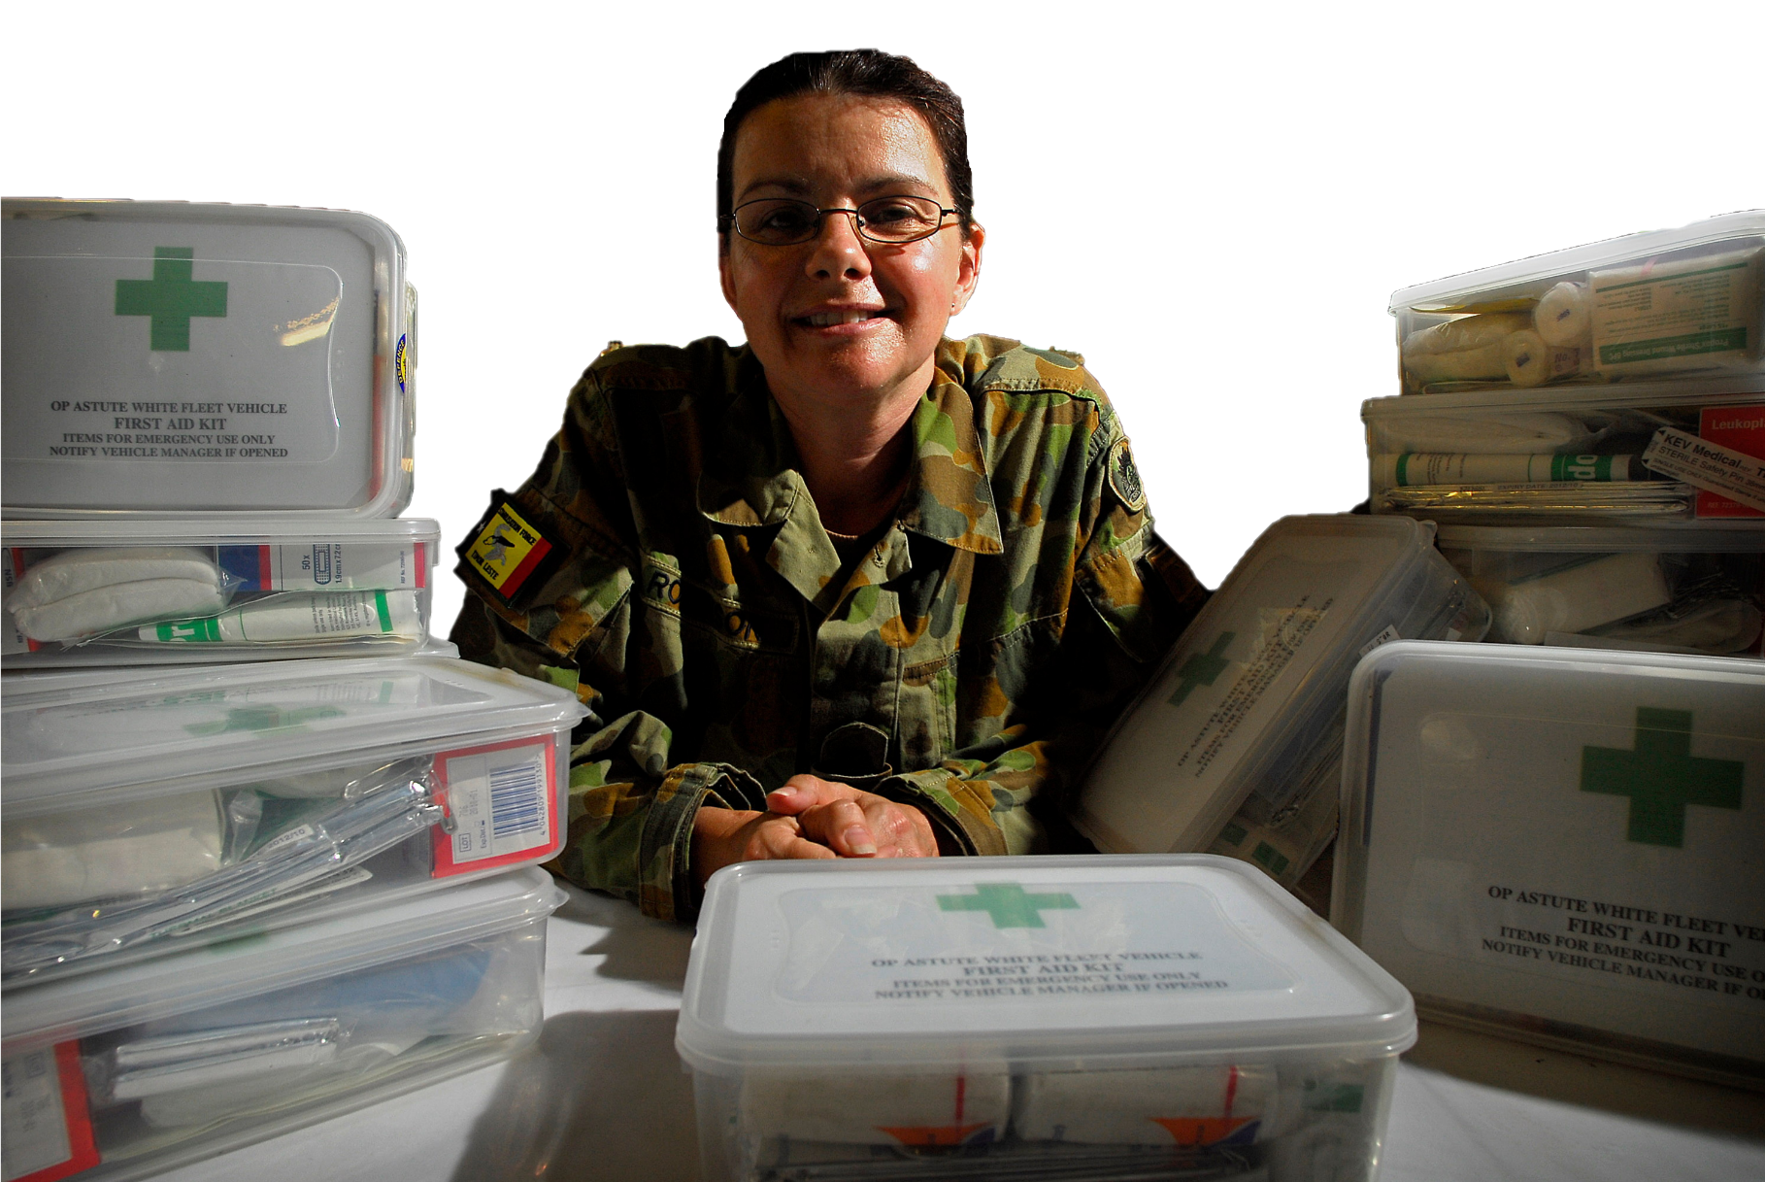

m. _____________________

- Learn the meaning of the words injury and wound. Read the explanation below.
Do you know
?

the difference
A wound is when you get a cut or a scrape on your skin. You can see blood and it might need a bandage to help it heal. An injury is when you hurt yourself, like when you fall down and bump your knee or twist your ankle.
A wound is a type of injury, but not all injuries are wounds.

Now write the words injury or wound next to the pictures.
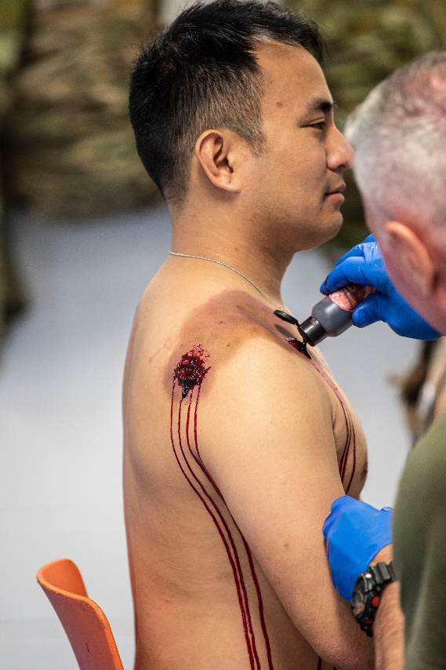
a. _______________

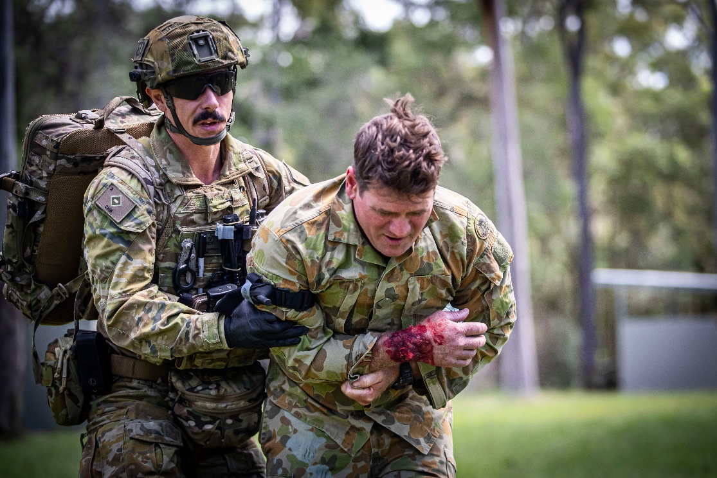
b. _______________
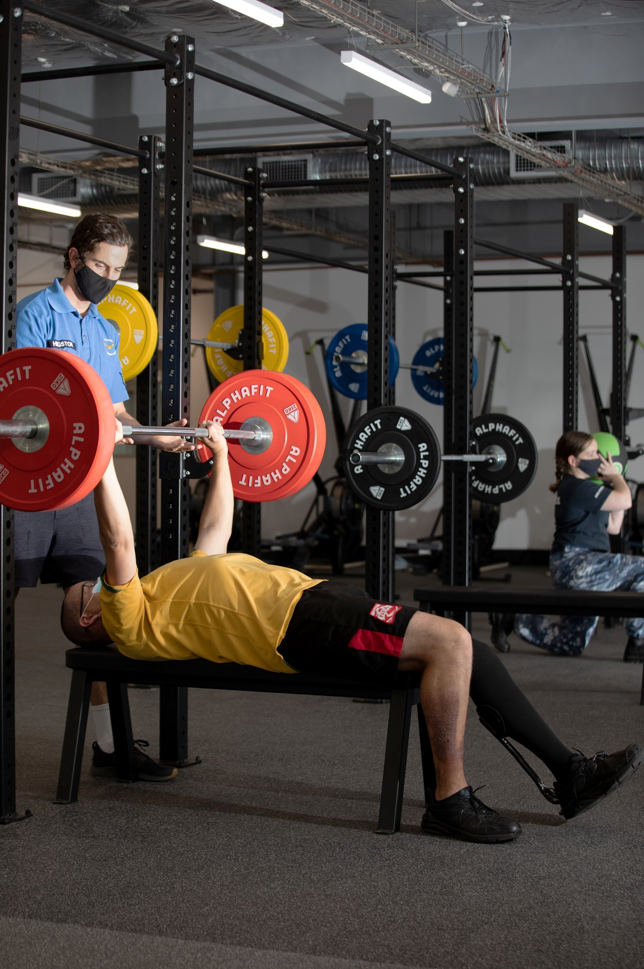
c. _______________

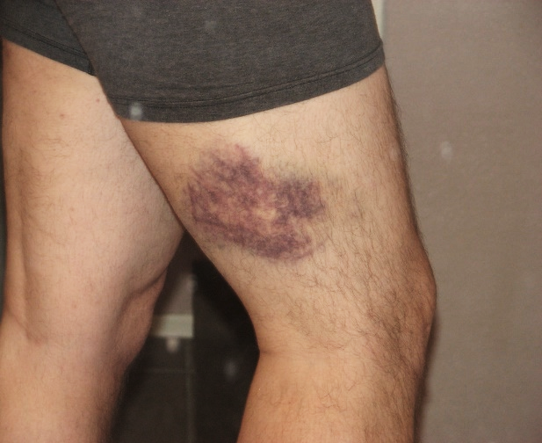
d. _______________

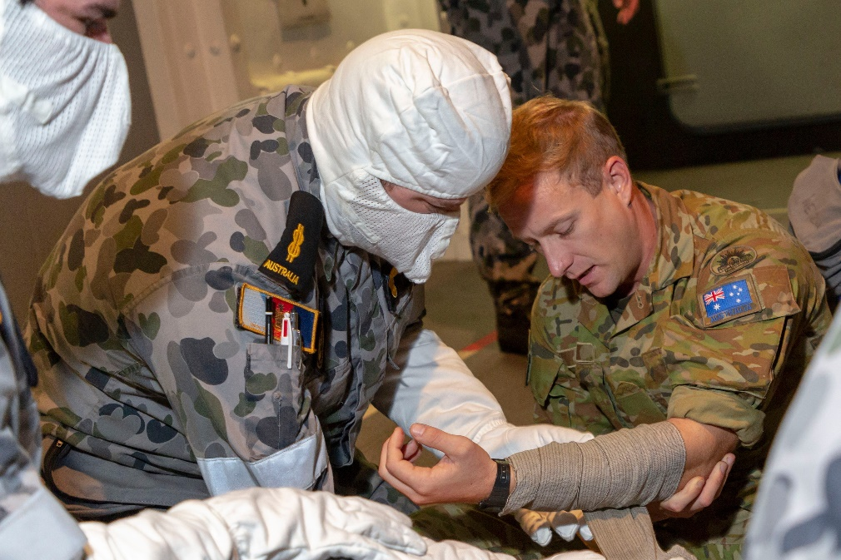
e. _______________

- Let’s practise saying the words. Listen and repeat.
- Using the words from the box below, fill in the gaps in the story. Look at exercises 1 and 2 for help.
The first one is done for you.
first aid kit // tourniquet // syringe // bandage // field medic // CPR // gunshot wound // stretcher // ambulance // medicine

field medic
SGT Nguyen, a 1.________________, ran to help a soldier in the battlefield. CAPT Johnson was on the ground, holding his leg. He had a gunshot 2. ________________ and it was bleeding. SGT Nguyen quickly opened his 3. _______________________ and took out a 4. __________________ to stop the blood. He wrapped a 5. __________________ tightly around the wound. He then used a 6. __________________ to give him some 7. _________________________ to stop his pain. SGT Nguyen’s team lifted CAPT Johnson onto a 8. ____________________. As they were moving him, Johnson stopped breathing so SGT Nguyen began 9. __________, pressing down on Johnson's chest. After a few minutes, Johnson coughed and started to breathe. They put him into the 10. ________________________ and sent him to a hospital. SGT Nguyen was happy that he had saved another life in the battlefield.

- Discuss these questions in groups of 2-3. Use as many of the words you learned in this lesson
as you can.
  - Have you ever needed to give first aid to anyone? What happened?
  - What does a soldier need to learn to become a medic?
  - How do field medics help soldiers with injuries?

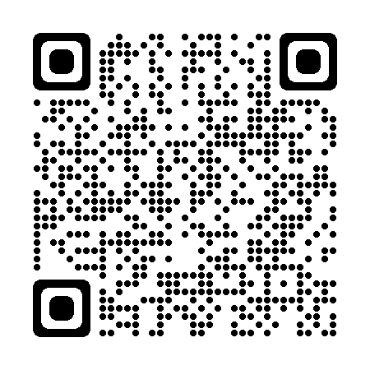
- Watch a video about Field Medicine. Type on YouTube Australian Army Medics, Nurses and Doctors conduct simulated casualty drill or scan the QR code
Tick the words below that you see / hear in the video.

☐ first aid kit ☐ medicine ☐ tourniquet ☐ syringe ☐ bandage
☐ field medic ☐ CPR ☐ gunshot wound ☐ stretcher
☐ ambulance ☐ stethoscope ☐ doctor ☐ injury ☐ nurse

- This Vocabulary Builder links with Lesson: PKO Medic – Part A, B

© Commonwealth of Australia 2024
This work is copyright. Apart from any use as permitted under the Copyright Act 1968 (Cth),
no part may be reproduced by any process without prior written permission from the Department of Defence.

