

**Military English**

Vocabulary Builder – Parts of a Vehicle Checkpoint

**Overview:**  
This worksheet lists vocabulary for military vehicle checkpoints.

**In this vocabulary builder, you will:**

* learn and use vocabulary related to military vehicle checkpoints.

1. Label the parts of a vehicle checkpoint. Match the words in the boxes to the pictures on pages 1 and 2.

**vehicle checkpoint** (VCP)– when soldiers (or the police) close a road and check that the vehicles (= cars, trucks, vans, buses, etc) are not dangerous e.g. they don’t have bombs, guns, drugs or anything that is against the law.

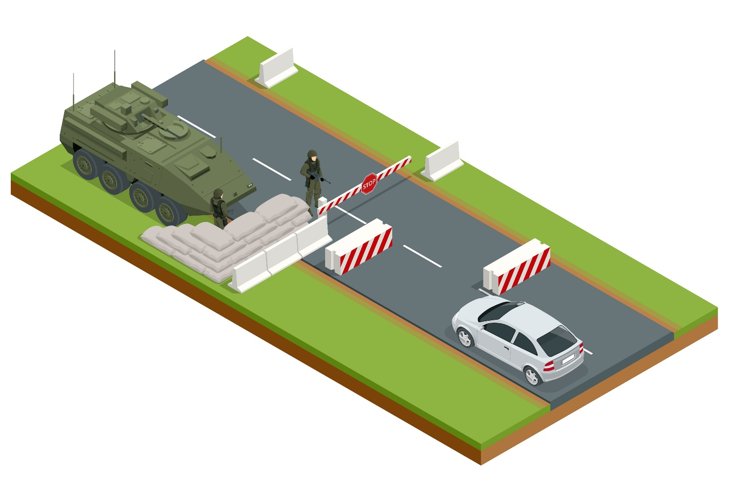



**c**

**a**

**d**

**b**

**e**



**f**

a. _____________________________________

b. _____________________________________

c. _____________________________________

vehicle // vehicle registration // barrier // chicane // boom gate // sandbags

d. _____________________________________

e. _____________________________________

f. _____________________________________

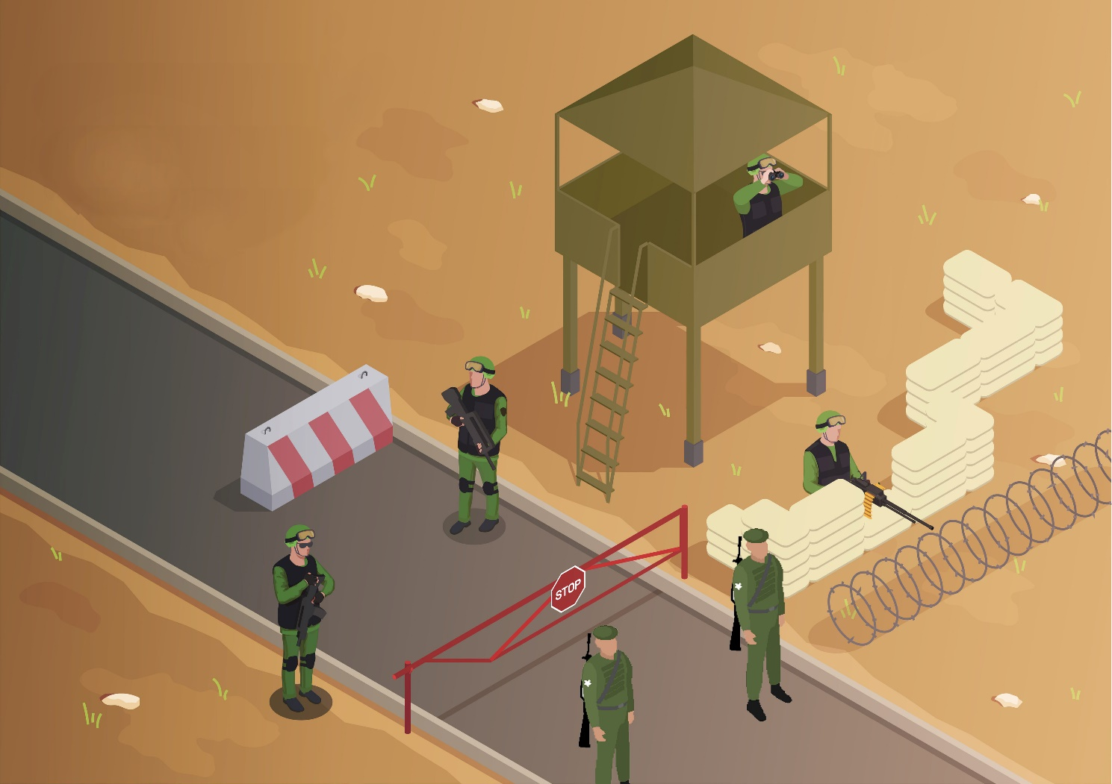

a. ________________________

**j**

_______________________

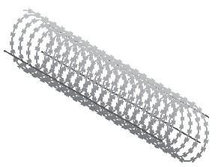

_______________________

_______________________

**k**

**g**

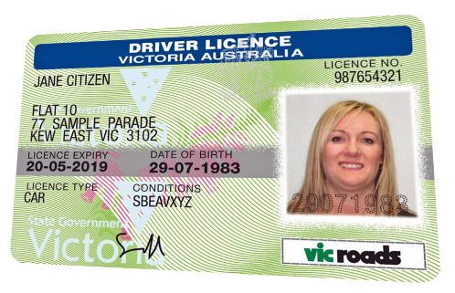

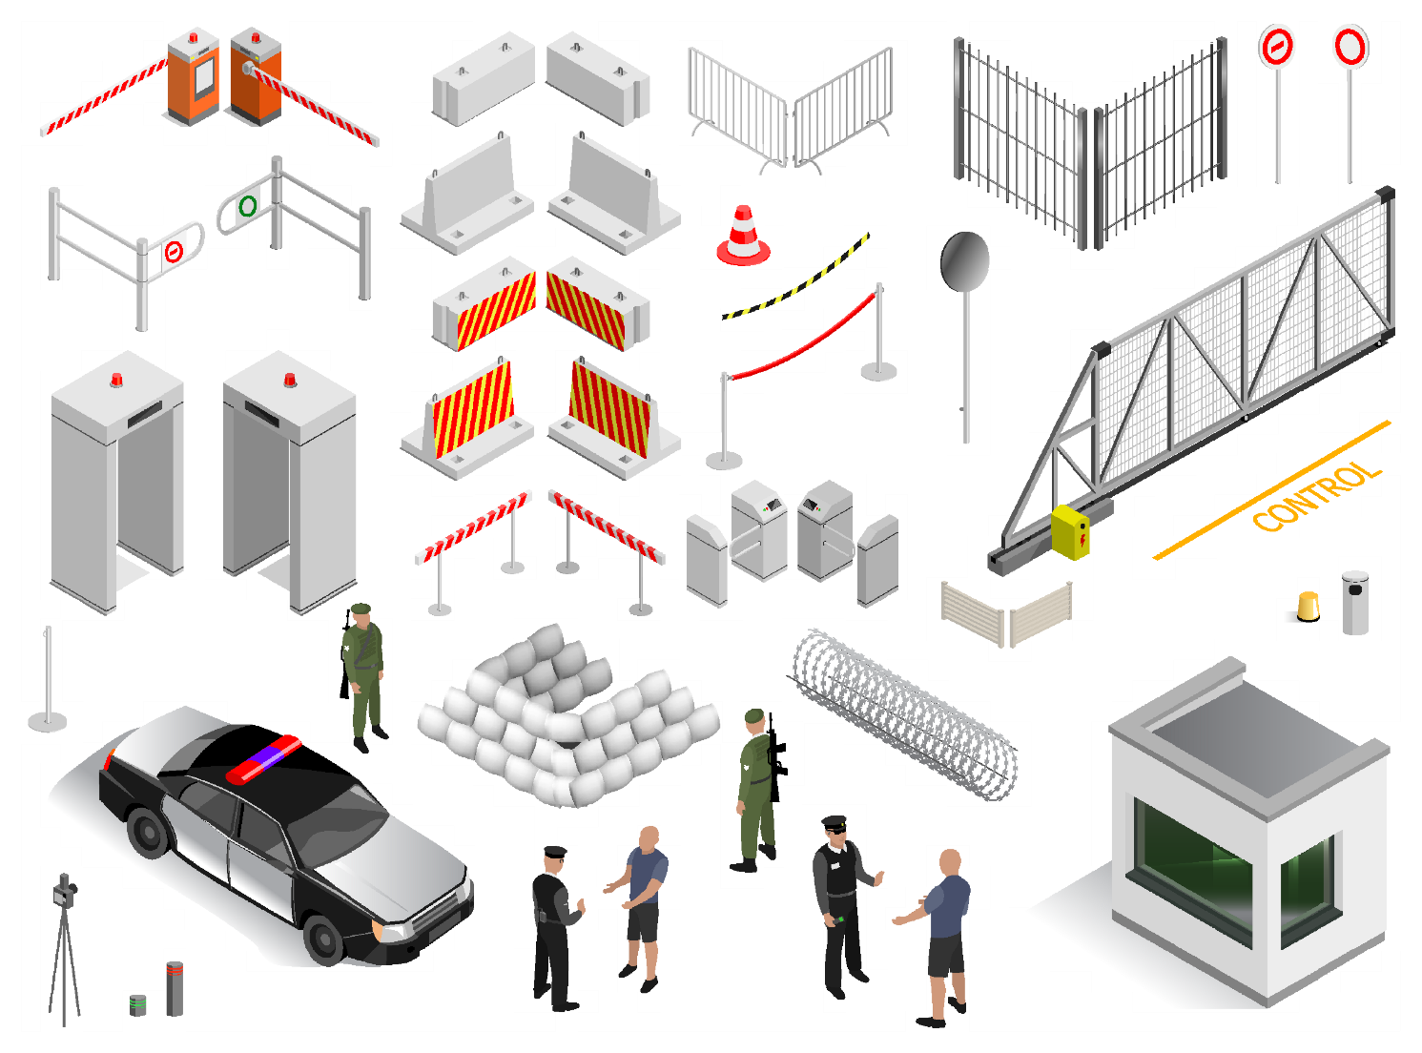

_______________________

**l**



_______________________

**h**

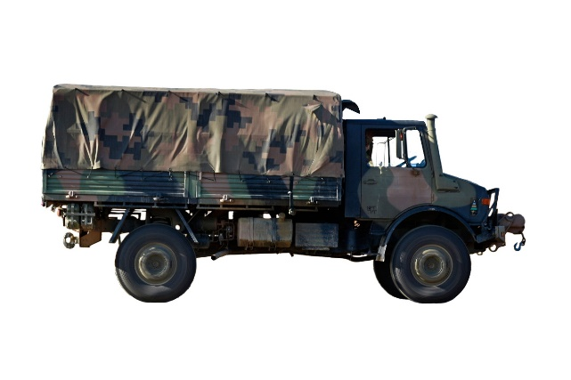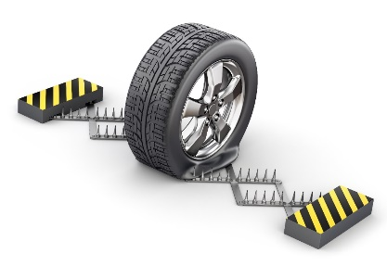

_______________________

**m**

_______________________

**i**

driver’s license // front barrier party // cones // razor wire // truck // covering party // spike strips

1. Now let’s listen to the words practised in this worksheet. Listen and repeat.
2. Write the correct words in the spaces below the definitions. Remember what you learned in exercise one. Each line is a letter. Look at the example.
3. This is used to guide vehicles around a road. It has this shape:

c o n e

1. Soldiers behind these don’t get hurt if someone shoots at them.

__ __ __ __ __ __ __ __

1. Another word for car, bus, motorcycle, truck, etc.

__ __ __ __ __ __ __

1. It is heavy and can stop cars. They are usually on the road.

__ __ __ __ __ __ __

1. A plate with numbers/letters on it. Every car, motorcycle, bus, etc has one.

__ __ __ __ __ __ __ __ __ __ __ __ __ __ __ __ __ __ __

1. Something that goes up and down and can stop vehicles from passing.

__ __ __ __ __ __ __ __

1. The soldiers at the front of a checkpoint.

__ __ __ __ __ __ __ __ __ __ __ __ __ __ __ __ __

1. A piece of wire that is very sharp; it makes it very difficult for people to go through.

__ __ __ __ __ __ __ __ __

1. If a vehicle goes over it, it cuts (or punctures) its tyres. It has this shape:

__ __ __ __ __ __ __ __ __ __ __

1. It makes cars slow down e.g. the car has to do a tight left-right turn.

__ __ __ __ __ __ __

1. These soldiers stay in a safe place (sometimes hiding). They protect the other soldiers at the checkpoint.

__ __ __ __ __ __ __ __ __ __ __ __ __

1. The police usually ask for this when they stop a driver on the road.

__ __ __ __ __ __ __ __ __ __ __ __ __ __

1. Use the words in the box to fill in the gaps in the text below. Look at the example.

driver’s license // front barrier party // covering party // ~~truck~~ // vehicle registration // barriers // boom gate

truck

At a military vehicle checkpoint, a 1. ___________ arrived at the front barrier. A soldier from the   
2. ________________________________________ checked the 3. _____________________________ and   
4. _____________________. Two 5. _____________________ guided the truck through a chicane, making the vehicle slow down. After the chicane, a soldier lifted the 6. __________________________ and the truck passed. Nearby, two soldiers from the 7. ___________________ ________________ were standing behind sandbags, holding their assault rifles. Soldiers do a lot of training so they know what to do in a checkpoint.

1. Discuss the following questions with a partner.
2. Point to the items on pages 1-2 that you have seen in real life.
3. Have you ever been stopped at a checkpoint? Why? What happened at the checkpoint?
4. Have you ever worked at a checkpoint? If yes, what were your tasks? If no, what job would you like to do?



* Watch this YouTube video and try to write the words from this lesson that you see in the video. Type on YouTube [Army Traffic Control Point (TCP) Training](https://www.youtube.com/watch?v=1qLfX1QUIJw) or scan the QR Code to the right:
* This Vocabulary Builder links with 🡪 Lesson: Radio Communications (Listening)

© Commonwealth of Australia 2024  
This work is copyright. Apart from any use as permitted under the Copyright Act 1968 (Cth),   
no part may be reproduced by any process without prior written permission from the Department of Defence.