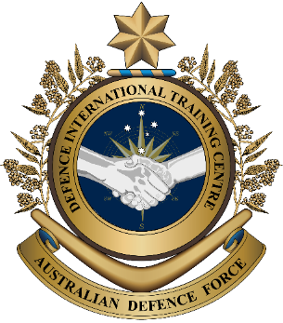
Military English
Vocabulary Builder: Facilities on a Navy Base

Overview:
This worksheet presents vocabulary related to the places and facilities on a navy base.
In this vocabulary builder, you will:
- learn and use vocabulary related to the facilities on a navy base.

- Pages one and two detail the main facilities on most military bases.
Label the pictures. Use the words from the box.
facilities (n) – buildings, equipment
or services
a military base (n) – the place where military personnel work, live and train
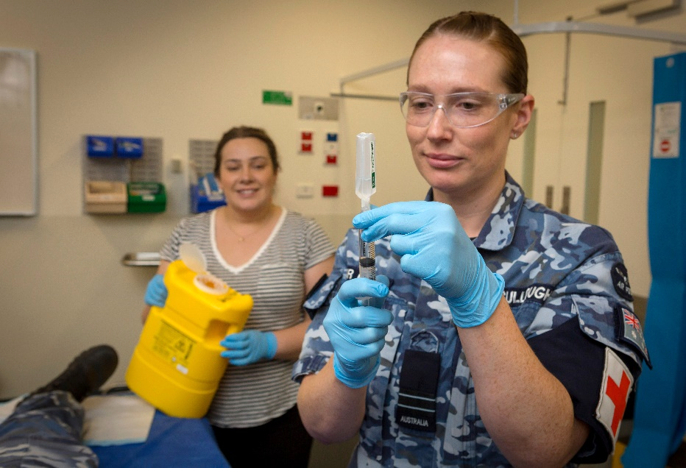
health centre // mess // pool

a. ________________________

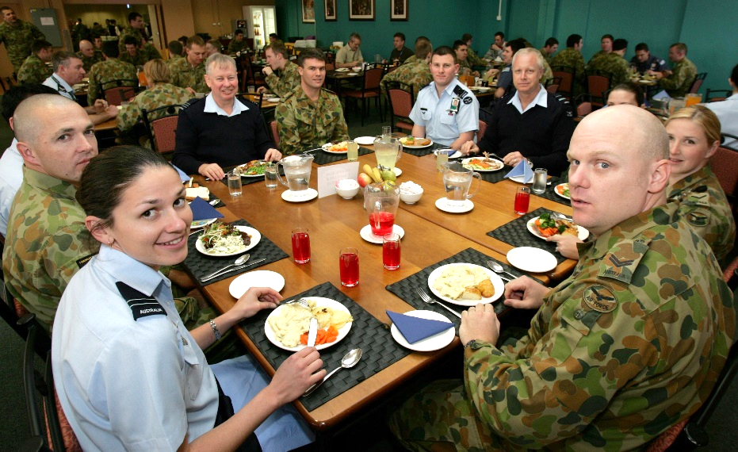

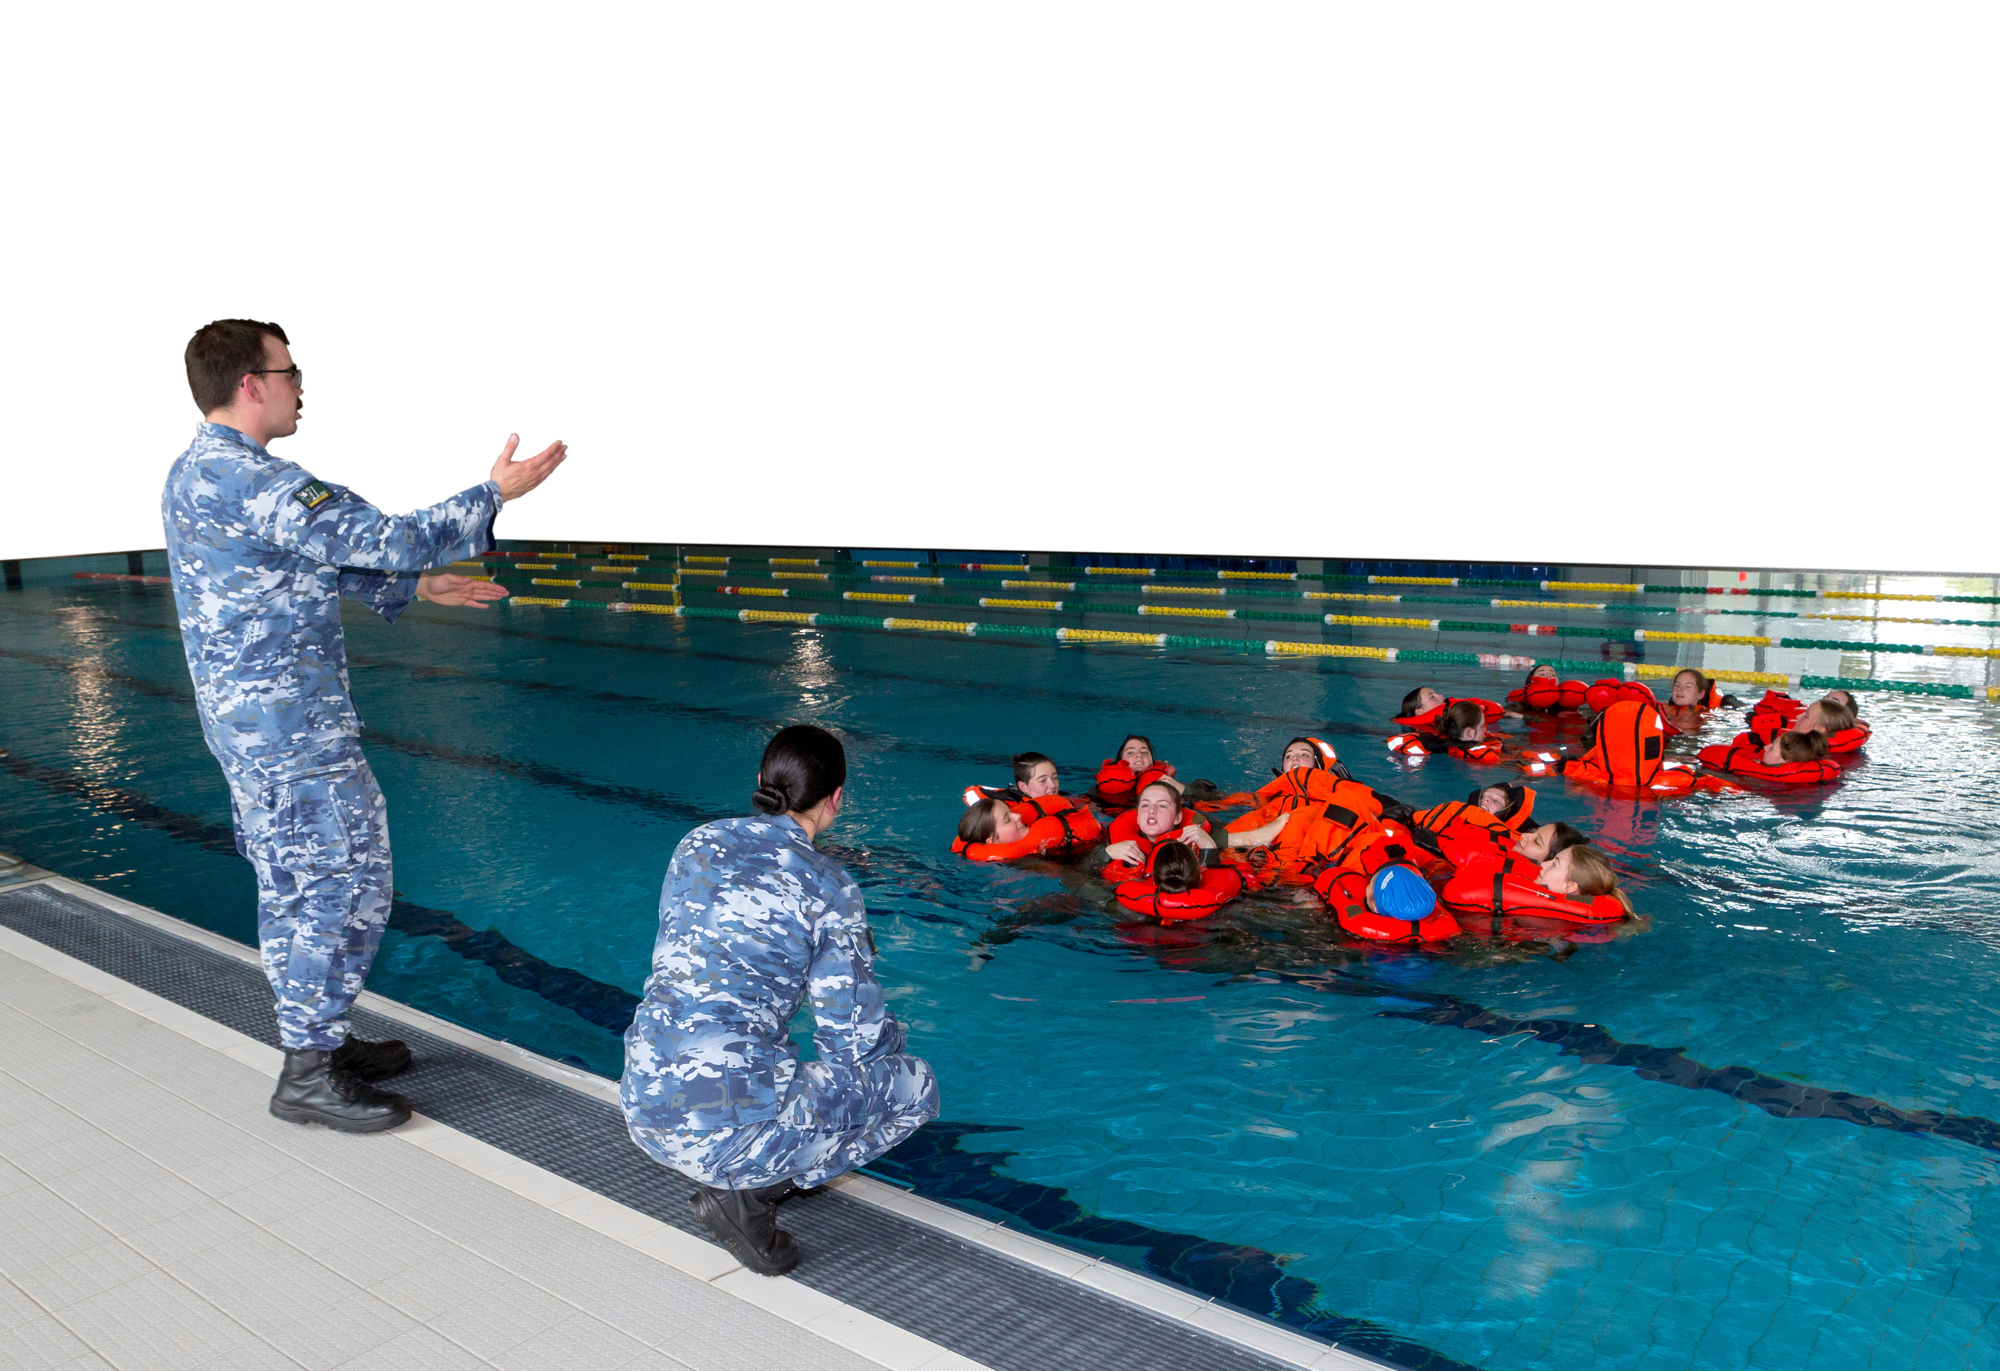
b. ________________________

c. ________________________

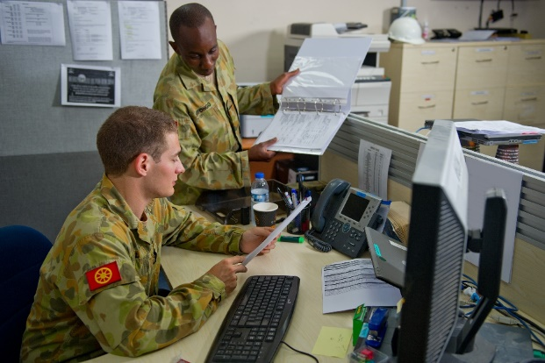
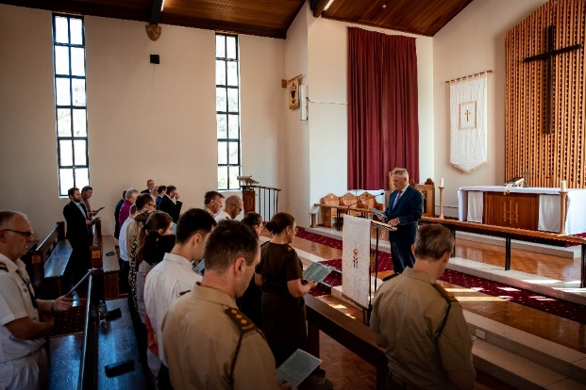

f. ________________________
d. ________________________

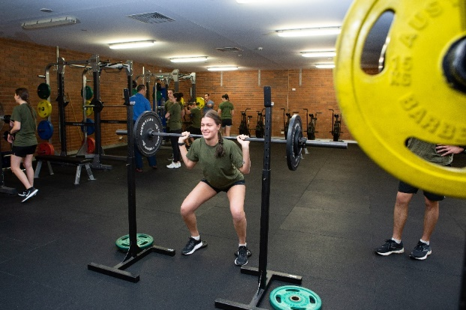
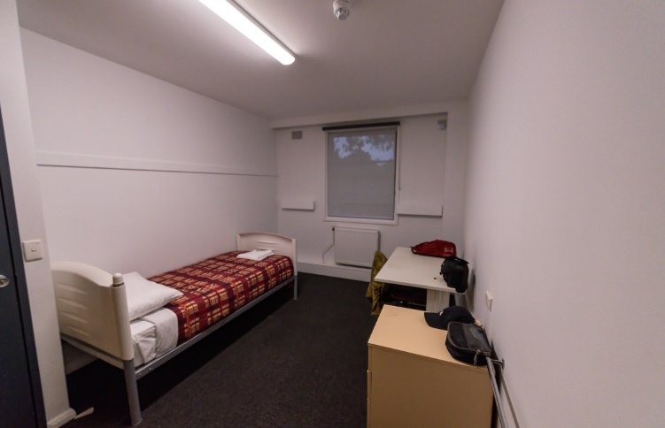

g. ________________________
e. ________________________

gym // accommodation // office // chapel

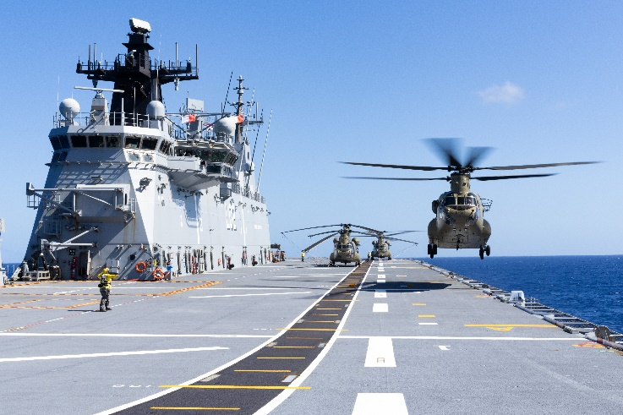
The Royal Australian Navy (RAN)

The RAN protects Australia’s coastline. It helps in emergencies and takes part in peacekeeping operations.
Here’s a snapshot of the RAN:
- 16 Navy bases around Australia;
- 19,000+ personnel, including 4,600 reservists;
- 40+ vessels and 40+ helicopters.

- Here are other facilities on a navy base. Match the words in the box to each picture.
dry dock // survival equipment workshop // dock // boat ramp // pontoon // maintenance workshop
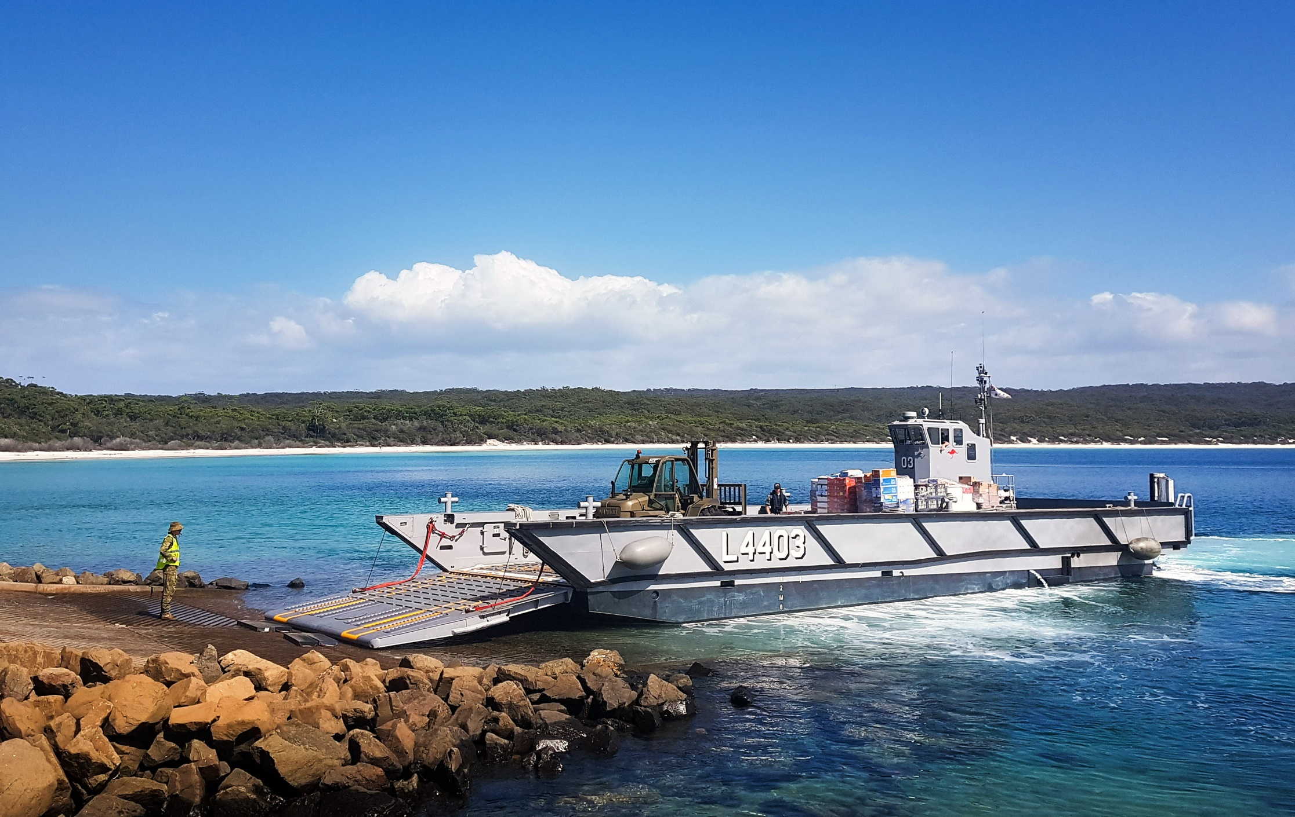
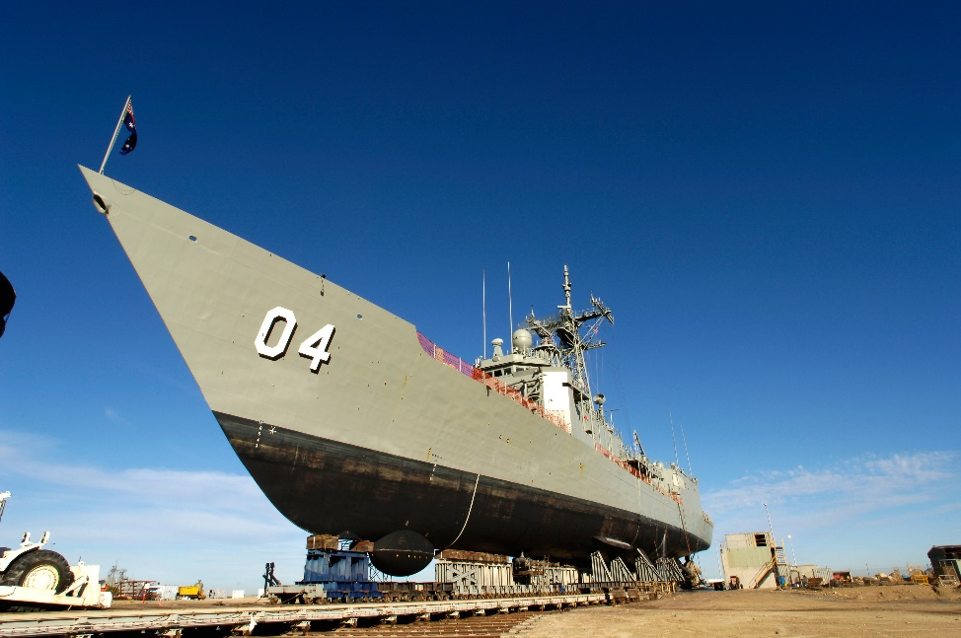
a. ________________________
d. ________________________

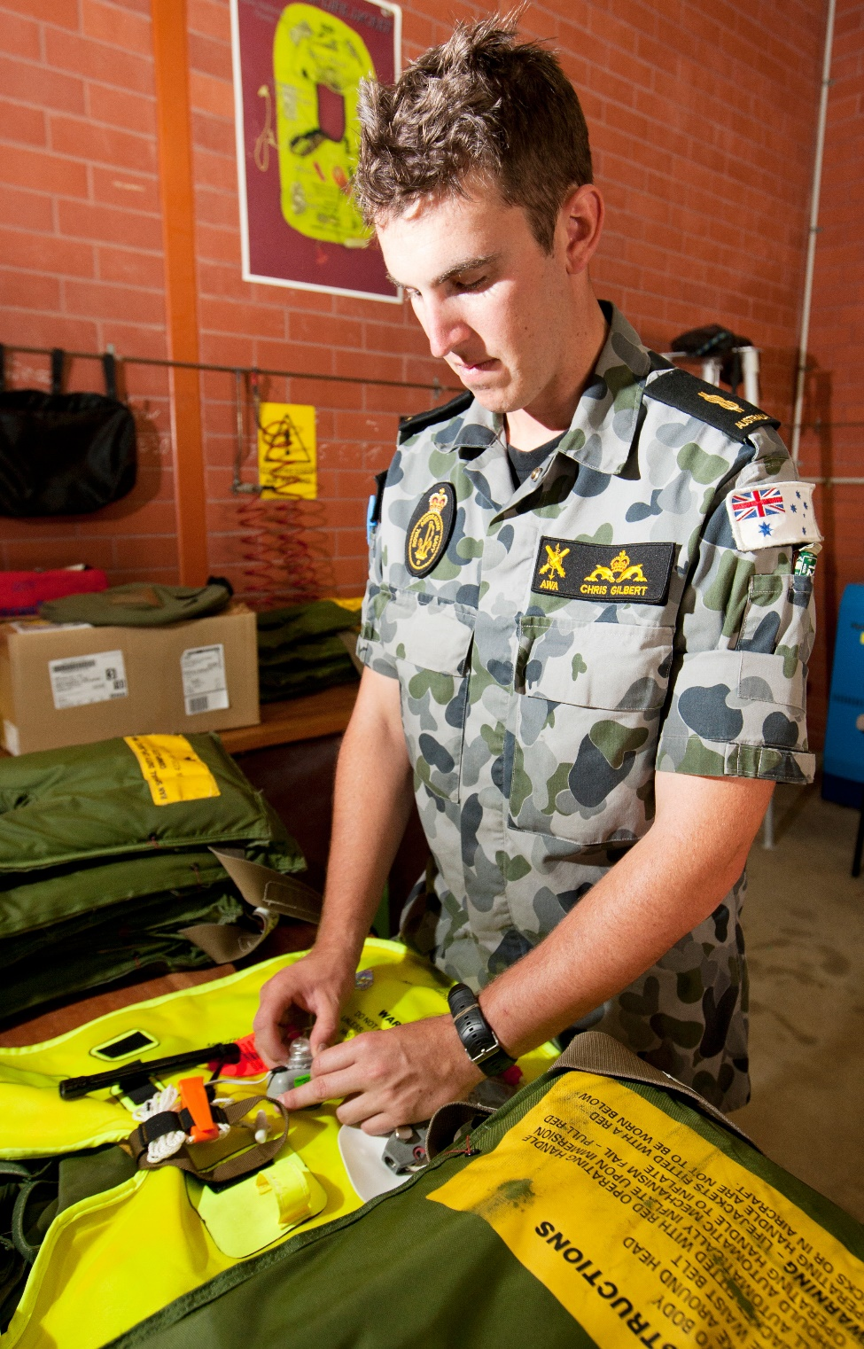
e. ________________________

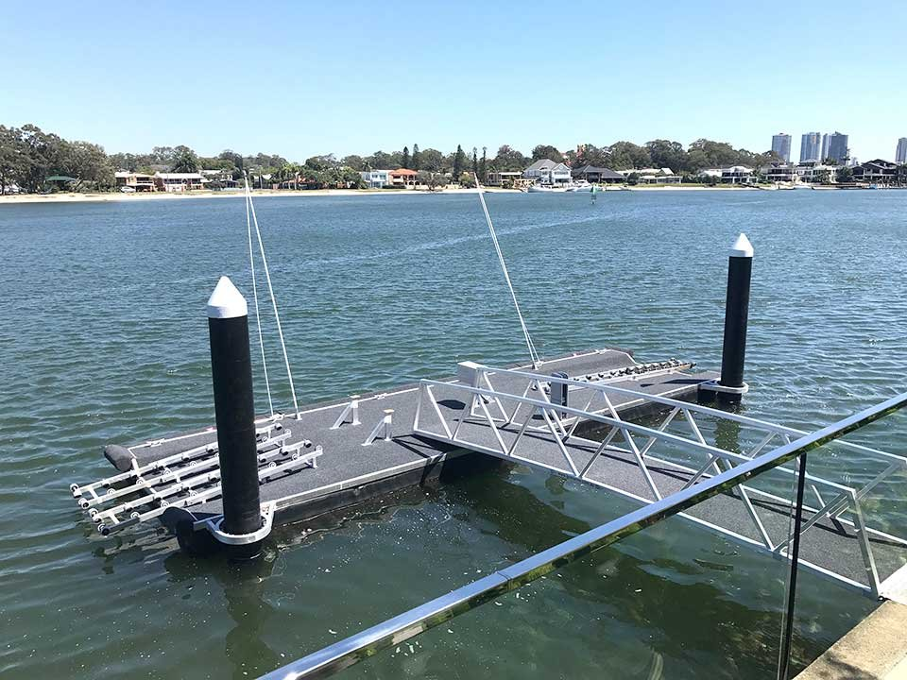
b. ________________________

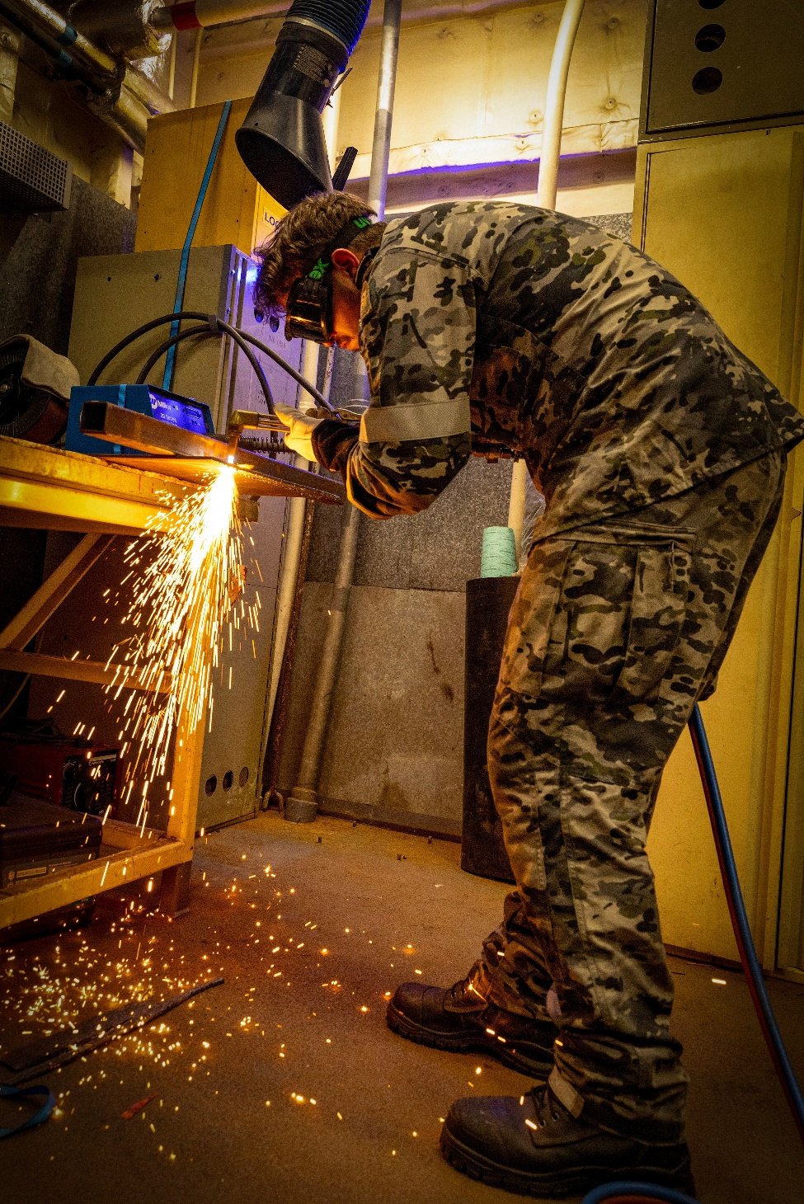
c. ________________________

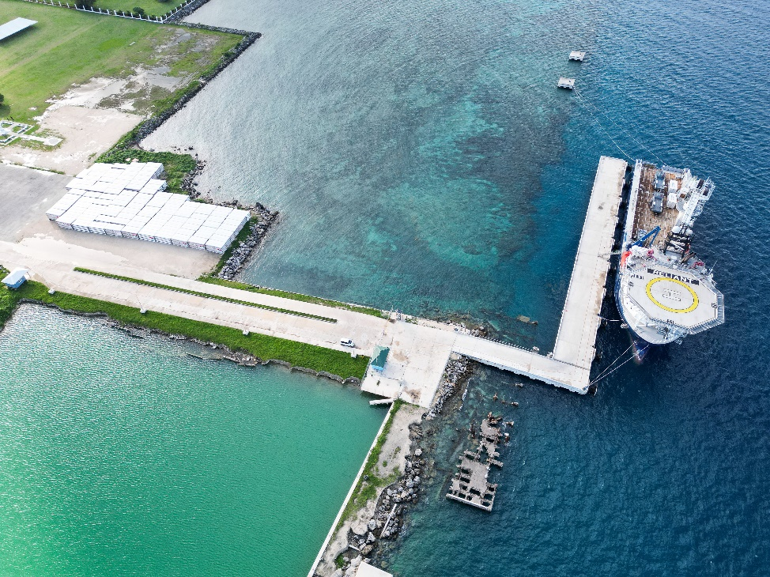
f. ________________________

- Let’s practise saying the words. Listen and repeat.

- Work with a partner. Play a game.
Student A, stay on this page. Student B, turn to the next page.

STUDENT A
- This is a competition. The student with the most correct answers is the winner.
- Ask your partner the questions below. If they give the correct answer, it’s one point for him/her.
- Take turns. You ask one question, then your partner asks you one question, and so on.
- When you’re answering, give complete answers.
- For example: A: Where do you go if you’re sick?
B: If you’re sick, you go to the ___________.

Read these questions to student B. | If student B gives these answers, give them one point. | Put a tick () in each space below if student A answers correctly.
Where do you go if you are sick? | health centre
Where do boats come in and out of the water? | boat ramp
Where can you swim? | pool
Where can people fix boats? The boats are out of the water. | dry dock
Where do personnel work at desks in front of computers? | office
Where do personnel fix equipment for staying safe when things go wrong? | survival equipment workshop
Where do sailors sleep? | accommodation
Total:

STUDENT B
- This is a competition. The student with the most correct answers is the winner.
- Ask your partner the questions below. If they give the correct answer, it’s one point for him/her.
- Take turns. You ask one question, then your partner asks you one question, and so on.
- When you’re answering, give complete answers.
- For example: A: Where can you eat lunch on an army base?
B: You can eat lunch at the ___________.

Read these questions to student A. | If student A gives these answers, give them one point. | Put a tick () in each space below if student A answers correctly.
Where can you eat lunch on a navy base? | mess
What is the thing that floats on the water? Ships can park, there. | pontoon
Where can I pray on a base? | chapel
Where do navy personnel fix equipment? | maintenance workshop
Where do boats usually stay when they are not moving? | dock
Where can I get fit? | gym
Total:

- This Lesson links with Lesson: Snapshot of the Royal Australian Navy

© Commonwealth of Australia 2024
This work is copyright. Apart from any use as permitted under the Copyright Act 1968 (Cth),
no part may be reproduced by any process without prior written permission from the Department of Defence.

