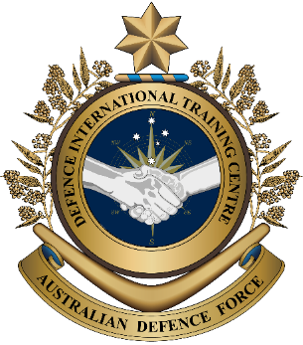
Military English
Vocabulary Builder: Facilities on an Air Force Base

Overview:
This worksheet presents vocabulary related to the places and facilities on an air force base.
In this lesson, you will:
- learn and use vocabulary related to facilities on an air force base.

- On pages one and two are the main facilities of most military bases.
Label the pictures. Use the words from the box.
facilities (n) – buildings, equipment
or services
a military base (n) – the place where military personnel work, live and train
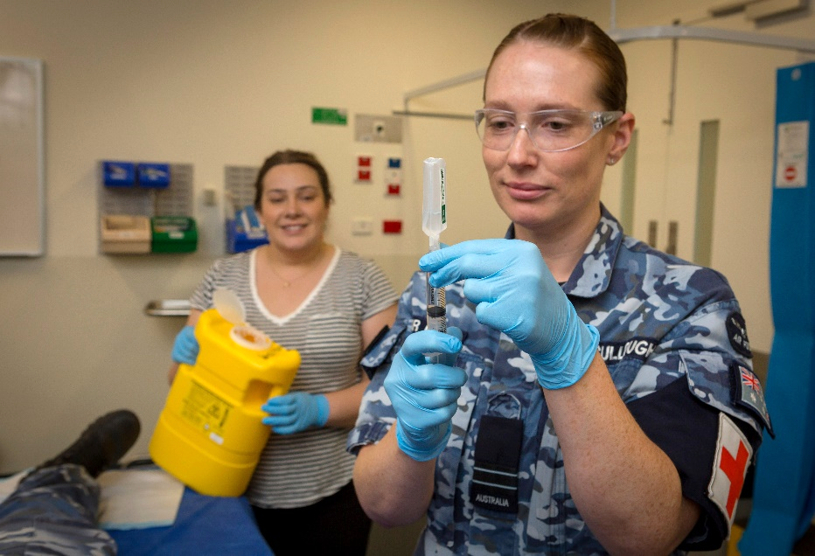
health centre // mess // pool

a. ________________________

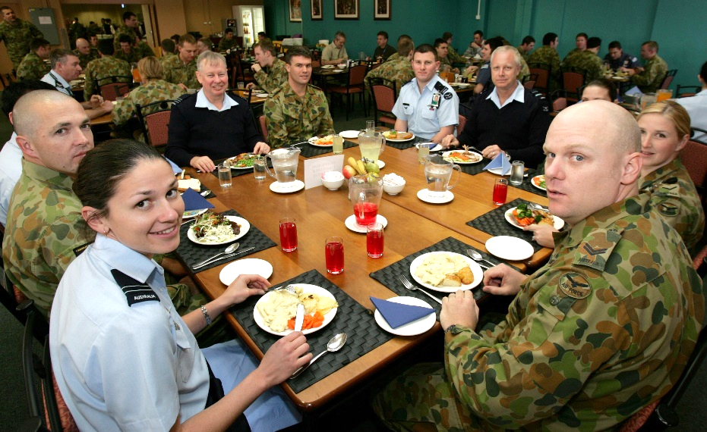

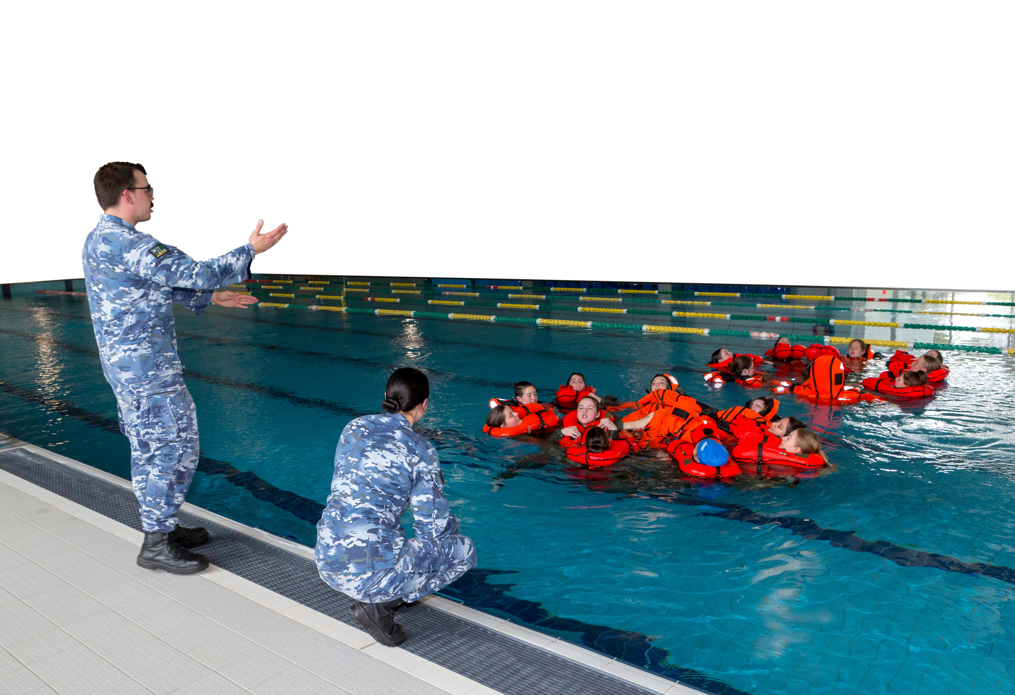
b. ________________________

c. ________________________

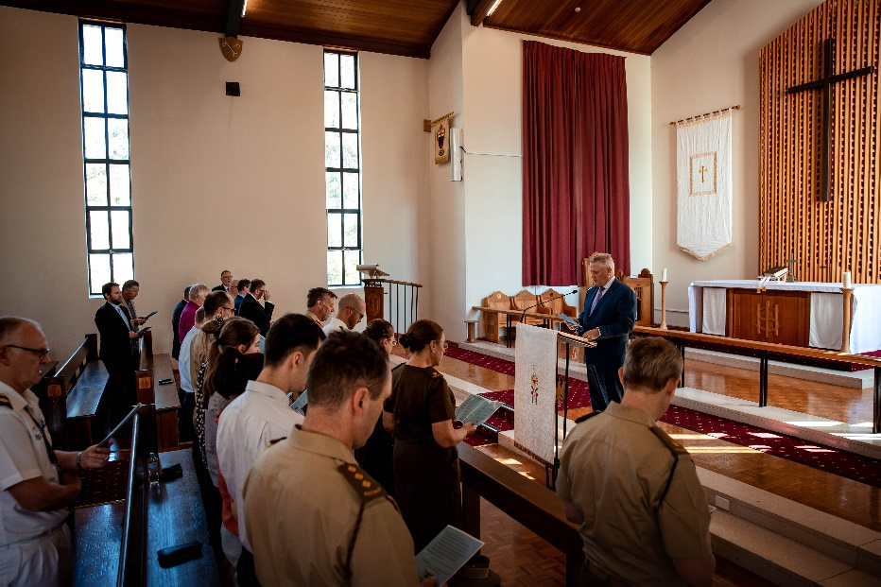
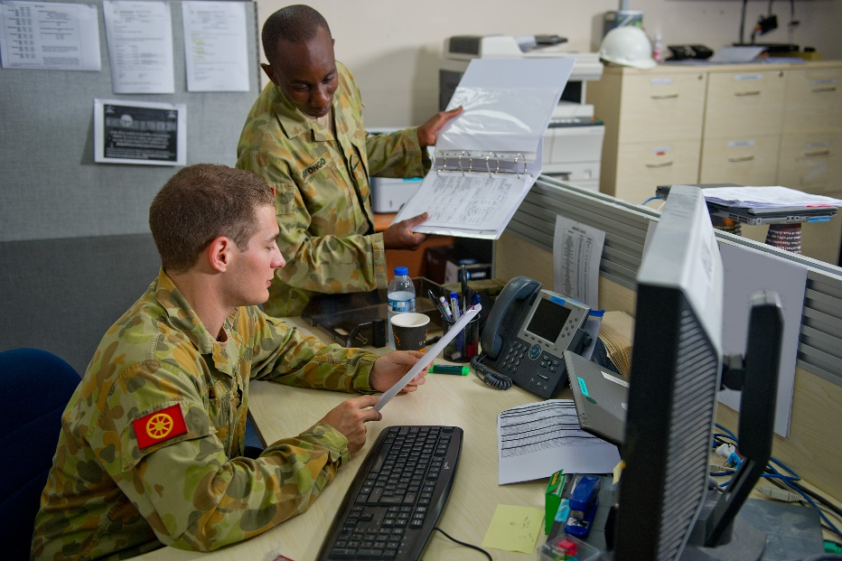

d. ________________________
f. ________________________

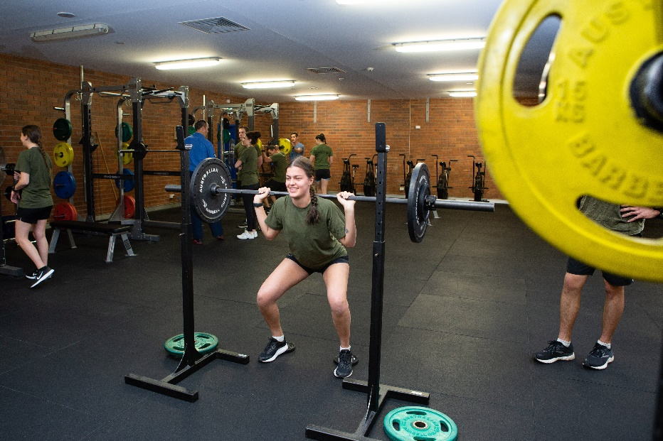
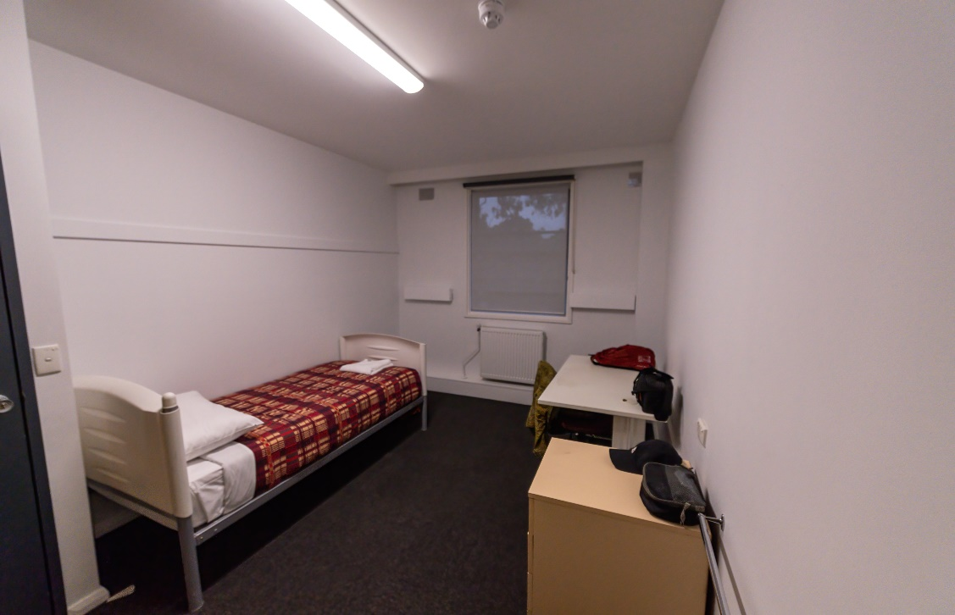

g. ________________________
e. ________________________

gym // accommodation // office // chapel

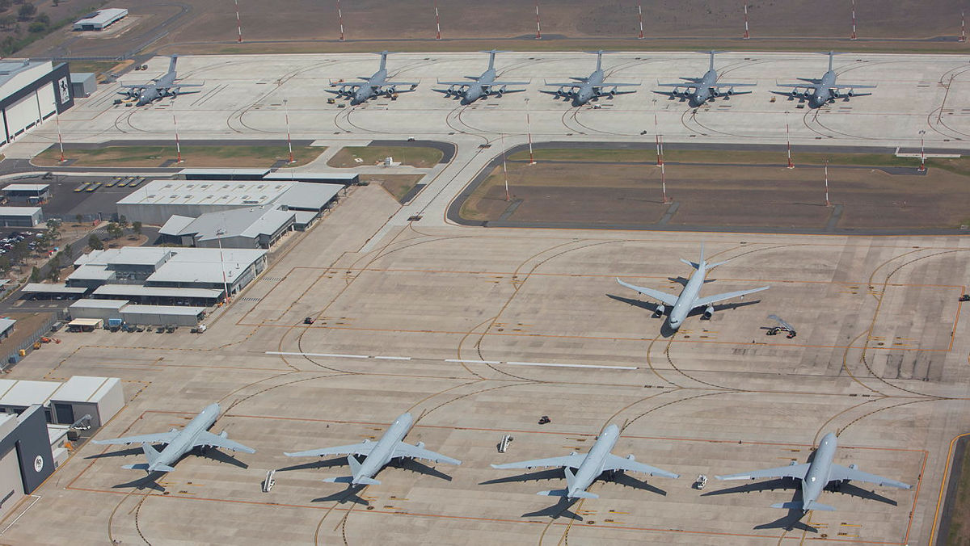
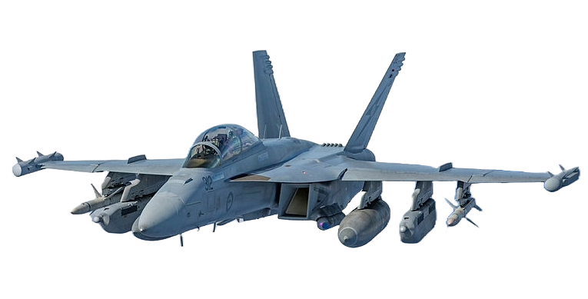
The Royal Australian Air Force (RAAF)

The RAAF uses different types of aircraft to help keep Australia safe and help in emergencies.
Here’s a snapshot of the RAAF:
- 17 air bases across Australia;
- 21,000+ personnel, including
- 6,400 reservists;
- 270+ aircraft.

- Here are other facilities on an air force base. Match the words in the box to each picture.
fire station // fuel facility // control tower // runway // maintenance workshop // hangar
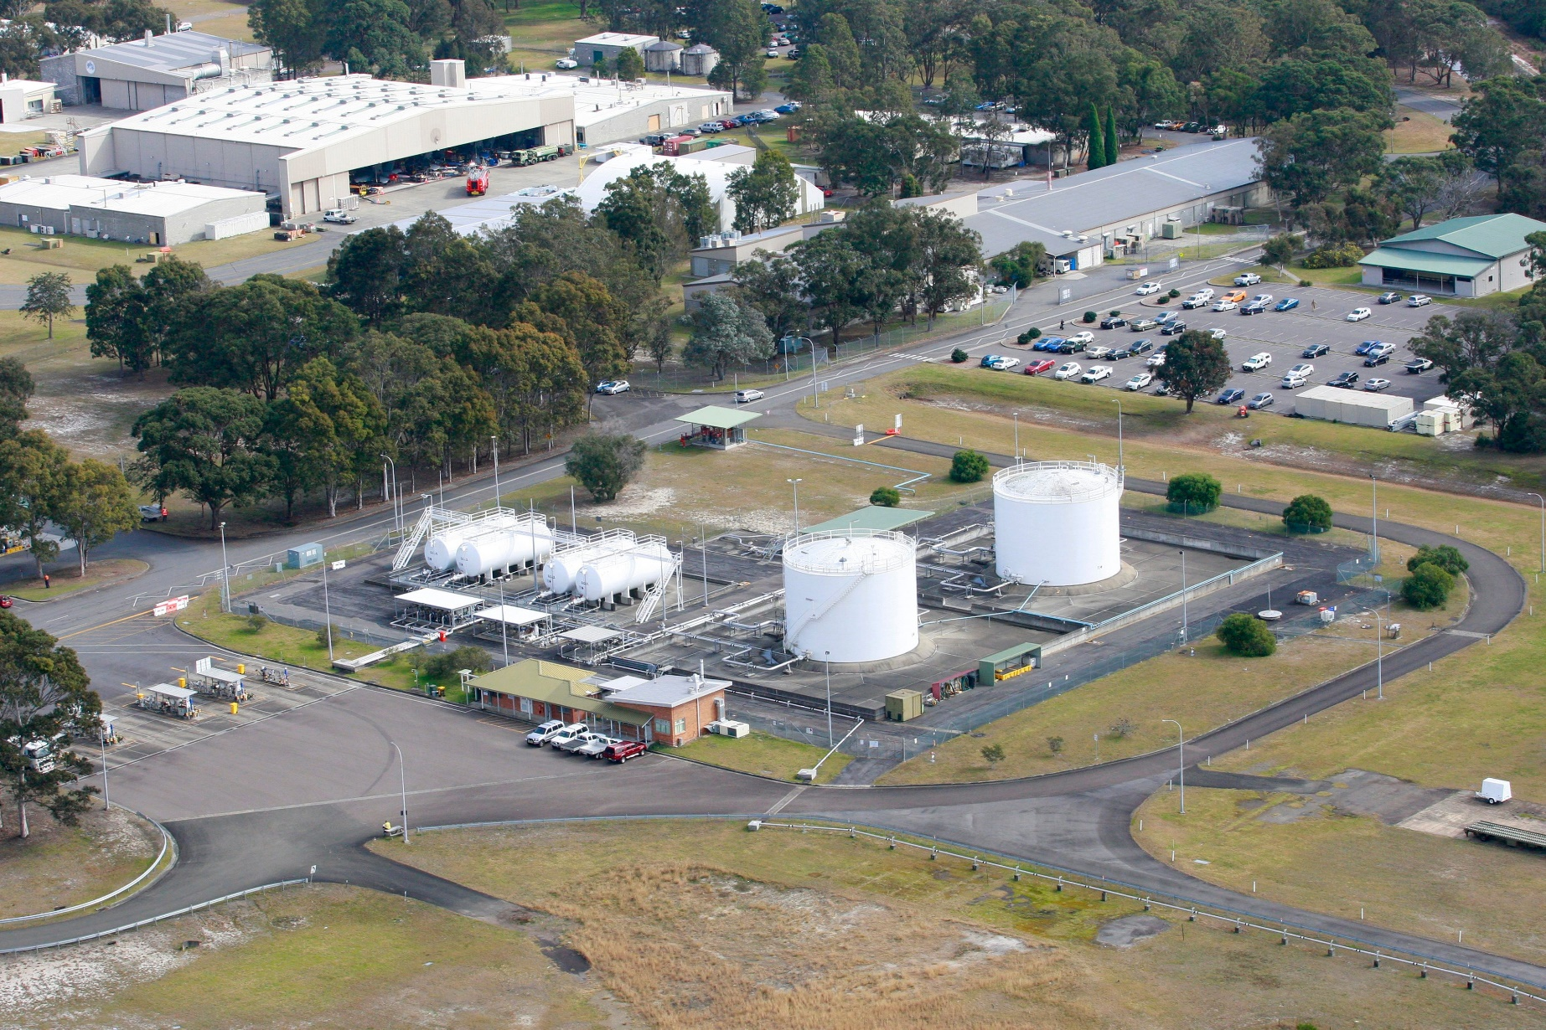

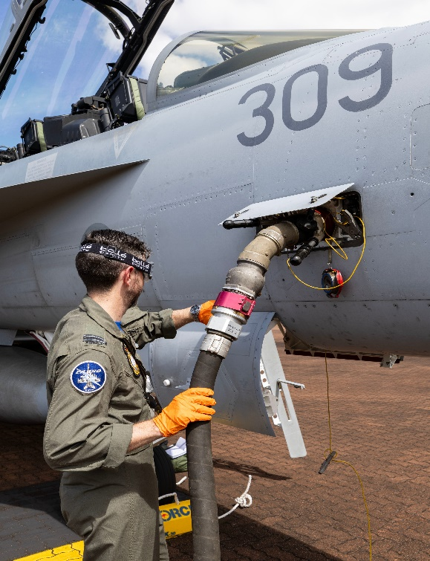

d. ____________________
a. ____________________
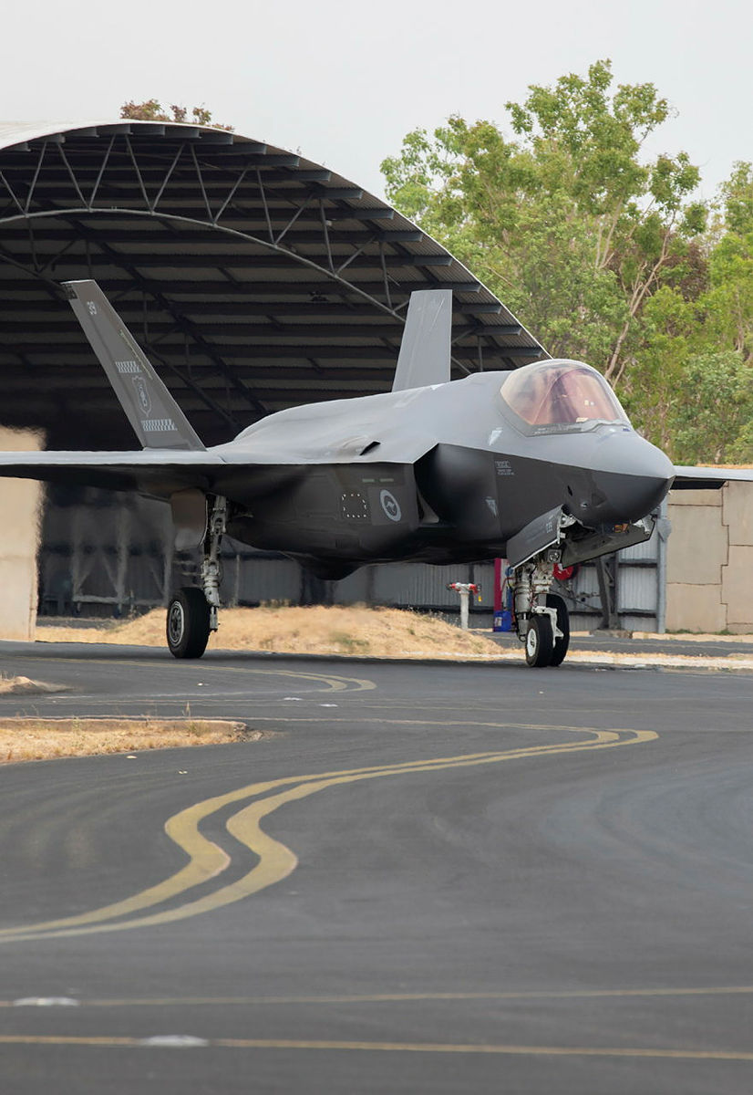

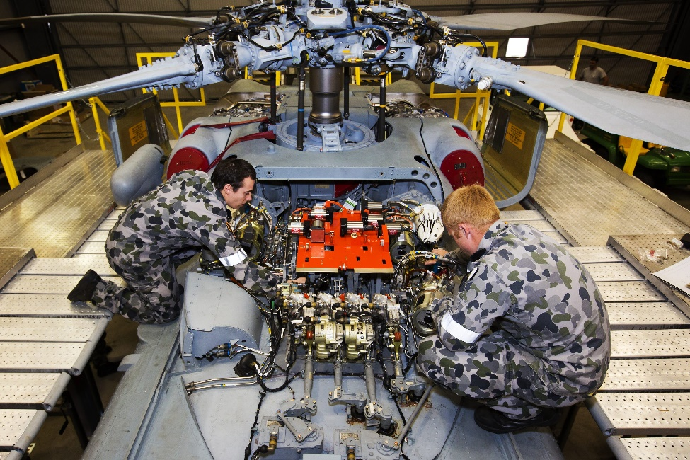
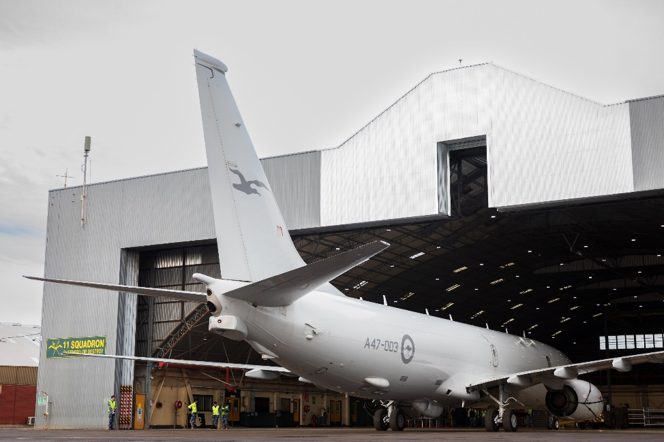
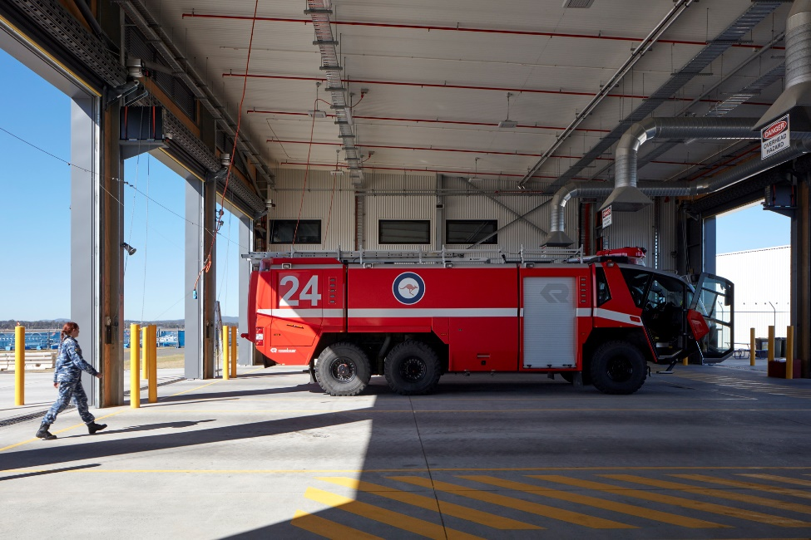
e. ____________________
b. ____________________

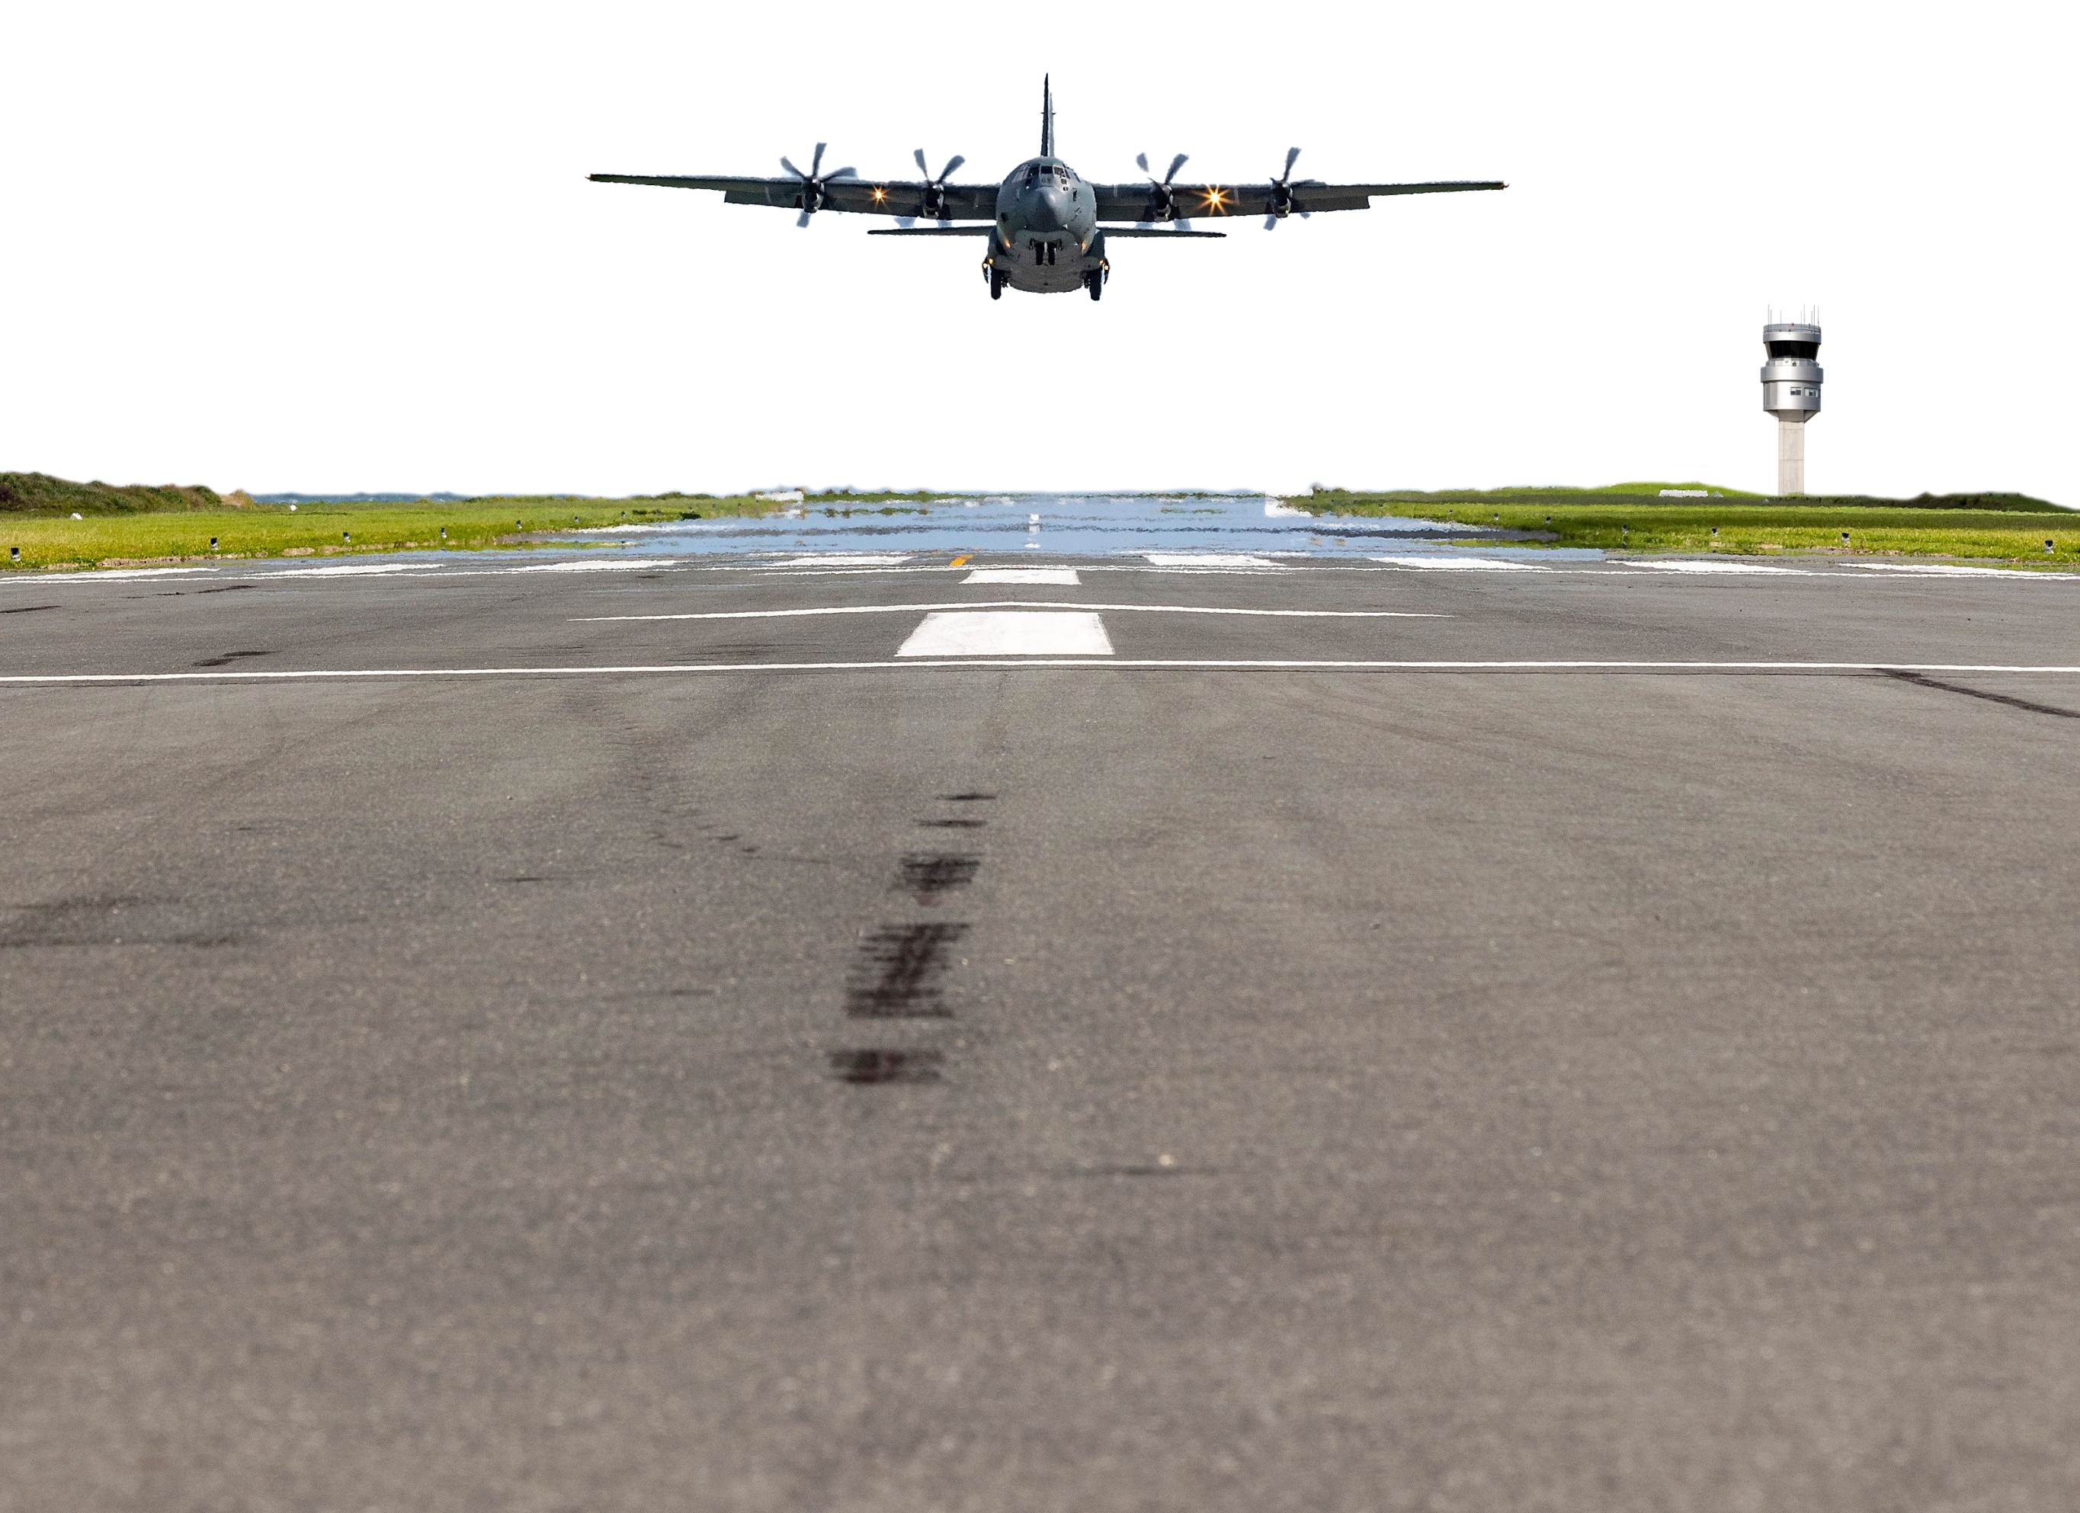

f. ____________________
c. ____________________
- Now let’s practise saying the words. Listen and repeat.

- Do you still remember the words you learned in this lesson? Work with a partner. Play a game.
Student A, stay on this page. Student B, turn to the next page.

STUDENT A
- This is a competition. The student with the most correct answers is the winner.
- Ask your partner the questions below. If they give the correct answer, it’s one point for him/her.
- Take turns. You ask one question, then your partner asks you one question, and so on.
- When you’re answering, give complete answers.
- For example: A: Where do you go if you’re sick?
B: If you’re sick, you go to the ___________.

Read these questions to student B. | If student B gives these answers, give them one point. | Put a tick () in each space below if student B answers correctly.
Where do you go you if you are sick? | health centre
Where do air force personnel fix aircraft? | maintenance workshop
Where can you swim? | pool
Where are the fire trucks parked? | fire station
Where are the planes parked under a roof? | hangar
Where do air force personnel sleep? | accommodation
Where do personnel work at desks in front of computers? | office
Total:

STUDENT B
- This is a competition. The student with the most correct answers is the winner.
- Ask your partner the questions below. If they give the correct answer, it’s one point for him/her.
- Take turns. You ask one question, then your partner asks you one question, and so on.
- When you’re answering, give complete answers.
- For example: A: Where do you eat lunch on an air force base?
B: You eat lunch on an air force base at the ___________.

Read these questions to student A. | If student A gives these answers, give them one point. | Put a tick () in each space below if student A answers correctly.
Where do you eat lunch on an air force base? | mess
Where can I pray on a base? | chapel
Where is the aircraft fuel on an air force base? | fuel facility
Where do planes take off from? | runway
Where can I get fit? | gym
Where do personnel work to guide aircraft during take-off and landing? | control tower
Total:



- Watch this video. Which facilities do you see? Type on YouTube RAAF Base Richmond Aerial Tour, or scan the QR code to the right

- This Vocabulary Builder links with Lesson: Snapshot of the Royal Australian Air Force (RAAF)

© Commonwealth of Australia 2024
This work is copyright. Apart from any use as permitted under the Copyright Act 1968 (Cth),
no part may be reproduced by any process without prior written permission from the Department of Defence.

