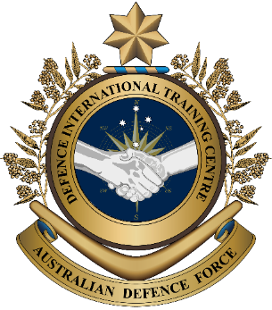
Military English
Vocabulary Builder: Facilities on an Army Base

Overview:
This worksheet presents vocabulary related to the places and facilities on an army base.
In this lesson, you will:
- learn and use vocabulary related to facilities on an army base.

- Pages one and two detail the main facilities of most military bases.
Label the pictures. Use the words from the box.
facilities (n) – buildings, equipment
or services
a military base (n) – the place where military personnel work, live and train
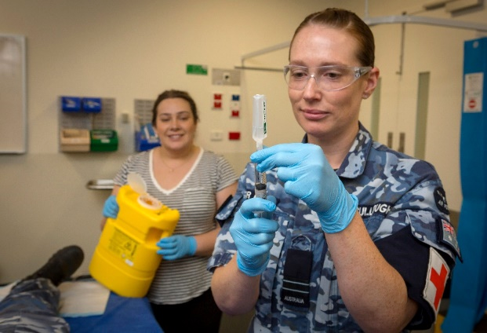
a. ________________________
health centre // mess // pool

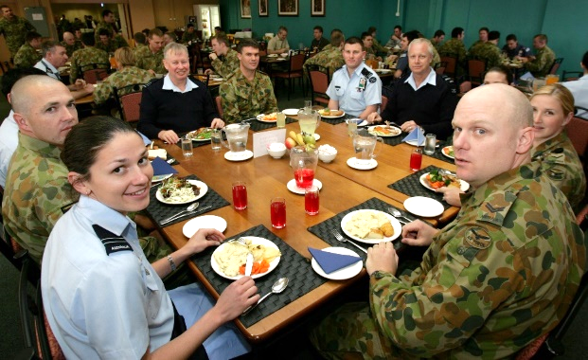

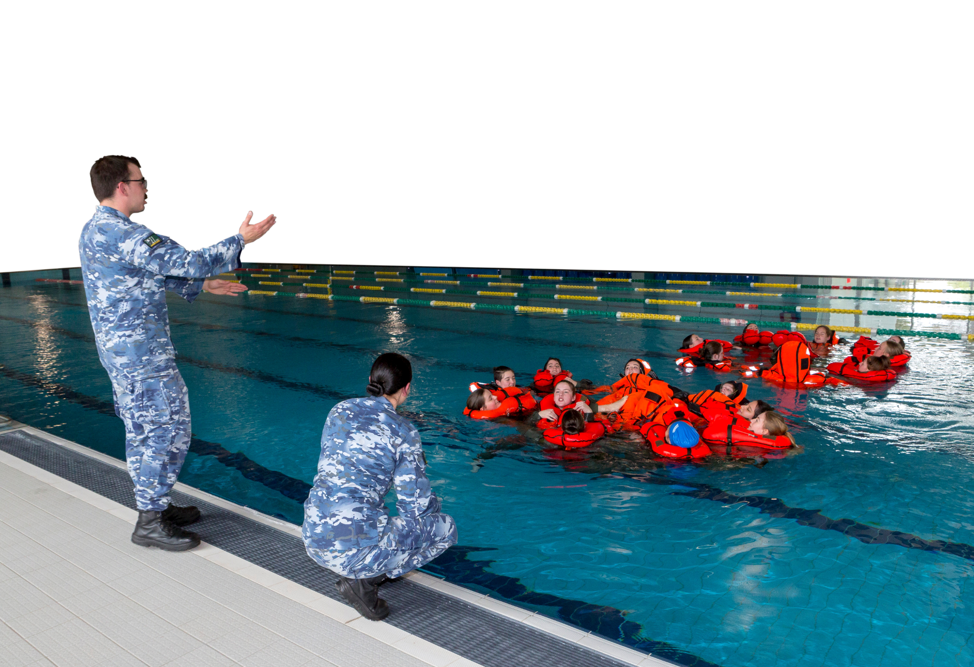
b. ________________________

c. ________________________

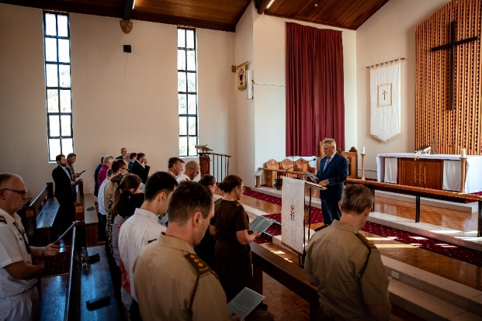
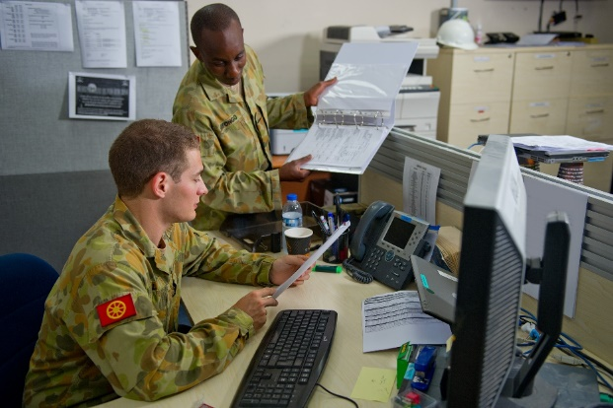

d. ________________________
f. ________________________

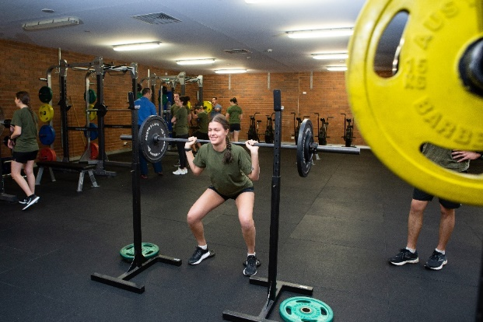
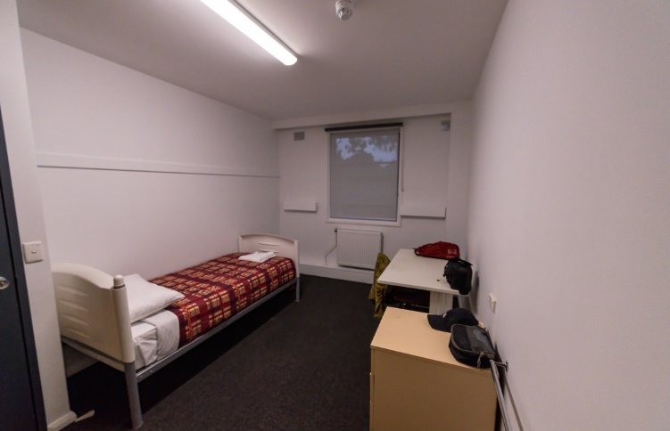

g. ________________________
e. ________________________

gym // accommodation // office // chapel

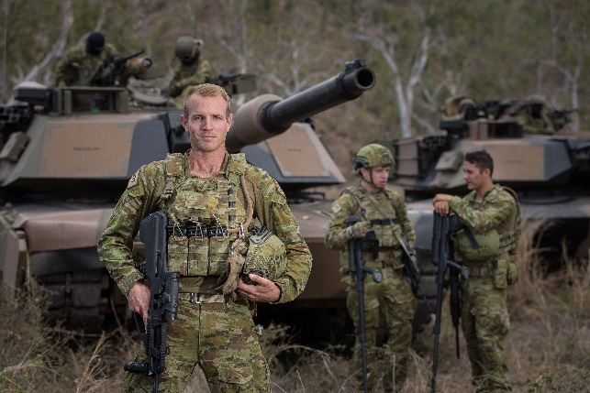
The Australian Army
The Australian Army protects Australia by land, helps in emergencies and supports peacekeeping missions around the world.
Here’s a snapshot of the Australian Army:
- 53 army bases across Australia;
- 28,000+ personnel, including
- 15,000+ reservists;
- It operates vehicles such as the M1A1 Abrams tanks, Bushmaster Protected Mobility Vehicles, attack and transport helicopters.

- Here are other facilities on an army base. Match the words in the box to each picture.
firing range // maintenance workshop // armoury // obstacle course // training area

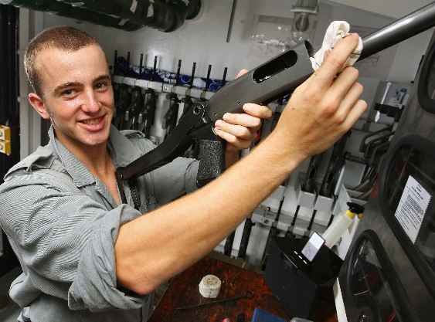

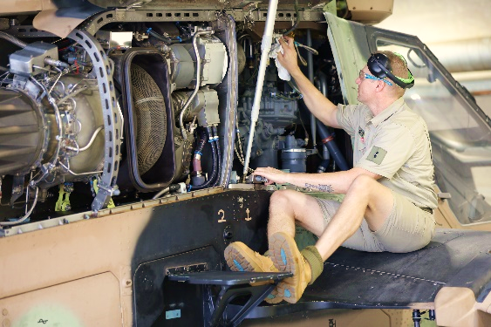
d. ____________________

a. ____________________
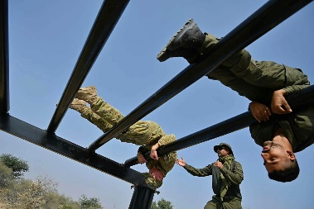
e. ____________________
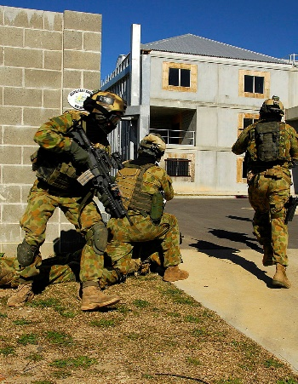

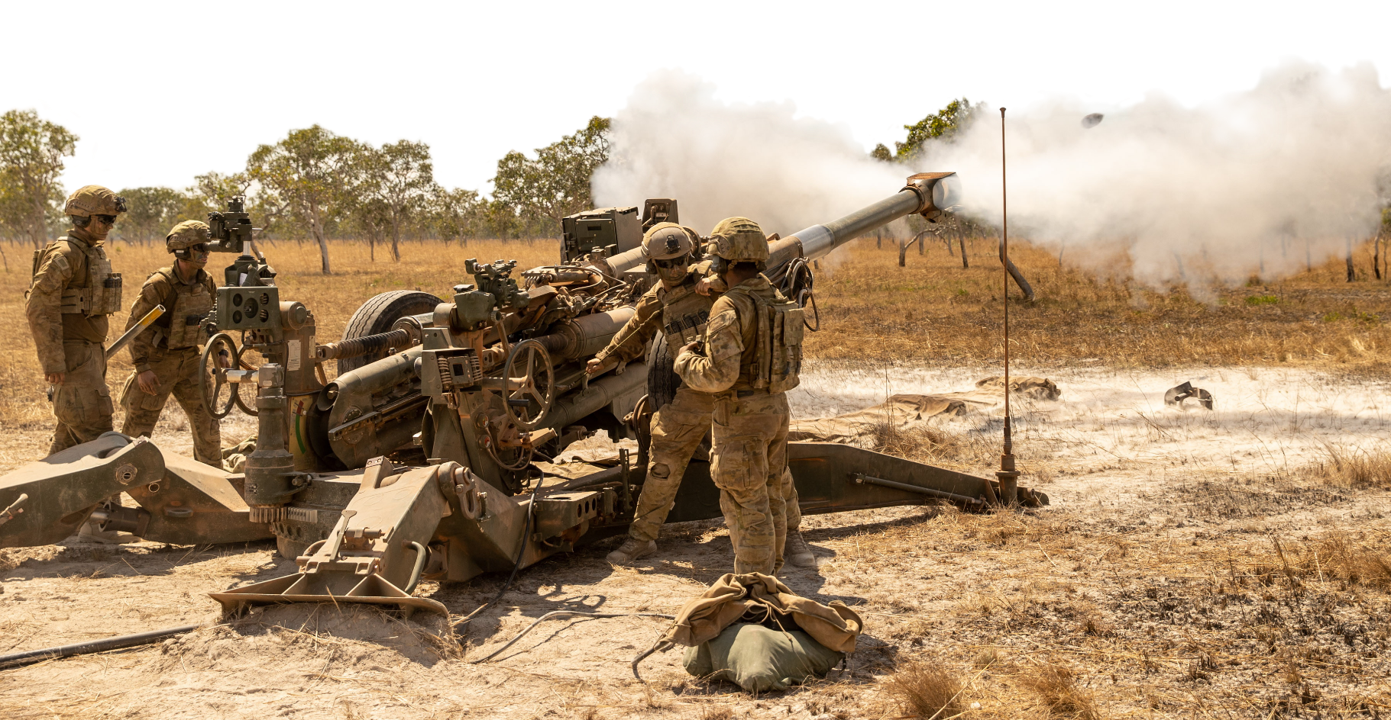
b. ____________________

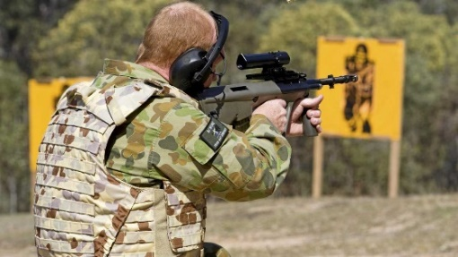

c. ____________________

- Now let’s practise saying the words. Listen and repeat.

- Do you remember the words for facilities on an army base? Write the name of the facility under the picture and check with your partners when you finish. Check your answers and spelling on page 2 after you finish.

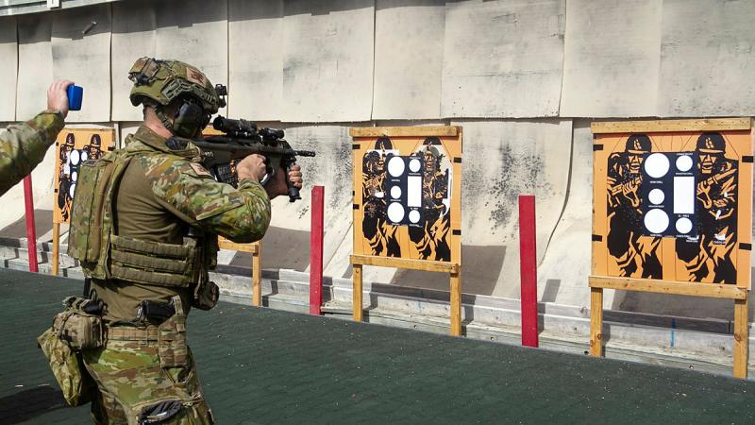
a. ____________________

c. ____________________

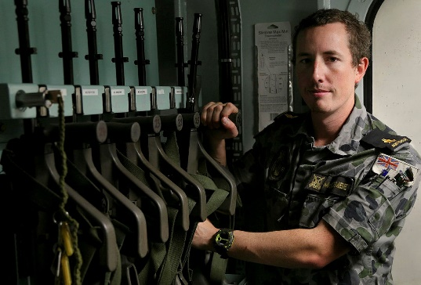
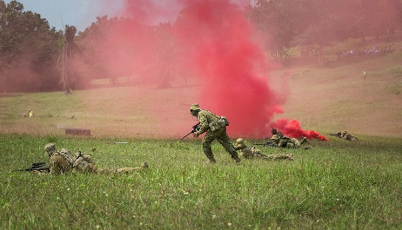

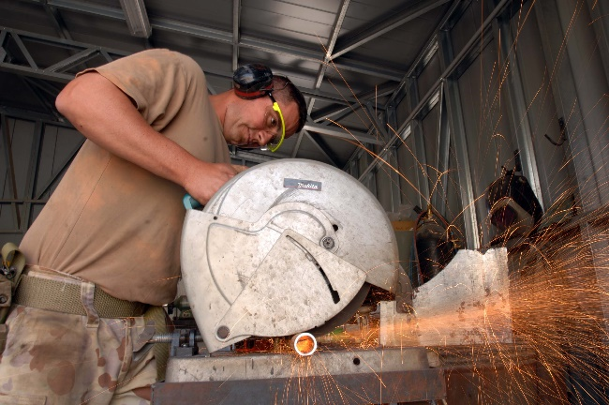

b. ____________________
d. ____________________
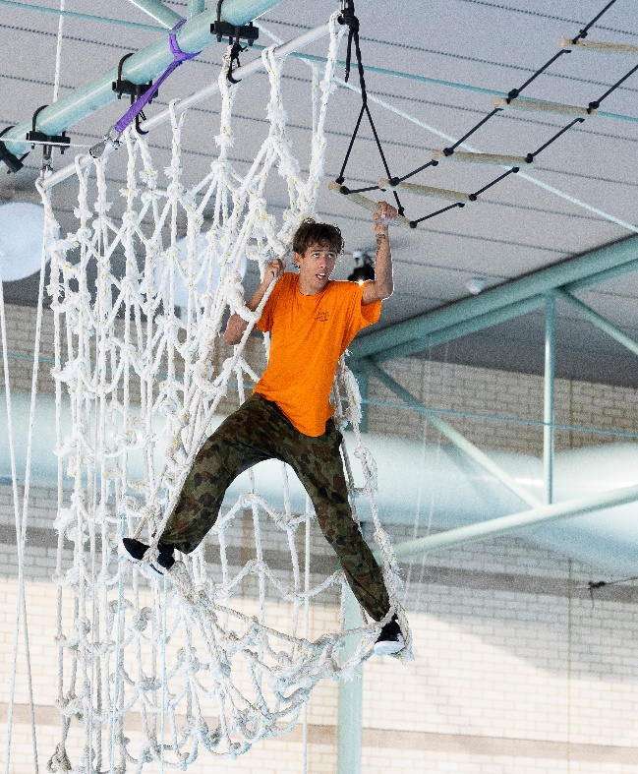
c. _________________________
g. _________________________

e. ____________________
- Work with a partner. Play a game.
Student A, stay on this page. Student B, turn to the next page.

STUDENT A
- This is a competition. The student with the most correct answers wins.
- Ask your partner the questions below. If they give the correct answer, it’s one point for him/her.
- Take turns. You ask one question, then your partner asks you one question, and so on.
- When you’re answering, give complete answers.
For example: A: Where do you go if you’re sick?
B: If you’re sick, you go to the ___________.

Read these questions to student B. | If student B gives these answers, give them one point. | Put a tick () in each space below if student A answers correctly.
Where do you go if you are sick? | health centre
Where do soldiers practise special skills in the field? | training area
Where can you swim? | pool
Where do you practice shooting? | firing range
Where are the weapons in a military base? | armoury
Where do soldiers sleep? | accommodation
Total:

STUDENT B
- This is a competition. The student with the most correct answers is the winner.
- Ask your partner the questions below. If they give the correct answer, it’s one point for him/her.
- Take turns. You ask one question, then your partner asks you one question, and so on.
- When you’re answering, give complete answers.
For example: A: Where can you eat lunch on an army base?
B: You can eat lunch at the ___________.

Read these questions to student A. | If student A gives these answers, give them one point. | Put a tick () in each space below if student A answers correctly.
Where can you eat lunch on an army base? | mess
Where do personnel work at desks in front of computers? | office
Where can I pray on a base? | chapel
Where do personnel fix equipment such as tanks and trucks? | maintenance workshop
Where do soldiers run, climb and jump? | obstacle course
Where can I get fit? | gym
Total:

- This Lesson links with Lesson: Snapshot of the Australian Army

© Commonwealth of Australia 2024
This work is copyright. Apart from any use as permitted under the Copyright Act 1968 (Cth),
no part may be reproduced by any process without prior written permission from the Department of Defence.

